Jan Christian SJ Samaniego

janchristian.samaniego@gmail.com (+63) 915-346-9613 linkedin.com/in/janosamaniego

Full-Stack Software Developer with 2+ years of professional experience building performant, maintainable, and user-centric software across AI, enterprise OTA systems, and legal-tech. Strong experience in TypeScript, NestJS, React, Next.js, Java, and Spring Boot, developing production systems across the full software lifecycle. Experienced in scalable application architecture, cloud infrastructure, databases, asynchronous processing, testing, CI/CD, and cross-team collaboration.

Technical skills

Language & Frameworks  Backend & Databases | Typescript, React JS, NextJS, NodeJS, NestJS, Java, Spring Boot  PostgreSQL, Prisma ORM, MongoDB, Mongoose, Redis
APIs and Async Processing | REST APIs, RabbitMQ, BullMQ, WebSockets, Socket.IO
Frontend & State Management | TanStack Query, Redux Toolkit, RTK Query, Zustand, Tailwind CSS, ShadCN UI, PrimeReact, Material UI
Cloud, DevOps & Tools | AWS (EC2, S3, RDS, Lambda, DynamoDB, CloudFront), Docker, Jenkins, Dokploy, SonarQube, Git, GitHub
Architecture & Engineering | Microservices, Multi-Tenant Systems, Role-Based Access Control, Feature Flagging, SSR, Localization (i18n), Responsive Design, Large-Scale Migration
Testing | Jest, React Testing Library, Unit Testing, Integration Testing
Projects

Lexphere (June 2024 ~ August 2026)
- Served as a primary contributor to the development of a multi-tenant law management platform covering case management, timesheets, contracts, invoices, expenses, and incentive workflows, scaling to hundreds of attorneys, thousands of clients, thousands of cases, and tens of thousands of timesheets in production.
- Started as a Frontend Developer and transitioned into a full-stack role, becoming the sole Backend Developer responsible for system architecture, database design, API contracts, and long-term platform maintenance as the last remaining founding team member.
- Designed and implemented scalable services using NestJS, RabbitMQ, Prisma, PostgreSQL, Redis, and REST APIs, including RBAC, tenant-level resource isolation, transaction-safe operations, background job processing, and schema evolution.
- Built and maintained secure authentication and authorization workflows using JWT, NextAuth, access and refresh tokens, and cookie-based sessions, supporting role-based access control across a multi-tenant environment.
- Developed enterprise document and financial workflows, including Excel/PDF exports, time and billing reconciliations, automated financial reporting, and attorney compensation calculations, supporting recurring billing and compensation processes.
- Developed and maintained the frontend using Next.js, React, TanStack Query, Zustand, PrimeReact, Tailwind CSS, TipTap, and Next-Intl, with responsive and accessible interfaces, English/Korean localization, automated testing, and consistent design system foundations.

- Improved system reliability and developer workflows through GitHub Actions/Jenkins CI/CD, SonarQube, Jest and React Testing Library, Docker, and Dokploy, while supporting ongoing production troubleshooting and performance improvements.

LG Energy Solution — RSU / Device Management (February 2026 ~ August 2026)
- Contributed to the development and maintenance of an enterprise Remote Software Update (RSU/OTA) platform supporting software distribution and device management workflows across LG's connected-device ecosystem.
- Developed and maintained backend services using Java 17, Spring Boot, Maven, and MariaDB across the DM Manager, Package Manager, Push Manager, and DM Core components, supporting the end-to-end software update lifecycle.
- Implemented and maintained REST APIs, package management workflows, asynchronous processing, and device management operations, integrating multiple services across the RSU platform.
- Worked with AWS S3, DynamoDB, CloudFront, and Lambda to support software package storage and distribution, metadata management, secure downloads, and cloud-based processing.
- Developed features for the RSU Portal using React and Spring Boot, including user management, approval workflows, authentication, tenancy, and administrative functionality, while working with SyncML and MQTT for device-server communication.
- Supported production maintenance and release activities across interconnected services, including version synchronization, component indexing, troubleshooting, compatibility management, and technical documentation.

Evandis (April 2024 ~ June 2024)
- Contributed to the development of a customizable Content Management System (CMS) focused on landing page creation and visual branding.
- Built features allowing users to upload, manage, and organize images and media assets used across dynamic landing pages.
- Implemented flexible page configuration tools enabling non-technical users to customize layouts, visuals, and content without developer intervention.
- Worked on frontend and backend integration to ensure efficient asset handling, optimized image delivery, and smooth content updates.
- Improved usability and performance of the platform to support marketing and promotional use cases.

Comake (February 2024 ~ April 2024)
- Worked on an AI-assisted legal document analysis system that parses contracts and evaluates clause quality against predefined legal requirements. Implemented logic to classify clauses into positive, cautionary, and negative findings and compute an overall document quality score.
- Built scalable backend APIs and database models to handle student records, class relationships, and role-based access

- Served as the sole Frontend Developer, building the platform using Next.js, shadcn/ui, and React Query.
- Also contributed to the backend by implementing Next.js Server API endpoints for PDF/DOCX parsing and OCR-based text extraction.

Professional Experience
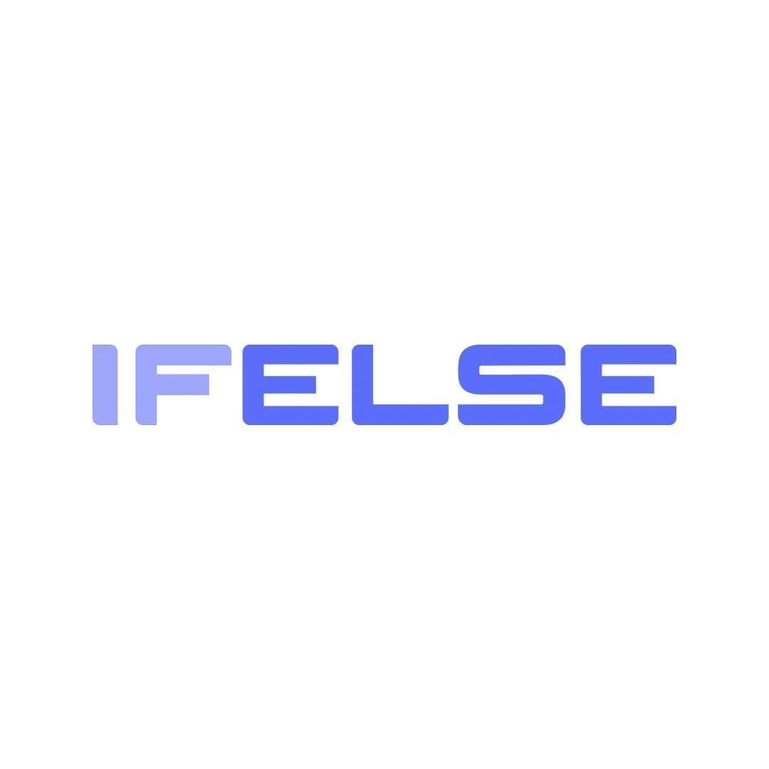

IFelse Philippines - Manila (South Korean owned)
Software Developer | February 2024 - August 2026

Education


AB Literature
Far Eastern University | 2014 - 2019

