Supporting Information

ChemFate: a fate and transport modeling framework for evaluating radically different chemicals under comparable conditions

Mengya Tao a and Arturo A. Keller a

a Bren School of Environmental Science & Management, University of California, Santa Barbara, USA

Corresponding Author: Arturo A. Keller

Phone: 805-893-7548

Fax: 805-893-7612

Email: [keller@bren.ucsb.edu](mailto:keller@bren.ucsb.edu)

Figure S1. Map of Visalia, CA region.

H:\Clicc\Visalia\Visalia_Map.tif

Figure S2. Comparison of model results and median observed data (obs.) for 2,4-D. The simulation results from ionOFate are at the end of the 10-year simulation time and the median observed values for air and freshwater are presented.

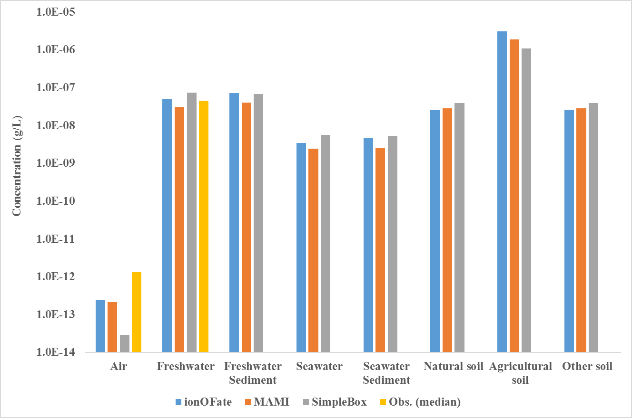

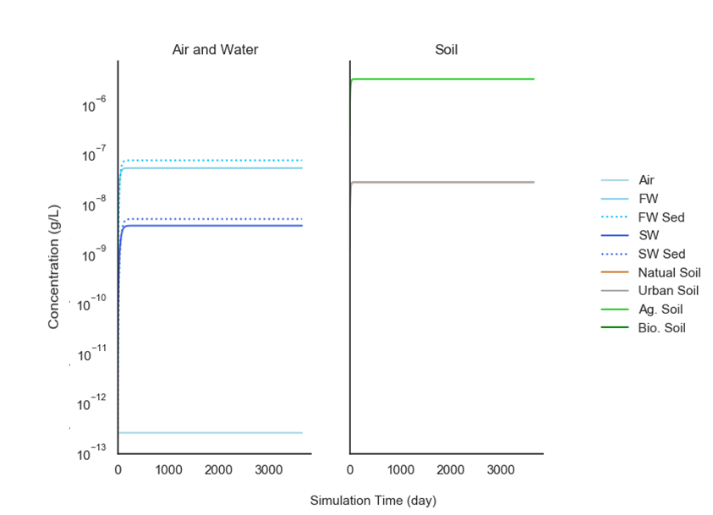Figure S3. Predicted environmental concentrations for 2,4-D in ionOFate with default rate constants.

Figure S4. Climate data for New York region from 2005-2014.



Figure S5. Predicted 2,4-D concentrations in different environmental media, including air, water (freshwater and seawater), and soil (natural soil, agricultural soil, and other soil).

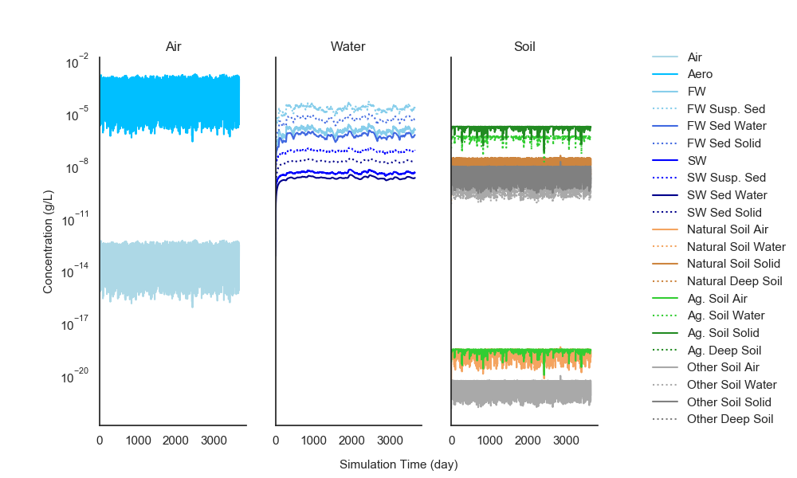

Figure S6. Mean concentrations for neutral and ionic forms of 2,4-D over the 10-year simulation in major environmental compartments (left) and mass fraction distributions of 2,4-D at the end of 10-year simulation (right).

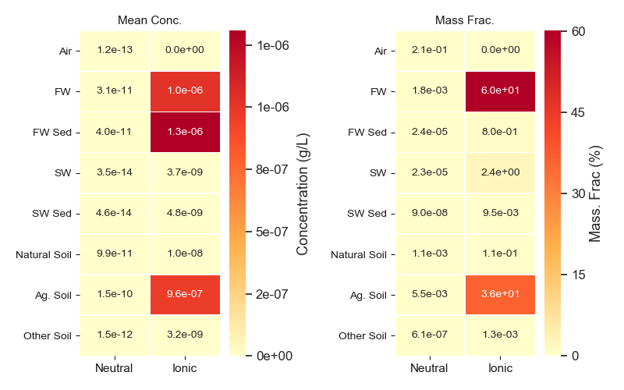

Figure S7. Predicted environmental concentrations for Ni in metalFate.

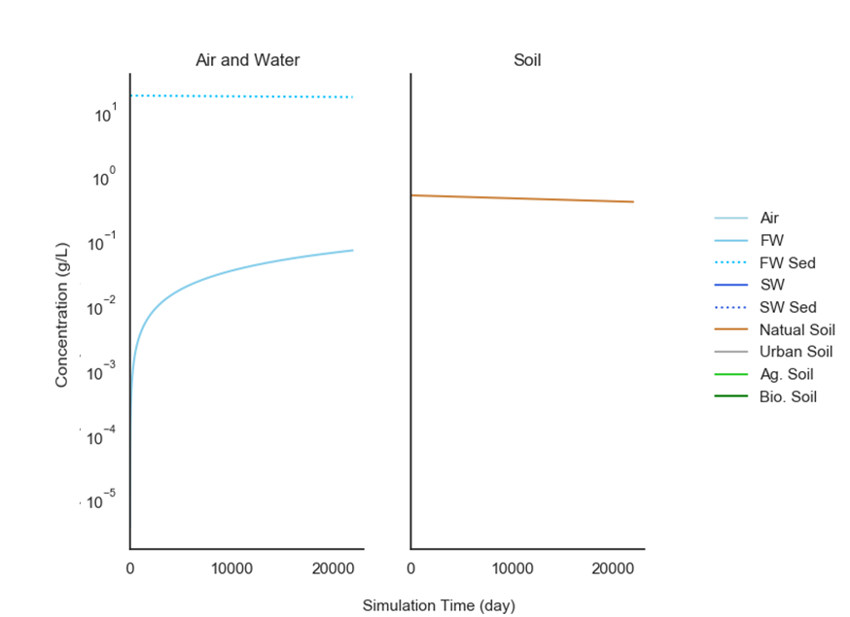

Figure S8. Mean concentrations for particulate, colloidal, and dissolved forms of Ni over the 60-year simulation in major environmental compartments (left) and mass fraction distributions of Ni at the end of 60-year simulation (right).

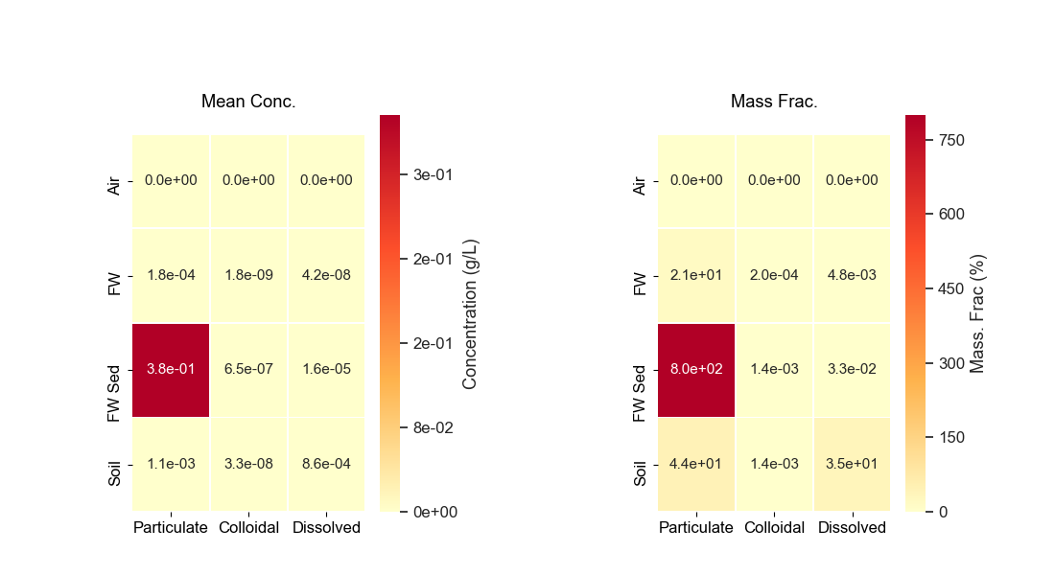

Figure S9. Predicted environmental concentrations for benzene in organoFate.

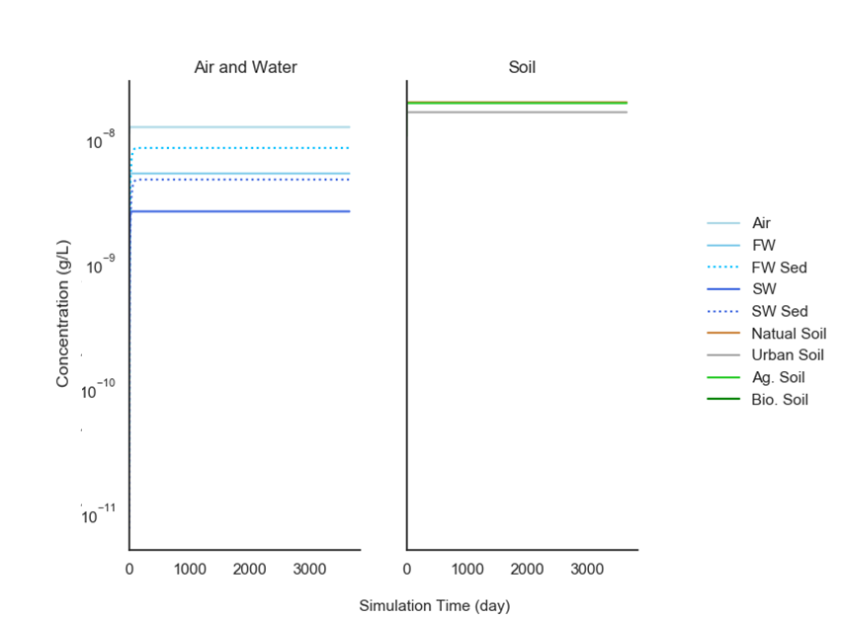

Figure S10. Predicted environmental concentrations in freshwater compartment for the selected four pesticides as a function of the agricultural soil runoff curve number (CN), comparing the original simulation (green) to a 2-unit decrease (orange) or 2-unit increase (blue).

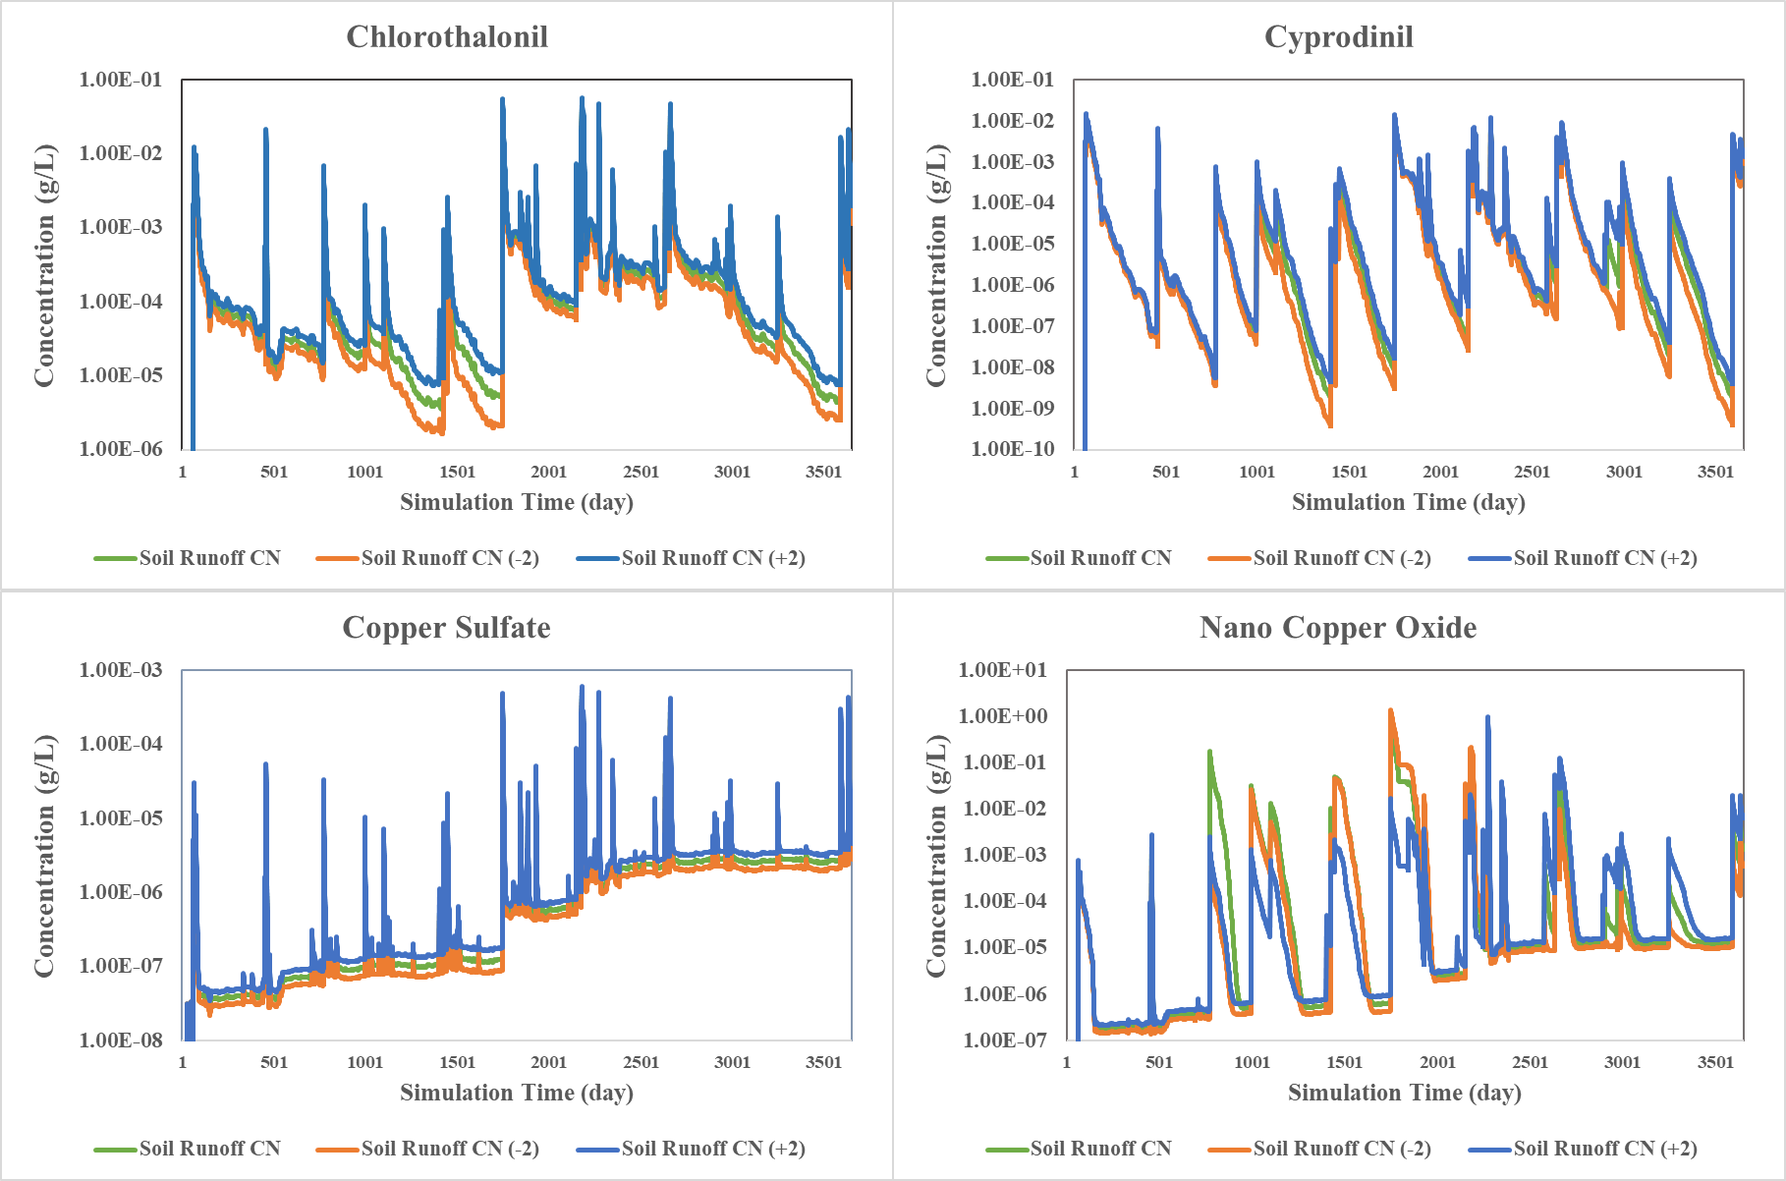

Figure S11. Percentage change in predicted environmental concentrations in freshwater compartment for the selected four pesticides as a function of the agricultural soil runoff curve number (CN), comparing the original simulation (green) to a 2-unit decrease (orange) or 2-unit increase (blue).

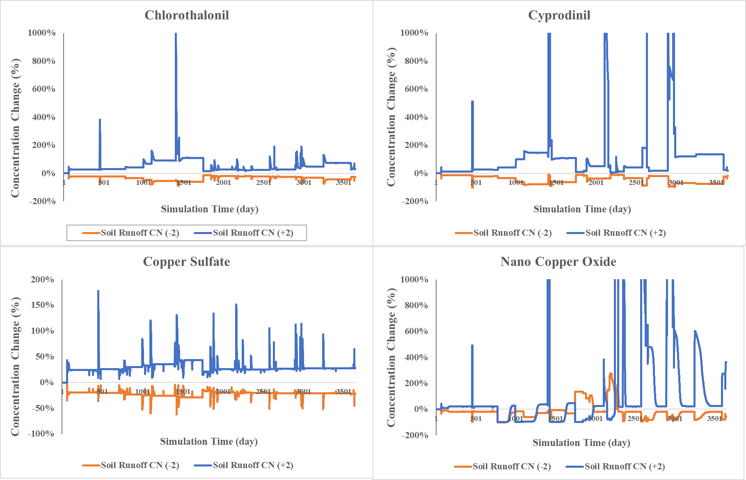

Figure S12. Predicted environmental concentrations in the freshwater compartment for the selected four pesticides with 50% decrease (orange) and increase (blue) of the freshwater sediment resuspension rate, compared to the original simulation (green).

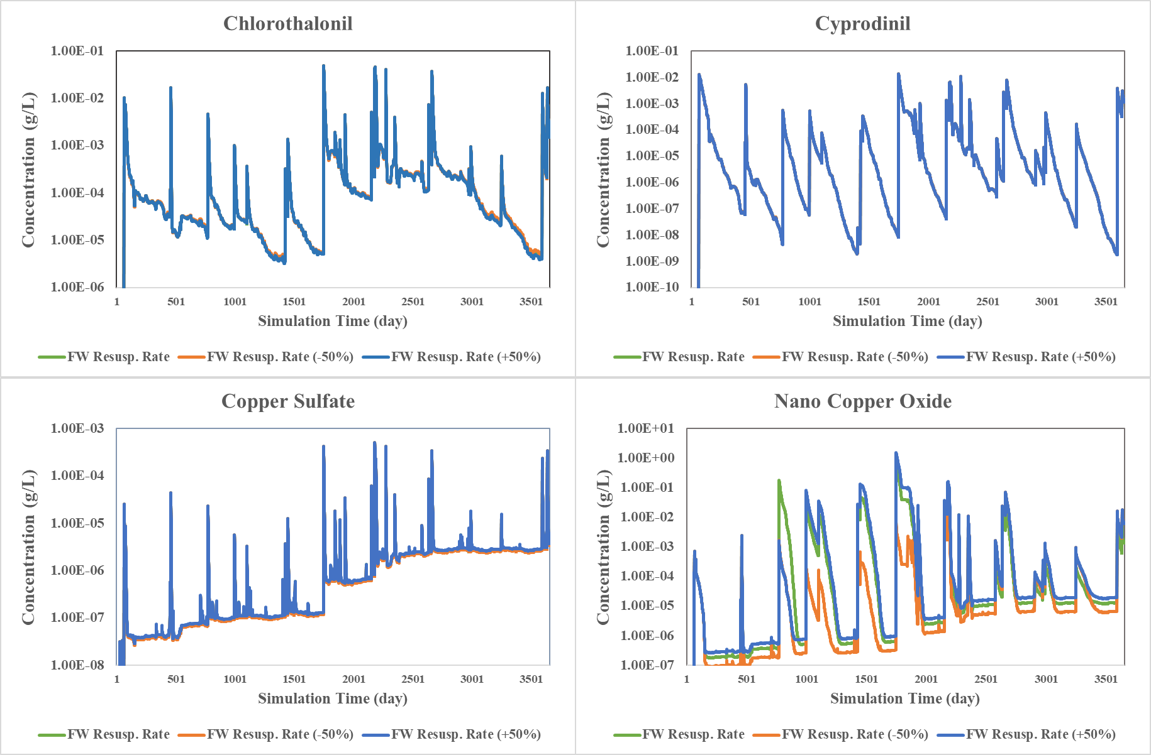

Figure S13. Percentage change in predicted environmental concentrations in freshwater compartment between the baseline freshwater sediment resuspension rate (green) and 50% decrease or 50% increase (blue).

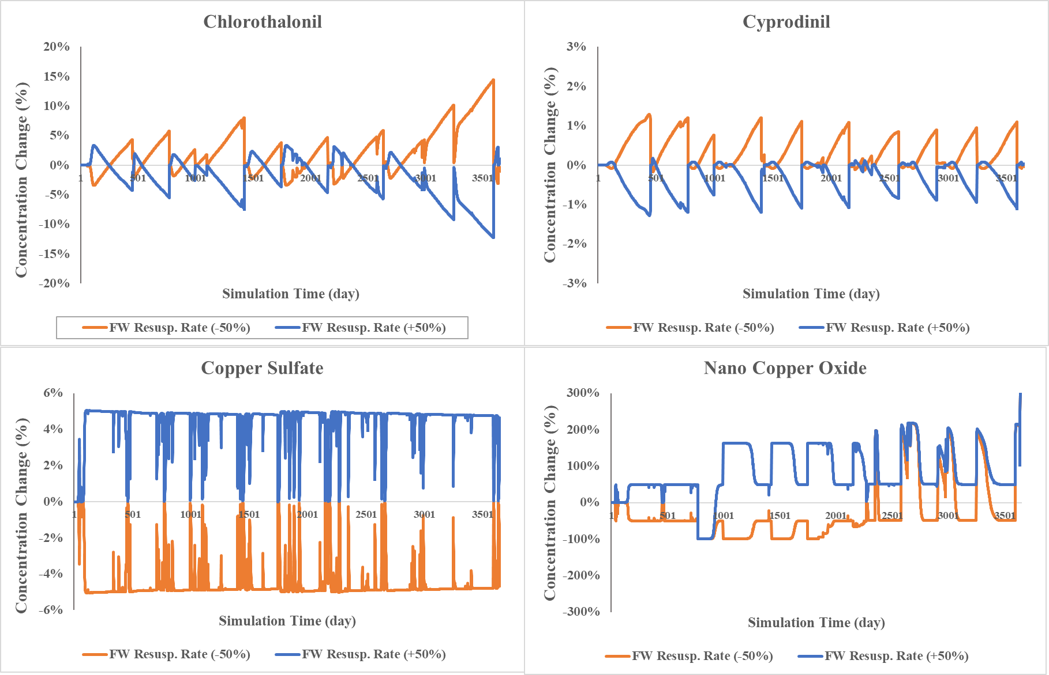

Figure S10 shows the PECs in freshwater with 50% decreased and increased freshwater sediment resuspension rate values.