SQL ASSIGNMENT-1

* Create database Northwind
* Create database Northwind
* Creating Tables :
* Suppliers Table:

create table Suppliers(

SupplierID int primary key identity(1,1),

CompanyName VARCHAR(40) unique NOT NULL,

ContactName VARCHAR(30),

ContactTitle VARCHAR(30),

Address VARCHAR(60),

City VARCHAR(15),

Region VARCHAR(15),

PostalCode VARCHAR(10),

Country VARCHAR(15),

Phone VARCHAR(24),

Fax VARCHAR(24),

HomePage VARCHAR(250)

)

* Categories Table:

create table Categories

(

CategoryID int primary key identity(1,1),

CategoryName VARCHAR(15) unique NOT NULL,

Description VARCHAR(250)

)

* Products Table:

create table Products

(

ProductID int primary key identity(1,1),

ProductName VARCHAR(40) unique NOT NULL,

SupplierID int ,

FOREIGN KEY (SupplierID) REFERENCES Suppliers(SupplierID),

CategoryID int,

FOREIGN KEY (CategoryID) REFERENCES Categories(CategoryID),

QuantityPerUnit VARCHAR(20),

UnitPrice DECIMAL(10,4),

UnitsInStock SMALLINT,

UnitsOnOrder SMALLINT,

ReorderLevel SMALLINT,

Discontinued BIT

)

1. select ProductId, ProductName, UnitPrice

from Products

where UnitPrice < 20

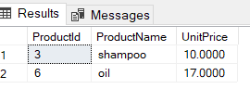

1. select ProductId, ProductName, UnitPrice

from Products

where UnitPrice between 15 and 25

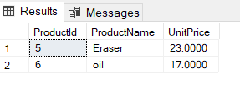

1. SELECT DISTINCT ProductName, UnitPrice

FROM Products

WHERE UnitPrice > (SELECT avg(UnitPrice) FROM Products)

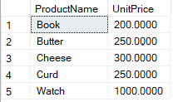

1. select top 10 MAX(UnitPrice) as ProductPrice, ProductName

from Products

group by ProductName

order by ProductPrice desc

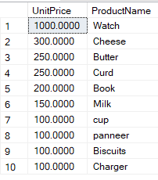

1. select COUNT(ProductName) as Products

from Products

group by Discontinued

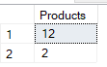

1. select ProductName, UnitsOnOrder, UnitsInStock

from Products

where UnitsInStock < UnitsOnOrder

