**SQL ASSIGNMENT – 2**

1. Salesman Table

create table salesman

(

salesman_id int primary key,

name varchar(20),

city varchar(20),

grade int not null

)

1. Customer Table

create table customer

(

customer_id int primary key,

cust_name varchar(20),

city varchar(20),

grade int not null,

salesman_id int,

foreign key (salesman_id) references salesman(salesman_id)

)

1. Order Table

create table orders

(

ord_no int primary key,

purch_amt float,

ord_date date,

customer_id int,

foreign key (customer_id) references customer(customer_id),

salesman_id int,

foreign key (salesman_id) references salesman(salesman_id)

)

1. select s.name,c.cust_name,c.city

from salesman as s

inner join customer as c

on s.city = c.city

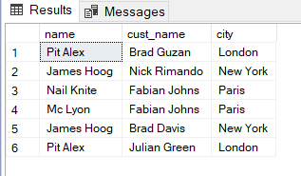

1. select o.ord_no,o.purch_amt,c.cust_name,c.city

from orders as o

inner join customer as c

On o.customer_id = c.customer_id

where o.purch_amt between 500 and 2000

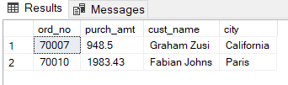

1. select s.name,c.cust_name,c.city,s.commision

from salesman as s

inner join customer as c

on c.salesman_id = s.salesman_id

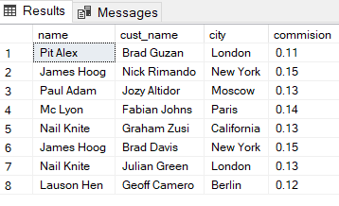

1. select c.cust_name as customer,c.city, s.name as salesman ,s.commision

from salesman as s

inner join customer as c

on s.salesman_id = c.salesman_id

where s.commision > 0.12

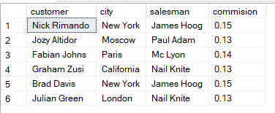

1. select c.cust_name as customer,c.city as [customer city], s.name as salesman ,s.city as [salesman city],s.commision

from salesman as s

inner join customer as c

on s.salesman_id = c.salesman_id

where s.commision > 0.12 and s.city != c.city

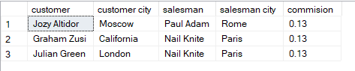

1. select o.ord_no as [Order Number], o.ord_date as [Order Date],o.purch_amt as [Purchase Amount],c.cust_name as Customer,c.grade as Grade,s.name as Salesman,s.commision as Commision

from orders as o

inner join customer as c

On o.customer_id = c.customer_id

inner join salesman as s

On s.salesman_id = c.salesman_id

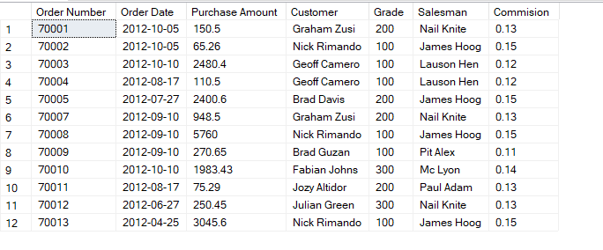

1. SELECT customer.customer_id, customer.cust_name CustomerName, customer.city City, customer.grade Grade,

salesman.salesman_id, salesman.name SalesmanName, salesman.commision Commission,

ord.ord_no OrderNo, ord.purch_amt OrderAmount, ord.ord_date OrderDate

FROM customer, salesman, Orders as ord

WHERE customer.customer_id = ord.customer_id AND ord.salesman_id = salesman.salesman_id AND customer.city = salesman.city

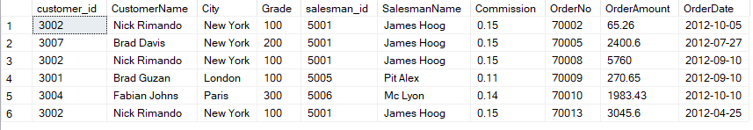

1. select c.cust_name as Customer, c.city as [Customer City],c.grade as Grades,s.name as Salesman,s.city as [Salesman City]

from customer as c

inner join salesman as s

on c.salesman_id = s.salesman_id

order by c.customer_id ASC

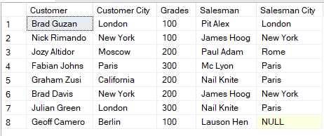

1. select c.cust_name as Customer, c.city as [Customer City],c.grade as Grades,s.name as Salesman,s.city as [Salesman City]

from customer as c

inner join salesman as s

on c.salesman_id = s.salesman_id

where c.grade < 300

order by c.customer_id ASC

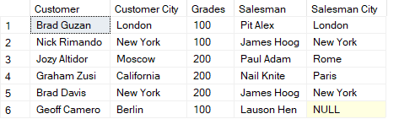

1. select c.cust_name as Customer ,c.city as City, o.ord_no as [Order No],o.ord_date as [Order Date],o.purch_amt as [Order Amount]

from customer as c

left join

orders as o

on c.customer_id = o.customer_id

order by c.customer_id ASC

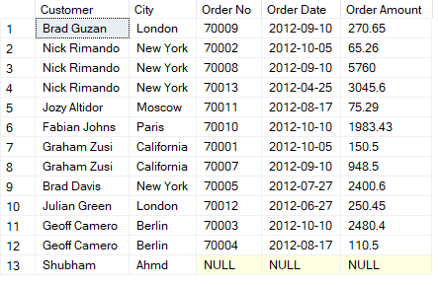

1. select c.cust_name as Customer ,c.city as City, o.ord_no as [Order No],o.ord_date as [Order Date],o.purch_amt as [Order Amount], s.name as Salesman,s.commision as Commision

from customer as c

left join

orders as o

on c.customer_id = o.customer_id

left join

salesman as s

on s.salesman_id = c.salesman_id

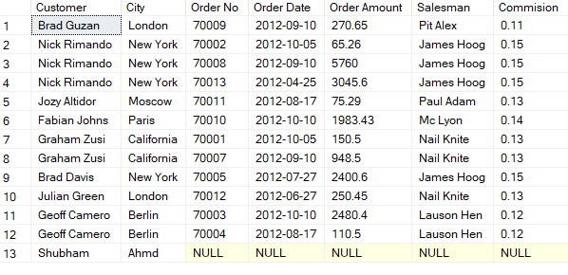

1. select s.name as "Salesman"

from salesman s

LEFT JOIN customer c

ON s.salesman_id=c.salesman_id

ORDER BY c.salesman_id ASC;



1. select s.name as Salesman, c.cust_name as Customer ,c.city as City,c.grade as Grade, o.ord_no as [Order No],o.ord_date as [Order Date],o.purch_amt as [Order Amount]

from salesman as s

inner join customer as c

on s.salesman_id= c.salesman_id

inner join orders as o

on c.customer_id = o.customer_id

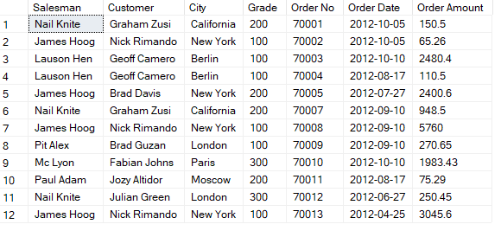

1. select s.name as "Salesman"

from salesman s

LEFT JOIN customer c

ON s.salesman_id=c.salesman_id

LEFT JOIN orders o

ON c.customer_id = o.customer_id

WHERE o.purch_amt > 2000

AND c.grade IS NOT NULL

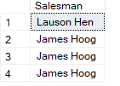

1. Same as above
2. select c.cust_name as Customer, c.city as City, o.ord_no as [Order No],o.ord_date as [Order Date],o.purch_amt as [Order Amount]

from customer as c

right join orders as o

on c.customer_id = o.customer_id

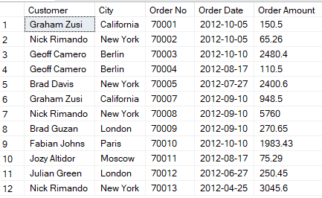

1. select *

from salesman

cross join

customer

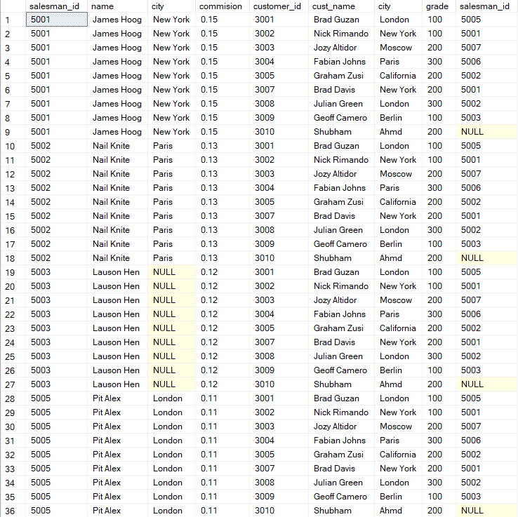

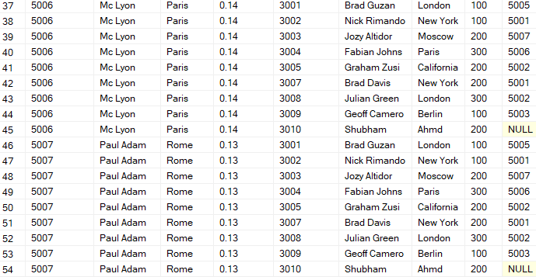

1. select s.name as Salesman , c.cust_name as Customer

from salesman as s

cross join

customer as c

where s.city is not null

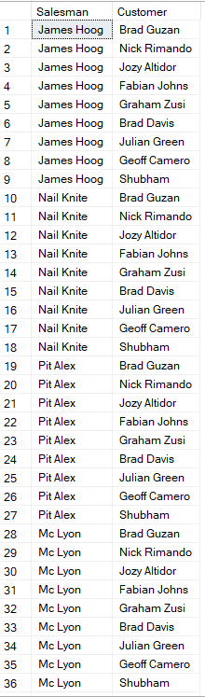



1. select s.name as Salesman , c.cust_name as Customer

from salesman as s

cross join

customer as c

where s.city is not null AND c.grade is not null

OUTPUT: Same as Above

1. select s.name as Salesman , c.cust_name as Customer

from salesman as s

cross join

customer as c

where s.city is not null and s.city != c.city and c.grade is not null

