**SQL ASSIGNMENT-3**

* **CREATING DEPARTMENT TABLE:**

create table Department(

dept_id int primary key,

dept_name varchar(20) not null

)

* **CREATING EMPLOYEE TABLE:**

create table Employee(

emp_id int primary key,

dept_id int,

foreign key (dept_id) references Department(dept_id),

mngr_id int ,

emp_name varchar(20),

salary int

)

1. select e.emp_name as Employee ,e.salary as Salary ,d.dept_name as Department

from Employee as e

join Department as d

on e.dept_id = d.dept_id

where e.salary in (select MAX(salary) from Employee group by dept_id)

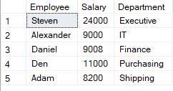

1. select count(*) as Employee,d.dept_name as Department

from Department as d

join Employee as e

on e.dept_id = d.dept_id

group by e.dept_id, d.dept_name

having count(*) < 3

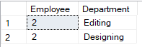

1. select count(*) as [No of Employees], d.dept_name as Department

from Employee as e

join Department as d

on e.dept_id = d.dept_id

group by e.dept_id, d.dept_name

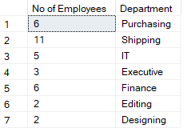

1. select count(*) as [No of Employees], d.dept_name as Department, SUM(e.salary) as [Total Salary]

from Employee as e

join Department as d

on e.dept_id = d.dept_id

group by e.dept_id, d.dept_name

