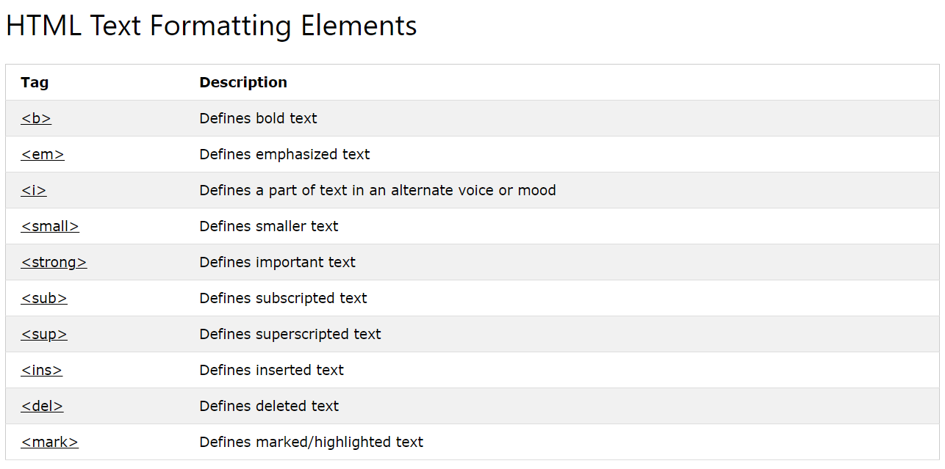

**Video Formats**

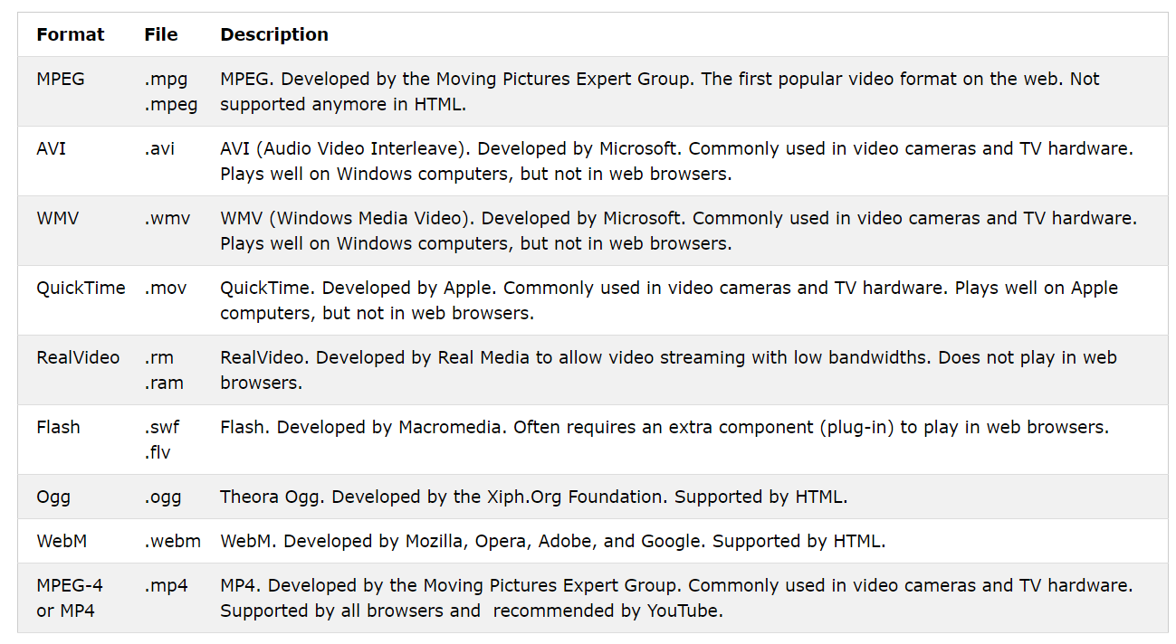

**Audio Formats**

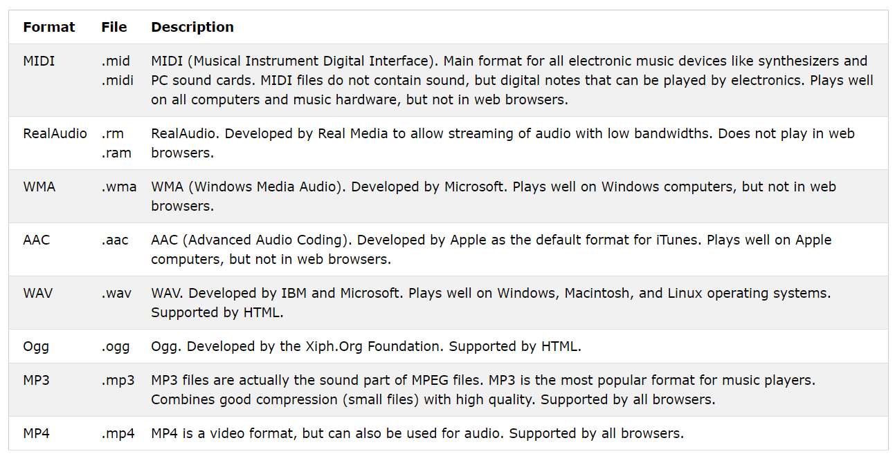

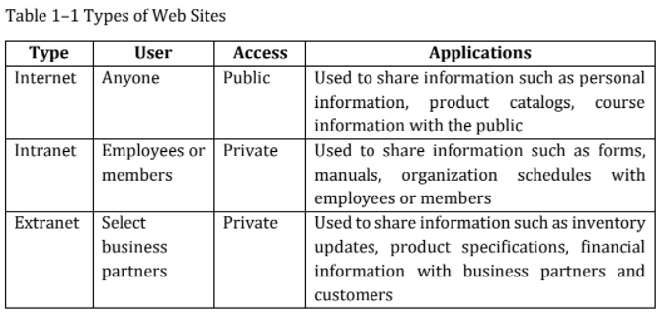

**Website Structures**

* **Linear Website Structure –** web pages in a straight line
* **Hierarchical Website Structure –** web pages in a treelike structure
* **Webbed Website Structure –** has no set of organization
* **Broad Website Structure –** the home page is the main index page.
* **Deep Website Structure -** requires the user to click many times to reach a particular Web page

**Web Development Phases**

1. **Planning**
2. **Analysis**
3. **Designing and Development**
4. **Testing**
5. **Implementation and Maintenance**

