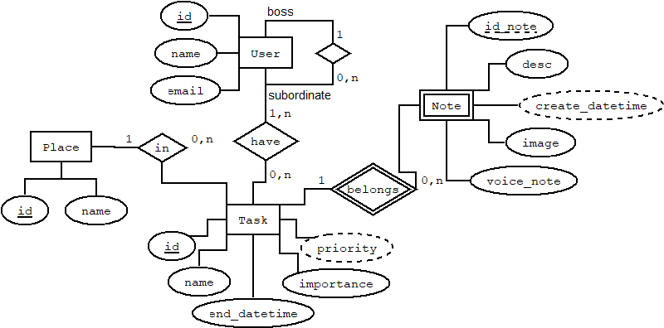

**MER**

*User (id_user, name, email, id_boss)

*User_Task ( id_user, id_task)

*Note (id_note, id_task, desc, voice_note, image)

*Task (id_task, name, end_datetime, importance, id_place)

*Place (id_place, name)

**Normalización**

Dependencias funcionales

id_user → name, email, id_boss

id_note, id_task → desc, voice_note, image

id_task → name_task, end_datetime, importance, id_place

id_place → name_place

R (id_user, name, email, id_boss, id_note, id_task, desc, voice_note, image, name_task, end_datetime, importance, id_place, name_place)

LLave candidata → id_user, id_note, id_task

LLave primaria → id_user, id_note, id_task

**1 FN**

**R**(id_user, id_note, id_task, name, email, id_boss, desc, voice_note, image, name_task, end_datetime, importance, id_place, name_place)

*Está en primera debido a que todos sus atributos son atómicos.*

**2 FN**

**R** (id_user, name, email, id_boss)

**R1** (id_note, id_task, desc, voice_note, image)

**R2** (id_task, name_task, end_datetime, importance, id_place, name_place)

*Está en segunda debido a que no presenta dependencias parciales.*

**3 FN**

**R** (id_user, name, email, id_boss)

**R1** (id_note, id_task, desc, voice_note, image)

**R2** (id_task, name_task, end_datetime, importance, id_place)

**R3** (id_place, name_place)

*Está en tercera debido a que no contiene dependencias transitivas.*