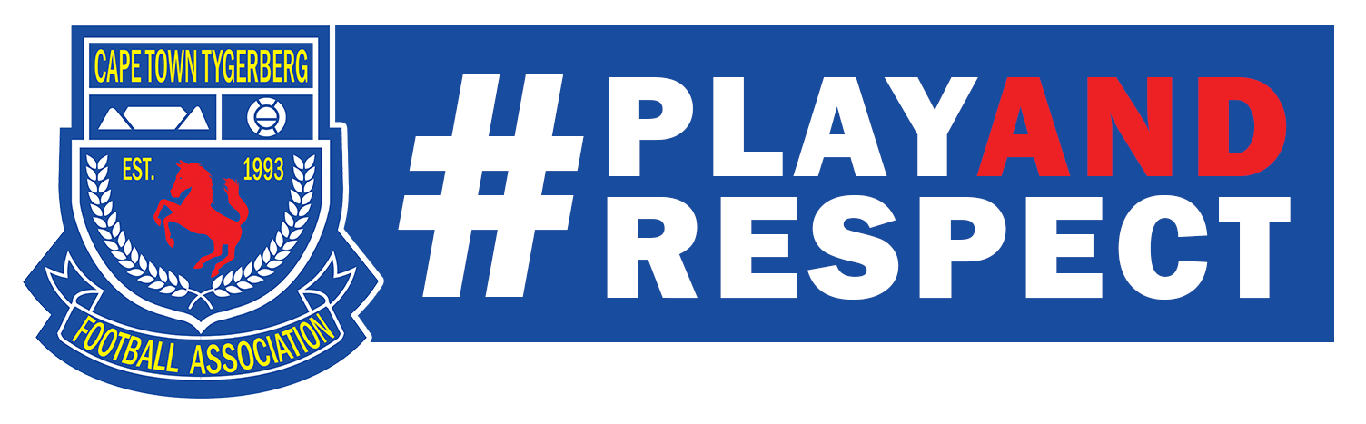

POLICY DOCUMENT
Proposed to be Adopted by the General Council
of the Cape Town Tygerberg Football Association

