NEMSU – Tagbina Campus Online Voting System User Manual Documentation
- Introduction

The NEMSU Tagbina Campus Online Voting System is a secure, efficient, and user-friendly digital platform developed to automate student elections. The system facilitates enforcement of university policies and election rules, while comprehensive audit trails and reports ensure transparency and accountability. Better coordination and communication among the candidates, voters, and administrators is another major benefit. The system also solves the security issue by authenticating user input, encrypting the vote data, and avoiding repeated voting. Finally, the system is flexible, so it can be a long term solution as the university expands and election requirements change. Fundamentally, a university-wide Voting System is a holistic investment that deepens democratic engagement, improves operational effectiveness, and fosters equality and integrity in student government.
This manual provides guidance for both admin and student voters:
- System Requirements
Device Compatibility: Desktop, Laptop, Mobile, Tablet
Browsers: Chrome, Firefox, Safari, Edge
Internet: Stable connection (2 Mbps+ recommended)
- Landing page
View Results, Live tally, Terms and conditions, Login forms also included.

- User Roles
Admin: Manages election operations, candidates, voters, and results.
Student/Voter: Registers, votes, and views results.

- Admin Overview
Feature | Description
Main Dashboard | Import Students, view Total candidates, Pending Voters, Download Result, and Manage Election Set, pause, or delete elections election automatically pause once count down is done.
Candidate Management | Add or remove candidates.
Voter Management/or Registered Students | Validate or remove voters.
Students Validation | Import student data form registrar and you can do manual adding.  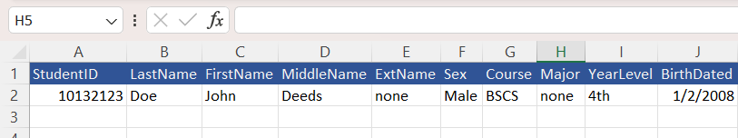  Figure 1 Sample template for exporting
- Voting Process (Students)
- Register using Student ID, Last Name, First Name, Middle Name personal information and it should be match on the record form the Student Validation Database.
- Log in using your email and password or login via Google.
- Select your preferred candidate and cast your vote.

6. Troubleshooting
Login Issues: Check your credentials or registration status or just reset password click below in the login form both for admin and users.
Vote Not Accepted: Election might be paused, ended or you already voted.
Missing Candidates: Admin may still be updating the list.

