Jorge Cosme

CSC 161-01

Lab 9B (5.5)

// File exists = False

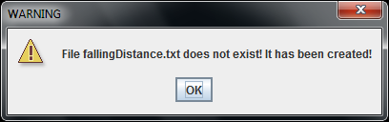

// File exists = True

