Jorge Cosme

CSC 161-01

Lab 9C (5.6)

// File exists = False

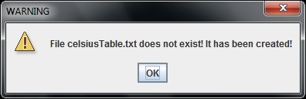

// File exists = True

