**03-06-2025**

**CLOUD COMPUTING**

**☁️ What Is Cloud Computing?**

Cloud computing is the delivery of computing services—such as servers, storage, databases, networking, software, and analytics—over the internet (“the cloud”). Instead of owning and maintaining physical data centers and servers, you can access these services on an as-needed basis from cloud providers like Amazon Web Services (AWS), Microsoft Azure, or Google Cloud Platform.

**Types of Cloud Services**

Cloud computing services are typically categorized into three main models:

1. **Software as a Service (SaaS)**: This model delivers software applications over the internet, on a subscription basis. Users can access these applications via web browsers, eliminating the need for installations or maintenance. Examples include Gmail, Microsoft Office 365, and Dropbox.
2. **Platform as a Service (PaaS)**: PaaS provides a platform allowing customers to develop, run, and manage applications without dealing with the infrastructure. It offers a framework for developers to build upon. Examples include Google App Engine and Microsoft Azure App Services.
3. **Infrastructure as a Service (IaaS)**: IaaS offers virtualized computing resources over the internet. It provides fundamental infrastructure like virtual machines, storage, and networks. Examples include AWS EC2 and Google Compute Engine.

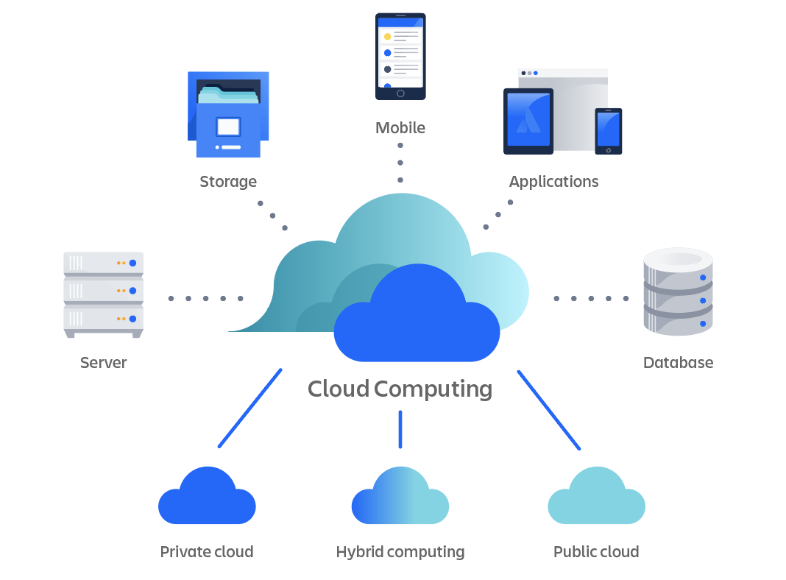

**Understanding the Diagram**

This diagram breaks down cloud computing into two main components:

1. **Front End (Client Side):**
   * **Users:** Individuals accessing cloud services via devices like computers, smartphones, or tablets.
   * **Applications:** Web browsers or client applications used to interact with cloud services.
2. **Back End (Cloud Infrastructure):**
   * **Servers:** Powerful computers that process data and run applications.
   * **Storage:** Systems that store data, such as databases and file storage services.
   * **Services:** Various services like application hosting, data processing, and machine learning.
   * **Management:** Tools and software that manage resources, ensure security, and handle traffic.

The **Internet** connects the front end and back end, allowing users to access and interact with cloud services from anywhere.

**How It Works**

When you use a cloud service (like streaming a movie or editing a document online):

1. **Request:** Your device sends a request over the internet to the cloud server.
2. **Processing:** The cloud server processes the request, accesses necessary data, and performs computations.
3. **Response:** The server sends the processed information back to your device, which displays the result.

**Deployment Models**

Cloud deployment models determine how cloud services are made available to users:

* **Public Cloud**: Services are delivered over the public internet and shared across organizations. Examples include AWS, Azure, and Google Cloud.
* **Private Cloud**: Services are maintained on a private network, offering greater control and security.
* **Hybrid Cloud**: Combines public and private clouds, allowing data and applications to be shared between them.
* **Multicloud**: Involves using multiple cloud computing services from different providers, enhancing flexibility and reducing dependency on a single vendor.

**Benefits of Cloud Computing**

* **Cost Efficiency**: Eliminates the capital expense of buying hardware and software.
* **Scalability**: Easily scale resources up or down based on demand.
* **Performance**: Major cloud services run on a worldwide network of secure data centres, which are upgraded to the latest generation of fast and efficient computing hardware.
* **Speed and Agility**: Resources can be provisioned in minutes, providing flexibility and reducing time to market.
* **Security**: Offers a set of policies, technologies, and controls that strengthen your security posture overall

**Considerations**

* **Downtime**: Dependence on internet connectivity means that service interruptions can affect access.
* **Limited Control**: Users may have less control over the infrastructure and services.
* **Security and Privacy**: Storing sensitive data off-premises requires ensuring that the cloud provider has robust security measures.