**FACE DETECTION AWS APP**

**ARCHITECTURE:**

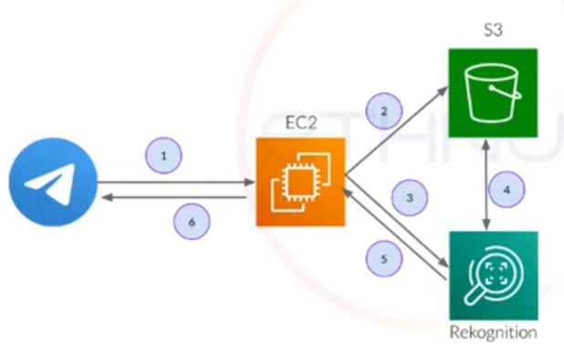

**SCREENSHOTS OF EC2**

1. **Logged in EC2 black screen**

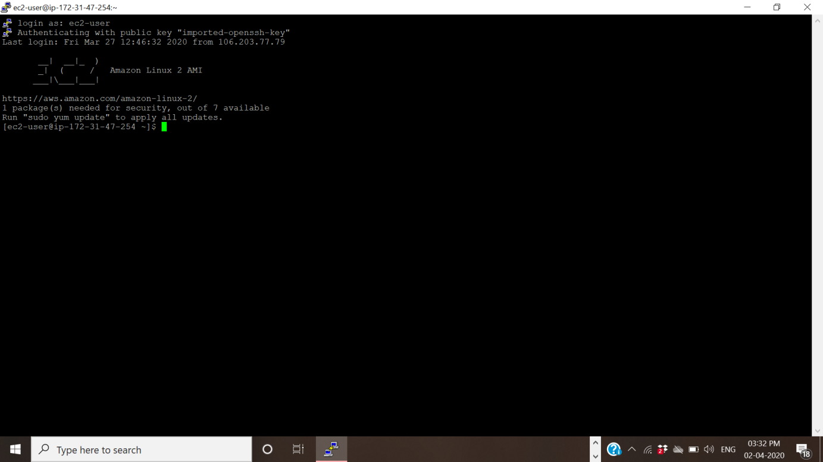

**SCREENSHOTS OF S3**

1. **Enabling Static Website**

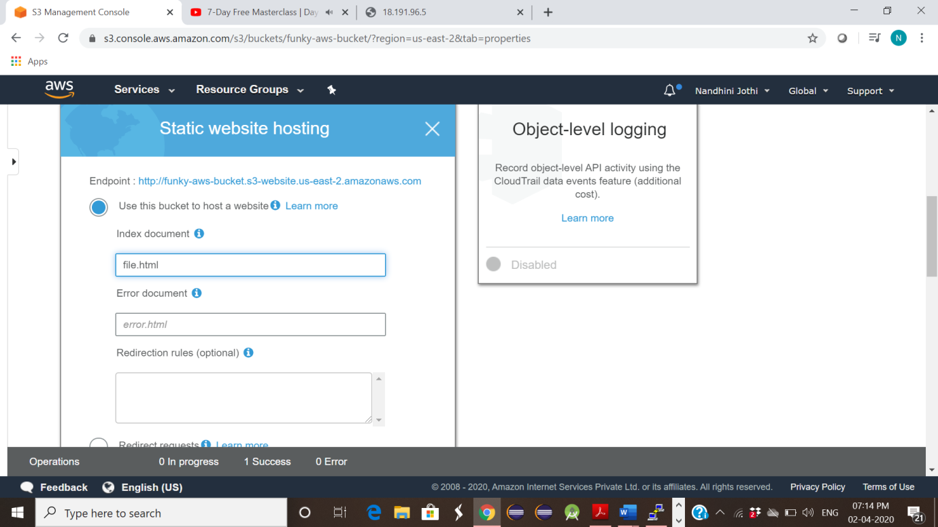

**SCREENSHOTS OF REKOGNITION:**

**1. Face Detect**

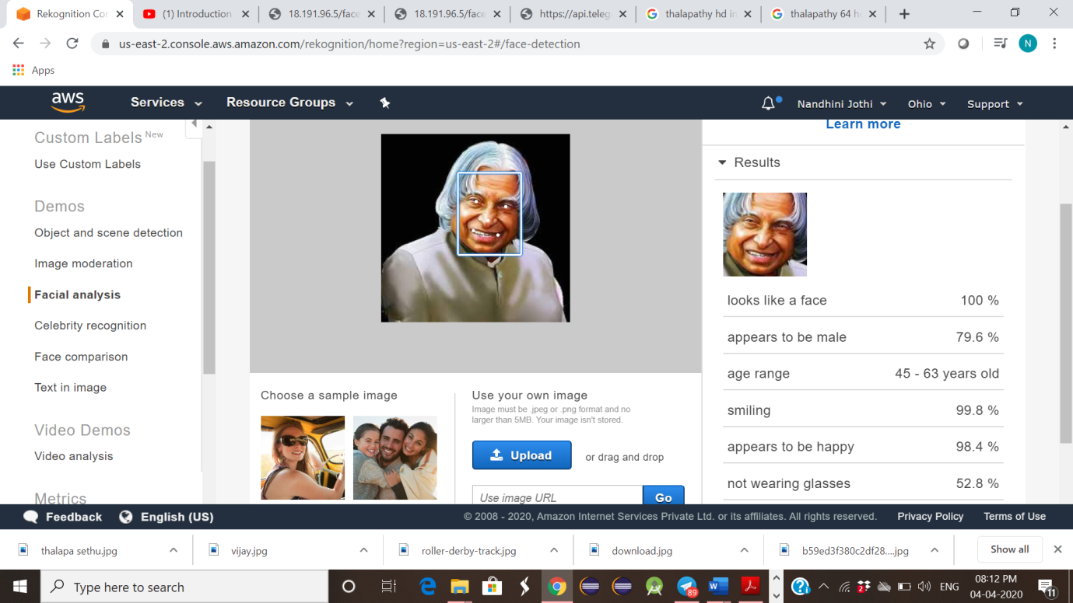

**2. Face Compare**

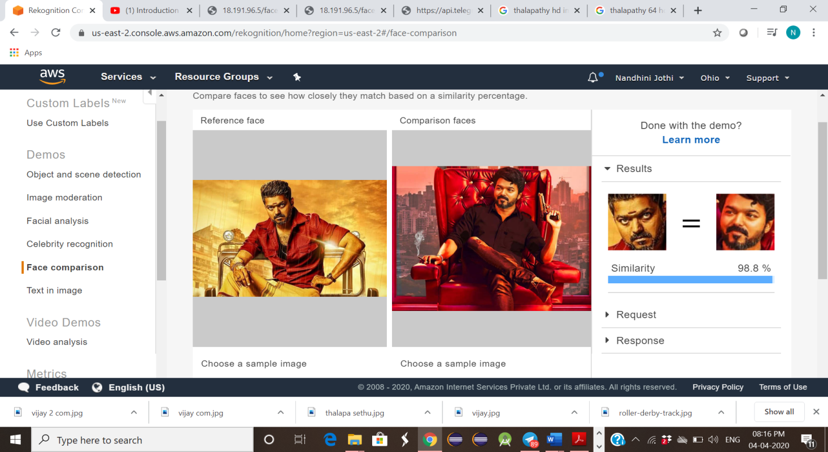

**SCREENSHOTS FOR EC2 and S3**

**1. Installing aws – sdk**

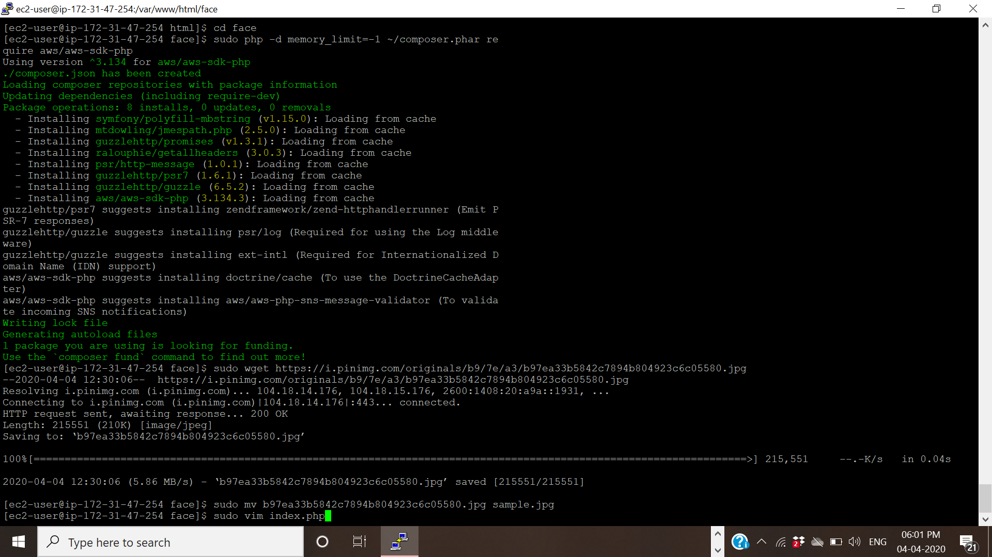

**2. Installing php**

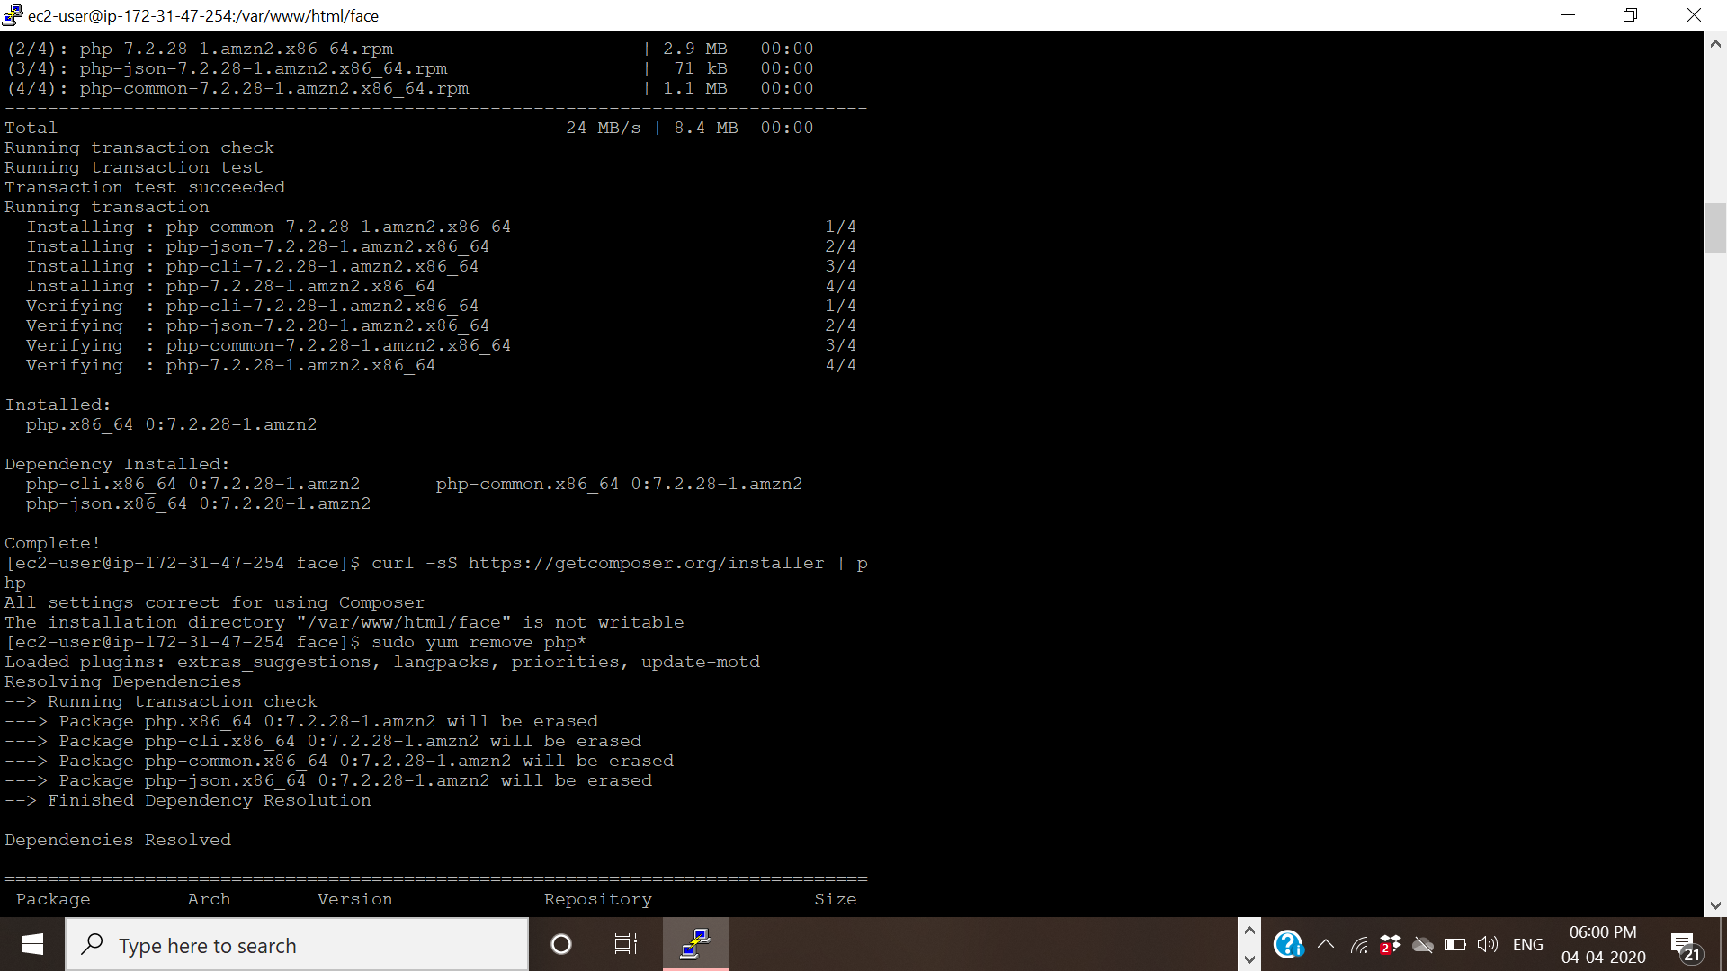

**SCREENSHOTS FOR EC2 and REKOGNITION**

**1. Face Detect success screenshot**

