Data Science and Visualization
Hack -A - Bit Project [Week-1 Report]
Team: 13
Project Title: Visualizing Crime Patterns for Safer Cities
Domain: Crime Data Analysis & Visualization
Dataset: Crime in Los Angeles Data from 2020 to Present (Kaggle Dataset)

---------------------------------------------------------------------------------------------------------------------------------------------------------------------------------------------------------------------------------------------------------------------------------------------------
WEEK 1:
Activity / Milestone
Team Formation & Data Searching:
- Team members were formed and responsibilities assigned
- Crime dataset selected from Kaggle
- GitHub repository created
- Introduction to Pandas and NumPy

Dataset:
https://www.kaggle.com/datasets/abdullahmazari/crime-data-of-los-angeles-from-2020-to-2025
Team Contribution:
All discussed about the dataset attributes in the dataset and clarifies which attributes give the main impact and used solve this problem.
---------------------------------------------------------------------------------------------------------------------------------------------------------------------------------------------------------------------------------------------------------------------------------------------------
WEEK 2:
Activity / Milestone
- Loaded dataset
- Checked data types and structure
- Identified missing and inconsistent values
- Generated first impression report
Interactive Python / GitHub / Kaggle Link
- GitHub Notebook:
https://github.com/JanuNandhini/24AD004_DSV_Team13./blob/main/Week-2.ipynb
Code and Screenshots:
1.Loading the data:
For loading the data, we use the pd. read_csv () function
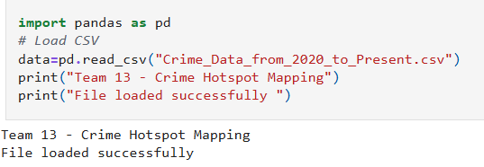
2.Data types:
Methods use to show the data types of the data used in dataset:
- df. dtypes () – It shows only the data types.
- df.info () – It shows columns, Non-null values and also data types.
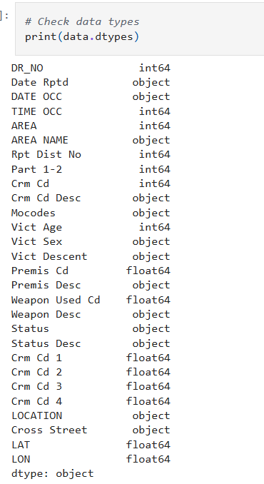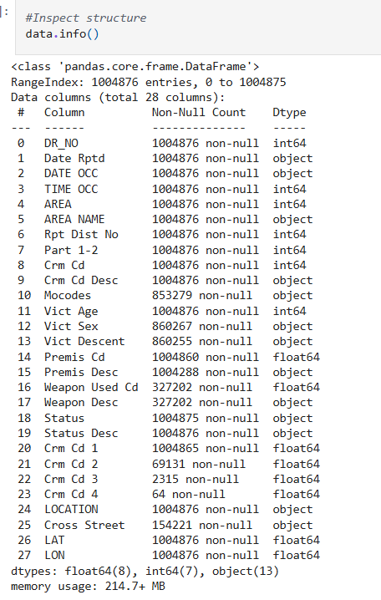

Team Contribution:
All members work together and completed the work.

FINAL OUTCOME OF WEEK 2:
All learned how to load the files and get clarity about the what datatypes are used

---------------------------------------------------------------------------------------------------------------------------------------------------------------------------------------------------------------------------------------------------------------------------------------------------
WEEK 3:
Activity / Milestone
The Cleaning Sprint
- Handled missing values using imputation
- Standardized crime descriptions
- Detected outliers using Boxplot and Z-score
- Cleaned time and location data
Interactive Python / GitHub / Kaggle Link
- GitHub Cleaning Notebook:
https://github.com/JanuNandhini/24AD004_DSV_Team13./blob/main/Week3.ipynb
Code and Screenshots:
First, we renamed the attributes to our convenient:
- 'Crm Cd Desc': 'Crime Description',
- 'TIME OCC': 'Time',
- 'DATE OCC': 'Date',
- 'LAT': 'Latitude',
- 'LON': 'Longitude'
1.Handling Missing values (Imputation Strategies):

For handling the null values, we have used the method – df.isnull(). sum()
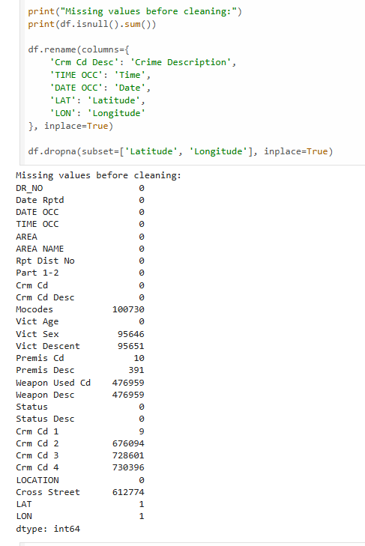

2. Outlier detection (Boxplot/Z-scores):
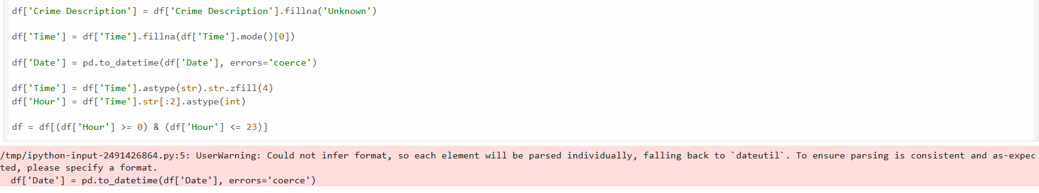
While we are defining the Date in the dataset it is in different format , So it shows the Warning message. We discussed and insisted in the code, use this if your dates look like MM/DD/YYYY.
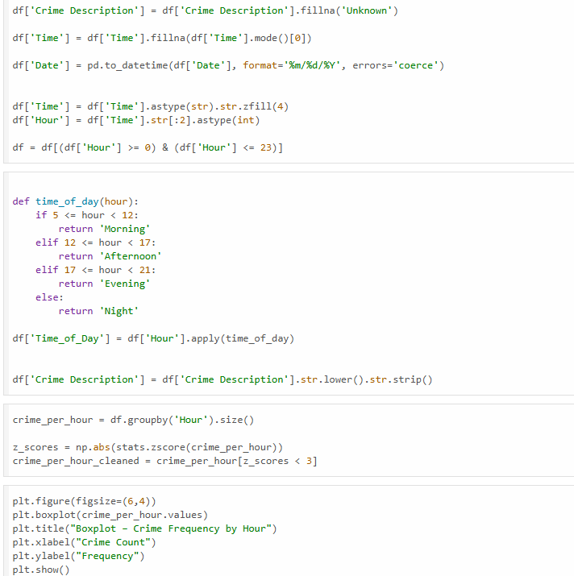

Output:
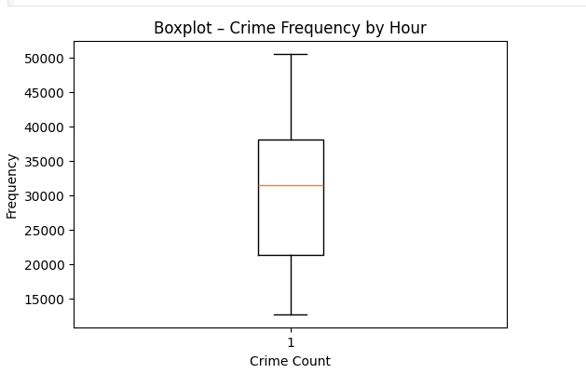

FINAL OUTCOME OF THE WEEK 3:
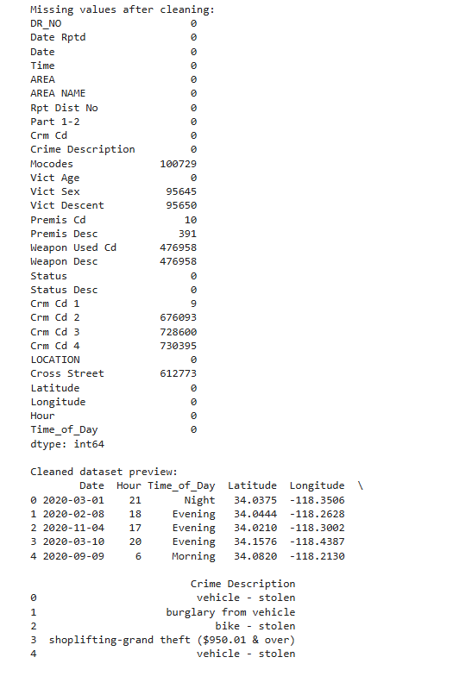
---------------------------------------------------------------------------------------------------------------------------------------------------------------------------------------------------------------------------------------------------------------------------------------------------
WEEK 4:
Activity / Milestone
EDA Deep Dive
- Univariate analysis of crime types
- Bivariate analysis of time vs crime
- Visualization using bar charts and heatmaps

Interactive Python / GitHub / Kaggle Link:
GitHub EDA Notebook:
https://github.com/JanuNandhini/24AD004_DSV_Team13./blob/main/week4.ipynb
Code and Screenshots:

1. BIVARIATE ANALYSIS BETWEEN THE HOUR ND THE NUMBER OF CRIMES:
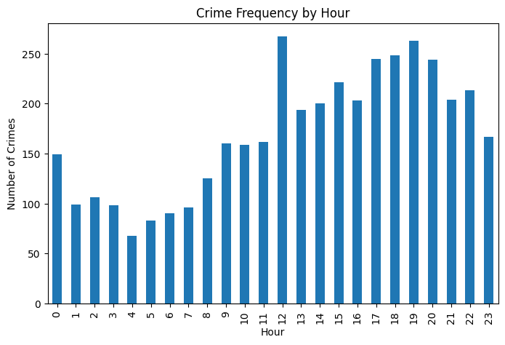
- The X-axis represents the Hour of the Day (0–23).
- The Y-axis represents the Number of Crimes.
- Each bar shows Lowest crime frequency occurs during early morning hours (around 3 AM – 6 AM).
- Crime frequency starts increasing from morning (8 AM onwards).
- Peak crime hour is around 12 PM.
- High crime levels continue during evening hours (5 PM – 8 PM).
- After 10 PM, crime frequency slightly decreases.
how many crimes occurred during that specific hour
2.UNIVARIATE ANALYSIS FOR CRIME OF THE DAY
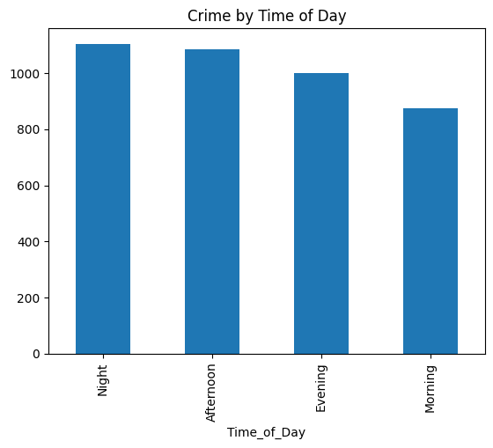
- Most crimes happen at night.
- Afternoon is the next busiest time.
- Evening has fewer crimes than afternoon and night, but still quite a lot.
- Morning has the least crime.
- Night is the riskiest time, morning is the safest

3.UNIVARIATE ANALYSIS FOR THE TOP 10 CRIME AREAS
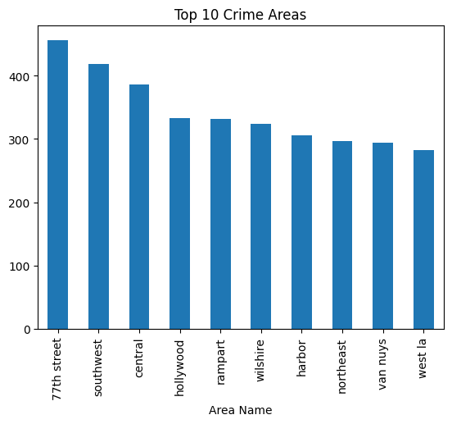
- 77th Street has the most crime — it’s clearly the top hotspot.
- Southwest and Central are also high-crime areas.
- Hollywood, Rampart, and Wilshire are in the middle range.
- Harbor, Northeast, and Van Nuys have fewer crimes than the above.
- West LA has the lowest crime among the top 10 listed.

4. SCATTER PLOT BETWEEN THE LATITUDE AND L0NGITUDE
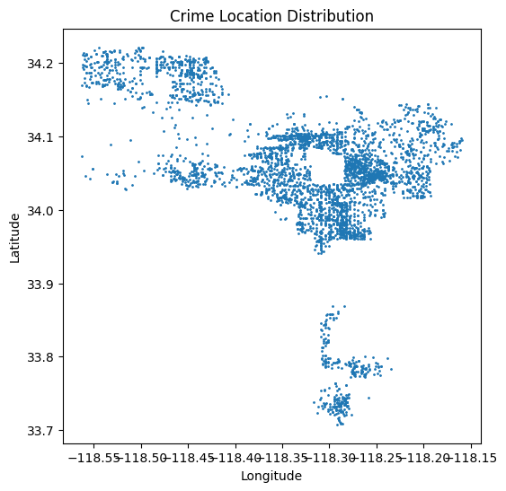
- Longitude range: about -118.55 to -118.15
- Latitude range: about 33.7 to 34.2
- These coordinates correspond to the Los Angeles metropolitan area in Southern California
The plot shows that crime incidents are not evenly spread but rather clustered in specific neighborhoods of Los Angeles, highlighting clear hotspots for intervention.

5. UNIVARAIATE ANALYSIS FOR TOP 10 CRIME TYPES
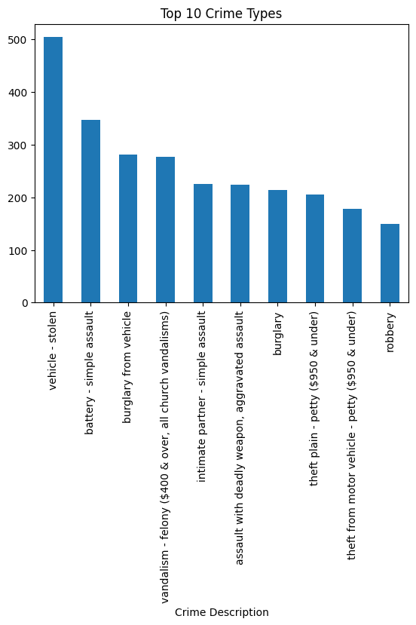
- Vehicle theft happens the most.
- Simple assault (battery) is the second most common.
- Burglary from vehicles comes third.
- Robbery is the least common among the top 10.
What it Means
- Most crimes are about stealing cars or things from cars.
- There are also a lot of fights and assaults.
- Property crimes (like theft and burglary) are more frequent than violent crimes.
- Police and communities may need to focus more on vehicle safety and preventing assaults.

6.HEATMAP FOR THE CORRELATION MATRIX:
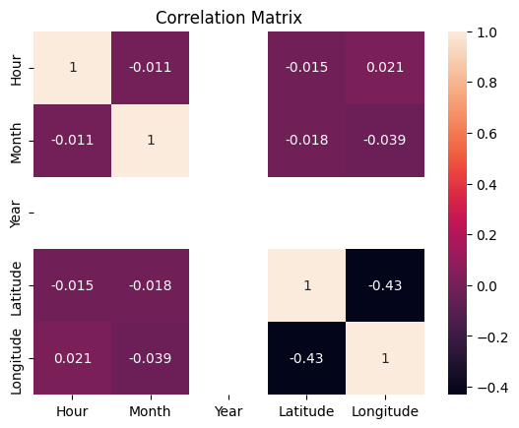
- Most of the numbers are close to zero → This means the variables (Hour, Month, Year, Latitude, Longitude) don’t really influence each other.
- The only clear relationship is between Latitude and Longitude (-0.43) → As one goes up, the other tends to go down.
- Time factors (Hour, Month, Year) show almost no link with location.

OUTCOME OF THE WEEK 4:
Learned about the dataset through the EDA process and visualization.
--------------------------------------------------------------------------------------------------------------------------------------------------------------------------------------------------------------------------------------------------------------------------------------------------

