Task1: Create a single layer perceptron class. Implement the AND, OR binary logic using the perceptron. improve the model accuracy.
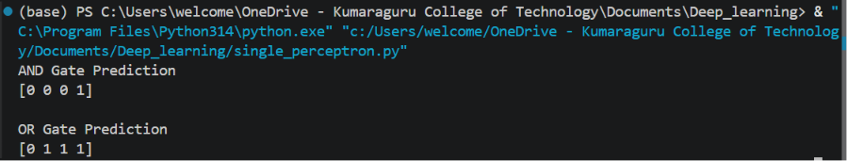

Task2: Use a random dataset to train, predict and calculate the accuracy of the model.
