

**School of Electronics Engineering (SENSE)**

**VIT Chennai**

**VLSI Make-a-thon Report (E1 Slot)**

**GROUP 11**

**Team members:**

* **23BEC1451 - R Prateek**
* **23BEC1406 – VL Janani**
* **23BEC1460 – Suvishesh D**

1. **CIRCUIT 01**

**Schematic:**

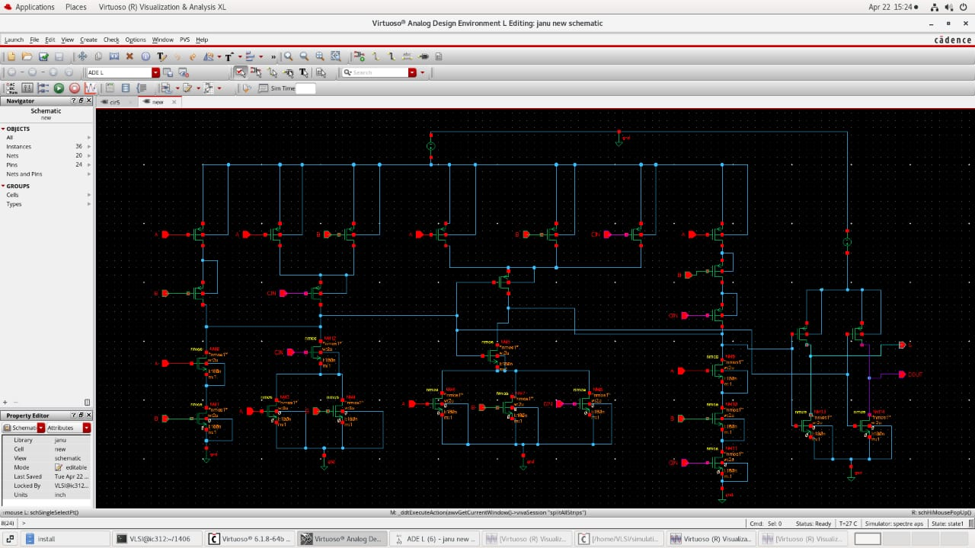

**Output Waveform:**

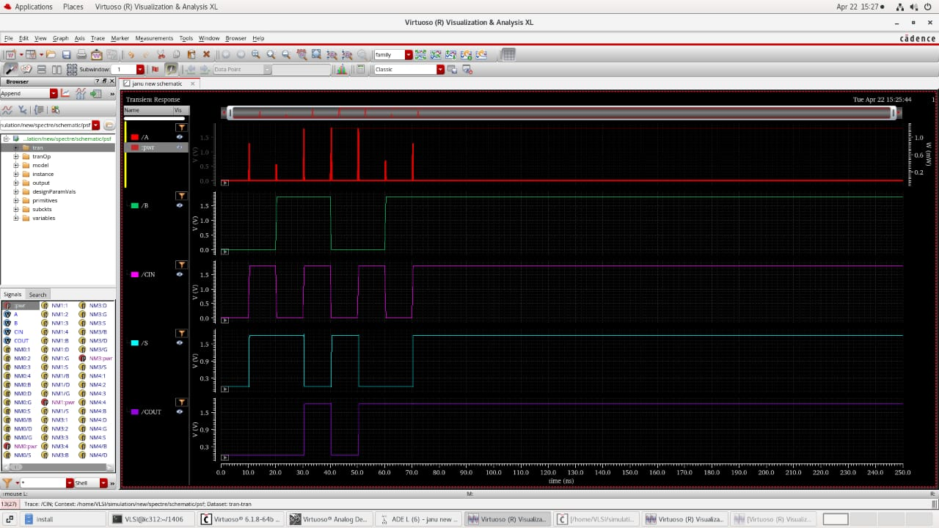

**Delay & Power Calculations (Pre-Sizing)**

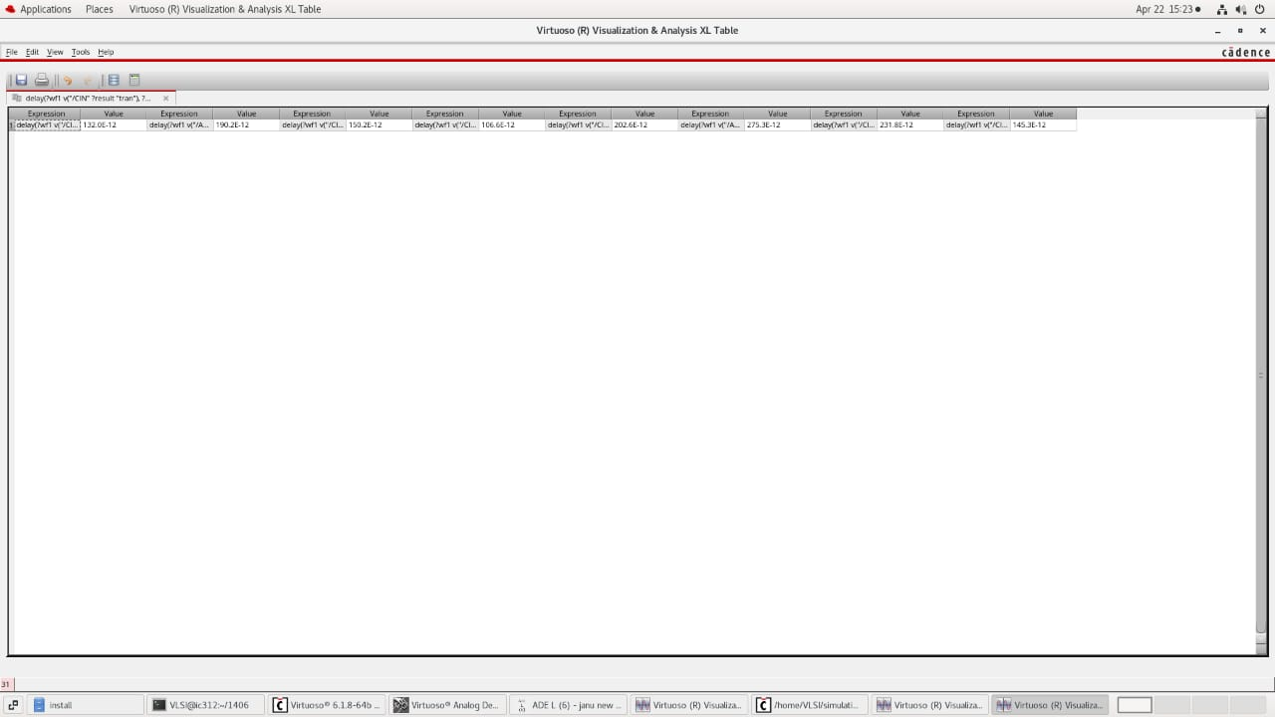

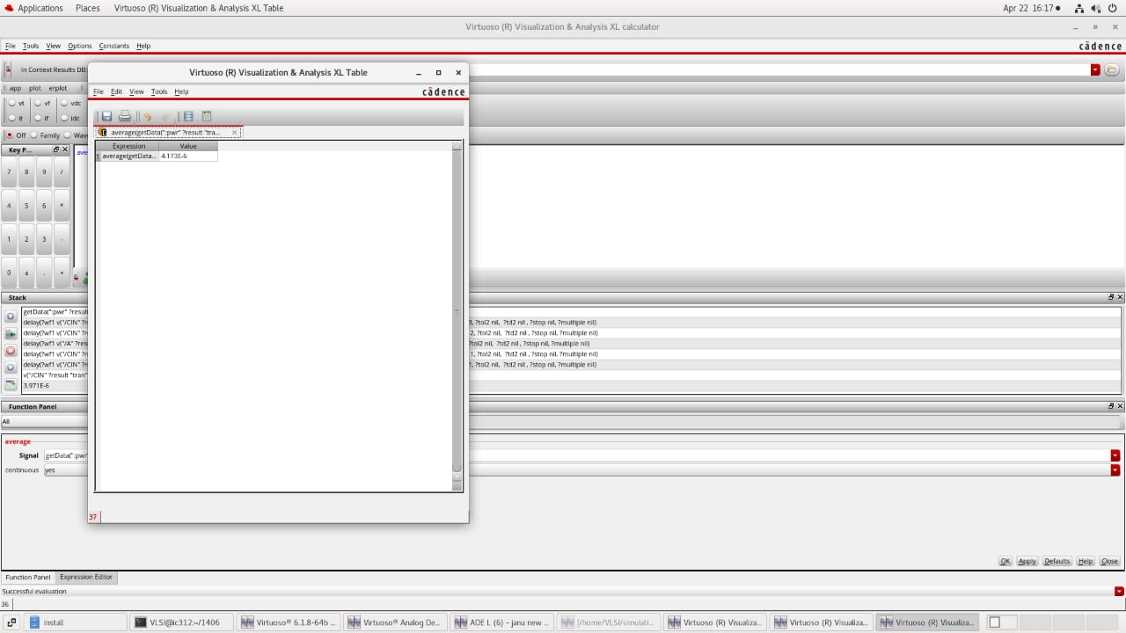

**Delay Calculations (Post-Sizing)**

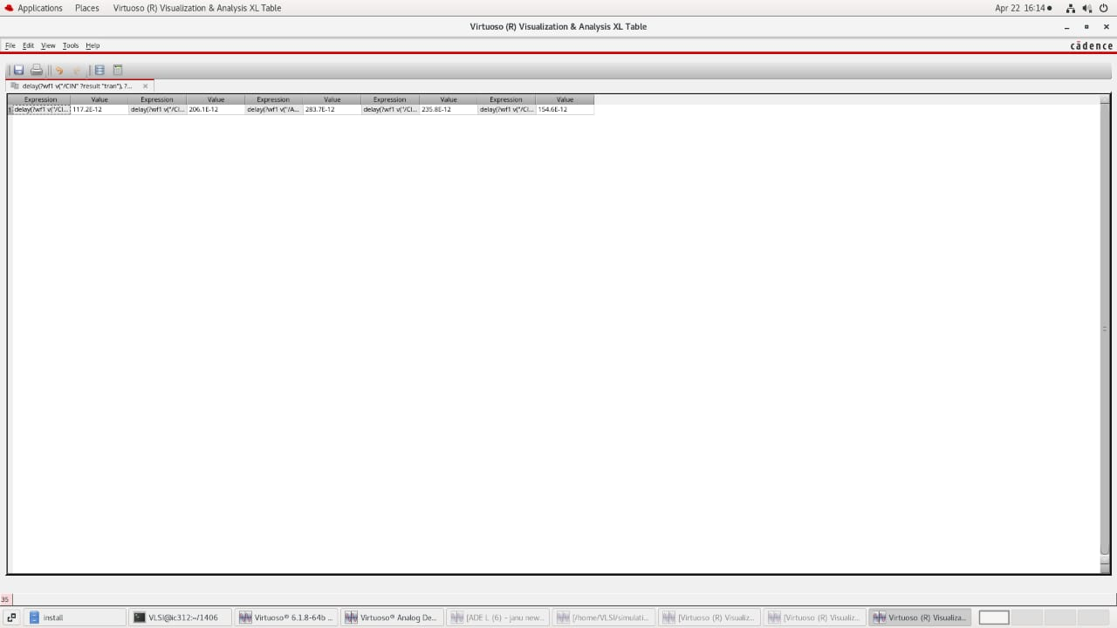

**Inference: Max delay is R1A & R2S – 301.4 x 10^(-12)**

1. **Circuit 02**

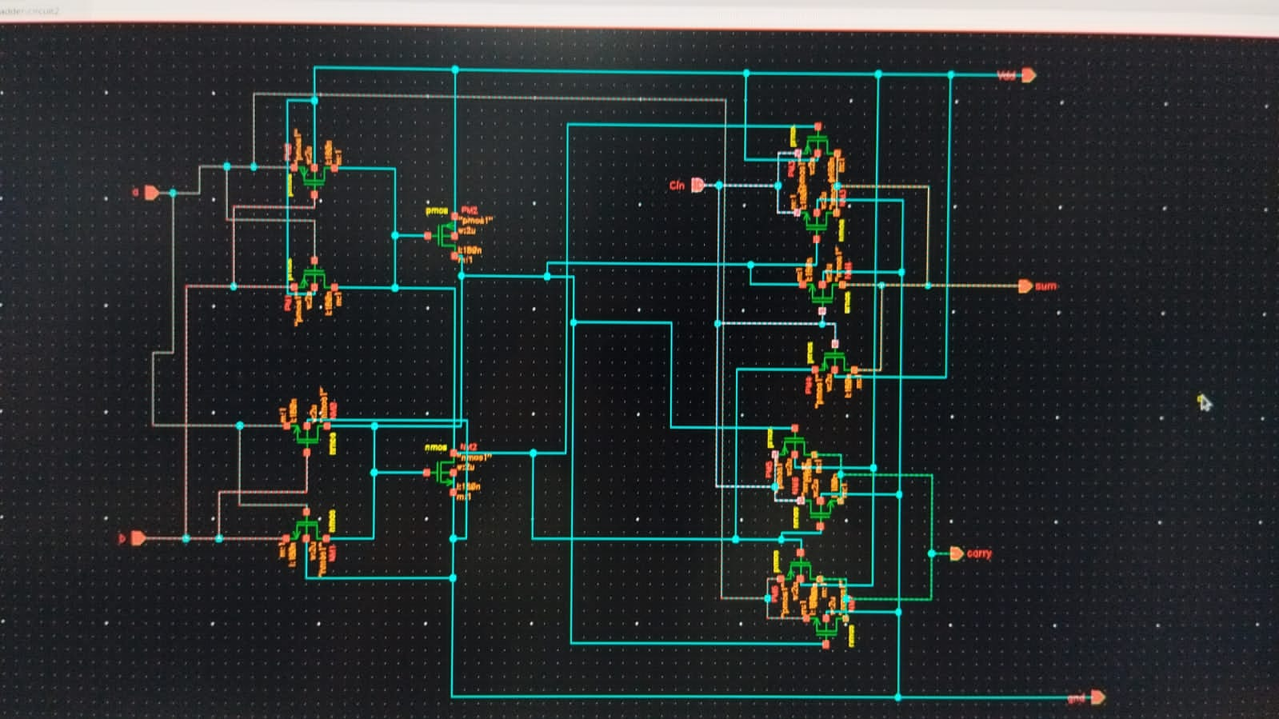

**Output waveform:**

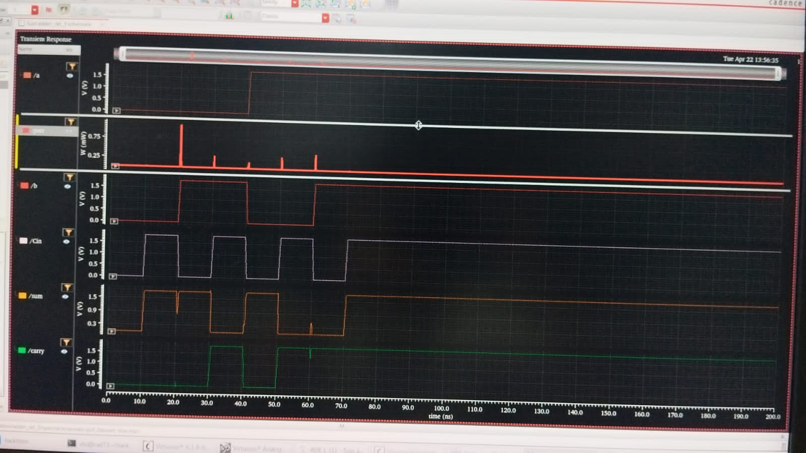

**Delay & Power Calculations (Pre-Sizing)**

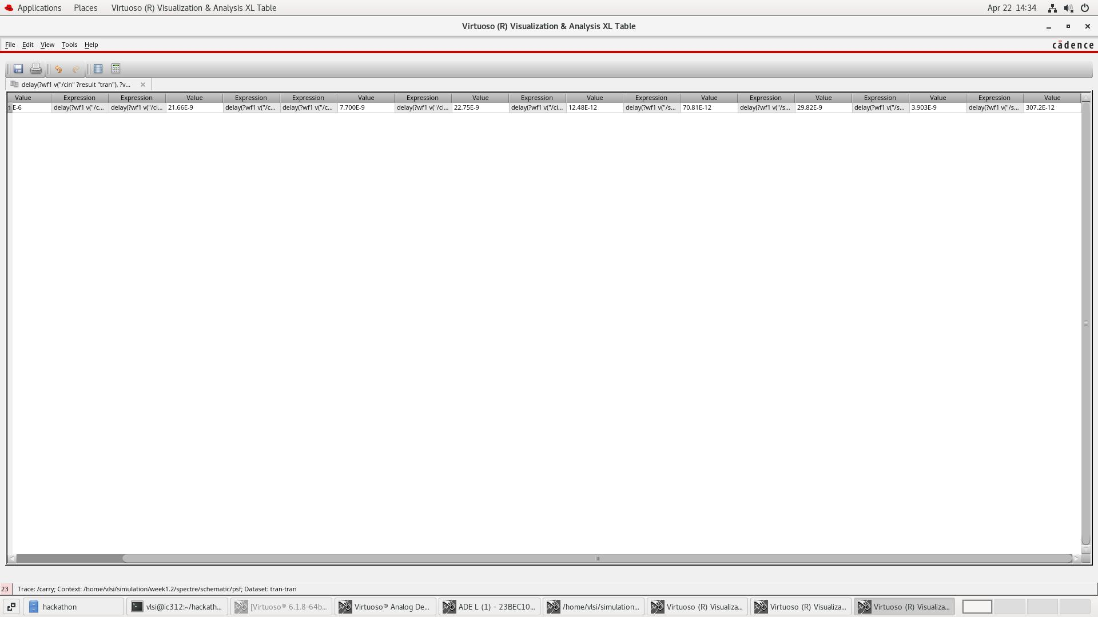

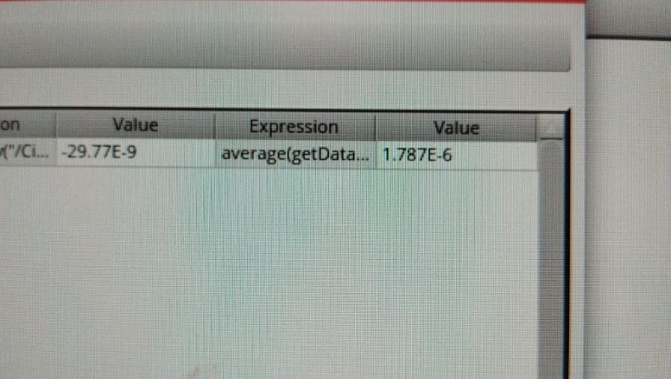

**Delay Calculations (After Sizing)**

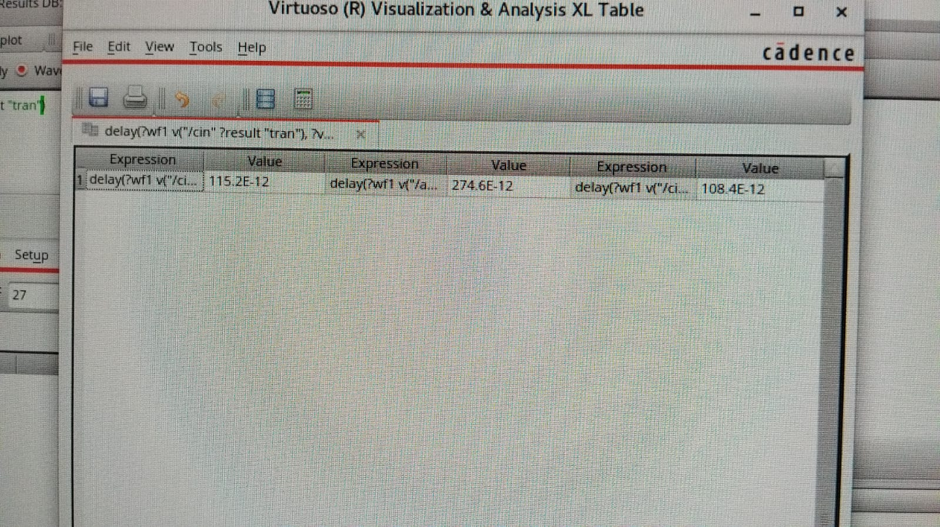

**Inference: Max Delay is R4Cin & R3S – 29.77 x 10^(-9)**

1. **Circuit 03**

**Schematic:**

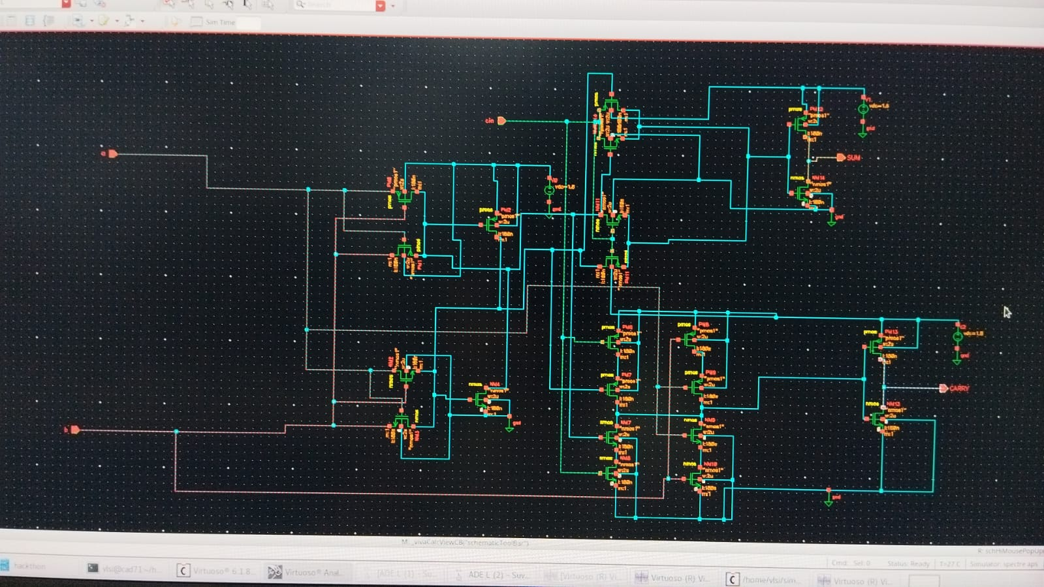

**Output Waveform:**

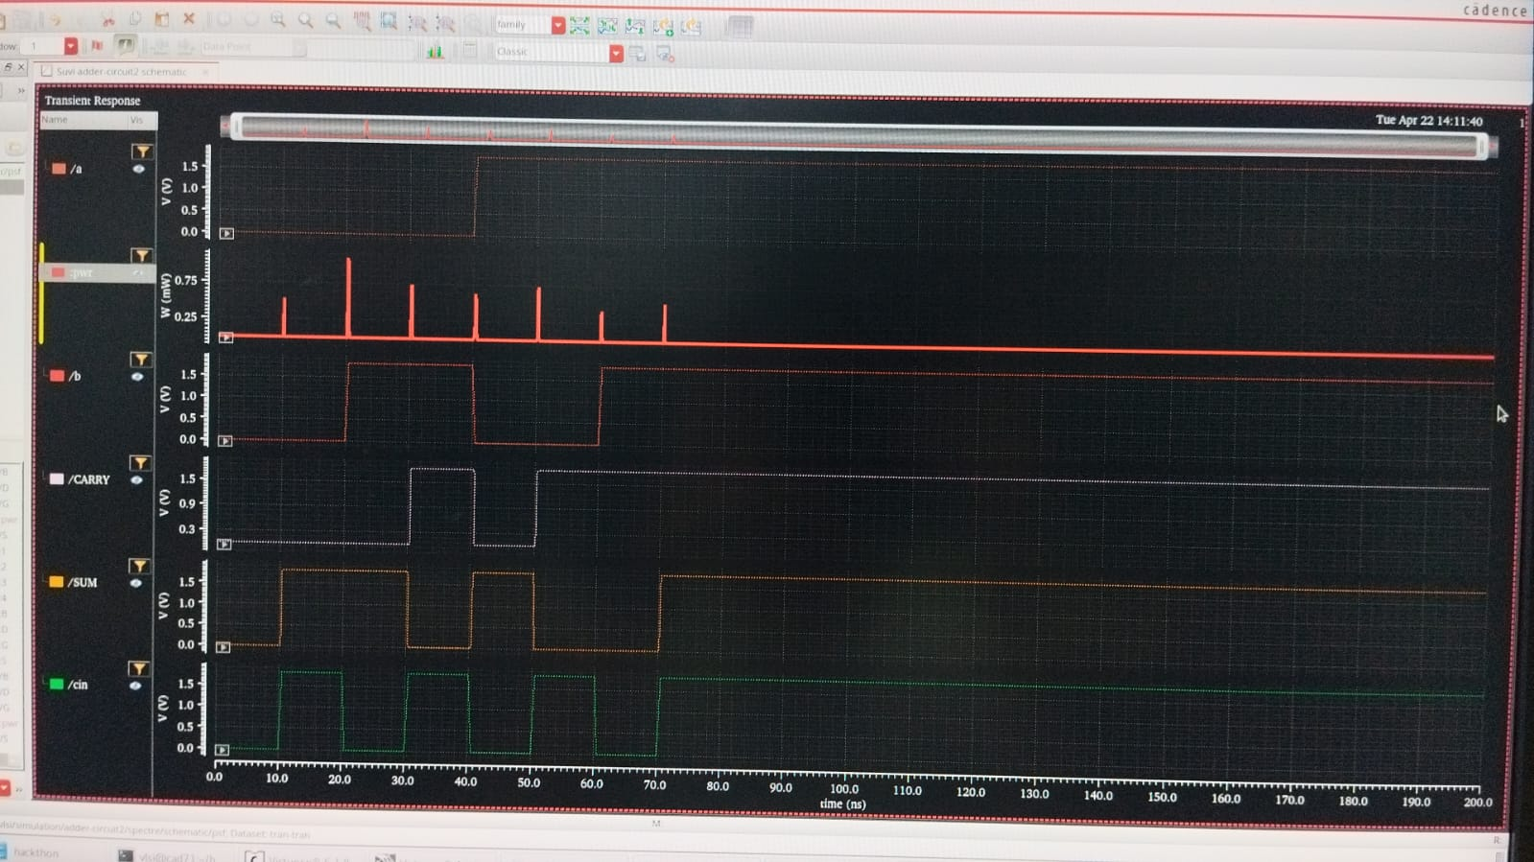

**Delay & Power Calculations (Pre-Sizing)**

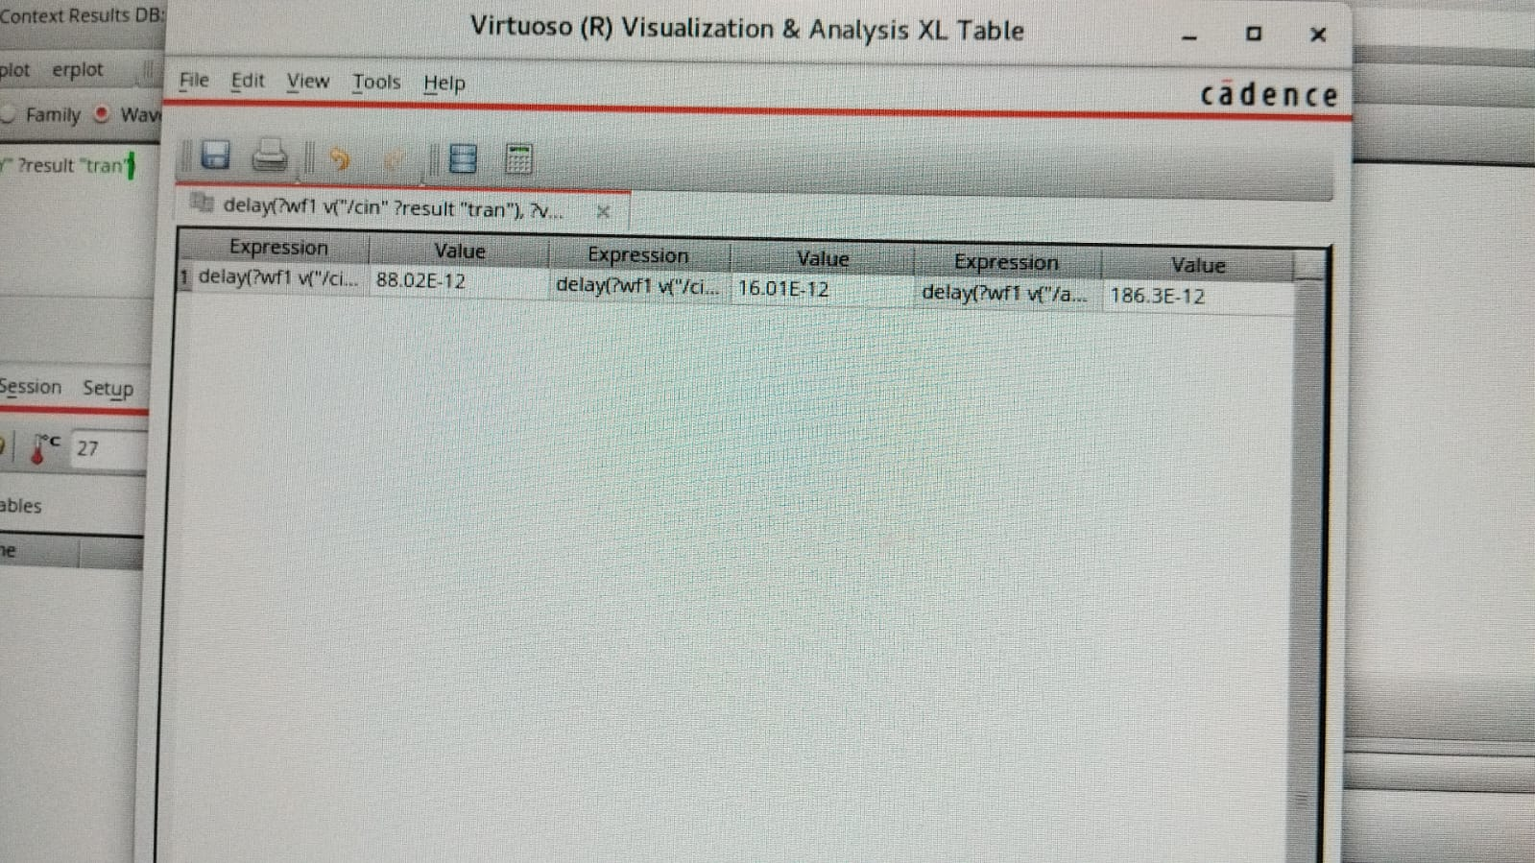



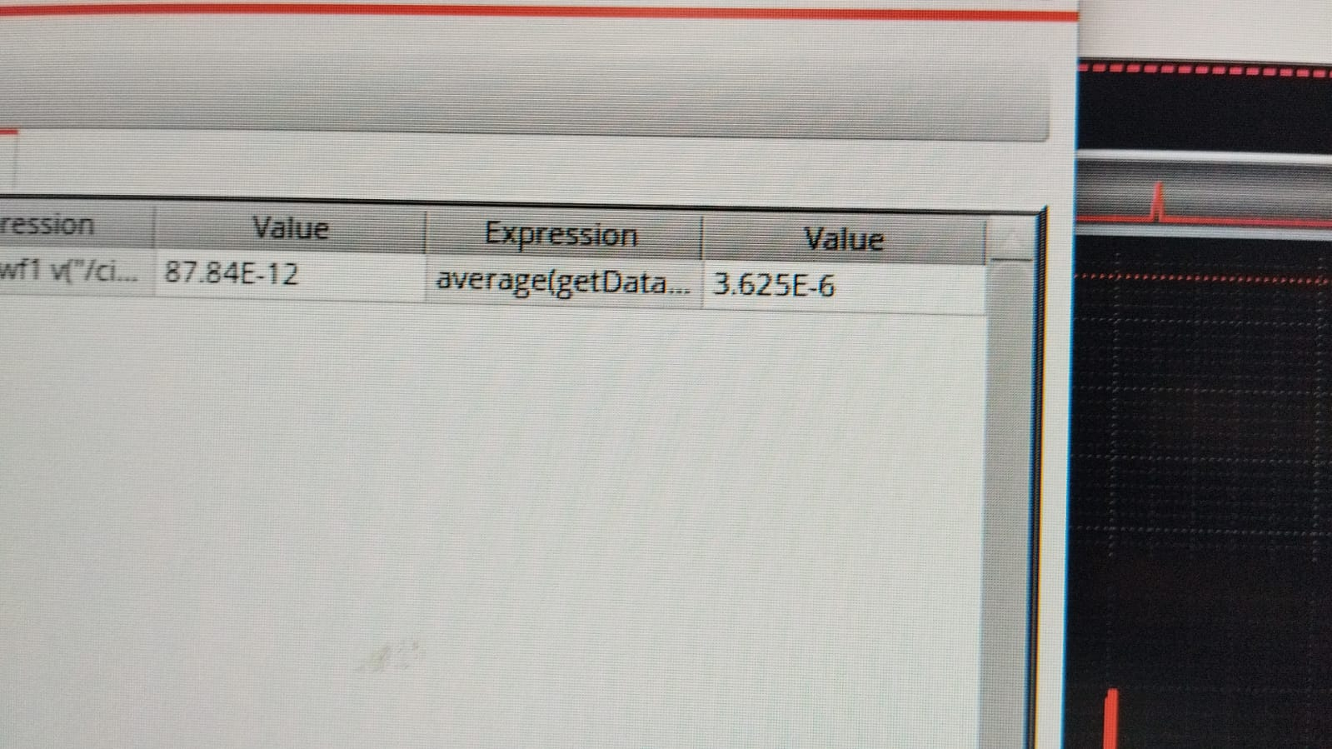

**Delay Calculations (Post – Sizing)**

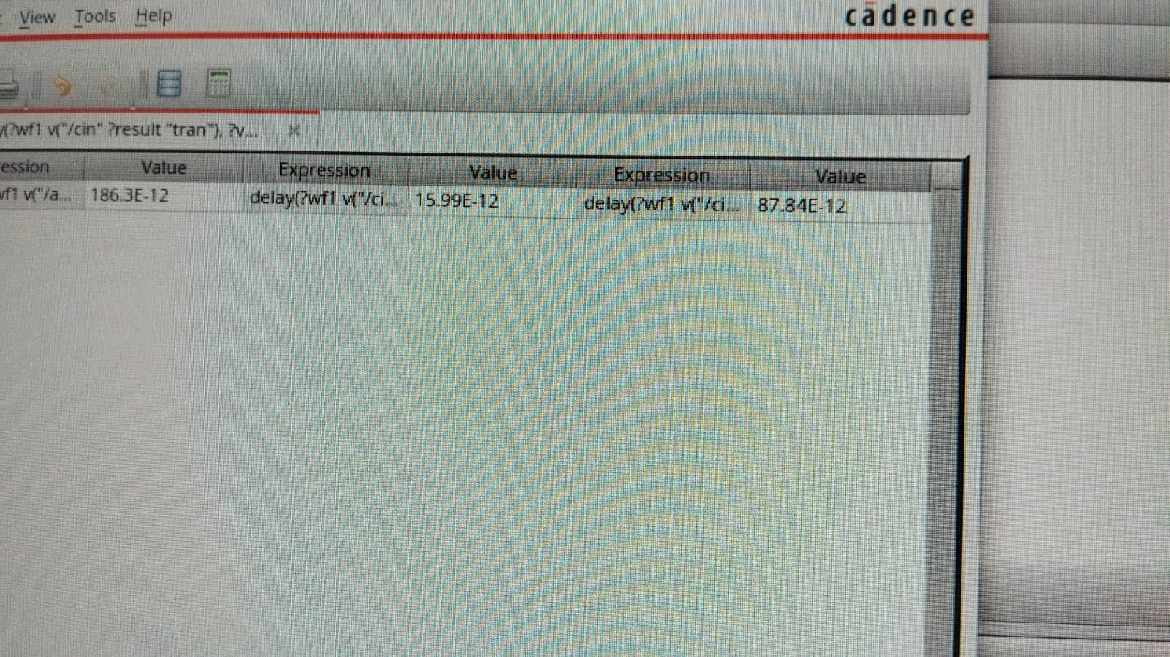

**Inference: Max Delay is R1A & F1Co – 274.6 x 10^ (-12)**

Circuit 03 was found to have the least maximum delay amongst all the full-adder circuits, so its symbol was created and was further used to implement the 4-bit multiplier.

1. **Circuit 04**

**Schematic:**

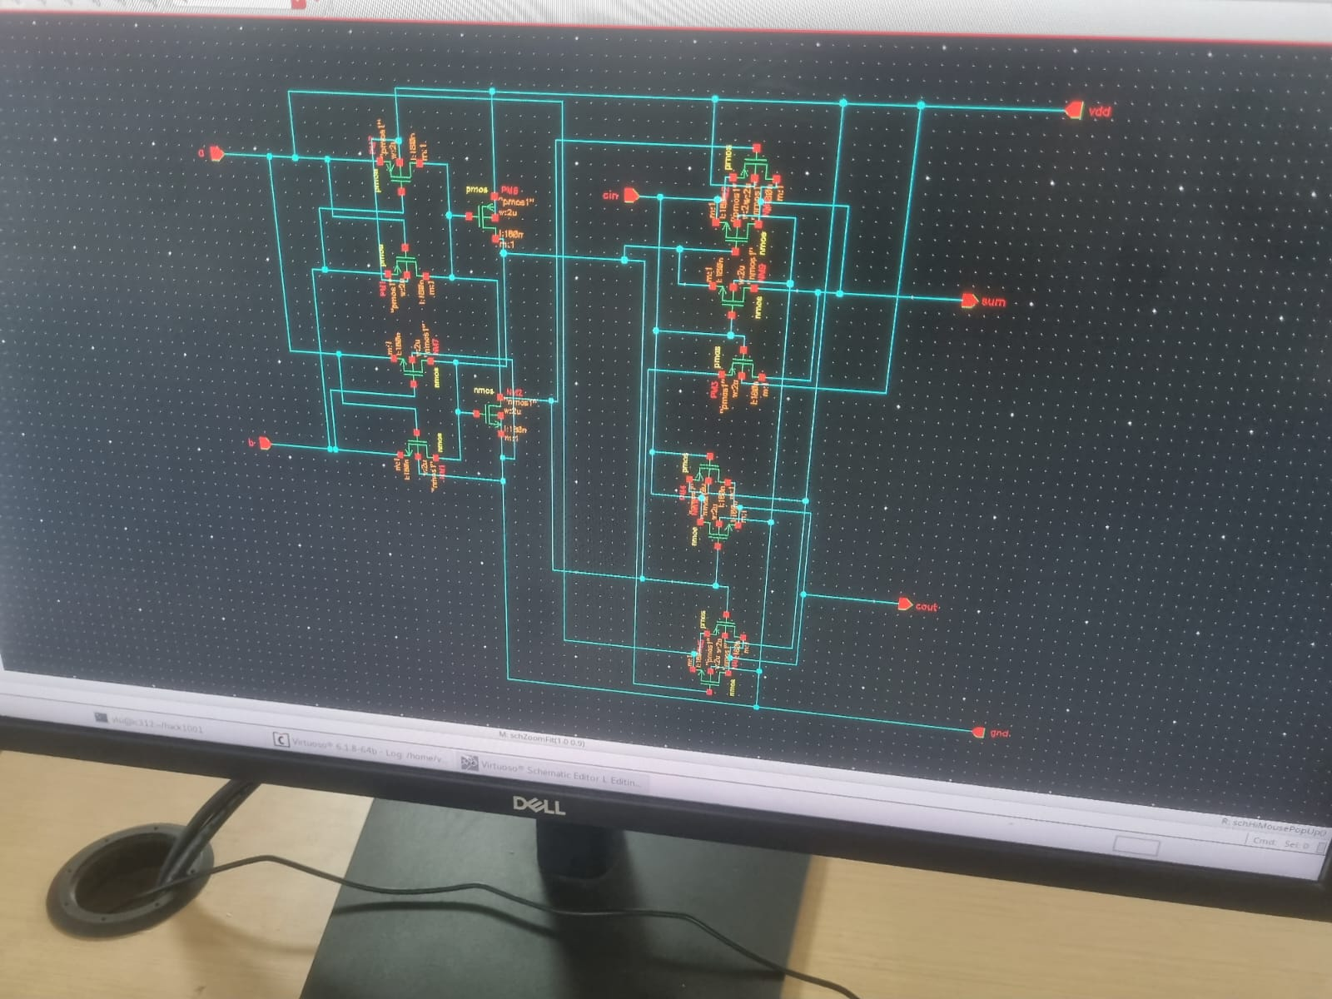

**Output waveform:**

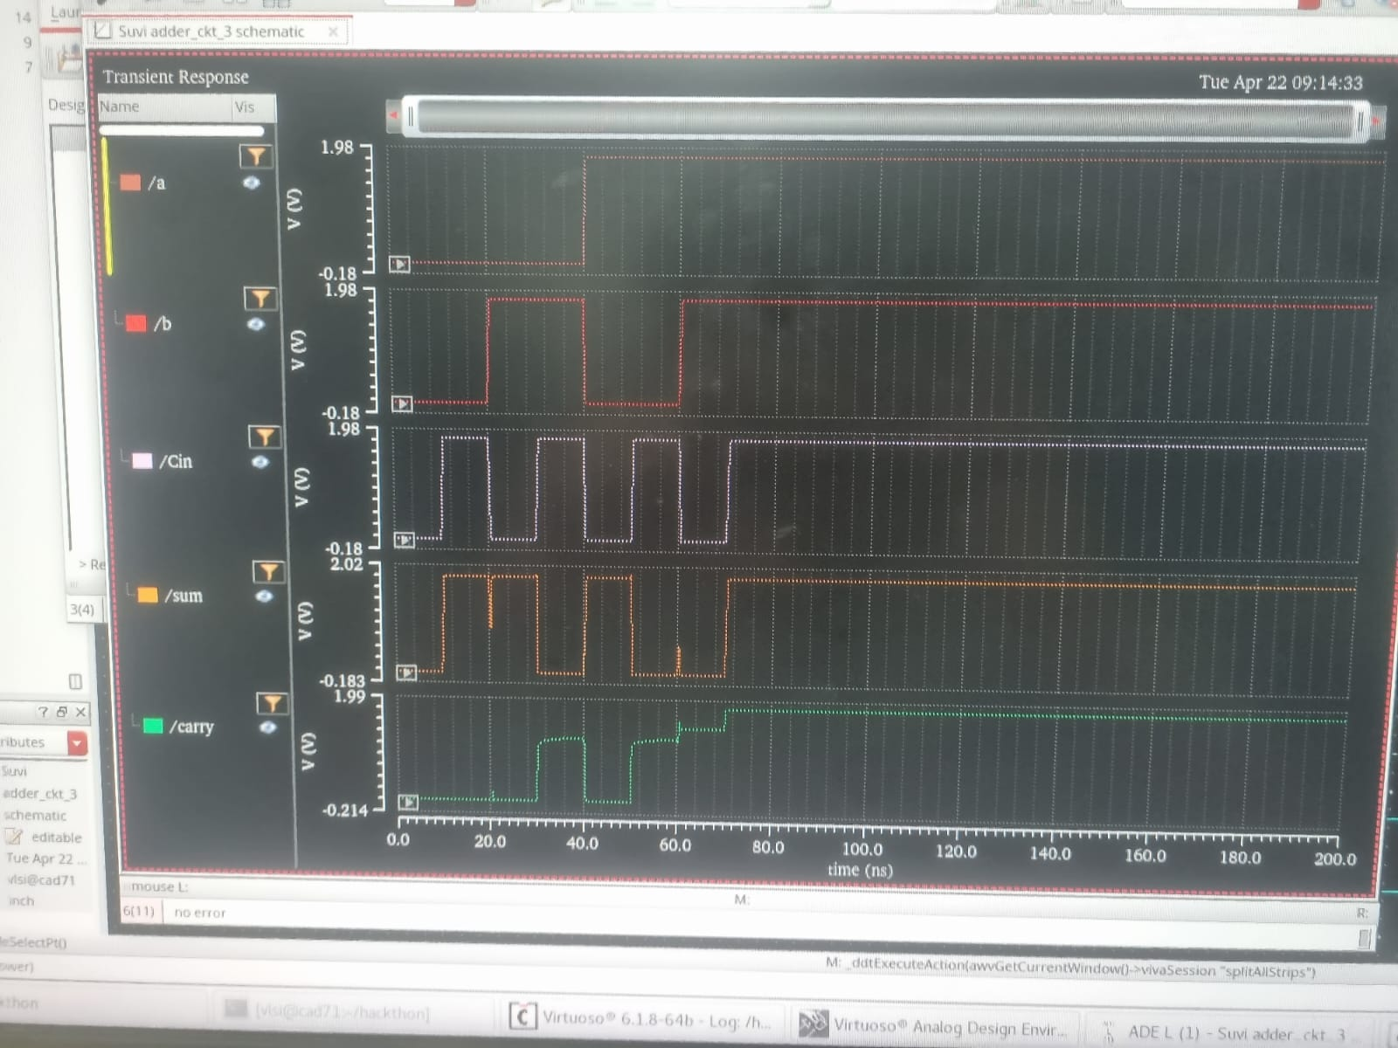

**Delay Calculations & Power (Pre-Sizing)**

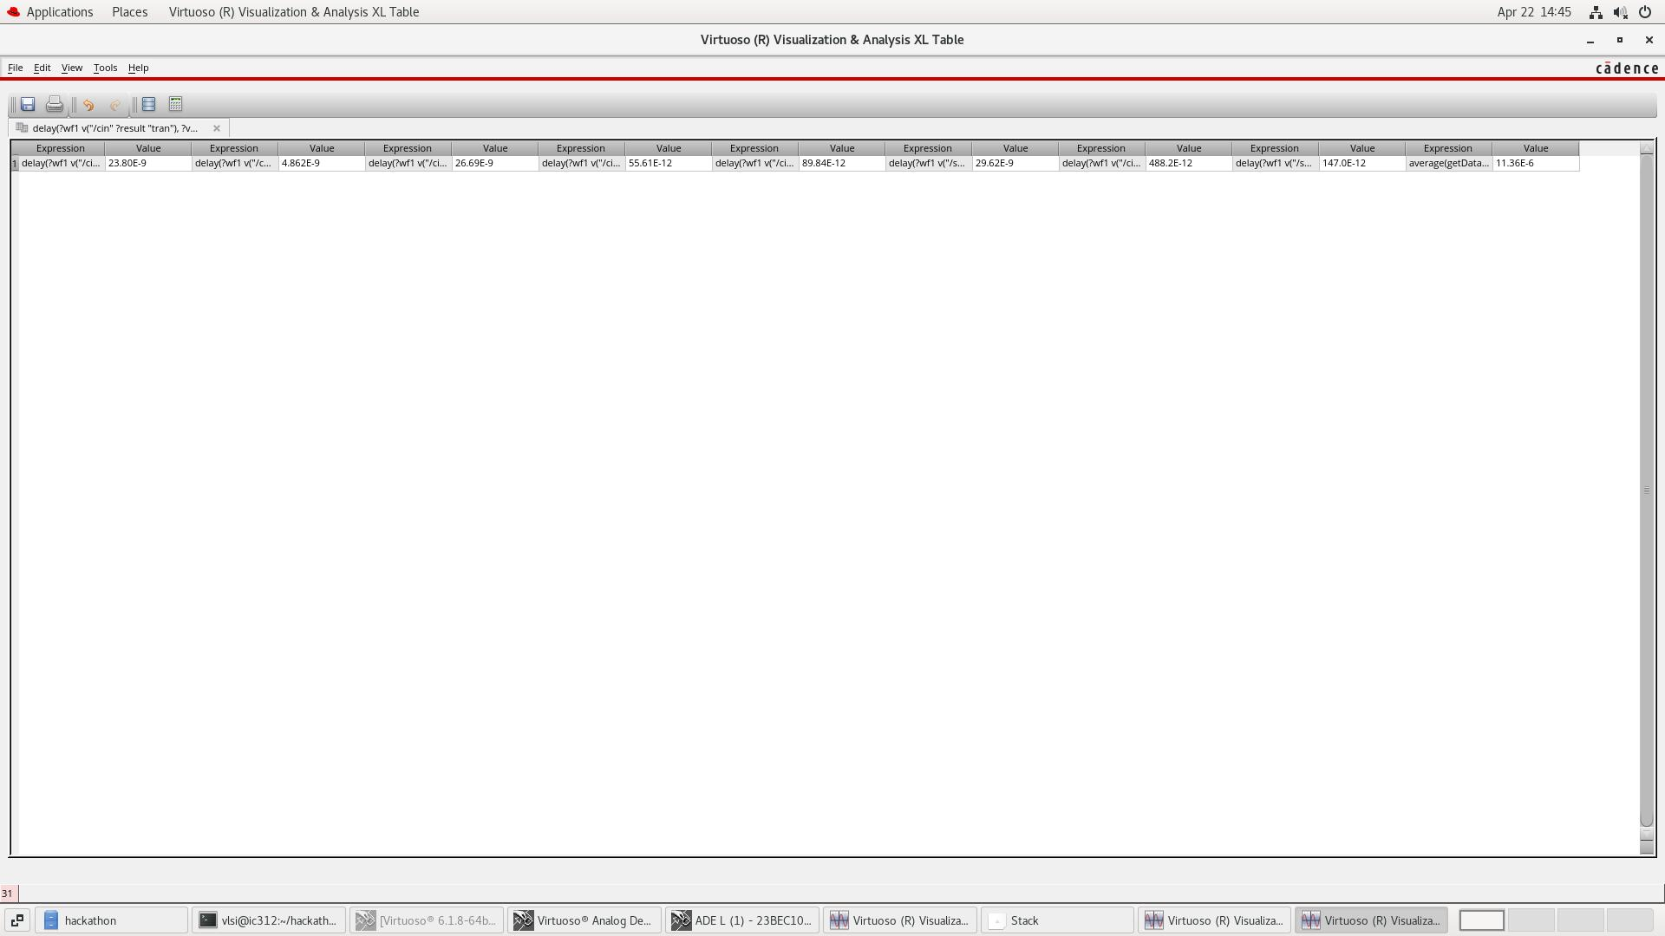

**Power: 81.89 x 10^ (-6)**

**After Sizing:**

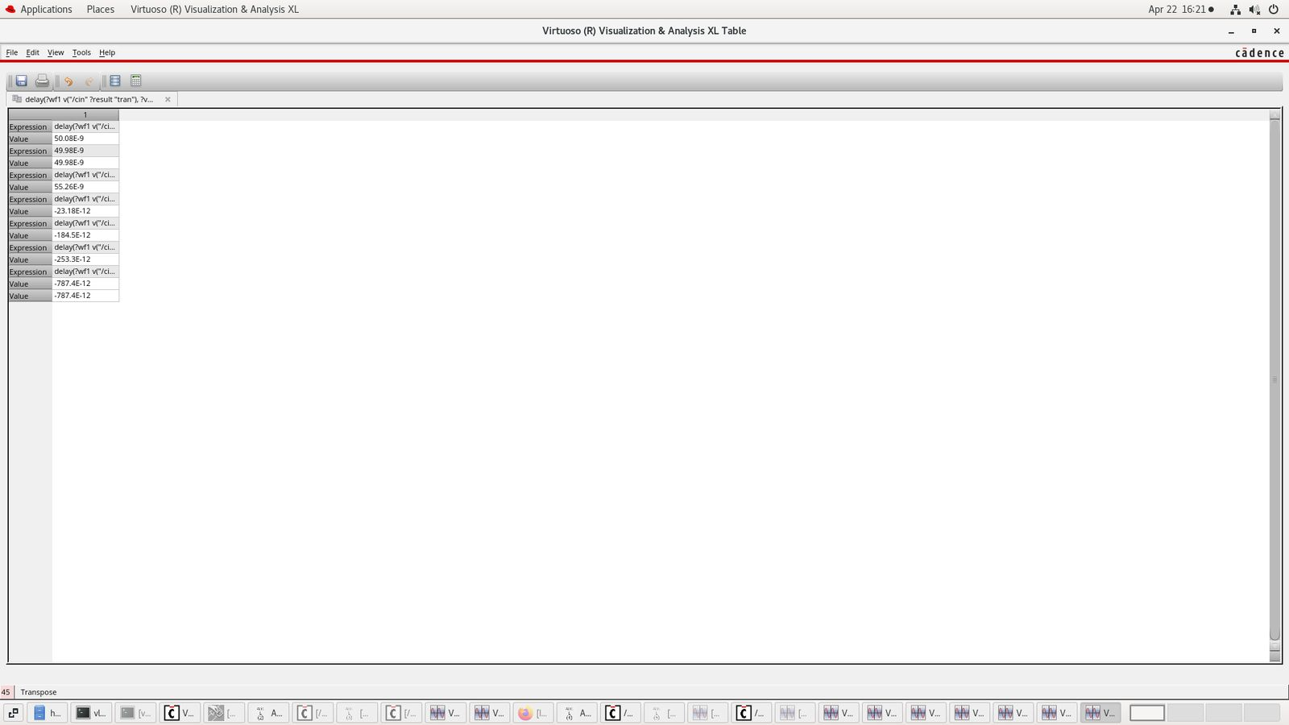

**Inference: Max Delay is R4Cin & R3S – 29.76 x 10^ (-9)**

1. **CIRCUIT 05**

**SCHEMATIC:**

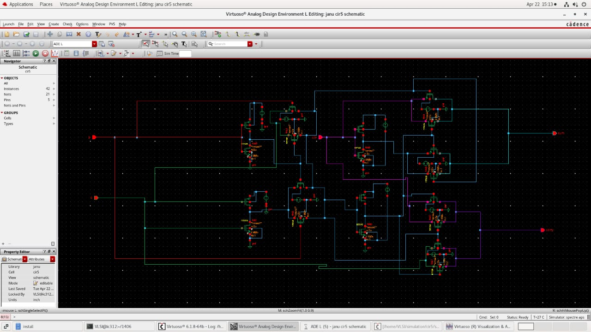

**OUTPUT WAVEFORM:**

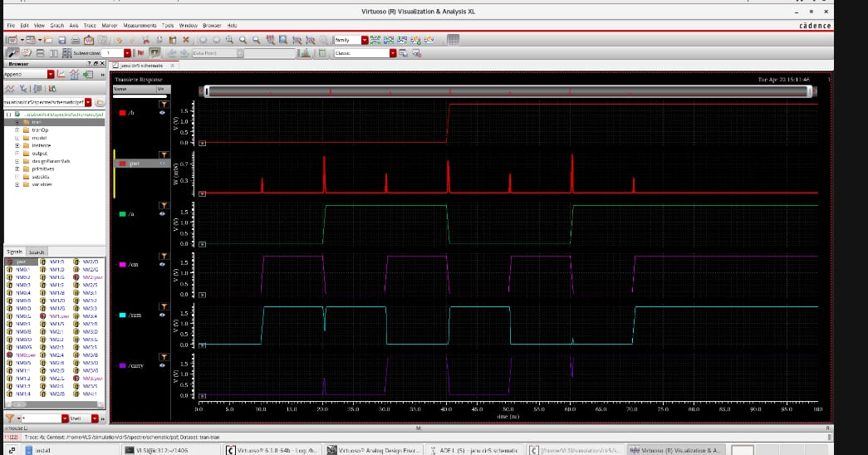

**DELAY & POWER CALCULATIONS (Pre-Sizing):**

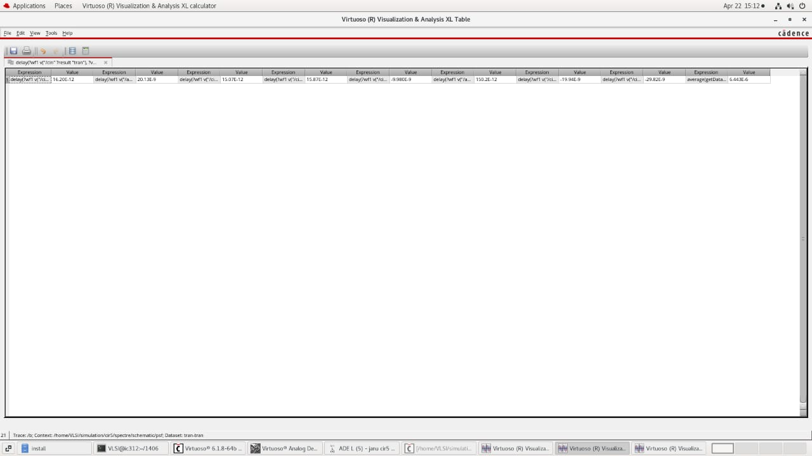

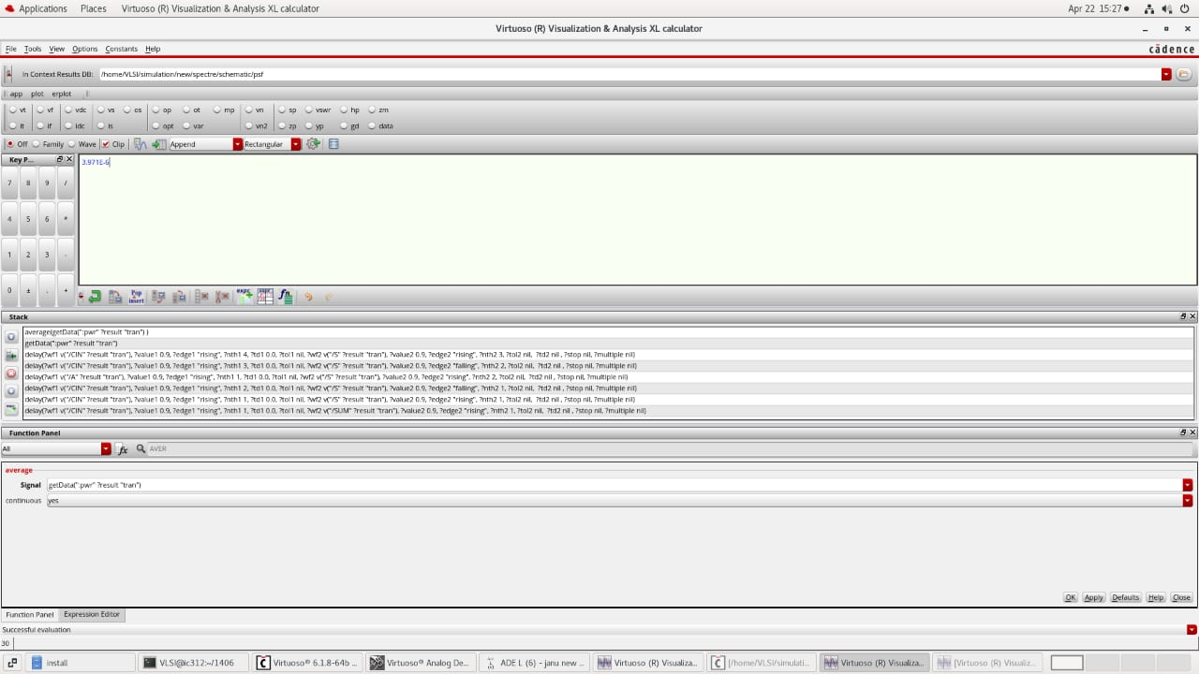

**After Sizing:**

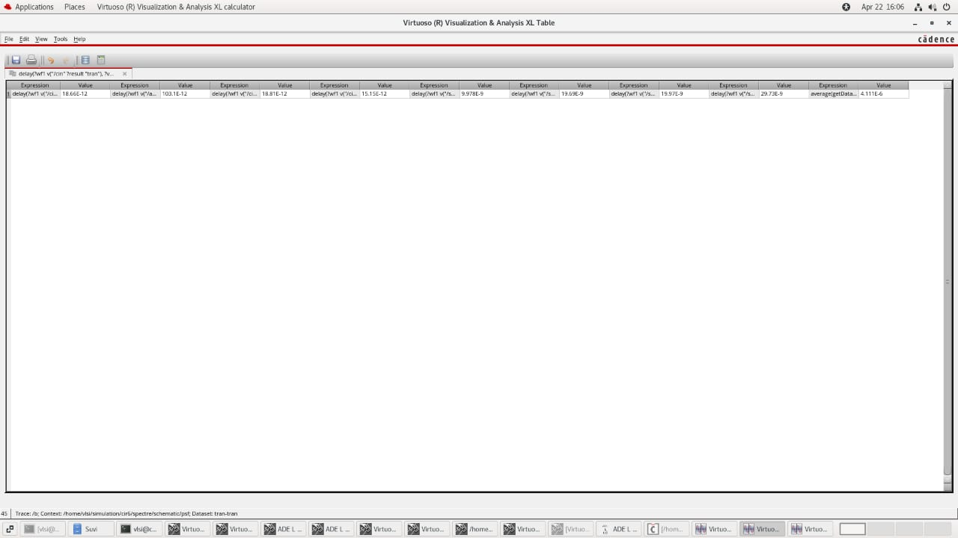

**Inference: Max Delay is R4Cin & R3S: 29.82 x 10^ (-9)**

1. **CIRCUIT 06**

**SCHEMATIC:**

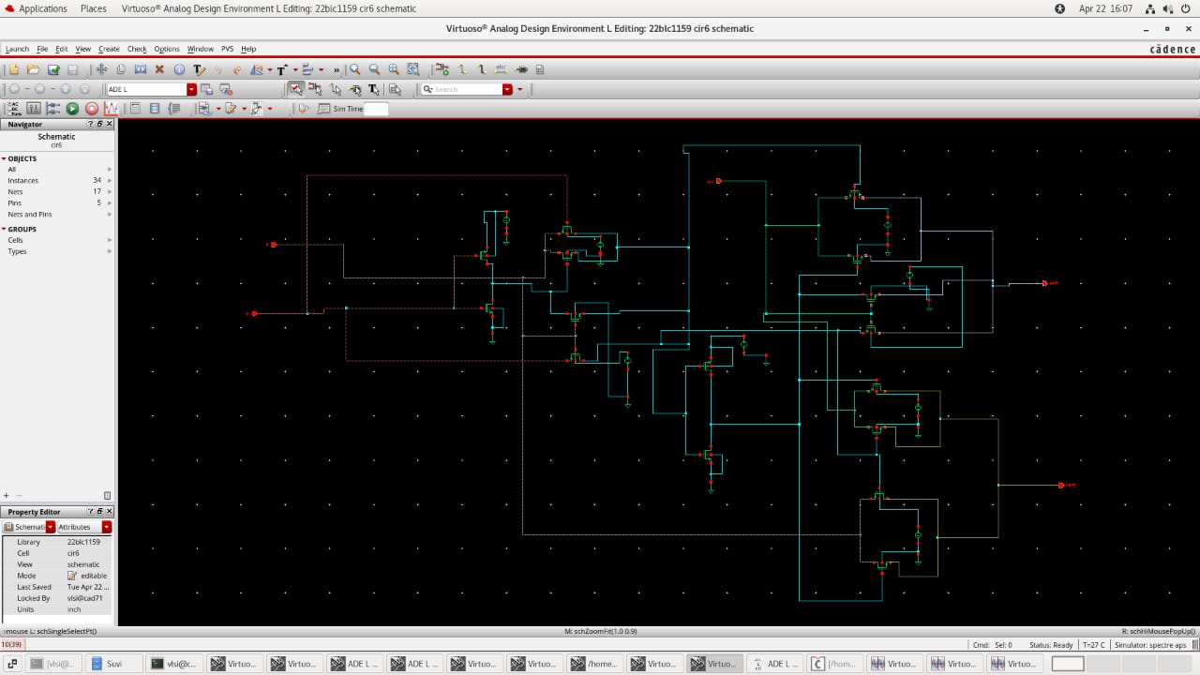

**OUTPUT WAVEFORM:**

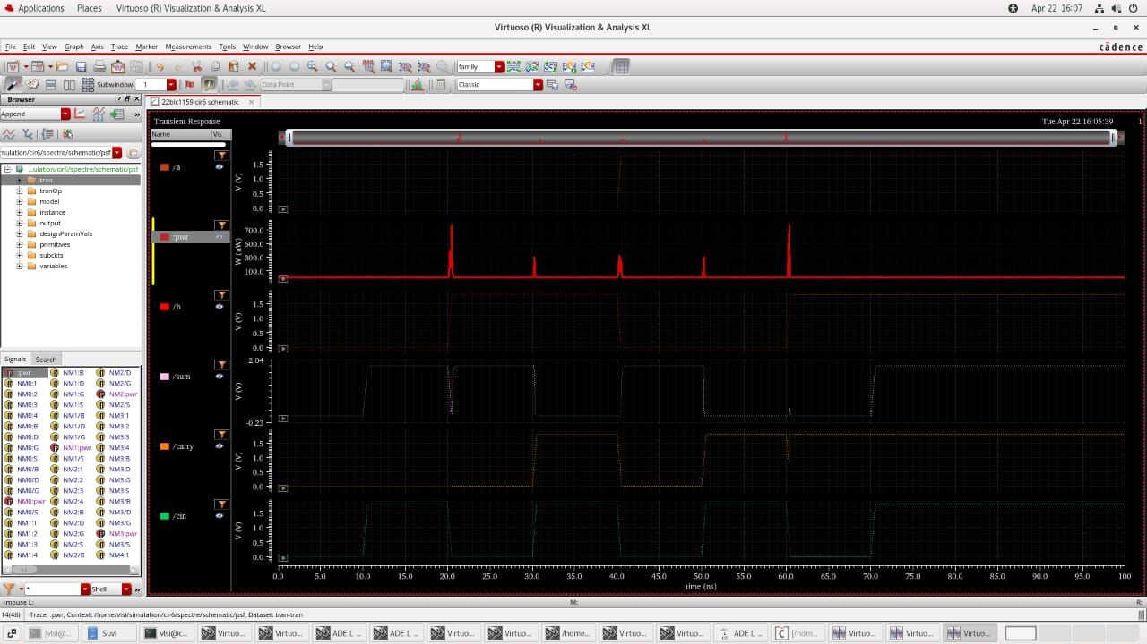

**DELAY & POWER CALCULATIONS (PRE-SIZING)**



**AFTER SIZING:**

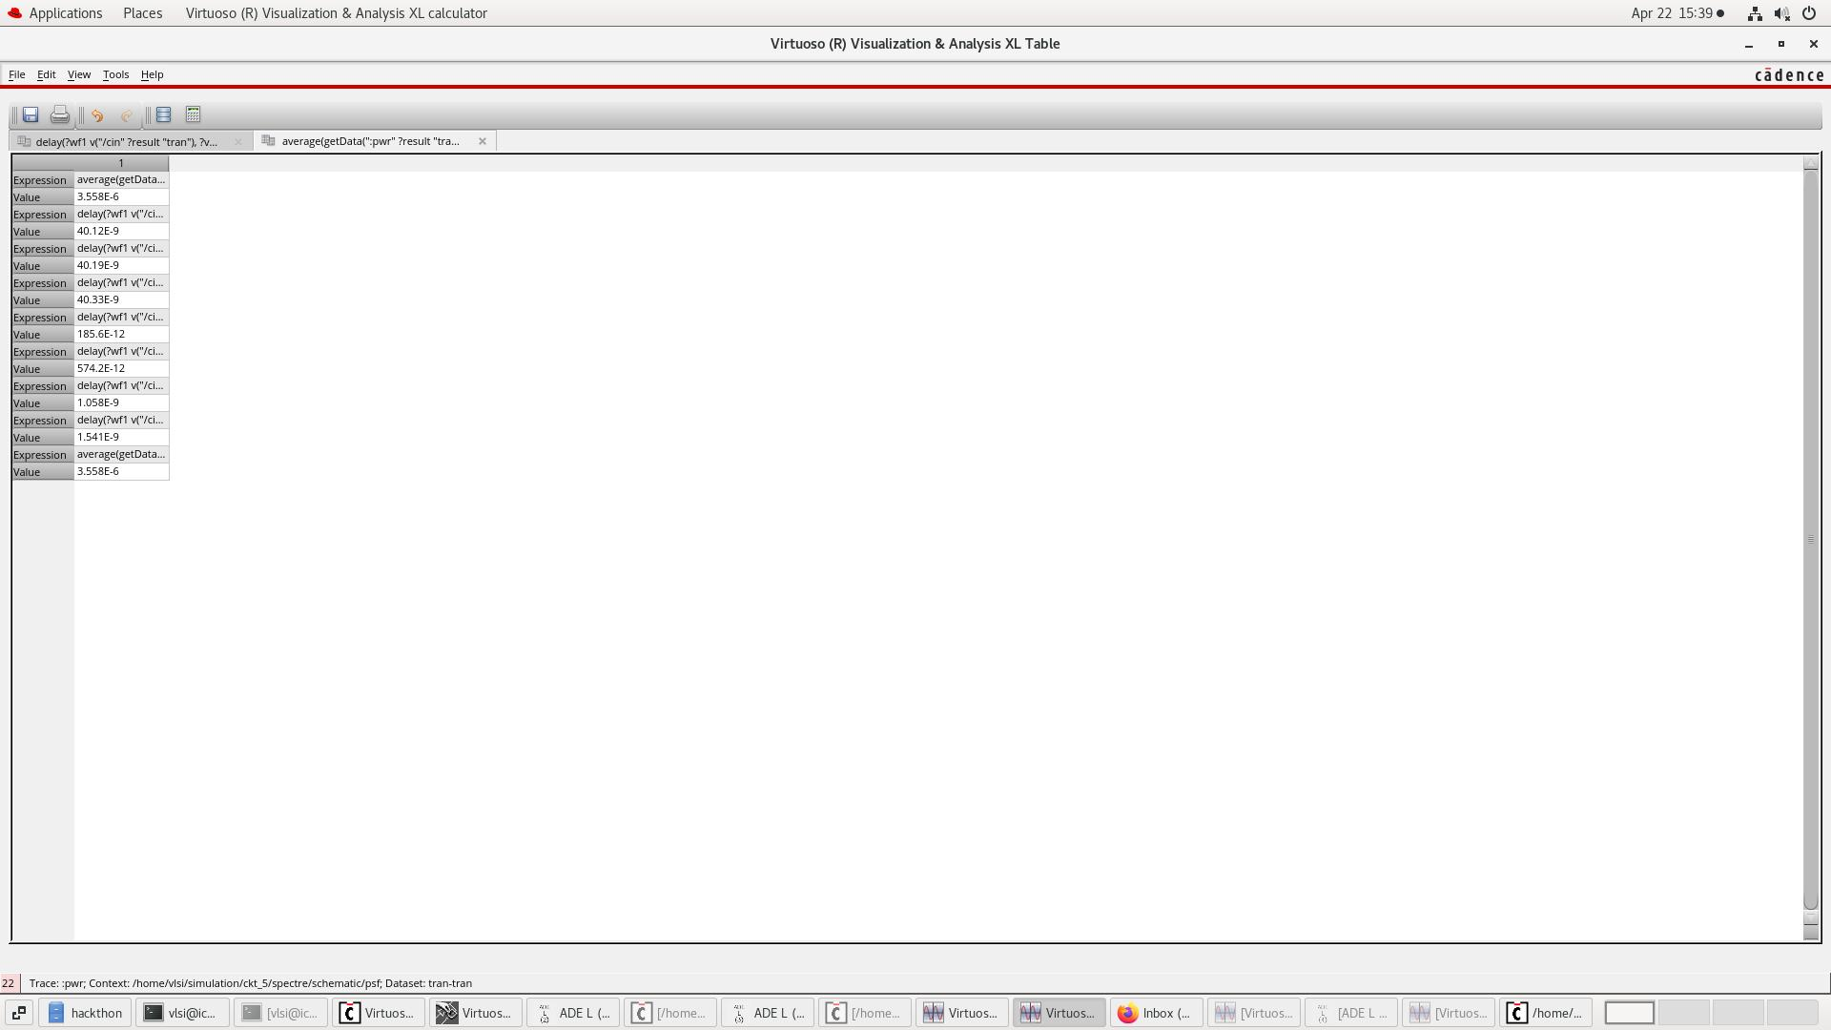

* **Implementing Multiplier using FA (Circuit 03) & 2-input NAND**

**Schematic**

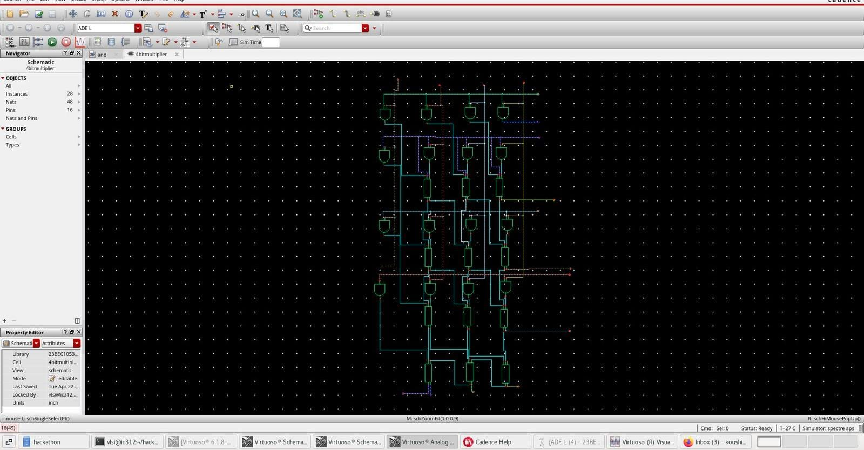

**Output Waveform**

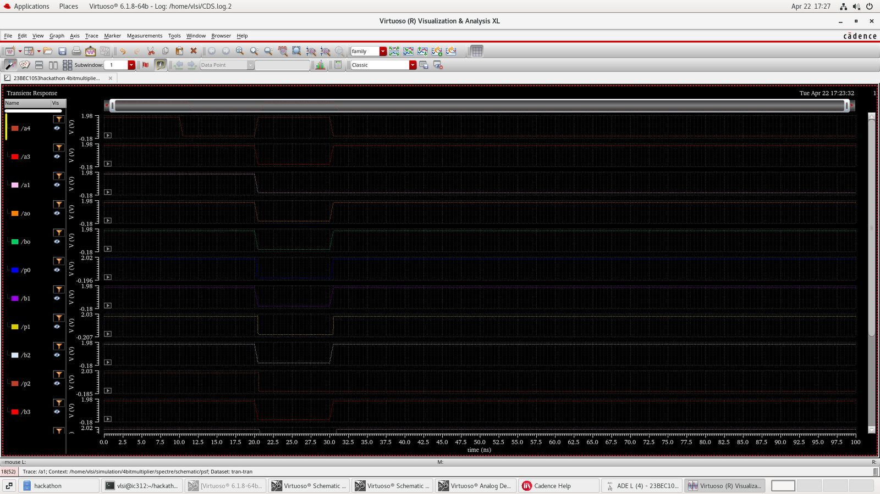

**Result: The 4 bit multiplier was succesfully implemented using full adder (the one with the least delay) & a 2 input nand gate, and it’s output waveform is noted for various inputs.**