How in LinkedList data is stored:+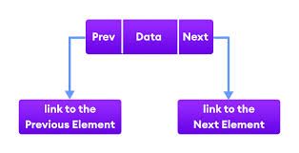

Linkedlist vs ArrayList data stores

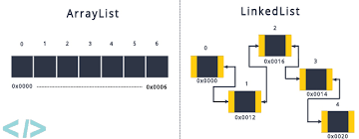

**Addition and Deletion in LinkedList**

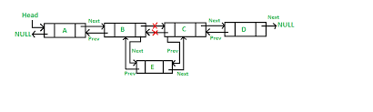

Stack data structure

