安徽大学《数字图像处理（双语）》实验报告（3）

学号 WA2224013 专业 机器人工程 姓名 郭义月
实验日期 2024.12.10 教师签字 成绩

【实验名称】:
基于直方图均衡的图像增强技术
【实验目的】：
1. 熟悉和掌握图像的直方图的意义
2. 通过MATLAB编程实现图像直方图的绘制并分析其和图像外观的关系
3. 通过MATLAB编程实现基于直方图均衡的图像增强
【实验内容】
Image Flipping
Write a MATLAB function flipImage which flips an image either vertically or horizontally. The function should take two parameters – the matrix storing the image data and a flag to indicate whether the image should be flipped vertically or horizontally. Use this function from the command line to flip the image woman.bmp both vertically and horizontally which should give the following results.
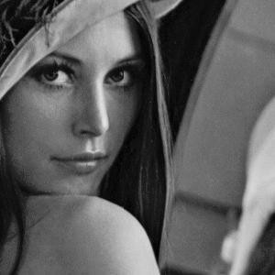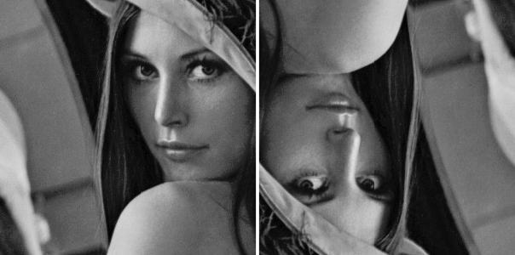
Image Histogram
Write a MATLAB function, generateHistogram, which generates the histogram of an image. The function should take an image data array (with pixel values in the range 0 – 255) as its only parameter and return an array containing the histogram of the image. The histogram can be displayed using the built in MATLAB function hist. For example:
A = generateHistogram(Image); bar(A);
Use this new function to generate and display histograms for the following images (darkPollen.jpg, lightPollen.jpg, lowContrastPollen.jpg and pollen.jpg).
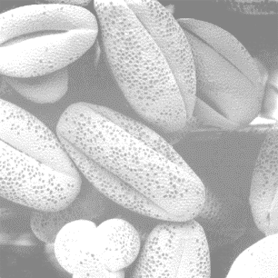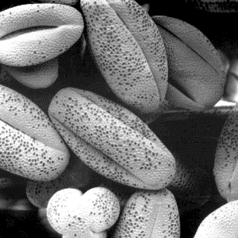
Dark Pollen light Pollen low Contrast Pollen pollen
Histogram Equalization
a) Implement the histogram equalization using your own code instead of the function in MATLAB. Perform histogram equalization on the above 4 images.
b) Plot the histogram of the original images and the histogram-equalization enhanced images.
As a minimum, your report should include the original image, a plot of its histogram, the enhanced image, and a plot of its histogram. Use this information to explain why the resulting image was enhanced as it was
【实验代码和结果】
Task 1：Image Flipping
实验代码：
clc;clear;close all;
image = imread("D:\Desktop\dip\Lab3\IMAGES\woman.tif");
subplot(1,3,1);
imshow(image);
title('original image');
subplot(1,3,2);
imshow(FlipImage(image,0))
title('flip vertically');
subplot(1,3,3);
imshow(FlipImage(image,1))
title('flip horizontally');
FlipImage函数
function [image1] = FlipImage(image,flag)
% flag 为1表示水平翻转，flag为0表示垂直翻转
if flag
image1 = flip(image,2);
else
image1 = flipud(image);
end
end
实验结果：
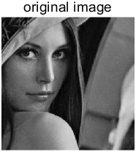 | 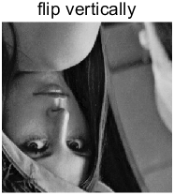 | 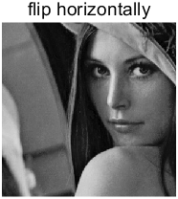
Task 2：Histogram Equalization
实验代码：
clc;clear;close all;
image1 = imread("D:\Desktop\dip\Lab3\IMAGES\darkPollen.jpg");
image2 = imread("D:\Desktop\dip\Lab3\IMAGES\lightPollen.jpg");
image3 = imread("D:\Desktop\dip\Lab3\IMAGES\lowContrastPollen.jpg");
image4 = imread("D:\Desktop\dip\Lab3\IMAGES\pollen.jpg");
subplot(2,2,1);
h1 = generateHistogram(image1);
title('original darkPollen');
subplot(2,2,2);
h2 = generateHistogram(image2);
title('original lightPollen');
subplot(2,2,3);
h3 = generateHistogram(image3);
title('original lowContrastPollen');
subplot(2,2,4);
h4 = generateHistogram(image4);
title('original pollen');
generateHistogram函数
function [h] = generateHistogram(image)
h = histogram(image(:));
end
实验结果
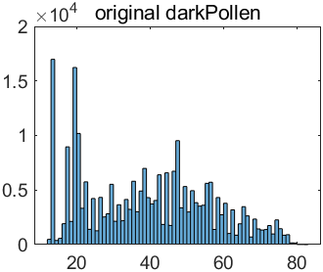 | 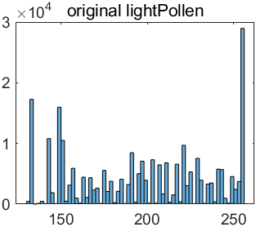
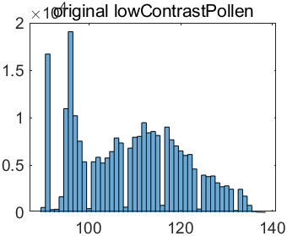 | 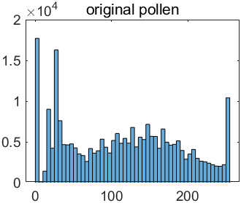
Task 3：Histogram Equalization
clc;clear;close all;
R = imread("D:\Desktop\dip\Lab3\IMAGES\darkPollen.jpg");
[row, col] = size(R);
subplot(2,2,1), imshow(R), title('original image');
subplot(2,2,2), imhist(R(:)), title('original histogram');
R1 = R;
PMF = zeros(1, 256);
for i = 1:row
for j = 1:col
PMF(R(i,j) + 1) = PMF(R(i,j) + 1) + 1;
end
end
PMF = PMF / (row * col);
CDF = zeros(1,256);
CDF(1) = PMF(1);
for i = 2:256
CDF(i) = CDF(i - 1) + PMF(i);
end
Sk = zeros(1,256);
for i = 1:256
Sk(i) = CDF(i) * 255;
end
Sk = round(Sk);
for i = 1:row
for j = 1:col
R(i,j) = Sk(R(i,j) + 1);
end
end
subplot(2,2,3), imshow(R), title('Histogram Equalization');
subplot(2,2,4), imhist(R(:)), title('Histogram Equalization');
figure;
h1 = histogram(R1(:));
h1.Facealpha = 0.3;
hold on;
h2 = histogram(R(:));
h2.Facealpha = 0.3; %调整透明度
title('darkPollen.jpg')
legend('original image','after Histogram Equalization')
实验结果：
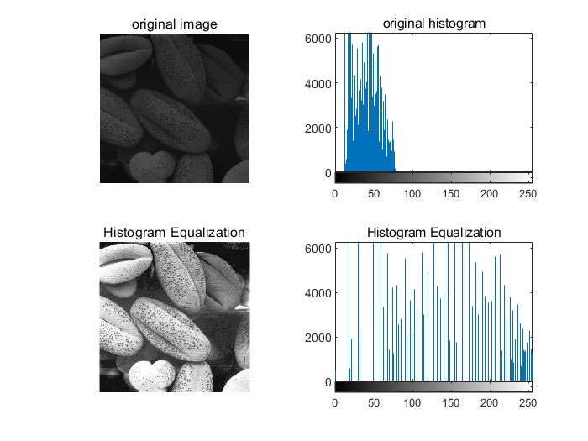 | 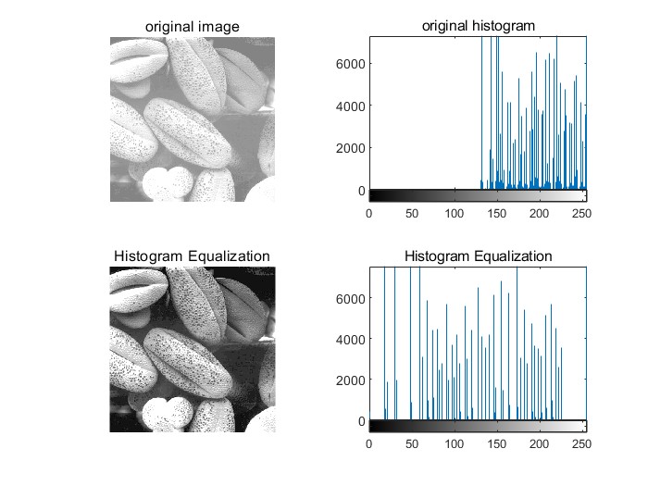
DarkPollen | LightPollen
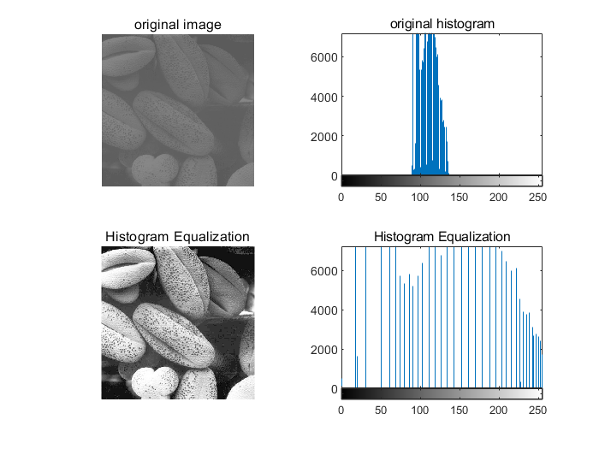 | 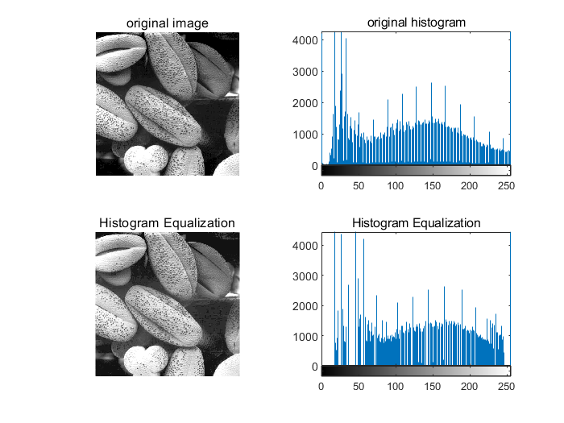
lowContrastPollen | Pollen
与原图的直方图对比，可得：
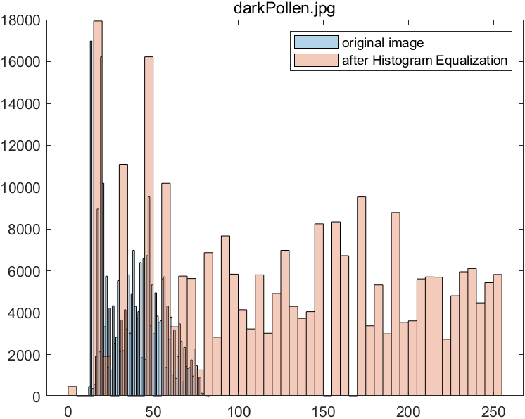 | 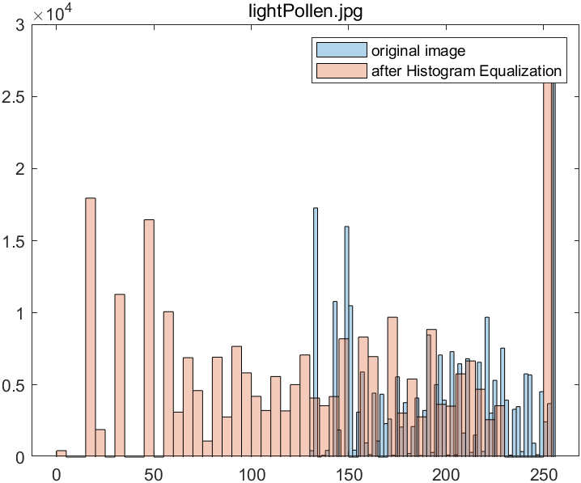
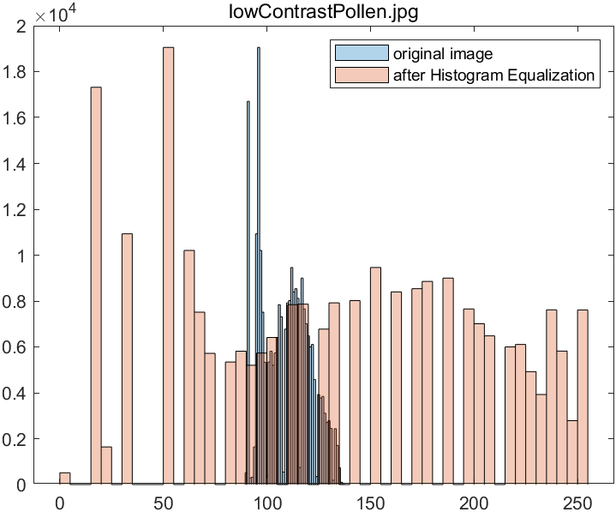 | 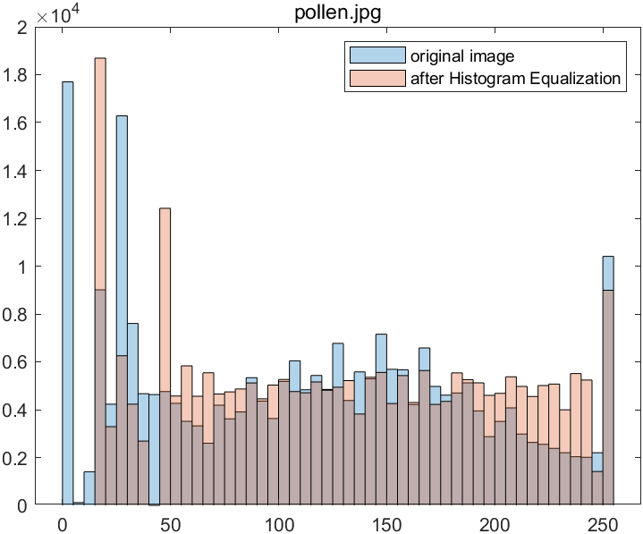
直方图均衡化的思想是把原始图像的灰度分布直方图变换为均匀分布的形式，扩大像素灰度值的动态范围，从而增强图像对比度。通过对比实验中原始图像和直方图归一化后的图像，可以发现，通过直方图均衡化，可以把提高图像的对比度，把较暗的图像变亮，把较亮的图像变暗，达到图像增强的效果。
【小结或讨论】
通过本实验，我学会了对图像进行翻转操作，图像的翻转实质是矩阵的翻转，通过使用flip函数和flipud函数，并结合简单的if对flag的判断，就可以实现对图像的水平翻转与垂直翻转功能
在任务2中，绘制图像的直方图，可以直接通过histgram来绘制。
在任务三中，理解直方图均衡化的逻辑之后，可以自己编写代码实现直方图均衡化，观察可知，直方图均衡化可以对图像有效的增强，达到一个比较好的视觉效果。
通过本次实验，提高了我的matlab画图能力，通过设置简单的图例，透明度，可以有效的美化图形，提高图片质量。

