安徽大学《数字图像处理（双语）》实验报告（2）

学号： 专业： 姓名及签字：

实验日期： 2017年10月31日 实验成绩： 教师签字：

【实验名称】: MATLAB入门及数字图像处理编程基础

【实验目的】：
1. 熟悉和掌握基于点处理的图像增强原理
2. 通过MATLAB编程实现图像求反的增强技术
3. 熟悉和掌握图像灰度等级分辨率的含义并通过MATLAB改变图像的灰度等级分辨率

【实验内容】
Image Enhancement Using Log Transformations
The focus of this project is to experiment with intensity transformations to enhance an image.Enhance the image “Fig_DFT_no_log.tif” by the log transformation of Eq.: s = clog (1 + r).Change the only free parameter c until (according to your judgment) you have the best visual result for the transformation

Image Enhancement Using Power-law Transformations

Enhance the image “Fig_fractured_spine.tif” by a power-law transformation of the for

shown in Eq.:s  crChange the two parameters, c and r until (according to your judgment) you have the best visual result for the transformation.
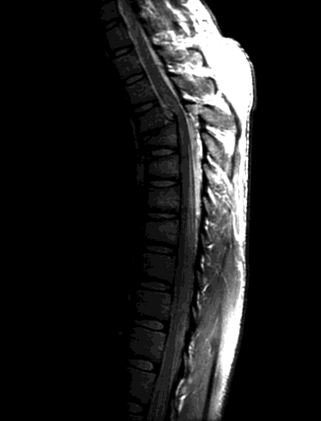
Fig_fractured_spine.tif

Image Enhancement Using Thresholding

Write a MATLAB function averageIntensity which calculates the average intensity level of an image. From the command line use this function on the image “Fig_blurry_moon.tif”.
(Hint: To calculate the average intensity of the pixels in an image simply iterate through every pixel in the image, summing all of their values and finally divide this sum by the total number of pixels.)
Write a MATLAB function thresholdImage which thresholds an image based on a threshold level given as a parameter to the function. The function should take two parameters – the image to be thresholded and the threshold level. The result of the function should be a new thresholded image. This function would be called as follows:
ThresholdedMoon = thresholdImage(Moon, ave);

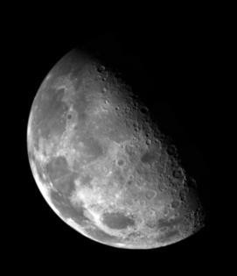

Use this new function from the command line on the image to give images similar to the following:

Thresholding means that a new image is generated in which each pixel has intensity 1.0 if the corresponding pixel in the original image has a value above the threshold and 0 otherwise.

【实验代码和结果】

【小结或讨论】

