# PROJECT 03-04

## Image Flipping

Write a MATLAB function **flipImage** which flips an image either vertically or horizontally. The function should take two parameters – the matrix storing the image data and a flag to indicate whether the image should be flipped vertically or horizontally. Use this function from the command line to flip the image woman.bmp both vertically and horizontally which should give the following results.

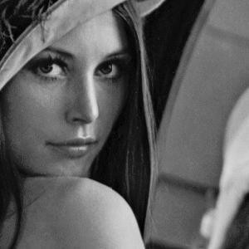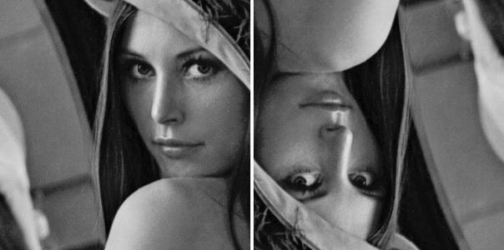

# PROJECT 03-05

## Image Histogram

Write a MATLAB function, **generateHistogram**, which generates the histogram of an image. The function should take an image data array (with pixel values in the range 0 – 255) as its only parameter and return an array containing the histogram of the image. The histogram can be displayed using the built in MATLAB function hist. For example:

A = **generateHistogram**(Image); **bar**(A);

Use this new function to generate and display histograms for the following images (darkPollen.jpg, lightPollen.jpg, lowContrastPollen.jpg and pollen.jpg).

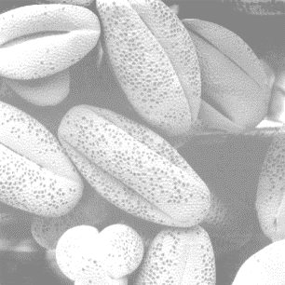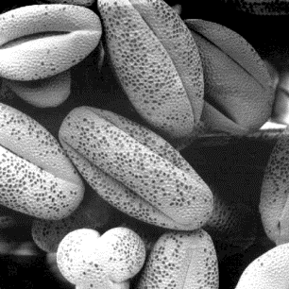

Dark Pollen light Pollen low Contrast Pollen pollen

# PROJECT 03-06

## Histogram Equalization

1. Implement the histogram equalization using your own code instead of the function in MATLAB. Perform histogram equalization on the above 4 images.
2. Plot the histogram of the original images and the histogram-equalization enhanced images.

As a minimum, your report should include the original image, a plot of its histogram, the enhanced image, and a plot of its histogram. Use this information to explain why the resulting image was enhanced as it was.