# PROJECT 03-01

## Image Enhancement Using Log Transformations

The focus of this project is to experiment with intensity transformations to enhance an image.

Enhance the image “Fig_DFT_no_log.tif” by the log transformation of Eq.: *s* = *clog* (1 + *r*).

Change the only free parameter *c* until (according to your judgment) you have the best visual result for the transformation

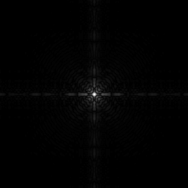

Fig_DFT_no_log.tif

# PROJECT 03-02

## Image Enhancement Using Power-law Transformations

Enhance the image “Fig_fractured_spine.tif” by a power-law transformation of the form

shown in Eq.:*s*  *cr*

. Change the two parameters, *c* and *r* until (according to your

judgment) you have the best visual result for the transformation.

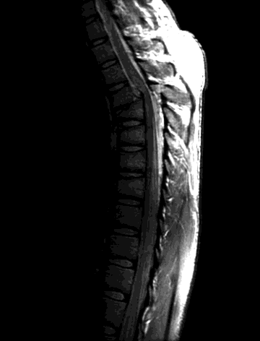

Fig_fractured_spine.tif

# PROJECT 03-03

## Image Enhancement Using Thresholding

1. Write a MATLAB function **averageIntensity** which calculates the average intensity level of an image. From the command line use this function on the image “Fig_blurry_moon.tif”.

**(Hint**: To calculate the average intensity of the pixels in an image simply iterate through every pixel in the image, summing all of their values and finally divide this sum by the total number of pixels.)

1. Write a MATLAB function **thresholdImage** which thresholds an image based on a threshold level given as a parameter to the function. The function should take two parameters – the image to be thresholded and the threshold level. The result of the function should be a new thresholded image. This function would be called as follows:

## ThresholdedMoon = thresholdImage(Moon, ave);

Use this new function from the command line on the image to give images similar to the following:

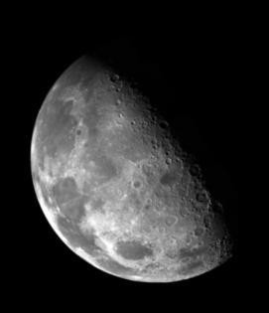

Thresholding means that a new image is generated in which each pixel has intensity 1.0 if the corresponding pixel in the original image has a value above the threshold and 0 otherwise.