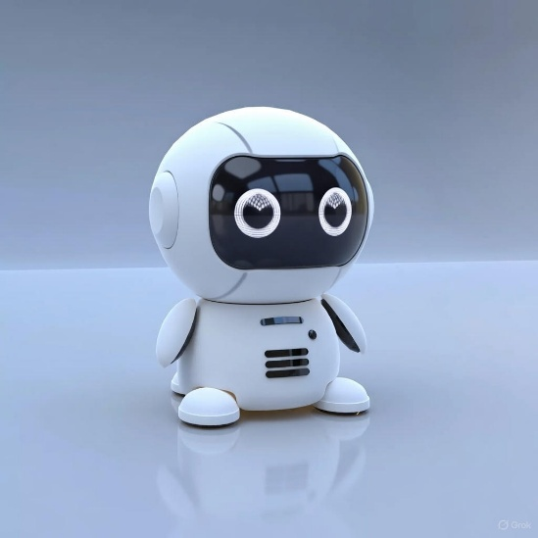
]
Januka Chaudhary
Web Developer/UX Designer

