Direct API Integrations (e.g. Syncing with an LMS)
If you want to sync data directly from an external system—such as a Learning Management System (LMS), an HR system, or a CRM—without requiring the user to upload a physical file, the underlying logic is exactly the same as parsing a JSON file.
Instead of parsing a file, you make a network request (fetch) to the external API, receive a JSON response, and inject it straight into the SchedulerManager.

Architecture Flow

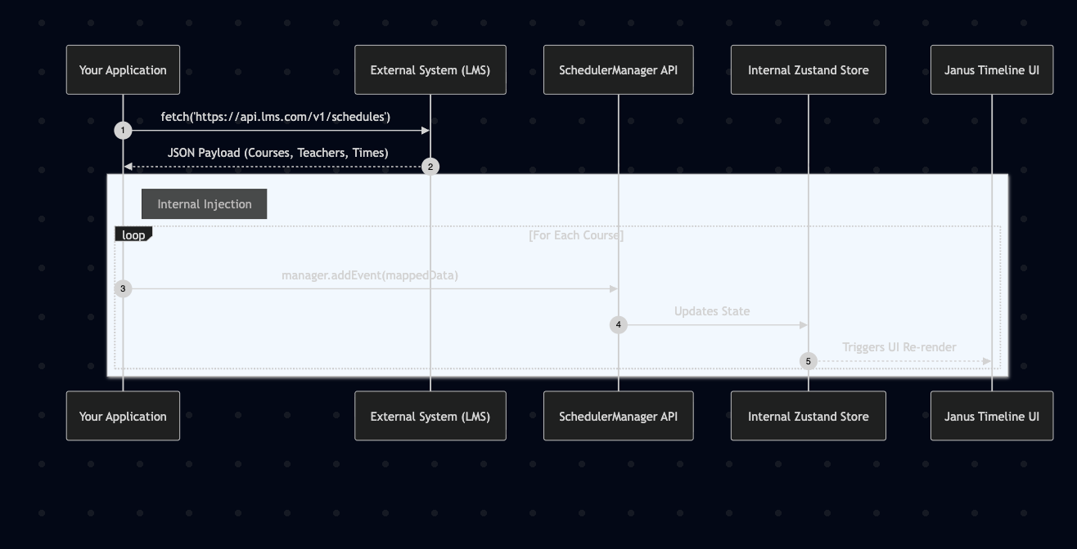

Example Implementation
Here is how you would write a synchronization function that runs automatically when a component mounts, or when a user clicks a "Sync with LMS" button:
javascript
import { SchedulerManager } from '@janus-scheduler/core';
import { manager } from './your-manager-file';
export async function syncFromExternalLMS() {
try {
// 1. Authenticate and fetch from the external API
const response = await fetch('https://api.theirlms.com/v1/courses', {
method: 'GET',
headers: {
'Authorization': 'Bearer YOUR_API_KEY',
'Content-Type': 'application/json'
}
});
if (!response.ok) {
throw new Error(`External API returned status: ${response.status}`);
}
const lmsData = await response.json();
// 2. Loop through the external payload and map it to Janus Scheduler format
let importedEvents = 0;
lmsData.courses.forEach(course => {
// Ensure the teacher (resource) exists before adding the event
if (!manager.getResource(course.teacherId)) {
manager.addResource({
id: course.teacherId,
name: course.teacherName,
type: "staff"
});
}
// Add the course as an event
manager.addEvent({
id: course.id,
title: course.courseName,
// Convert external dates to Javascript Epoch Timestamps
startTime: new Date(course.startDate).getTime(),
endTime: new Date(course.endDate).getTime(),
resourceId: course.teacherId
});
importedEvents++;
});
console.log(`Successfully synced ${importedEvents} events from LMS!`);
} catch (error) {
console.error("Failed to sync from LMS:", error);
alert("Synchronization failed. Please check the logs.");
}
}

Webhooks (Real-Time Sync)
If the external LMS supports Webhooks (e.g., they ping your server whenever a new course is created), the workflow is:
- The LMS sends a POST request to your backend Node/Python server.
- Your server saves the new course to your database.
- Your server sends a WebSocket message (or Server-Sent Event) to your frontend web app.
- Your frontend receives the WebSocket message and calls manager.addEvent() in real-time.
Because SchedulerManager handles reactivity instantly, the new course will pop into the user's timeline without them needing to refresh the page!

SchedulerManager API Reference
When performing a synchronization, you can use the following methods exposed by the SchedulerManager instance to mutate or query the internal state. All of these methods automatically update the timeline UI and trigger your database lifecycle hooks (onEventAdd, onEventUpdate, etc.).

Event Methods

addEvent(event: EventData): void
Injects a new event into the timeline.
- Payload: { id: string, title: string, startTime: number, endTime: number, resourceId: string, color?: string, allDay?: boolean, recurrenceRule?: string }
- Sync Flow: Triggers onEventAdd() hook.

updateEvent(id: string, updates: Partial<EventData>): void
Updates an existing event by its ID. Use this for syncing updates (e.g., event rescheduled on the LMS).
- Payload: Only the fields you wish to change.
- Sync Flow: Triggers onEventUpdate() hook.

deleteEvent(id: string): void
Removes an event from the timeline.
- Payload: The string ID of the event to delete.
- Sync Flow: Triggers onEventDelete() hook.

getEvent(id: string): Event | undefined
Retrieves a single event by its ID. Useful for checking if an event already exists before blindly adding it during a sync.

getEvents(): Event[]
Returns an array of all events currently loaded in the timeline.

Resource (Staff/Room) Methods

addResource(resource: ResourceData): void
Injects a new resource (e.g., Teacher, Doctor, Room) into the timeline.
- Payload: { id: string, name: string, type?: string, avatarType?: 'initials' | 'image', avatarUrl?: string }
- Sync Flow: Triggers onResourceAdd() hook.

updateResource(id: string, updates: Partial<ResourceData>): void
Updates an existing resource's metadata (e.g., changing a teacher's name).
- Payload: Only the fields you wish to change.
- Sync Flow: Triggers onResourceUpdate() hook.

deleteResource(id: string): void
Removes a resource from the timeline. This also visually hides any events assigned to that resource.
- Payload: The string ID of the resource to delete.
- Sync Flow: Triggers onResourceDelete() hook.

getResource(id: string): Resource | undefined
Retrieves a single resource by its ID. Useful for checking if a teacher or room is already loaded in the timeline before adding them.

getResources(): Resource[]
Returns an array of all resources currently loaded in the timeline.

