ML MAJOR PROJECT
Intelligent Hybrid Profile-Based Matching & Recommendation System
Student: Janusha Brahmadevuni | B.Tech CSE (AI & ML)
1. Datasets Used
users_.csv
Main user profile dataset with 100 synthetic user profiles containing user_id, name, age, location, profession, experience_years, professional_summary, about_me, mbti and interests. Source: generated using Python in the project notebook per the supplied dataset creation guidelines; synthetic data, not from an external dataset.
feedback_.csv
Interaction history for the feedback-learning component: 800 synthetic interactions with user_id, matched_user_id, action and timestamp (1 = Accept, 0 = Reject). Source: generated using Python to simulate user feedback.
feedback_ml.csv
Machine-learning-ready feedback dataset containing matching features used for learning — text similarity, MBTI score, location score and the feedback action. Source: prepared from the generated profile and feedback data.
Saved Model Files
tfidf_vectorizer.pkl (trained TF-IDF vectorizer), feedback_model.pkl (final Logistic Regression feedback model), user_adaptive_weights.pkl (personalized weights per user).
2. About the Project
The project is an intelligent profile matching and recommendation system that compares users using both structured information and free-text profile data. Rather than relying only on fixed filters, it combines professional and personal profile information, personality compatibility, location and previous feedback to generate a compatibility score. The pipeline spans synthetic profile creation and data analysis, NLP processing and similarity calculation, hybrid profile scoring, feedback-based learning, and a Streamlit application that recommends the Top 5 profiles.
3. Data Preparation and EDA
The generated data was checked for missing values, duplicate records, duplicate user IDs, invalid MBTI types, empty text fields and invalid age or experience values. Exploratory Data Analysis examined age, experience, profession, location, MBTI distribution, text length and feedback distribution, along with profession vs. MBTI, age vs. experience, and acceptance rate by profession.
4. NLP and Profile Matching
Text Processing
- Professional Summary, About Me and Interests were combined to create the profile text.
- Text was lowercased and punctuation removed.
- Stopwords were removed and lemmatization was performed.
- TF-IDF converted the cleaned text into numerical vectors.
- Cosine similarity measured similarity between two user profiles.
Hybrid Compatibility Scoring
The matching system combines three factors: text similarity, MBTI compatibility and location compatibility, weighted initially at 50% / 30% / 20% respectively. The weighted result is converted into a compatibility percentage between 0 and 100. For MBTI matching, a predefined compatibility rule is used: identical MBTI types receive a defined score, complementary personality pairs receive a higher score, and other combinations receive a standard score. Location compatibility is higher when users share the same city.
5. Feedback Learning and Personalization
The system records whether a recommended profile is Accepted or Rejected, and these interactions train a Logistic Regression model. A balanced version of the model was also tested, since the feedback dataset contains more Reject interactions. The project further generates user-specific adaptive weights, representing the importance of text similarity, MBTI and location for an individual user based on their past feedback.
6. Recommendation Process
- A user is selected from the available profiles.
- The system compares that user with the other profiles.
- Text similarity, MBTI compatibility and location compatibility are calculated.
- Personalized weights are applied when available.
- Profiles are sorted according to the final compatibility score.
- The Top 5 profiles are displayed with their score and basic profile information.
- The user can open an explanation to see the factors behind a recommendation.
- Accept or Reject feedback can be recorded for the recommended profile.
7. Machine Learning Results
Model / Evaluation | Result
Original Logistic Regression | 70.00% accuracy
Balanced Logistic Regression | 68.75% accuracy
Accept-class F1 score | 0.43 to 0.62
Chronological personalized holdout | 62.92% accuracy
Final error analysis | 50 incorrect predictions out of 160
The original Logistic Regression model achieved 70% accuracy. The balanced model achieved 68.75% accuracy, but its Accept-class F1-score increased from 0.43 to 0.62. The chronological holdout evaluation did not show a measurable accuracy improvement from personalized weights on this synthetic dataset — reported as observed, rather than assuming personalization always improves performance.
8. Technologies Used
Python, Pandas, NumPy, Scikit-learn, NLTK, Matplotlib, Seaborn, Joblib and Streamlit.
9. Streamlit Application
A Streamlit web application was developed to demonstrate the completed recommendation system. The user can select a profile, view profile information and generate the Top 5 compatible profiles.
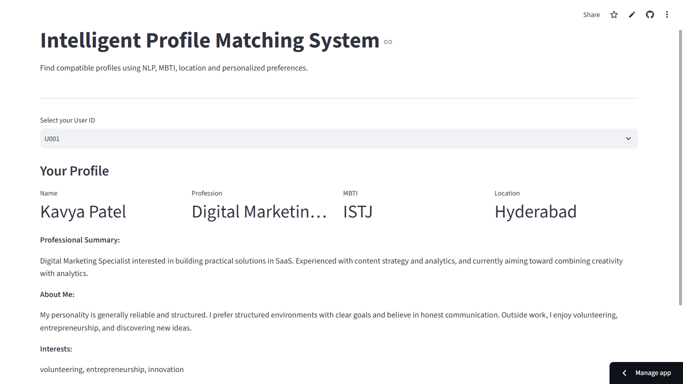
Figure 1. User profile selection and profile details
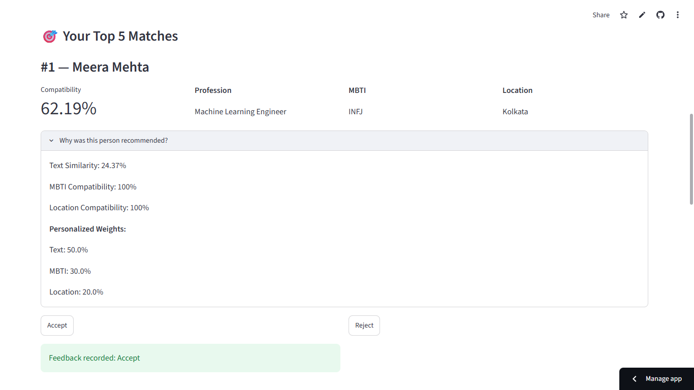
Figure 2. Top match, explanation and feedback
10. Project Output
The final application displays the selected user's profile and generates five recommended profiles. For each recommendation, the application shows the compatibility percentage, profession, MBTI type and location. The explanation section shows the text similarity, MBTI compatibility, location compatibility and the personalized weights used for that recommendation.
11. Conclusion
The completed project demonstrates an end-to-end hybrid profile matching system. A synthetic profile dataset was generated and analyzed, free-text information was processed using NLP, and TF-IDF with cosine similarity was used to compare profiles. MBTI and location compatibility were then combined with text similarity to produce a final compatibility score.
The project also includes a machine learning feedback component using Accept/Reject interactions and a personalized weighting mechanism. The Streamlit application brings the complete workflow together by providing Top 5 recommendations, explanations and feedback recording. The result is a working demonstration of how NLP, machine learning and recommendation logic can be combined into a practical profile matching system.

