FortuneController.java
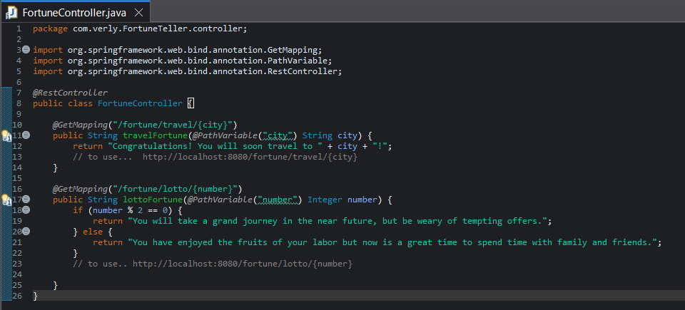
Output:

Travel Fortune
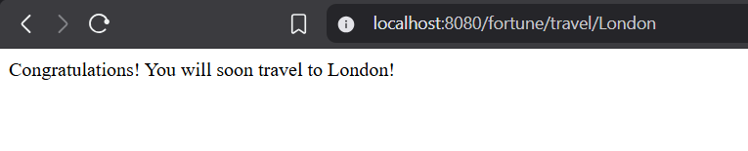
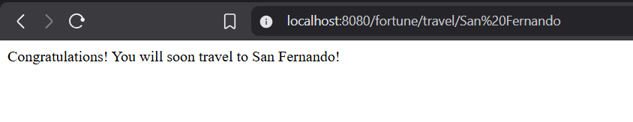
Lotto Fortune


