BACANI, JANVERLY MHAY O.

ACTIVITY: PUSHING an HTML / CSS Project

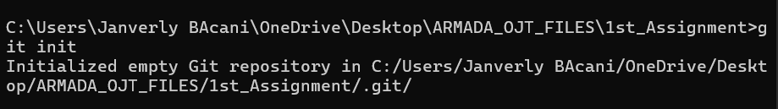
Initializes a new Git repository in the current folder.

Add all the files on the current folder. The dot(.) means everything in the folder is included.
Git add just prepares the folder and the subfolders, it does not save the files yet.

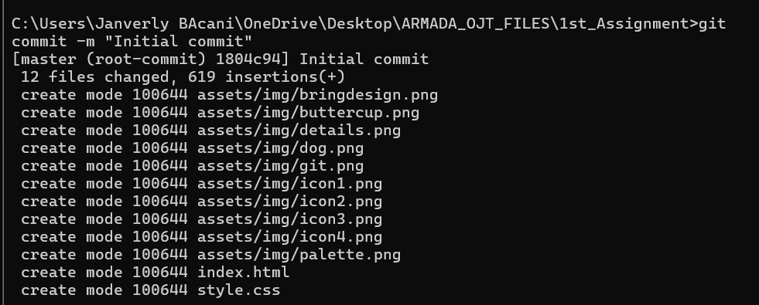
Git commit just saves a snapshot of all the staged files (the files that you have added with the git add .)
-m let’s you write a message, describing what the you want to say.
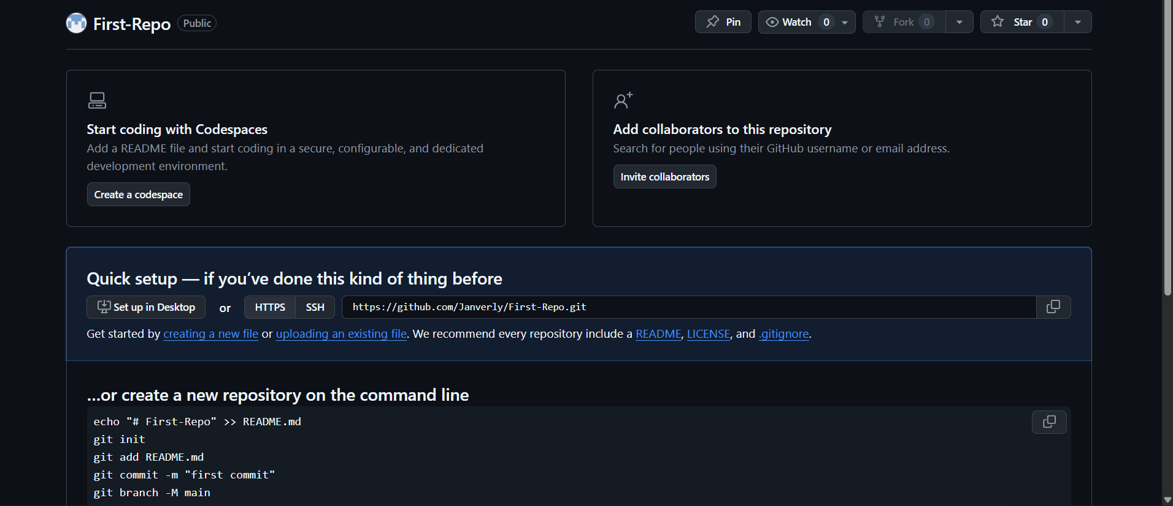
Created a new Repository for the pushing of the first_assignment
Copy the URL on the quick set up. 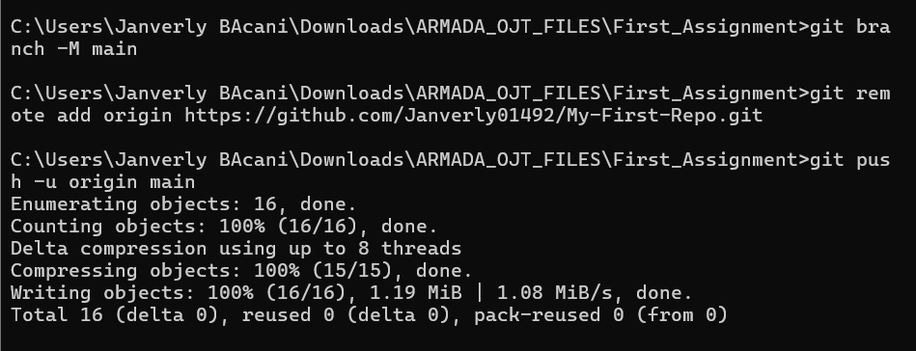
By default, older version of Git create a brqach called master. So I did git branch -M main, it renames the current branch (master) into main.
-M forces to rename

Git remote is to manage “remotes” (the other repositories your local repo can connect to)
Origin is the name you give to that remote repository (the main remote is called origin)

Git push, it sends the commits to the remote repository
-u, sets the origin or the main as the default upstream branch, so future git push or git pull commands can work without specifying branch or remote

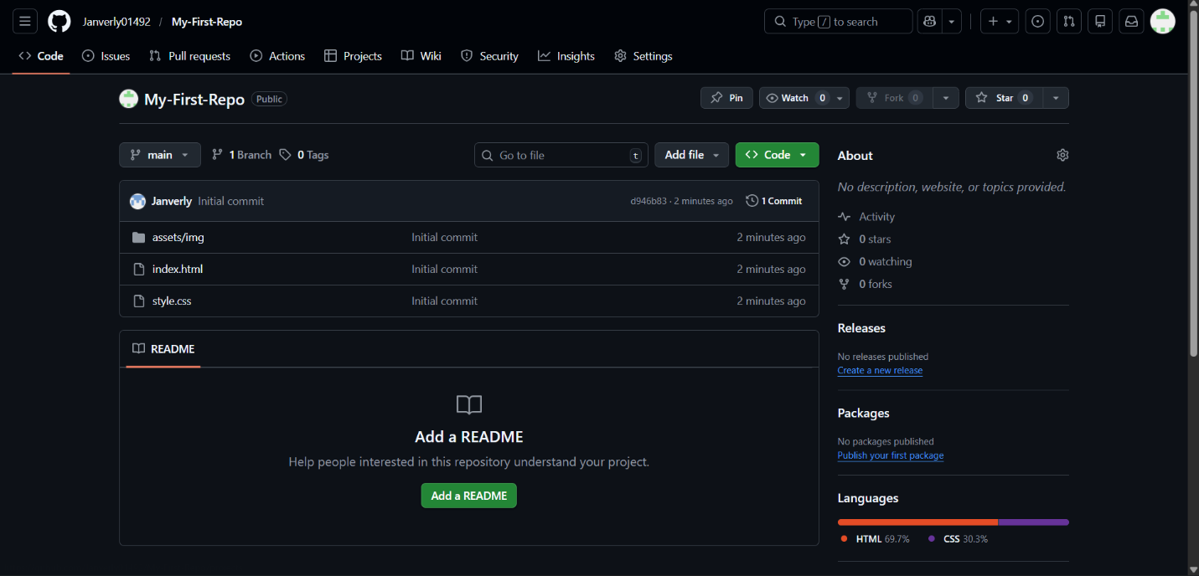
After pushing, go to your GitHub account and check is the folder/files are being pushed.
First project successfully pushed to GitHub!

