Student Trainee | : | JANVERLY MHAY O/ BACANI
Station | : | Armada Logics Incorporations
Month | : | January 2026

Week | Activity | No. of Working Hours | REMARKS
1 | January 19:  - Orientation with Mr. Mario Naravaez, Mr. Rogimer Urriza, and Mr. Lenard Cordial  - Discussion about the objective of the On-the-Job Training in Armada Logics  - The company gives some coding exercises after the orientation to assess what are our current knowledge about coding / programming  January 20:  - Mr. Cordial present and discuss an overview of importance of communication in workplace  - The company gives a learning material for communication course  January 21:  - The discussion focuses on the learning materials provided by the company yesterday.  - The supervisor let us give our insight / learning on the discussion after the meeting  - Throughout the session, us trainee’s completing the activities provided in Armada’s learning materials  January 22:  - Mr. Cordial gave us time to reflect on our learning about the communication course.  - Activity scenarios on learning materials and a brief discussion on each scenario  January 23:  - During the session, we presented our explanation / answers to each scenario, after which the supervisors offered their insights and suggestions for improvement | 40 | COMPLETED
2 | January 26:  - Had some issues with the learning platform but our co-trainees from other schools that already access the other modules shares the activity and the learning materials that was on the learning platform  - Regardless of the issue on the platform, the instructor still did their best to discuss our modules  - Also, we share some insights / reflection on last week’s topic, Communication Course.  January 27:  - An intern form Armada, Sir Vince, did present about Mastering Communication  - Sir Lenard also updated us about the learning platform  - On the technical skills, we discuss about the proper indentation, the basic structure of a web  January 28:  - Discussion about Emotional Intelligence: The Foundation for Success in All Areas of Life  - We also discussed about the uses of Semantic Tags, The Gift Wrapping in HTML  January 29:  - Discussion on Teamwork Collaboration, discussed by Sir Daryl Matthew  - Sir Lenard also let us watch Mr. Choi’s Different Types of Students  - And brief discussion on last part of our HTML course and introduction of CSS  January 30:  - Time Management discussed by Sir Jerick, that when you do something, focus on one work to another  - We showcase our codes (HTML and CSS) to our fellow trainees  - Evaluation / Giving insights on one’s code | 40 | COMPLETED

Photo Documentations:
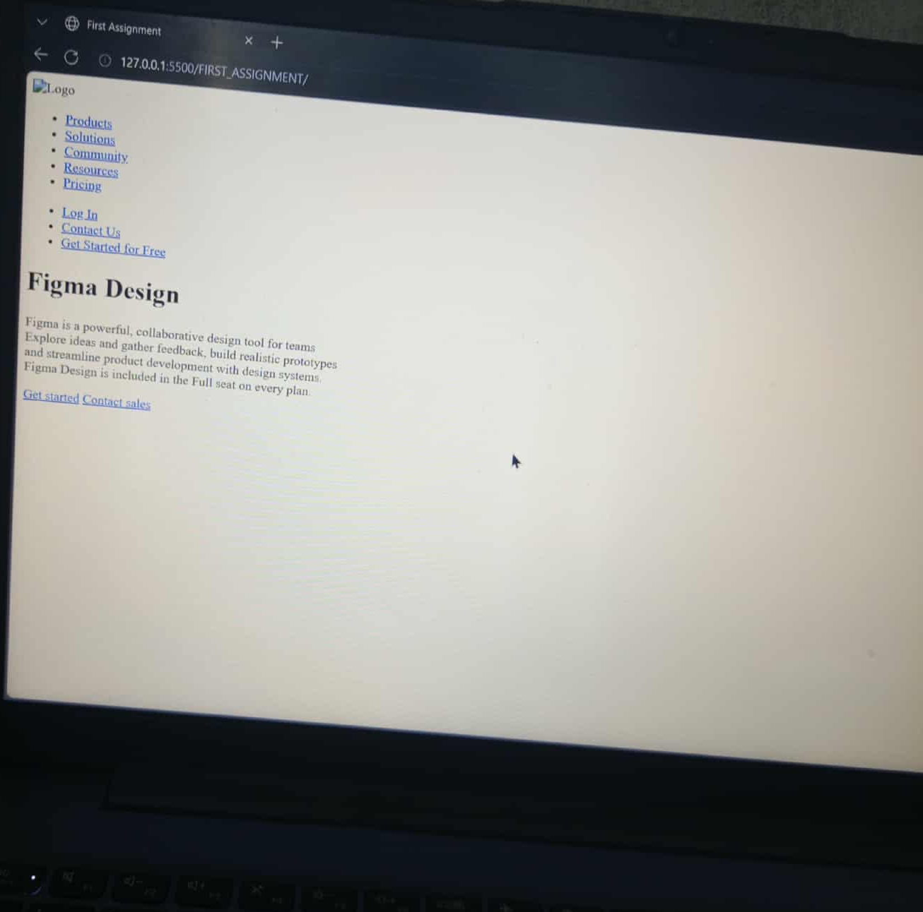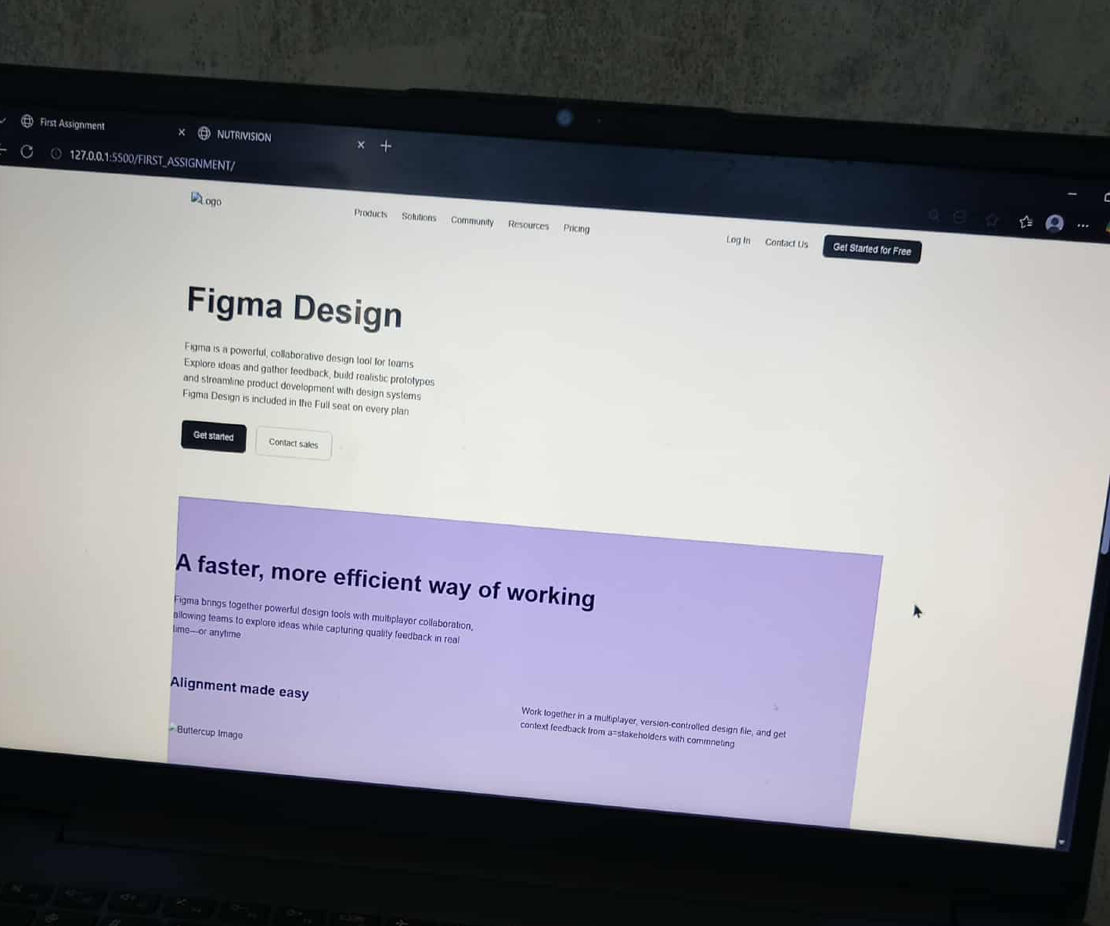
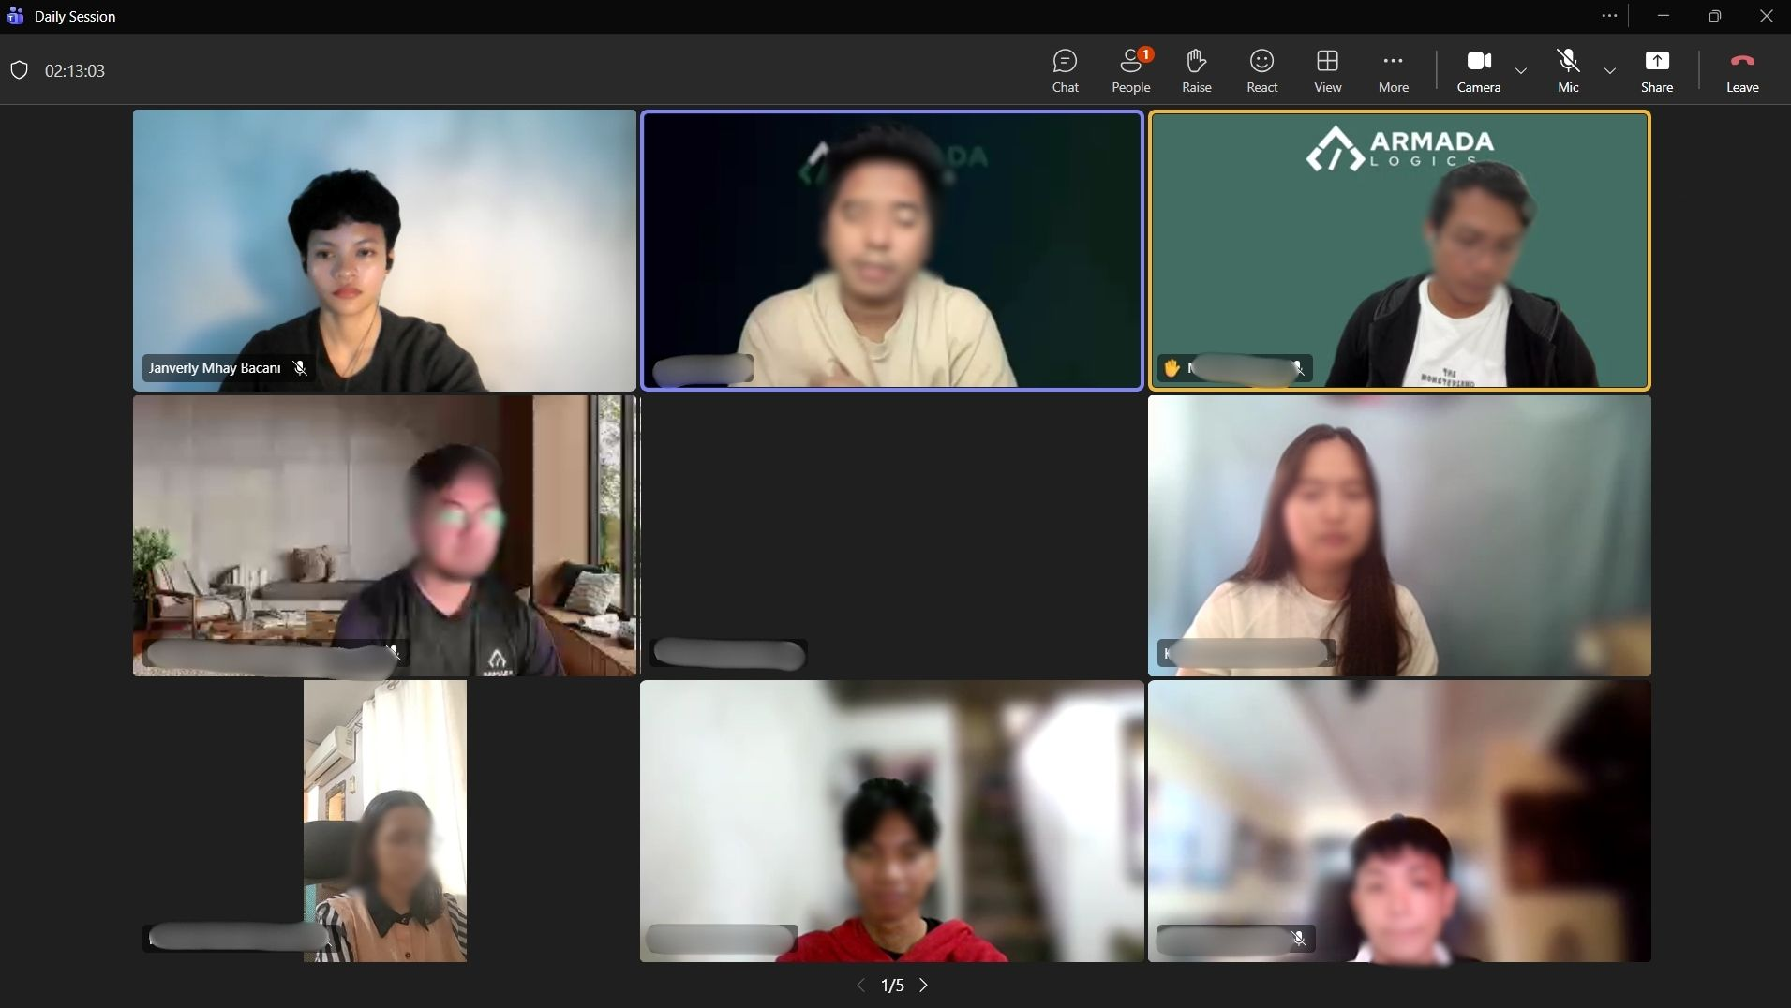

Prepared by:

JANVERLY MHAY O. BACANI
Student Trainee

Noted by:

Mr. Lenard Cordial
Instructor
Armada Logics Inc

MARK KRISTIAN C. LEDDA
OJT Coordinator
DMMMSU -MLUC

Certified by:

ALVIN R. MALICDEM
Chancellor

