CREATE DATABASE office;

USE office;

CREATE TABLE emp_details(

emp_id int not null,

first_name varchar(50),

last_name varchar(50),

department varchar(20),

salary int not null,

hire_date date);

drop table emp_details;

SELECT * FROM emp_details;

INSERT INTO emp_details(emp_id,first_name,last_name,department,salary,hire_date)

VALUES

(1,"John","Doe","IT",60000,"2019-01-10"),

(2,"Jane","Smith","HR",55000,"2018-03-05"),

(3,"Emily","Jones","IT",62000,"2020-07-23"),

(4,"Michael","Brown","FINANCE",70000,"2016-05-14"),

(5,"Sarah","Davis","FINANCE",69000,"2017-11-18"),

(6,"David","Johnson","HR",48000,"2021-09-10");

#1. Find the average salary of employees in each department.

SELECT department,avg(salary) as "average salary" from emp_details group by department;

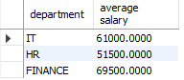

#2. Find the total number of employees hired after 2019.

SELECT count(hire_date) as "employees hired after 2019"

from emp_details

Where hire_date>"2019-01-10";



#3. List the departments and the total salary of all employees in each department, ordered by the total salary.

SELECT department, sum(salary) as "total salary" from emp_details group by department order by sum(salary)asc;

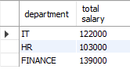

#4. Find the highest salary in the Finance department.*/

SELECT department, max(salary) as "highest salary" from emp_details where department = "FINANCE";



#5. Get the top 3 highest-paid employees.

SELECT first_name,last_name, max(salary) as "top 3 highest-paid employees" from emp_details group by first_name,last_name order by max(salary) desc limit 3;

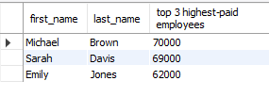

#6. Find the department with the minimum average salary.

SELECT department, avg(salary) as "Average Salary of employee" from emp_details group by department order by avg(salary) asc limit 1;

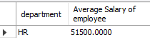

#Q7. Display the total number of employees in each department, ordered by the number of employees.

SELECT department, count(emp_id) as "total number of employees" from emp_details group by department order by count(emp_id);

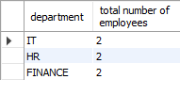

#Q8. Find the average salary of employees who were hired before 2020.

SELECT hire_date, avg(salary) as "average salary" from emp_details group by hire_date having hire_date < "2020-07-23";

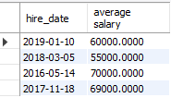

#9. List the names of employees in the IT department ordered by hire date, with the most recently hired employees first.

Select first_name,last_name, hire_date from emp_details where department="IT" order by hire_date desc;

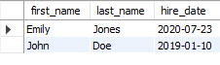

#10. Find the sum of salaries for all employees hired after January 1, 2019, ordered by salary.

Select count(emp_id) as no_of_employee,sum(salary) as total_salary from emp_details where hire_date>"2019-01-01";



#11. Get the employee with the lowest salary in the HR department.

select first_name, last_name, salary from emp_details where department="HR" order by salary limit 1;



#12. Find the total salary paid to employees in each department, but limit the result to the top 2 highest-paying departments.

Select department,sum(salary) as total_salary from emp_details group by department order by total_salary desc limit 2;

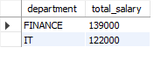

#13. List all employees hired after 2018, ordered by salary, and show only the first 4 employees.

SELECT CONCAT(first_name, ' ', last_name) AS full_name, salary

FROM emp_details

WHERE hire_date > '2018-12-31'

order by salary desc

limit 4;

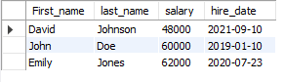

#14. Find the highest salary in the IT department, but limit the results to the top 1 result.

Select max(salary) as Highest_Salary from emp_details where department="IT";



#15. Get the average salary of employees in each department and list only departments with an average salary greater than $60,000.

Select department, avg(salary) as avg_salary from emp_details group by department having avg_salary>60000;