CREATE DATABASE sales_db;

USE sales_db;

CREATE TABLE sales_table (

SaleID INT PRIMARY KEY,

ProductID INT,

CustomerID INT,

SaleDate DATE,

Quantity INT,

UnitPrice INT,

Region VARCHAR(20));

INSERT INTO sales_table (SaleID,ProductID,CustomerID,SaleDate,Quantity,UnitPrice,Region)

VALUES

(1, 101, 1001, '2024-01-05', 5, 200, 'North'),

(2, 102, 1002, '2024-01-10', 10, 150, 'East'),

(3, 103, 1003, '2024-02-15', 2, 300, 'North'),

(4, 104, 1001, '2024-02-20', 7, 250, 'West'),

(5, 101, 1004, '2024-03-05', 1, 200, 'East');

SELECT * FROM sales;

**#1. Write a query to calculate the total sales (Quantity * UnitPrice) for each product.**

SELECT ProductID, SUM(quantity*UnitPrice) as total_sales from sales_table group by ProductID;

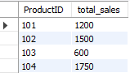

**#2. Write a query to find the total number of products sold in each region.**

SELECT region,sum(Quantity) as ProductsSold from sales_table group by region;

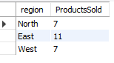

**#3. Write a query to get the average sales amount per product.**

SELECT ProductID, avg(quantity*UnitPrice) as AverageSale from sales_table GROUP BY ProductID;

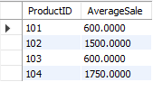

#4.Find the regions where total sales are more than 3000.

SELECT region, sum(quantity*UnitPrice) as total_sales from sales_table group by region having total_sales>3000;



**#5. Write a query to get the maximum quantity sold for each product.**

SELECT ProductID, max(quantity) as maxquantity from sales_table group by ProductID;

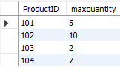

**#6. Write a query to calculate the average quantity of products sold per region.**

SELECT Region, avg(quantity) as avgQuantity from sales_table group by Region;

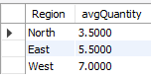

**#7. Find the product IDs that have generated a total sales amount of more than 1000.**

SELECT ProductID, sum(Quantity*UnitPrice) as TotalSales from sales_table group by ProductID having TotalSales>1000;

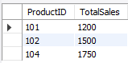

**#8. Write a query to get the total number of sales (rows) made for each customer.**

SElECT CustomerID, count(Quantity) as SalesRows from sales_table group by CustomerID;

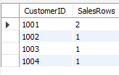

**#9. Find the products for which the average quantity sold is less than 5.**

SELECT ProductID, avg(quantity) as "average quantity sold" from sales_table group by ProductID having avg(quantity) < 5;

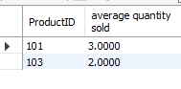

**#10. Write a query to find the sum of total sales for each customer in each region.**

SELECT CustomerID, Region, sum(Quantity * UnitPrice) as "Total Sales" from sales_table group by CustomerID, Region;

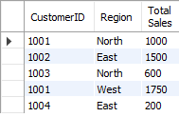

**#11. Write a query to calculate the total sales for each month.**

SELECT extract(MONTH FROM SaleDate) as month, sum(Quantity * UnitPrice) as "Total Sales" from sales_table group by EXTRACT(MONTH FROM SaleDate);

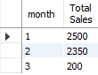

**#12. Find the regions where the average unit price is more than 200.**

SELECT Region, avg(UnitPrice) as "average unit price" from sales_table group by Region having avg(UnitPrice) > 200;

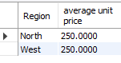

**#13. Write a query to get the minimum and maximum quantity sold per region.**

SELECT Region, max(Quantity) as maxQuantity, min(Quantity) as minQuantity from sales_table group by Region;

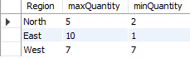

**#14. Find the customers who have made more than 2 purchases.**

SELECT CustomerId, count(SaleID) as Purchases from sales_table group by CustomerID having Purchases>2;



**#15. Write a query to find the total sales for each product and filter only those products where the total sales exceed 1500**.

SELECT ProductID, sum(Quantity * UnitPrice) as "total sales" from sales_table group by ProductID having sum(Quantity * UnitPrice)>'1500';

