**#1. Create a database named library and a table named books with the following columns:**

**id (INT, Primary Key, Auto Increment)**

**title (VARCHAR(255))**

**author (VARCHAR(100))**

**year (YEAR)**

**genre (VARCHAR(100))**

CREATE DATABASE library;

USE library;

CREATE TABLE books (

id INT PRIMARY KEY AUTO_INCREMENT,

title VARCHAR(255),

author VARCHAR(100),

year YEAR,

genre VARCHAR(100));

**#2. Insert the following book records into the books table:**

**"The Great Gatsby", "F. Scott Fitzgerald", 1925, "Fiction"**

**"Pride and Prejudice", "Jane Austen", 1813, "Romance"**

**"To Kill a Mockingbird", "Harper Lee", 1960, "Fiction"**

**"1984", "George Orwell", 1949, "Dystopian"**

**"Moby Dick", "Herman Melville", 1851, "Adventure"**

INSERT INTO books(title,author,year,genre)

VALUES

("The Great Gatsby", "F. Scott Fitzgerald", 1925, "Fiction"),

("Pride and Prejudice", "Jane Austen", 1913, "Romance"),

("To Kill a Mockingbird", "Harper Lee", 1960, "Fiction"),

("1984", "George Orwell", 1949, "Dystopian"),

("Moby Dick", "Herman Melville", 1951, "Adventure");

select * from books;

**#3. Write a query to select all books where the title starts with the letter 'T' using the LIKE operator**.

SELECT * FROM books WHERE title LIKE 'T%';

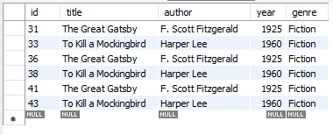

**# 4. Write a query to find all books where the author's last name ends with 'son' using the LIKE operator.**

SELECT * FROM books WHERE author LIKE '%son';



**# 5. Write a query to find all books where the title contains the word 'and' using the LIKE operator**.

SELECT * FROM books WHERE title LIKE '%and%';

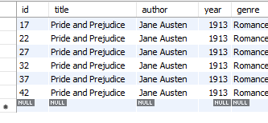

**# 6. Write a query to retrieve all books where the title ends with the word 'bird' using the LIKE operator.**

SELECT * FROM books WHERE title LIKE '%bird';

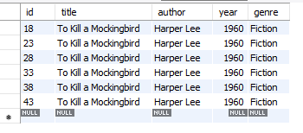

**#7. Write a query to find all books where the title has exactly 3 characters using the REGEXP operato**r.

SELECT * FROM books WHERE title REGEXP '^[A-Za-z0-9]{3}$';



**#8. Write a query to select all books where the title contains a number using the REGEXP operator.**

SELECT * FROM books WHERE title REGEXP '[0-9]';

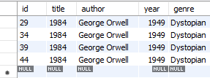

**#9. Write a query to retrieve all books where the author's name starts with any letter between 'A' and 'J' using the REGEXP operator.**

SELECT * FROM books WHERE author REGEXP '^[A-Ja-j]';

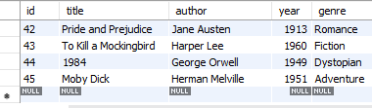

**# 10. Write a query to select all books where the genre is either 'Fiction' or 'Adventure' using the REGEXP operator.**

SELECT * FROM books WHERE genre REGEXP 'Fiction|Adventure';

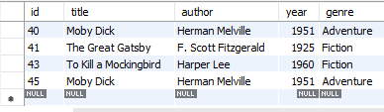

**#11. Write a query to find all books where the title contains at least one uppercase letter using the REGEXP operator.**

SELECT * FROM books WHERE title REGEXP '[A-Z]';

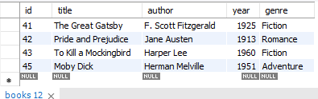

**# 12. Write a query to find all books where the year of publication is between 1800 and 1950 using the LIKE operator**.

SELECT * FROM books WHERE year LIKE'18%'OR year LIKE'1950';



**#13. Write a query to retrieve all books where the author's name contains exactly two words using the REGEXP operator**.

SELECT * FROM books WHERE author REGEXP '[a-zA-Z]+ [a-zA-Z] +$';

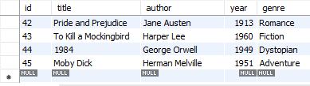

**# 14. Write a query to find all books where the title starts with the letter 'P' and contains exactly two words using the REGEXP operator.**

SELECT * FROM books WHERE title REGEXP '^P [a-zA-Z]+ [a-zA-Z]+';



**# 15. Write a query to find all books where the title contains any special characters (e.g., '!', '@', '#', etc.) using the REGEXP operator.**

SELECT * FROM books WHERE title REGEXP '[[:punct:]]';

