- This homepage displays all registered local businesses in a simple and organized format. Users can browse, search, and directly contact businesses. The interface is designed to be clean, user-friendly, and accessible for both customers and business owners. 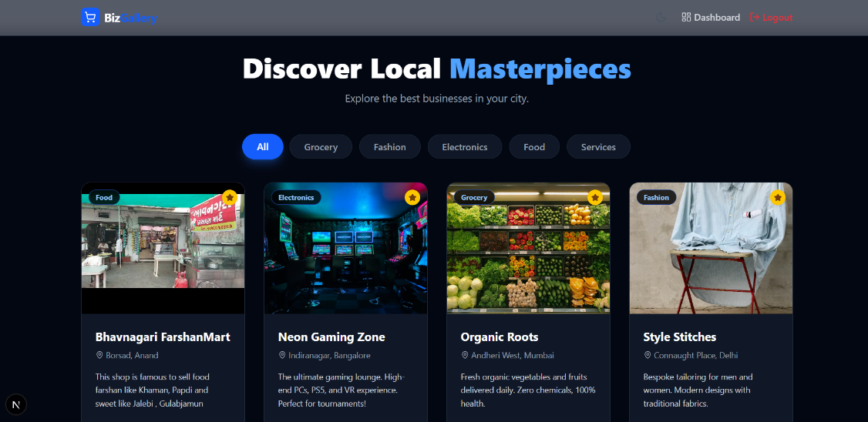

- This page allows a logged-in user to create their shop listing by entering business details. After submission, the shop is securely stored in the database and displayed on the homepage.as well as after this for creating any shop there will appear some form based question related to business to make it’s webview .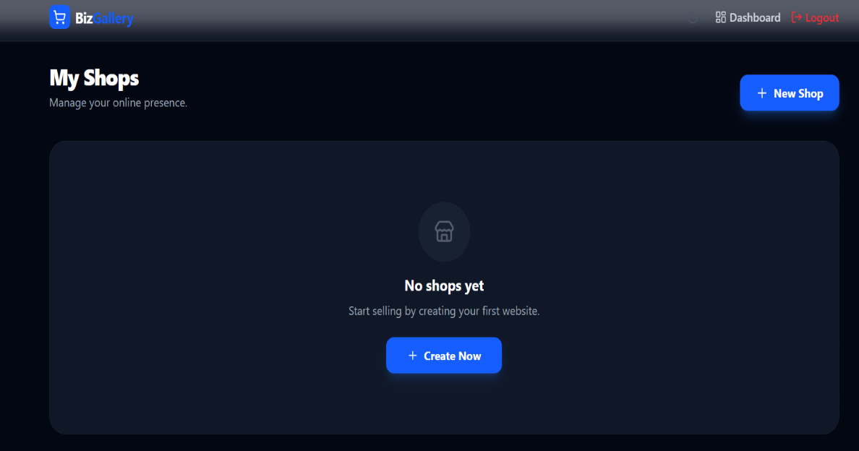

- This dashboard shows the logged-in user's business listing. From here, they can manage, edit, or delete their shop securely. The system ensures that users can only access their own data.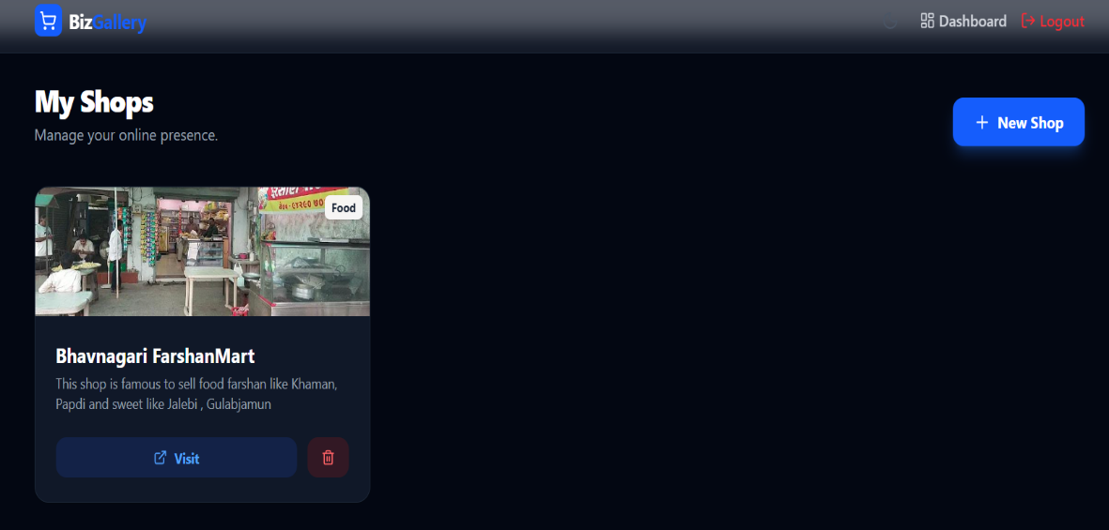
- As I mentioned in 3rd point that there will appear a form that asks business based question it willhelp to create this webview by this all customer can reach this business’ all infomtion as well as contact number or whatsapp directly .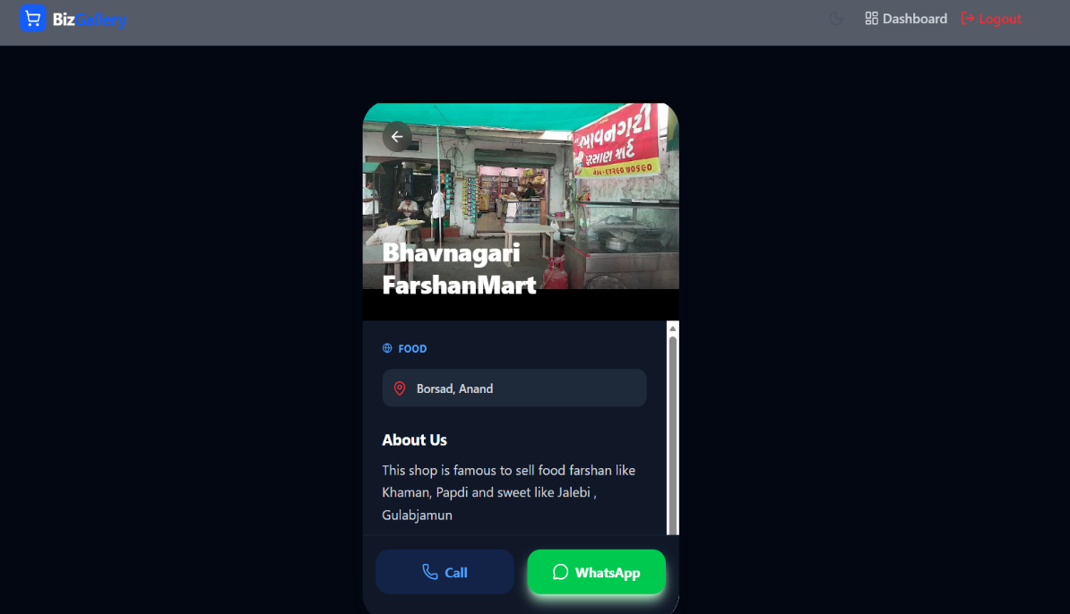

5.As in 4th point if we clicked in whatsapp it will go into realtime whatsapp with this prewritten message.
