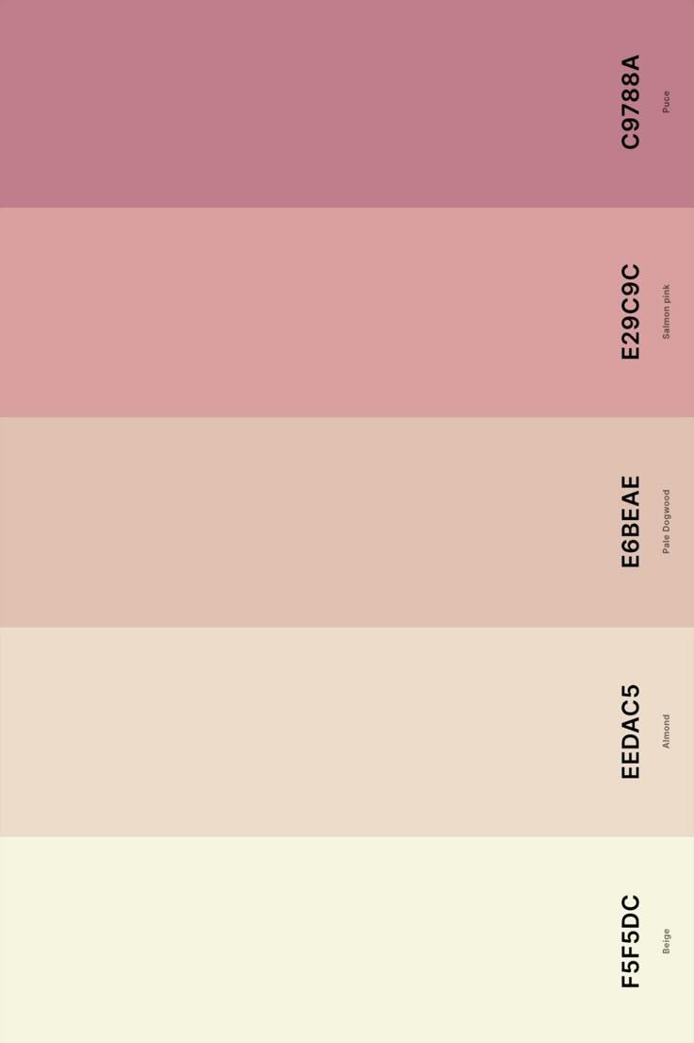
Inspiration of colour palette of website

Inspiration of my sign which need to me turned like a logo to be put up above or beside the banner “Welcome to my portfolio”

