Name: Janvi Upare

Batch: may – cyber security

**Network Scanner nmap**

Nmap (Network Mapper) is a powerful and widely used open-source network scanning tool designed to discover hosts and services on a computer network. Created by Gordon Lyon, also known as Fyodor, Nmap is capable of network inventory, managing service upgrade schedules, and monitoring host or service uptime. It provides various functionalities for network administrators and cybersecurity professionals to perform network discovery and security auditing.

1. Host Discovery: Nmap can quickly identify live hosts on a network. It uses various techniques, such as ICMP echo requests, TCP SYN, and ACK packets, to detect active devices and map the network topology.

2. Port Scanning: Nmap can scan a range of ports on a host to identify open, closed, or filtered ports. This helps in understanding the services running on a network and detecting potential vulnerabilities.

3. Service and Version Detection: Beyond identifying open ports, Nmap can determine the services running on those ports and their versions. This is crucial for identifying outdated or vulnerable services that need attention.

4. Operating System Detection: Nmap uses TCP/IP stack fingerprinting to determine the operating system of a remote host. This helps in understanding the network’s composition and identifying systems that might need different security measures.

5. Scriptable Interaction with the Network: The Nmap Scripting Engine (NSE) allows users to write scripts for custom scanning and network interaction. These scripts can perform a wide range of tasks, from vulnerability detection to more sophisticated network audits.

6. Flexible and Powerful Output Options: Nmap provides various output formats, including plain text, XML, and HTML, allowing for easy integration with other tools and comprehensive report generation.

7. Firewall and IDS Evasion: Nmap includes options to evade firewalls and IDS/IPS by adjusting scan timing, packet sizes, and using fragmented packets.

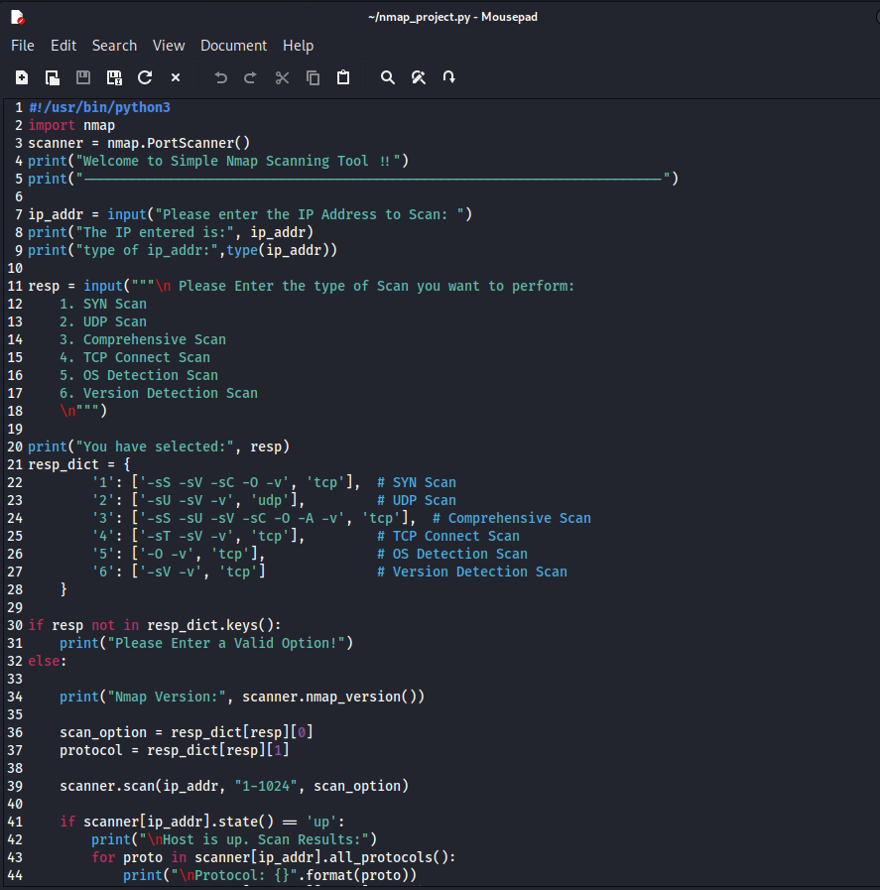

Output:

