Trading App Simulator
Concise Technical Documentation

1. System Overview
- Full-stack MERN application (MongoDB, Express, React, Node.js)
- Simulates stock trading using virtual money
- Users can buy/sell stocks, track portfolio, and view leaderboards
- External APIs provide live stock prices and financial news

2. System Architecture
- React frontend handles UI
- Axios manages API communication
- Node.js + Express provides backend APIs
- MongoDB stores users, trades, and portfolio data
- External APIs provide market prices and news
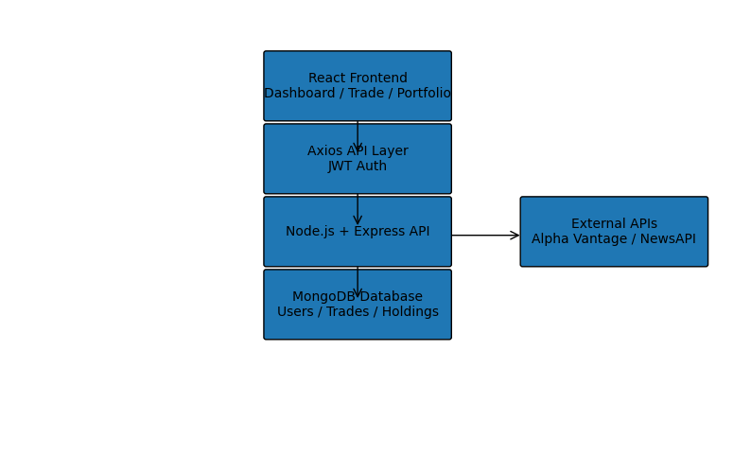

3. Technology Stack
Frontend:
- React
- React Router
- Axios
- Tailwind CSS
- Context API
Backend:
- Node.js
- Express.js
- MongoDB
- Mongoose
- JWT
- bcrypt

4. Core Functionalities
- User authentication
- Buy and sell stock orders
- Portfolio dashboard with P&L tracking
- Watchlist and price alerts
- Community chat and leaderboard
- Financial news integration

5. Trading Workflow
- User places buy/sell order
- Backend validates request
- System retrieves stock price
- Database transaction updates holdings
- Portfolio value updated
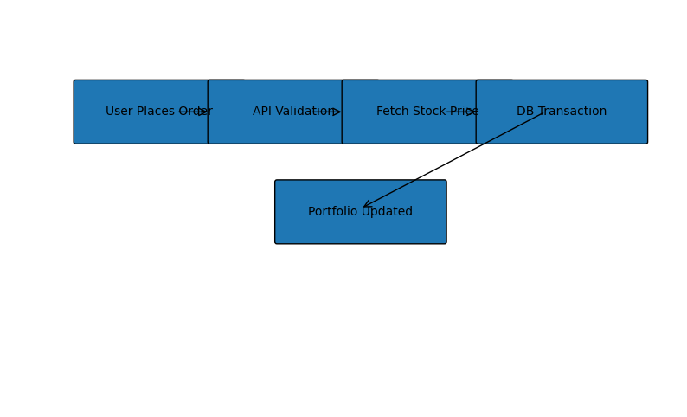

6. Security Measures
- JWT authentication
- bcrypt password hashing
- Rate limiting
- Input validation
- Security headers via Helmet

7. Testing Coverage Gaps
- No backend unit tests
- Minimal frontend tests
- No integration testing
- Trading logic not validated
- No performance or security tests

8. Scalability Improvements
- Redis caching
- Load-balanced Node.js servers
- MongoDB replica sets
- WebSocket real-time updates
- Background job queues

9. Summary
- Full-stack trading simulator
- Good learning platform
- Requires testing and scaling improvements before production

