GLA University, Mathura – 2020 BOOK FINDER APP

(MINI PROJECT)

Literature ReviewReport

(Synopsis)

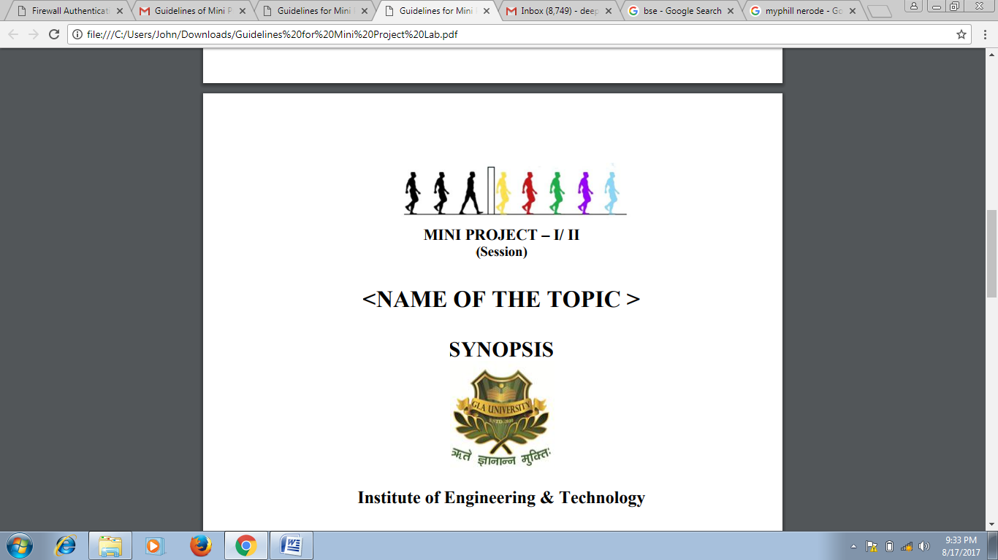

Under the Supervision

Of

**Mr. Mandeep Singh**

**(Technical Trainer)**

**GLA UNIVERSITY, MATHURA**

|  |  |  |  |
| --- | --- | --- | --- |
| NAME | | SECTION | GITHUBUSERNAME |
| ASHITA GOYAL | A1 | | ashitag64 |
| BHARTI GAUTAM K | A1 | | bgautam9045 |
| JANVI PANGORIYA | A1 | | JanviPangoriya |
| NIDHI GUPTA | A2 | | nidhi2611 |
| NAINA AGRAWAL | A2 | | naina2901 |

**Efforts By:**

CONTENTS

* Group Description
* Introduction
* Objective
* Existing System
* Motivation
* Technology
* Hardware Requirement
* Future Scope

Group Description

* Ashita Goyal
  + University Rollno: 181500144
  + Mobile number :6397663447
  + E-mail address :[ashita.goyal_cs18@gla.ac.in](mailto:ashita.goyal_cs18@gla.ac.in)
* Bharti Gautam .K
* University Rollno :181500192
* Mobile number :8445092214
* E-mail address :<bharti.gautam_cs18@gla.ac.in>
* Janvi Pangoriya
* University Rollno:181500292
* Mobile number :7617740300
* E-mail address :<janvi.pangoriya_cs18@gla.ac.in>
* Nidhi Gupta
* University Rollno :181500422
* Mobile number :6396492523
* E-mail address :<nidhi.gupta_cs18@gla.ac.in>
* Naina Agrawal
* University Rollno :181500408
* Mobile number :7417971808
* E-mail address :<naina.agrawal_cs18@gla.ac.in>

Introduction

Proposed Book Finder App is an android application that will allow users to search for books by title, author name or subject name. This application takes in a user input and searches the Google Books APIwith the user input and gets a list of published books based on the users search query. Search result screen will contain a list of book with following details:

* Author of the Book
* Title
* Average Rating
* Price of the Book

To get the information of the particular book user can click upon the book from the list and then will be taken to the new tab where description and other information related to the book will be available. Users can also add the book to the favourites.

Our app will contain some other features as:

1. A “Welcome Page (Splash Page)” which displays the logo and the name of the app.
2. A “Login Page” which asks the users email id and password.
3. A “Registration Page” where our users can create an account for the app.
4. A “Search page” where user can enter the query.
5. A “Book list page” which will contain all the recommended books.
6. A “Book description page “where the details of the book the user liked will be displayed.
7. A forgot password page which will enable the user to reset the password.
8. A “Profile Page” where the user information will be displayed.
9. A “Favourite Page” where all the books marked as favourite by the user will be displayed.

Objective

The main objective of our Book Finder App is to provide an easy-to-use for kids, teens, parents, and educators in order to discover diverse books of different genres.

If you forgot a book, or do you want to know the author of a quote you remember, or you want to learn or explore something interesting and knowledgeable, this app is for you.

This app will give readers new ways to show their love for books, review them online, keep track of what they read, share photos of their bookshelf with friends, and, of course, discover new books to read.

Existing System

In the present scenario, we are dealing with the manual searching of book from thousands of other books present in Google Book API. With the help of this application we are able to find a place where we can easily find the book with the help of keywords. As this idea as already implemented here are the some snap how our application will look.

As soon as the user enters the app, there will be landing page containing the name of the app and then there will be a login /signup page .Initially there will be search bar as shown in the image below. Then on the basis of certain keywords the app will fetch the results and the books will be displayed as shown in the second screenshot.

In this we will add a feature to bookmarks the book or add to favorites as this will be helpful when the user try the use the same book again.

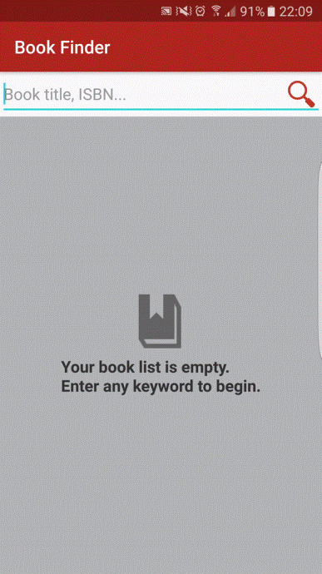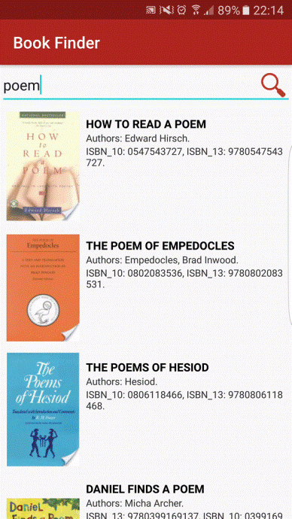  
Motivation

As we all have been facing a crucial lockdown periodic due to the pandemic, we have realized the importance of virtual learning and how important it is for us to have our resources online. And along with this we need to have a place to keep the resources for areas of our interest so we thought of developing this app and hence implementing it.

This app will be free of cost so all the students interested to learn can easily learn from it. Moreover this kind of application can be used in areas/schools where guardians /parents cannot afford to buy books. This would be an excellent effort to provide education without any boundaries to all.

Technology

* Technology Implemented: Android App Development
* Software used: Android Studio
* Language used : Kotlin, XML
* Database: Firebase
* User Interface Design : Android Application

Hardware Requirement

* Processor :intel i5
* Operating System :Windows 10
* RAM : 8 GB
* Hard disk : 256GB

Future Scope

This application has wide range of scope in the upcoming era. Some of them are listed below:

* Virtual Education: During the unpredictable period as we faced such as lockdown, it is impossible to arrange the hard copies of the book so this type of application can reduce the barrier to get knowledge at any place in a cost effective, productive way.
* E-library: For students who are interested in learning online can use this application and keep all the books they want to learn from at one place (in favourites section) and can ctreate their own personal E-library.
* Imparting Education complying with the new Educational Reforms and hence saving the paper that is used in making books.
* Book stores: Even individual book stores can have this system of book apps promoting their brand name as Digital Marketing and can gain number of customers.

***********************************************************************************************************************************************************************************************************