PDC - MINI PROJECT DATE:19/4/2020

**GROUP-12**

**SECRET IMAGE HIDING TECHNIQUE**(STEGANOGRAPHY):

SOFTWARE USE:MATLAB

CODE:

%program explaning steganography:an act of hiding images

%helpful for secure data/image transfer

cover=imread('input_image.bmp');

message=imread('sectret_image.bmp');

figure(1),imshow(cover);title('Original Image(Cover Image)');

figure(2),imshow(message);title('Image to Hide(Message Image)');

cover=double(cover);

message=double(message);

%imbed=no. of bits of message image to embed in cover image

imbed=7;

%shift the message image over (8-imbed)bits to right

messageshift=bitshift(message,-(8-imbed));

%show the message image with only embed bits on screen

%must shift from LSBs to MSBs

showmess=uint8(messageshift);

showmess=bitshift(showmess,8-imbed);

messageshift=imresize(messageshift,[250,250]);

%now zero out imbed bits in cover image

coverzero = cover;

for i=1:imbed

coverzero=bitset(coverzero,i,0);

end

%now add message image and cover image

coverzero1=imresize(coverzero,[250,250]);

coverzero1=double(coverzero1);

stego = uint8(coverzero1 + messageshift);

figure(3),imshow(stego);title('stego image');

imwrite(stego,'stego4.bmp');

OUTPUT:

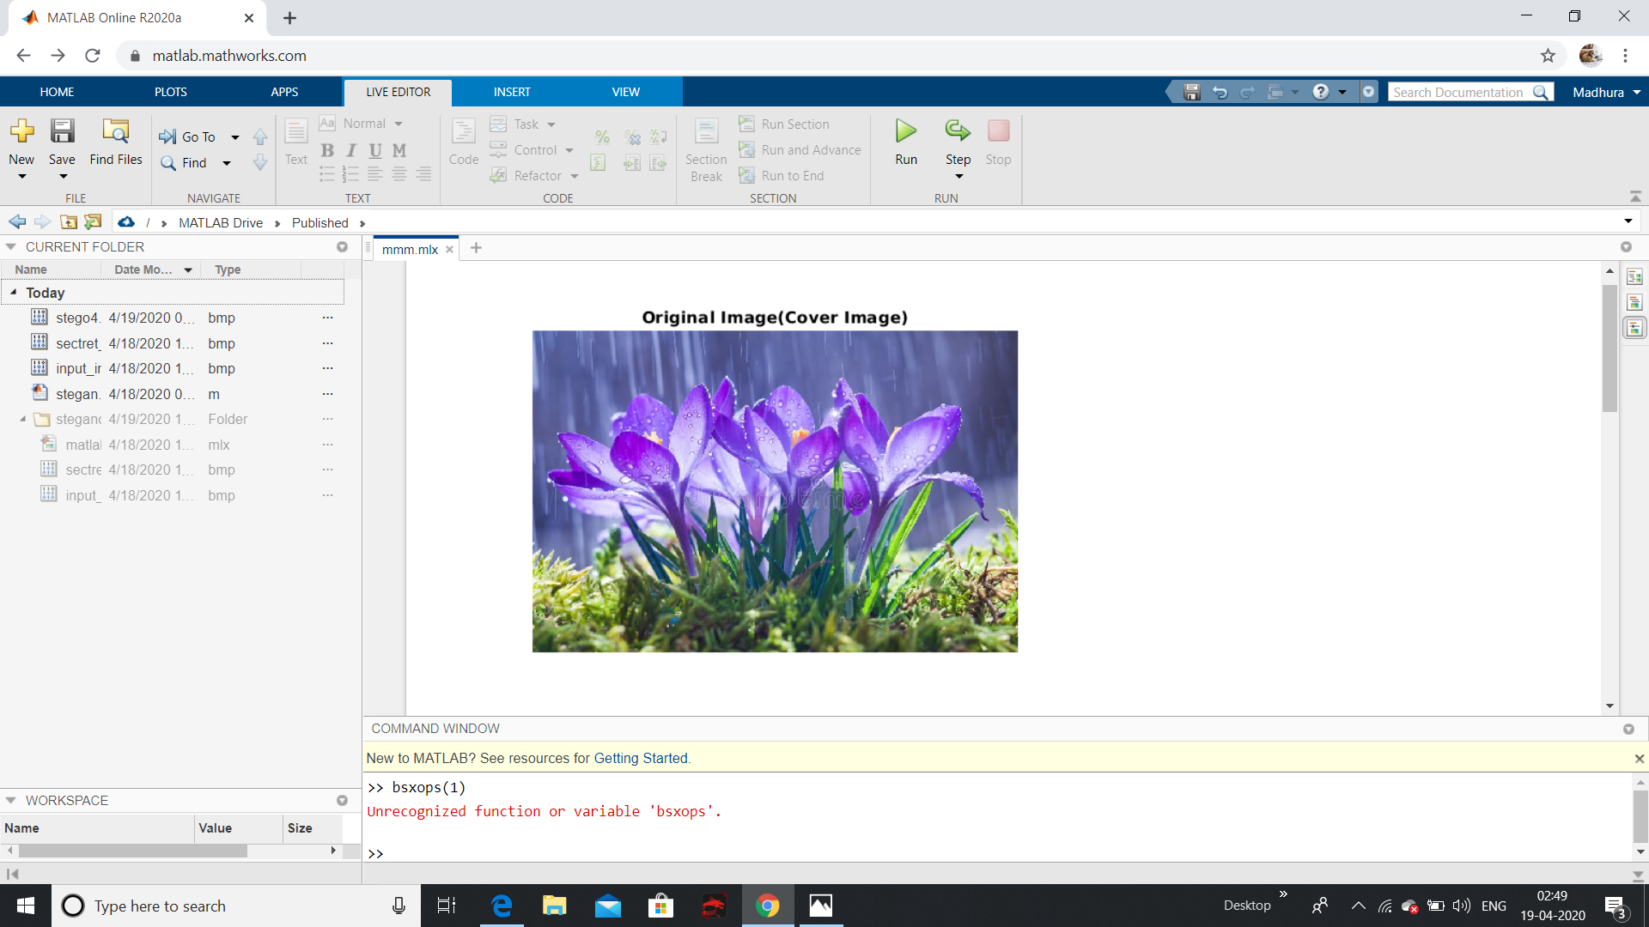

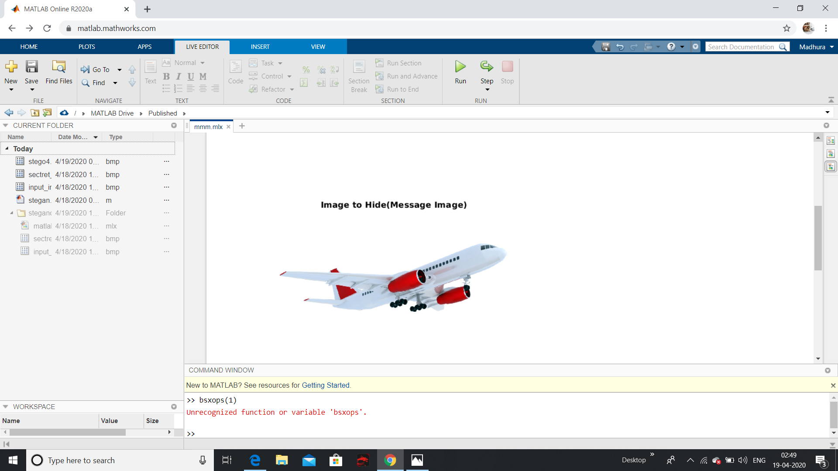

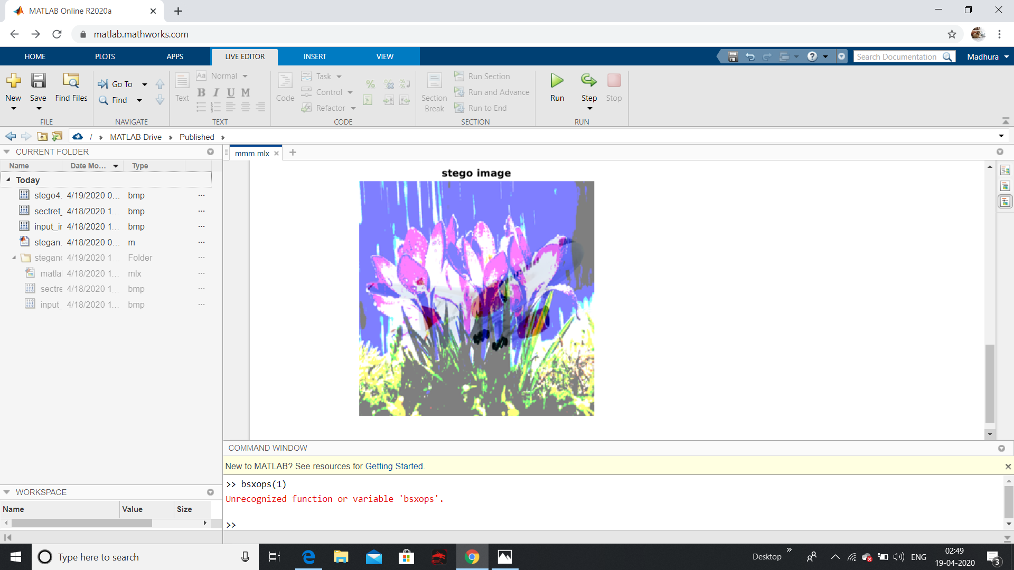

CONCLUSION:

Hence we get the secret image embedded in the cover image.As we increase the embedded bits in the cover image it becomes that much easier to detect the secret image.