**AI _ ML lab**

**Exploration of WEKA tool**

**Experiment 1:**

Exploration of WEKA tool for Regression task.

• **Open WEKA**:

* Launch WEKA and choose the "Explorer" option.

• **Load Dataset**:

* Click on the "Preprocess" tab.
* Load a dataset (e.g., cpu.arff from the data folder in WEKA).
* 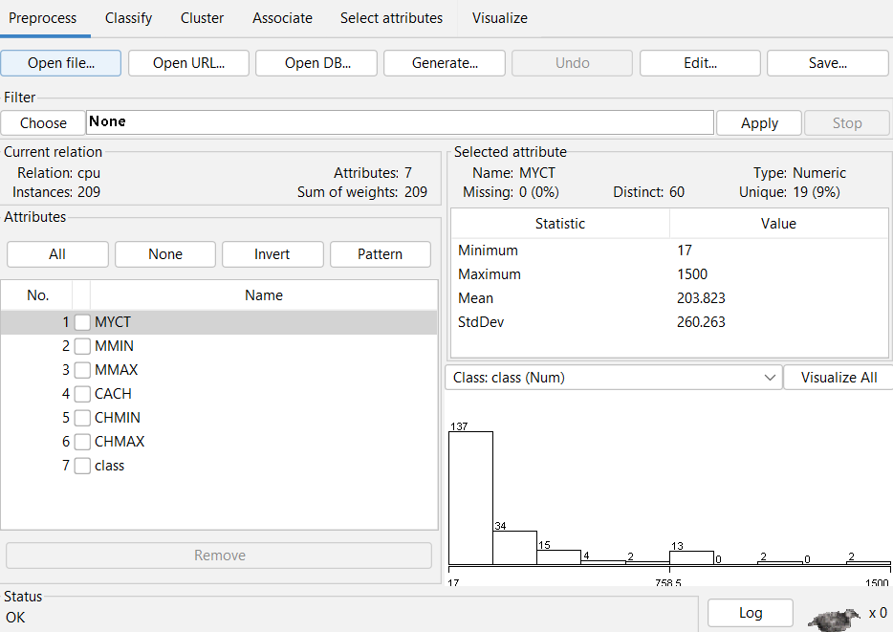

• **Normalize**

* For building any regression model first we have to need to do some data scaling beacause you’re going to see their each variable has different minimum, maximum,mean & StdDev value .
* For this we have to click “ choose”
* Then “ unsupervised”
* Then “Normalize”

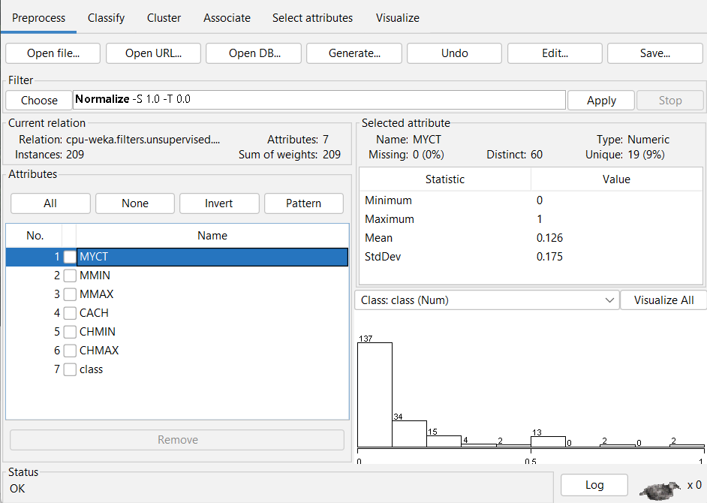

Now all the max and minimum value are 1 & 0.

Now it is comparable.

• **Select Regression Algorithm**:

* Navigate to the "Classify" tab.
* Set the "Classifier" to a regression algorithm like LinearRegression.
* For cross – validation no.of fold to be 10 ( we are going to splitting the data into 10 segments and using 9 segements in order to build a model and 1 left segement is use for prediction . . we will iterated the same model 10 times. )

• **Setup and Run**:

* Choose the target attribute (dependent variable) under the "Class" dropdown.
* Click "Start" to run the regression.
* 