Software Engineering Assignment

MODULE : 1

**SE – Overview of IT Industry**

Q1. What is software? What is software engineering?

* Software refers to a collection of data or computer instructions that tell the computer how to work. Software can be thought of as the variable part of a computer, while hardware is the invariable part.
* Software Engineering is a systematic approach to the design, development, maintenance, testing, and evaluation of software. The aim is to produce high-quality software that meets the needs of users efficiently and reliably.

1. Explain types of software

1.System Software:

This includes operating systems (like Windows, macOS, Linux), device drivers, utilities, and more. System software serves as a base for application software and manages hardware.

2. Application Software: These are programs that perform specific tasks for users, such as word processors (e.g., Microsoft Word), spreadsheets (e.g., Excel), media players, and more.

1. What is SDLC? Explain each phase of SDLC.

SDLC (Software Development Life Cycle) is a process used by software industry professionals to design, develop, and test high-quality software. The SDLC aims to produce software that meets or exceeds customer expectations, is completed within time and cost. The SDLC process is usually divided into several phases:

1. Planning :

* Define the project's scope, purpose, and feasibility.
* Identify resources, costs, timeframes, and potential risks.
* Create a project plan and timeline.

2. Requirements Analysis :

* Gather detailed business and system requirements.
* Conduct interviews, surveys, and meetings with stakeholders.
* Create requirement specification documents (e.g., Software Requirement Specification or SRS).

3. Design :

* Transform requirements into a blueprint for the software.
* Develop system architecture and design.
* Create detailed design documents.

4. Implementation (or Coding) :

* Write the code to build the software based on the design documents.
* Use appropriate programming languages and tools.
* Follow coding guidelines and standards.

5. Testing :

* Verify that the software works as intended and meets the requirements.
* Perform various types of testing (unit, integration, system, acceptance).
* Identify and fix defects and bugs.
* Ensure the software is reliable, secure, and performs well.

6. Deployment :

* Release the software to the production environment.
* Prepare deployment environment.
* Install and configure the software.
* Provide user training and documentation.

7. Maintenance :

* Ensure the software continues to function correctly and meets user needs.
* Monitor software performance.
* Provide technical support and user assistance.
* Implement updates, bug fixes, and new features.
* Perform regular maintenance tasks.

Q5. What is Flow chart? Create a flowchart to make addition of two numbers.

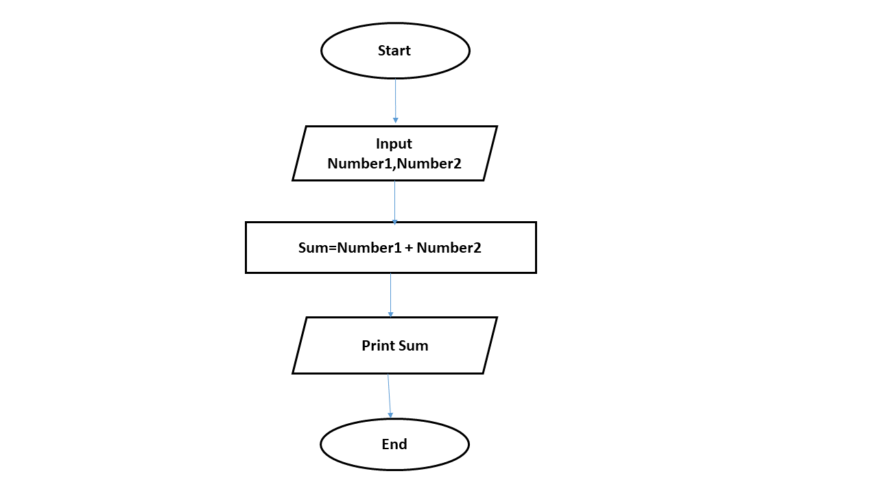

Q6. What is Use case Diagram? Create a use-case on bill payment on paytm.

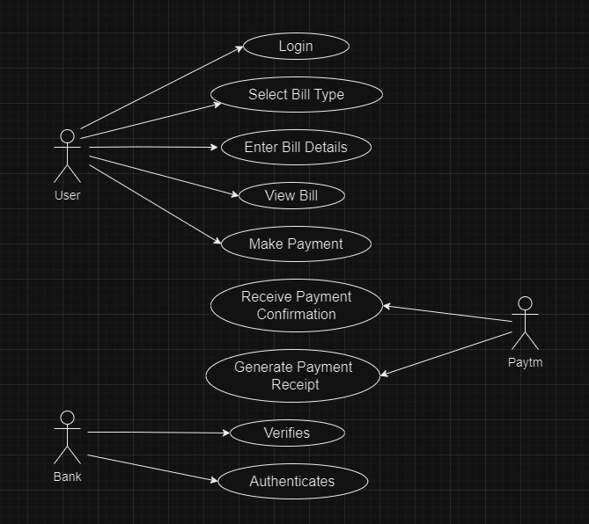

Q7. What is Use case Diagram? Create a use-case on bill payment on paytm.

Level – 0 :

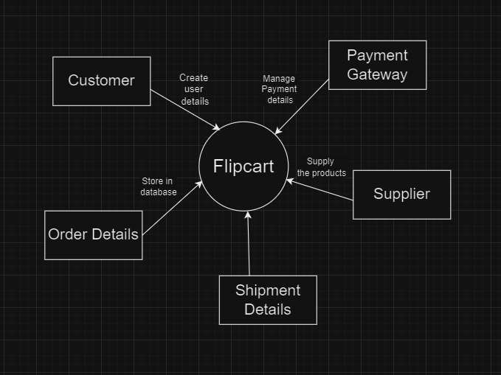

Level – 1 :

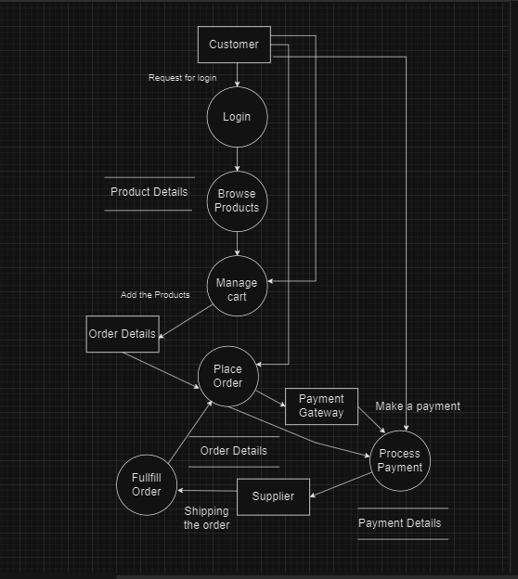

Level – 2 :

