***HTML***

1. What is internet…?

Ans: A global computer network providing a variety of information and communication facilities, consisting of interconnected networks using standardized communication protocols.

1. HTTP…?

Ans: Http: Hypertext transfer protocol🡪 The Hyper Text Transfer Protocol is used to load pages on the internet using hyperlinks.

1. HTTPS…?

Ans: Https: Hypertext transfer protocol Secure🡪 HTTPS is a secure way to send data between a web server and a web browser.

1. WWW…?

Ans: The World Wide Web 🡪 also known as the web, WWW or W3 -- refers to all the public websites or pages that users can access on their local computers and other devices through the internet.

1. Domain name…?

Ans: A domain name is **a string of text that maps to a numeric IP address, used to access a website from client software**.

Example:

1. .com
2. .in
3. .canada
4. .gov
5. .edu
6. .org
7. .net

6) Top Domain name…?

Ans: A top-level domain was intended **to help classify a feature of a website, such as its purpose, the owner, or the geographical origin**.

Example:

1. .country
2. .kim
3. .Date
4. .Wang
5. .party
6. .vip
7. What is SEO…?

Ans: SEO stands for “search engine optimization.” In simple terms, it means the process of improving your site to increase its visibility when people search for products or services related to your business in Google, Bing, and other [search engines](https://searchengineland.com/guide/google-searching-search-engines). The better visibility your pages have in search results, the more likely you are to garner attention and attract prospective and existing customers to your business.

1. What is HTML…?

Ans: HTML stands for **H**yper **T**ext **M**arkup **L**anguage.

HTML is the **standard markup** language for Web pages.

HTML **elements** are the building blocks of HTML pages.

HTML elements are represented by **<> tags.**

**Develop by Tim Berners Lee**

Example:

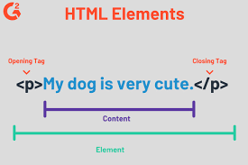

1. What is Text Editor…?

Ans: A text editor is **a computer program that lets a user enter, change, store, and usually print text** (characters and numbers, each encoded by the computer and its input and output devices, arranged to have meaning to users or to other program).

Example:

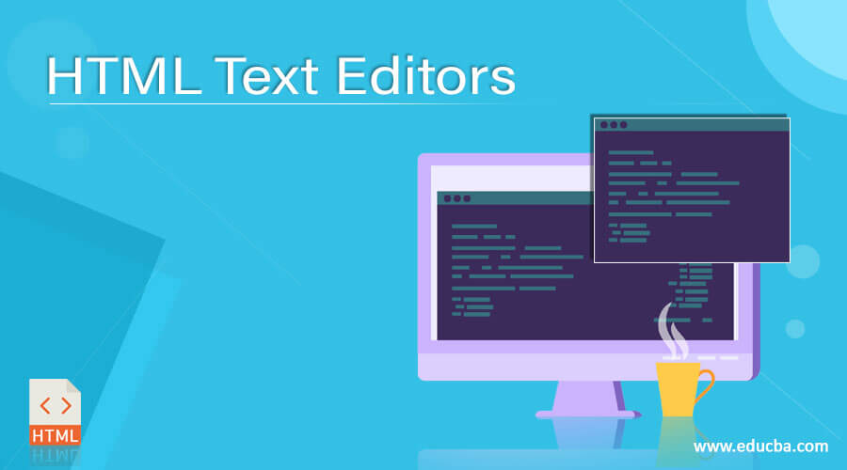

1. What is Web browser…?

Ans: The web browser is **an application software to explore www (World Wide Web)**. It provides an interface between the server and the client and requests to the server for web documents and services. It works as a compiler to render HTML which is used to design a webpage.

Example:

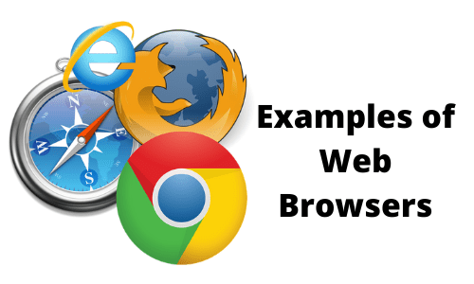

1. What is Html structure…?

Ans: HTML describes the structure of a Web page. **HTML consists of a series of elements**. HTML elements tell the browser how to display the content. HTML elements label pieces of content such as "this is a heading", "this is a paragraph", "this is a link", etc.

Example:

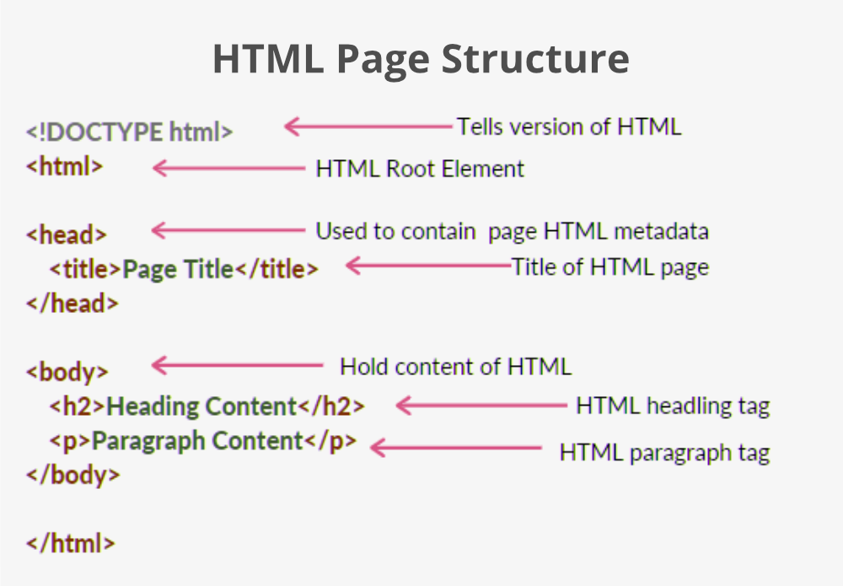

1. First program in html…?

Ans: <html>

HTML Documents  
  
The HTML document itself begins with **<html>** and ends with </html>. The visible part of the HTML document is between <body> and </body>.

Example:

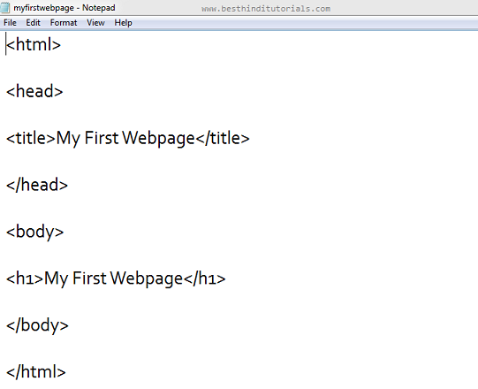

1. Introduction to html…?

Ans: **HTML**

**Hypertext Markup Language**

* HTML stands for Hyper Text Markup Language
* **Develop by Tim Berners Lee**
* HTML is the standard markup language for creating Web pages
* It describe the structure of web page
* HTML is case insensitive language
* Hypertext can be added to the text
* It is a markup language

Example:

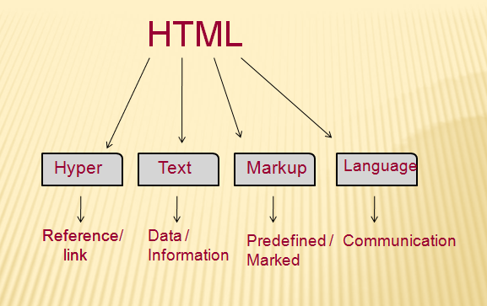

1. What is HTML Getting Started…?

Ans: In this article we cover the absolute basics of HTML. To get you started, this article defines elements, attributes, and all the other important terms you may have heard. It also explains where these fit into HTML. You will learn how HTML elements are structured, how a typical HTML page is structured, and other important basic language features. Along the way, there will be an opportunity to play with HTML too!

**Submitted by:** Janvi Panchal