**Detection of Moving Objects Behind the Wall**

**Objective, Methodology of the project with schematic diagrams.**

**Background:**

Wi-Fi has become a buzzword in modern era. Everyone uses wifi to transmit data through wireless medium at their home and work places. Wi-Fi uses 2.4GHz frequency, ISM band. Using such ISM band signals, it is an interesting idea to exploit the wifi signals for detecting the movement of objects behind wall. If we want to see through walls, the first thing comes into our head is thermal imaging [1] or X-ray images. As thermal imaging devices are costly, people cannot afford it. Nowadays, there is also wide use of RFIDs in various fields RFIDs [2] are affordable to most of the population than thermal imaging devices. It [2] can be used to receive the signals reflected off moving objects. There are through wall radar sensors which require the user to place the setup near the wall [3] and take long time which is not feasible in real time applications. In [3] [5], it requires the long antenna array (about 8 feet) and a large power source with 2 GHz of frequency. The antenna array implementation of ISAR(Inverse Synthetic Aperture Radar) has been developed [4] to overcome that problem.

**Objective:**

Following are the key objectives to achieve during the project:

1. Design a prototype for detecting object behind the wall.
2. Interface with Software Define Radio (SDR) with existing Wi-fi network.
3. Develop signal processing block set in GNURADIO using python and C++.
4. Optimization of MUSIC Algorithm for avoidance of flashing issue.
5. Testing and Debugging to track object movement.

**Design Flow and Methodology:**

Wi-fi signal uses 2.4 GHz ISM band.This prototype will use 20MHz wide Wi-fi channel. Array of antennas were used to eliminate the flash of walls and reflections of objects behind the wall. A large power source has been used to maintain a large array of antennas approximate 2.4 meters long. So the use of so many power and devices are not feasible other than military application. ISAR(Inverse Synthetic Aperture Radar) uses the movement of objects instead of antenna array.

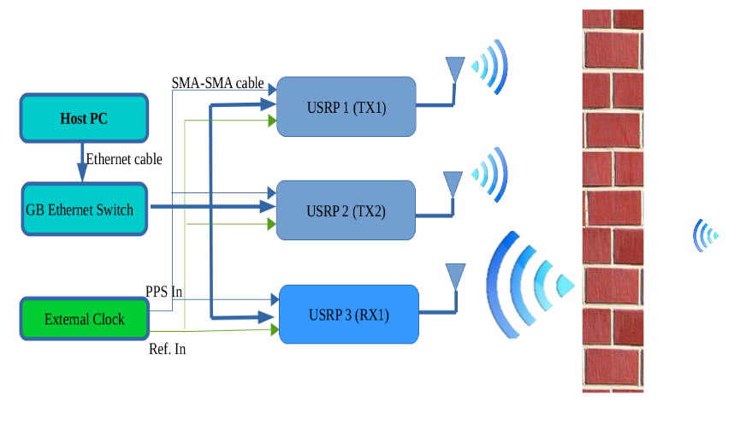

Figure1. Functional Block Diagram

Another challenge is to remove Flash Effect which is captured when reflection from wall itself is higher than reflection coming from the target behind the wall. To overcome the challenge, MIMO can be implemented. MIMO system can make transmissions such that at a particular receiver signals sum up to zero. MIMO system use this capability to eliminate the interference to other antennas and reflections ofstatic objects and walls. So basically there are two stage operations. First task [6] will be to measure the channel and the second, to null the reflections of static objects by using channel which we have measured in first task. Inverse Synthetic Aperture Radar (**ISAR**) has been used to emulate the antenna array based on human motion. By using standard antenna array beam steering, One can also track spatial direction of human.

**Implementation:**

We will be implementing two transmit antenna and one receive antenna(2x1 MISO) system. We have three USRPs N210 with SBX daughterboard and LP0965 antennas which is a directional antenna. It is used to focus energy in one direction(Direction of objects behind the wall). All the USRPs must work on a single clock. We perform synchronisation using GPSDO clocking device. This experiment will be conducted in a closed room without windows with doors of glass and thin wall. So at receiver majority part will be the reflections off wall. MIMO systems have capability of making signals null at the receiver. So by pre-coding the system, we can null the signals at receiver. It will be initial nulling. If any object moves then we will get some signal at the receiver. By giving that signal to MUSIC algorithm we can find the movement. Then again we pre-code the channel. It will be iterative Nulling.

**6. List of material, small equipment and specification of components.**

|  |  |  |  |
| --- | --- | --- | --- |
| Sr.No. | Name | Specification | Usage |
| 1 | USRP N210 | - Xilinx® Spartan® 3A-DSP 3400 FPGA  - Modular Architecture: DC-6 GHz  - 2 Gbps Expansion Interface  - Fully-Coherent MIMO Capability  - Gigabit Ethernet Interface to Host  - Auxiliary Analog and Digital I/O  - 1 MB High-Speed SRAM  - 0.01 ppm w/ GPSDO Option | - Generating  Transmitting and Receiving WiFi |
| 2 | LP0965 directional Antennas | - 850 MHz to 6.5 GHz Log Periodic PCB directional antenna, at 5-6dBi Gain.  - Works with any daughterboard that operates within 850 MHz to 6.5 GHz frequency range. | -Sending signal which are generated on USRP in air |
| 3 | SBX daughterboard | - 400 MHz to 4.4 GHz  - Transmit Antennas: TX/RX  - Receive Antennas: TX/RX or RX2  - Transmit Gains: PGA0, Range: 0-31.5dB  - Receive Gains: PGA0, Range: 0-31.5dB | - Generating 2.4GHz wifi signals |
| 4 | Octoclock with inbuilt GPSDO | - To discipline the USRP N210 reference clock to within 0.01 ppm of the worldwide GPS standard  - Frequency output 10MHz. | - Clocking device which connects two USRP |
| 5 | SMA-SMA cable | -Three USRP to Octoclock | - Connecting USRP |
| 6 | LAN cable | - Data transfer | - Data Transfer |

**Need for the Project :**

A new version of wireless technology which uses Wi-fi signals to detect moving humans behind walls and in-closed rooms. This Wi-fi technologyenables small cheap see through wall devices that operate in the ISM band, making them feasible to the general public. It also establishes a communication channel between itself and a human behind a wall, allowing him/her to communicate directly with this prototype without carrying any transmitting device. We envision that by leveraging finer nulling techniques and employing better hardware, the system can evolve to seeing humans through denser building material and with a longer range. These improvements will further allow Wi-Vi to capture higher quality images enabling the gesture-based interface to become more expressive, hence promising new directions for virtual reality**.**

**Major thrust area:**

Wi-Vi can be used in many areas as many places have Wi-fi nowadays. Law enforcement personnel can use the device to avoid attacks which are surprisingly done. It helps in minimizing casualties in standoffs and hostage situation. This device can be used by emergency personnel also. When there is earthquake and collapsed building, people are trapped in**.** In such uncertain scenario, emergency responder can see through the rubble or building and save the people. When every room is connected through Wi-fi in the campus**,** such prototypewill help to count people in each room. We can use this device largely in military to target enemies too. Such a technology will also allow us to detect the moving objects in fire or smoke as Wi-fi signals can pass through smoke. Fireman can use it to rescue people from fired building.

**Cost analysis:**

|  |  |  |  |  |
| --- | --- | --- | --- | --- |
| Sr. No. | Item Name with Technical Specification | Quantity | Cost (Rs.) | Remarks |
| 1 | USRP N210 | 3 | 0 | Available in Communication Lab, SEAS-AU |
| 2 | LP0965 directional antennas | 3 | 5000 |  |
| 3 | SBX daughter boards SBX 400-4400 MHz Rx/Tx 40 Mhz | 2 | 0 | Available in Communication Lab, SEAS-AU |
| 4 | Octoclock with inbuilt GPSDO | 1 | 0 | Available in Communication Lab, SEAS-AU |
| 5 | SMA-SMA | 6 | 1000 |  |
| 6. | RG Signal Strength Meter | 1 | 8000 |  |
| 6 | [Miscellaneous item](https://www.google.co.in/search?rlz=1C1CHWA_enIN632IN632&q=miscellaneous+item&spell=1&sa=X&ved=0ahUKEwi9opaJ9drRAhUYSo8KHSTtDNYQvwUIGCgA) | N/A | 2000 | Adapter or FPGA gets broken |
| 8 | Travelling and Accommodation for attending | N/A | 5000 |  |
| 9 | Stationary and Report | N/A | 1000 | Required for project |
| 10 | Technical events like conference / Workshop / Visits in Gujarat | N/A | 2000 |  |
| Total | | | 24000/- |  |