**LEASE MANAGEMENT**

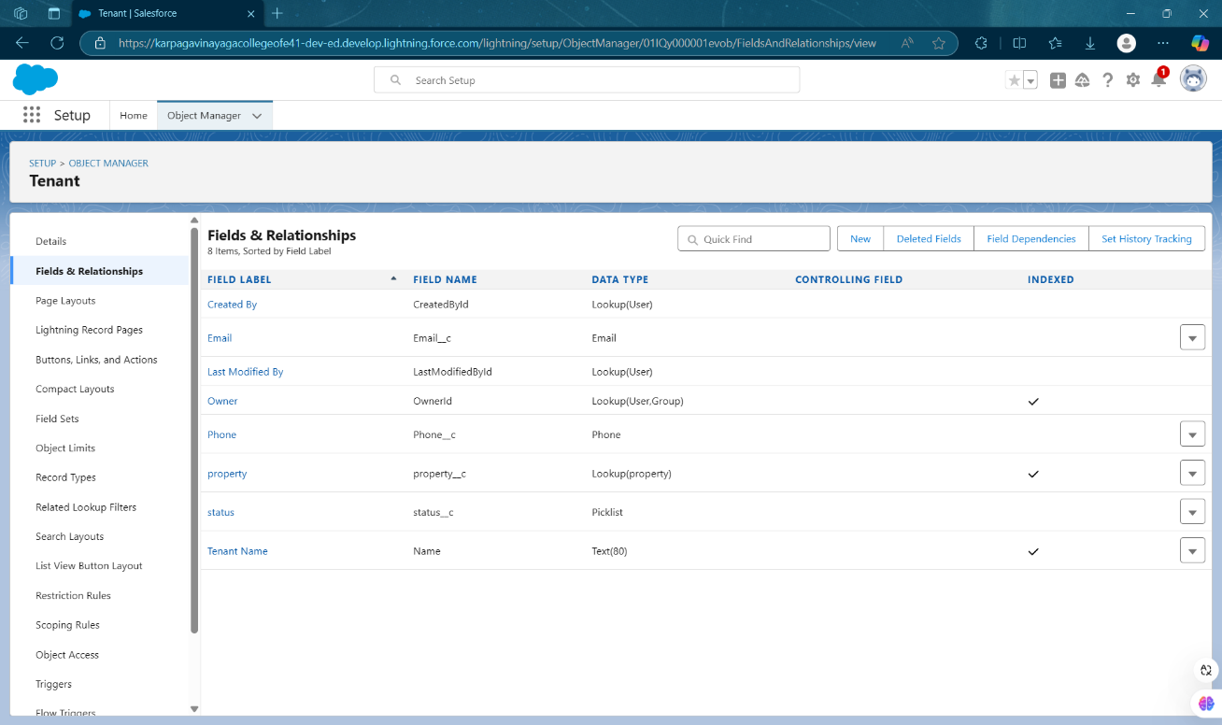

**Fig 1.1: Custom Object – Tenant**

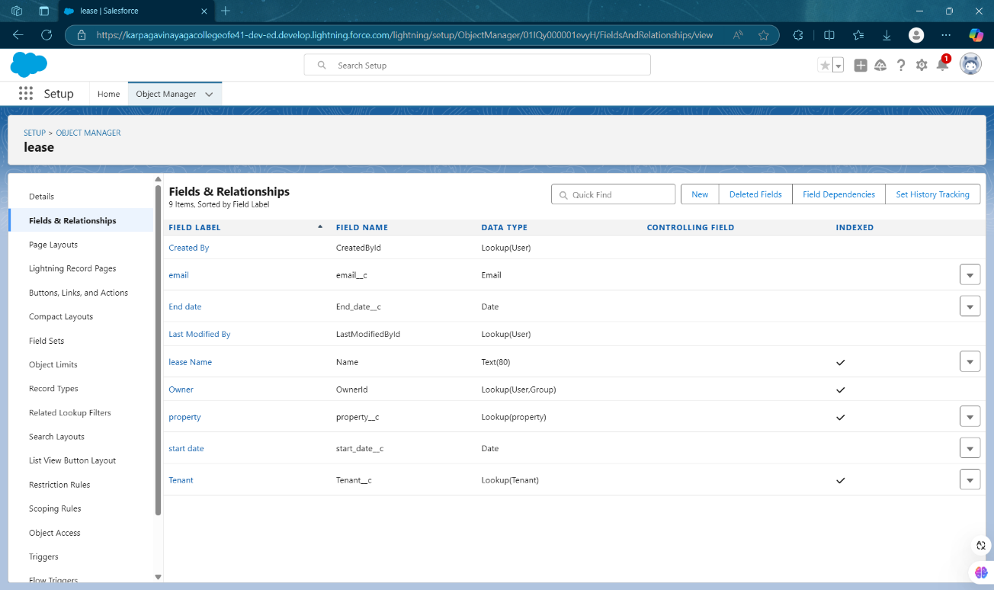

**Fig 1.2: Custom Object - Lease**

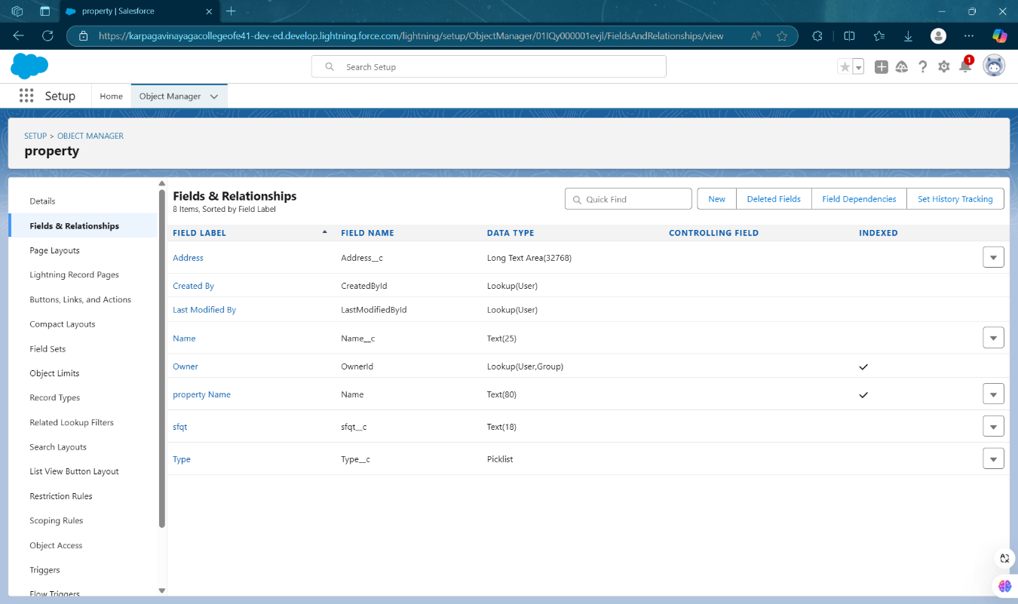

**Fig 1.3: Custom Object - Property**

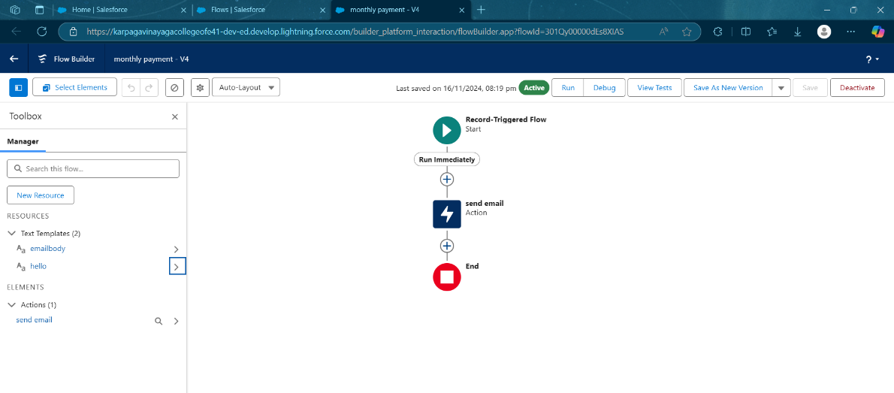

**Fig 1.4: Monthly Payment-Workflow**

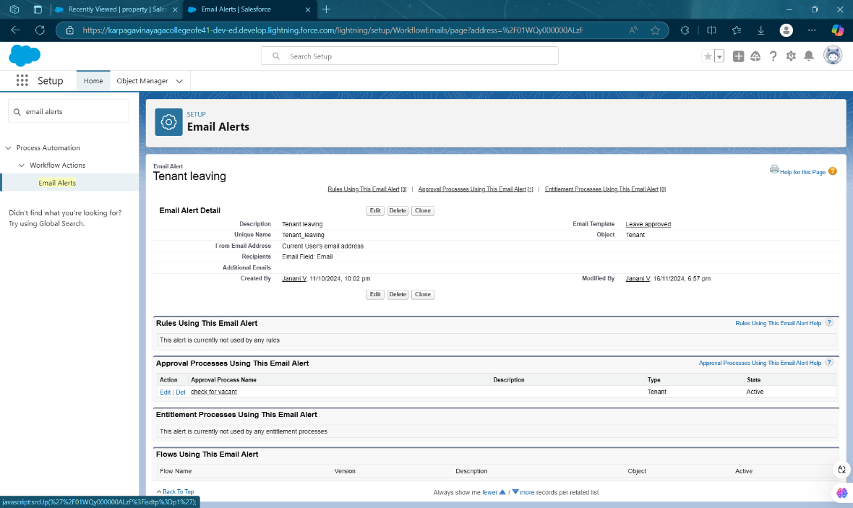

**Fig 1.5: Email Alerts – Tenant Leaving**

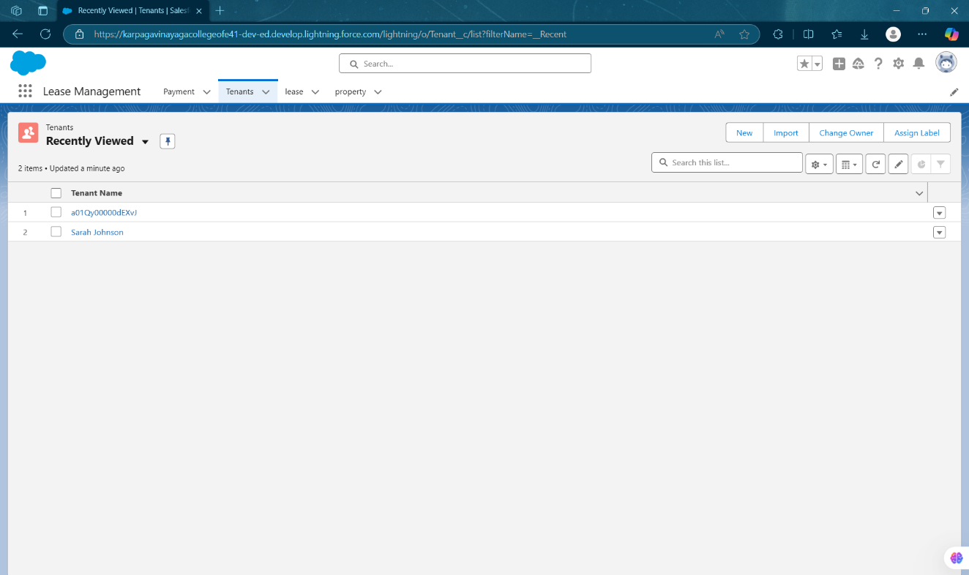

**Fig 1.6: Lease Management - Tenant**

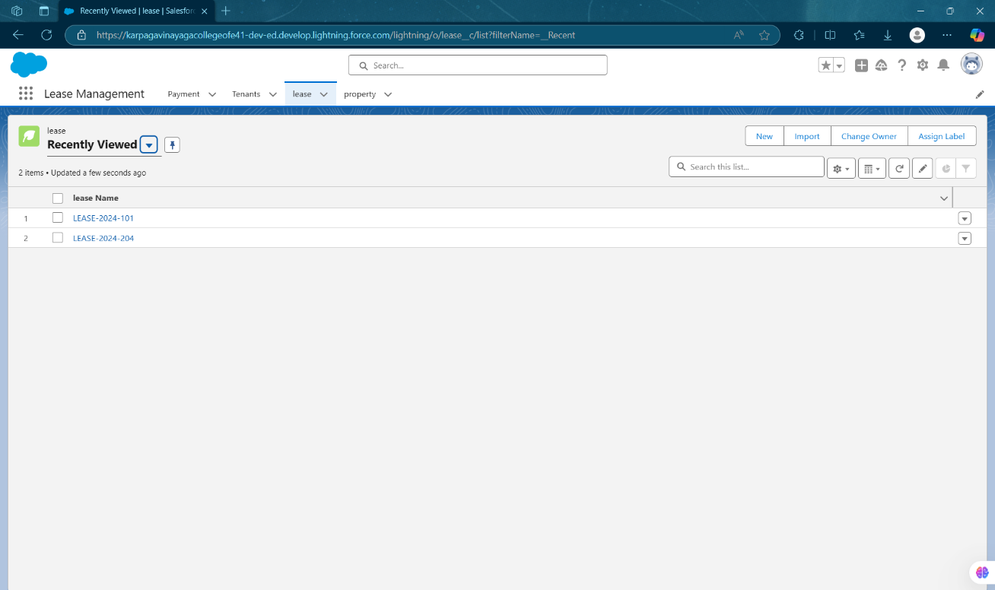

**Fig 1.7: Lease Management - Lease**

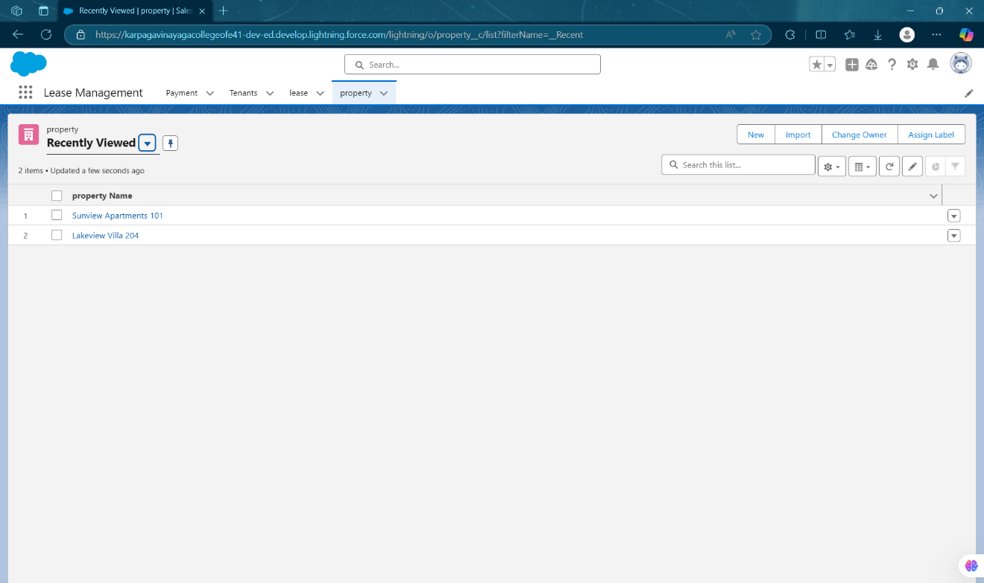

**Fig 1.8: Lease Management - Property**

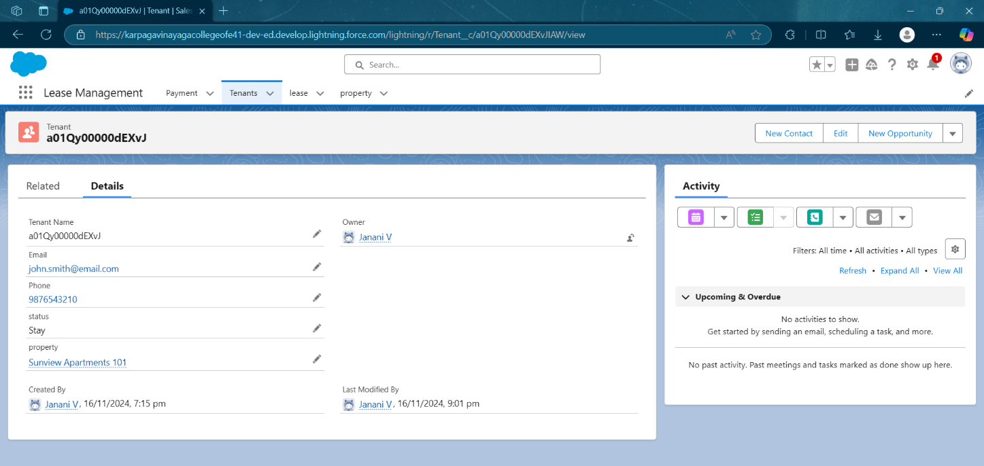

**Fig 1.9: Lease Management – Tenant Dashboard**

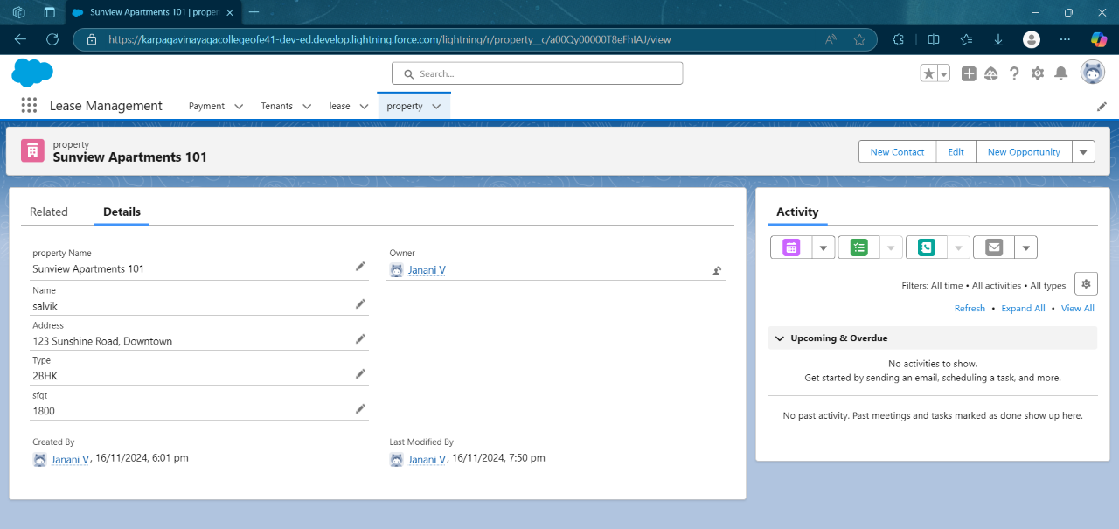

**Fig 1.10: Lease Management – Property Dashboard**

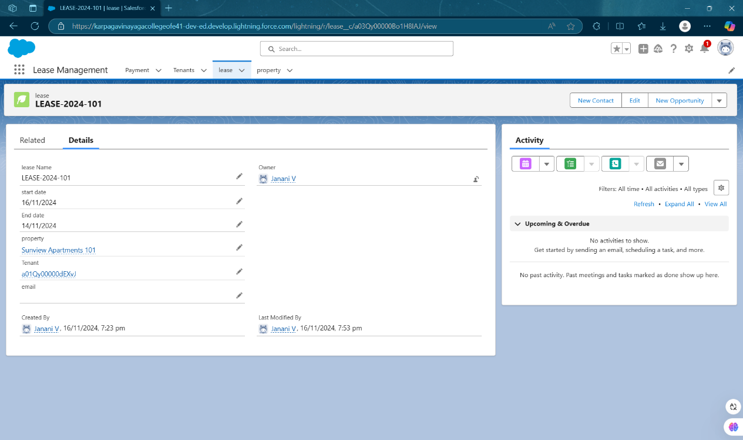

**Fig 1.11: Lease Management – Lease Details Page**

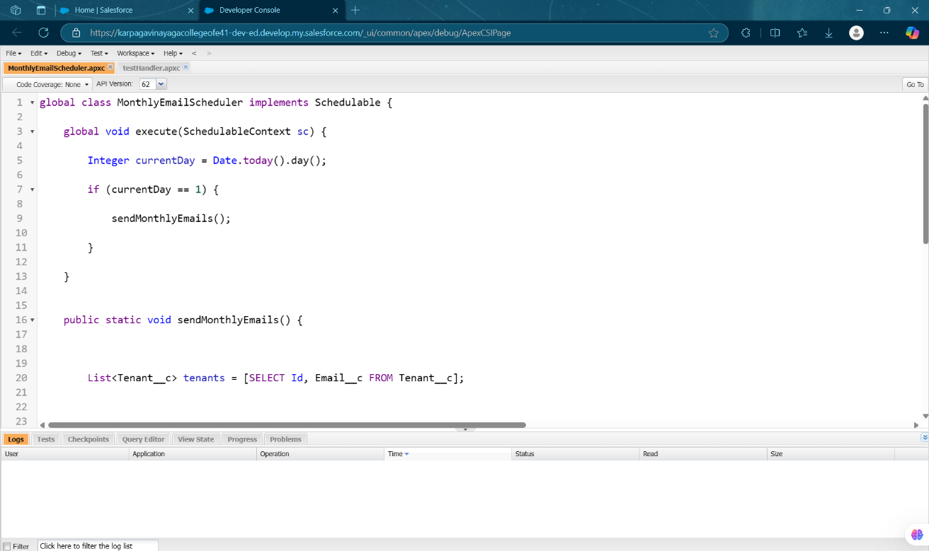

**Fig 1.12: Apex class – Monthly Email Schedular**

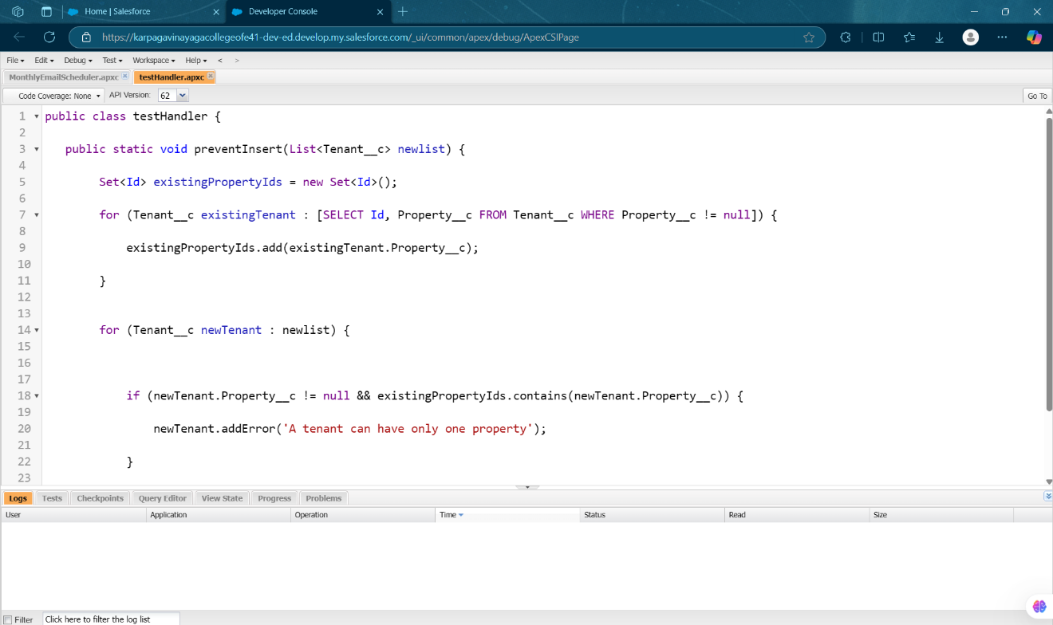

**Fig 1.13: Apex class – Test Handler**

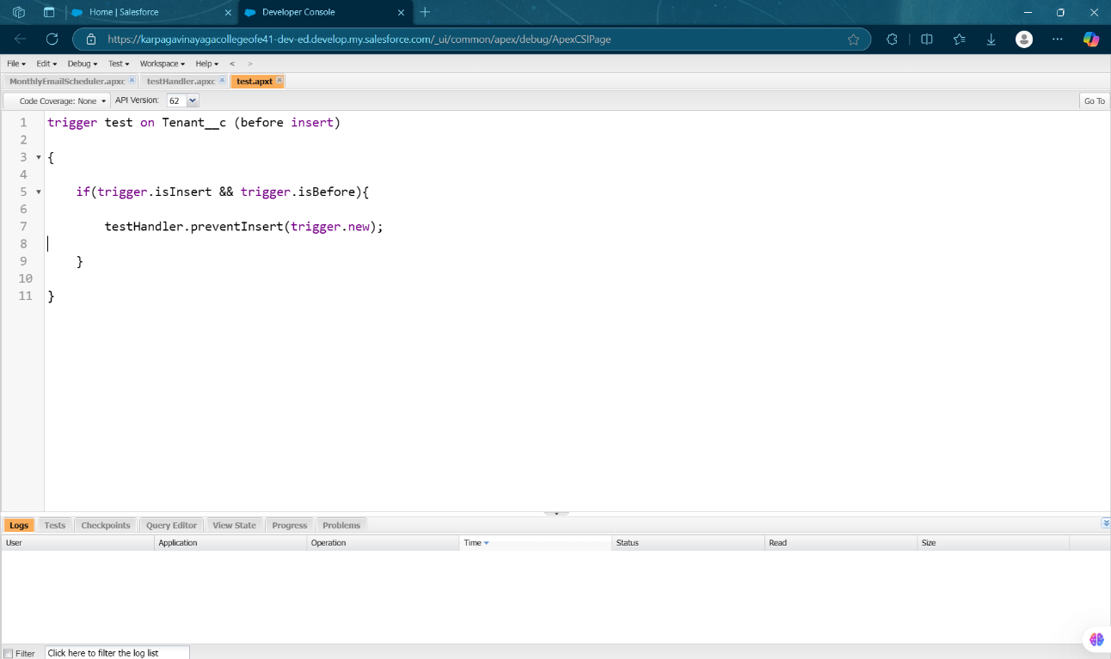

**Fig 1.14: Apex Trigger – Test**

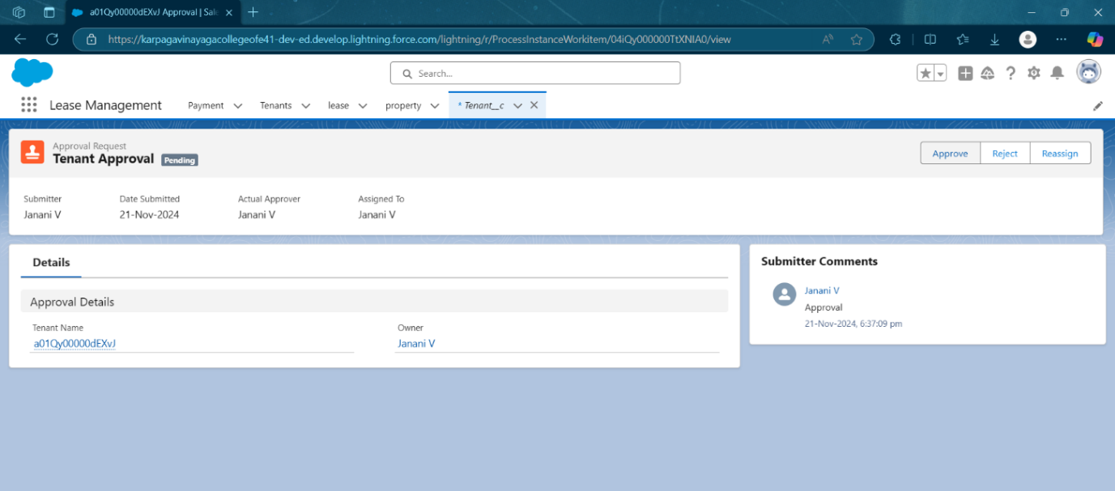

**Fig 1.15: Tenant Approval Pending**

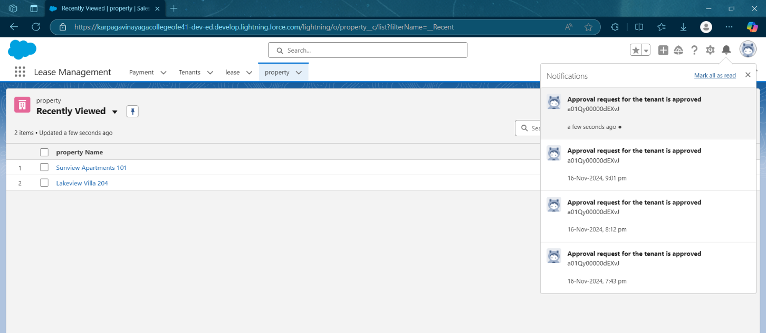

**Fig 1.16: Tenant Approval – Approved Notification**

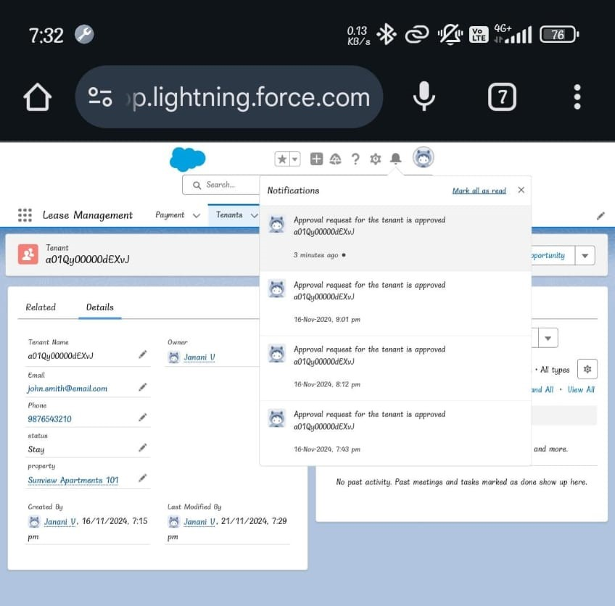

**Fig 1.17: Tenant Approval - Mobile Interface**