SOFTWARE REQUIREMENTS SPECIFICATION
(SRS)

Courier / Parcel Tracking System

Prepared by: JANVI THAKRE

Course / Subject: SEPM (Software Engineering & Project Management)

Institution: RAMDEOBABA UNIVERSITY ,NAGPUR

Date: 09/10/2026

Table of Contents
1. Introduction
1.1 Purpose
1.2 Scope
1.3 Intended Audience
1.4 Definitions, Acronyms and Abbreviations
1.5 References
2. Overall Description
2.1 Product Perspective
2.2 Product Features
2.3 User Classes and Characteristics
2.4 Operating Environment
2.5 Design and Implementation Constraints
2.6 Assumptions and Dependencies
3. Functional Requirements
4. Non-Functional Requirements
5. System Modules
6. Use Case Summary
7. System Architecture and Design Diagrams
7.1 Component Diagram
7.2 Deployment Diagram
7.3 Class Diagram
7.4 Sequence Diagram
7.5 State Diagram
7.6 Activity Diagrams
8. Entity-Relationship (ER) Description
9. Feasibility Study
9.1 Technical Feasibility
9.2 Economic Feasibility
9.3 Operational Feasibility
10. Project Estimation (COCOMO Model)
11. Project Schedule (Gantt Chart)
12. Advantages Over Manual System
13. Future Enhancements

1. Introduction

1.1 Purpose
This Software Requirements Specification (SRS) document formally defines the functional and non-functional requirements, system architecture, and design constraints for the Courier/Parcel Tracking System. It is prepared in accordance with the IEEE 830-1998 standard and serves as the primary reference for all stakeholders involved in the development, evaluation, and use of the system.

1.2 Scope
The Courier/Parcel Tracking System is a web-based application that enables end-to-end management of courier services. Key capabilities include:
- Customers can register, log in, book parcels with sender/receiver details, and track shipments using a unique tracking ID.
- The system automatically generates a unique tracking ID per booking and calculates delivery charges based on parcel weight and distance.
- Delivery agents can view assigned parcels, scan barcodes at pickup, update real-time status, and confirm delivery using an OTP/confirmation code.
- Admin/courier staff can manage all bookings, assign delivery agents, monitor status, and generate operational reports.
- The system maintains a complete audit trail of parcel status transitions from booking to delivery.
The scope is limited to a web-based platform. Native mobile applications and live GPS hardware integration are considered future enhancements.

1.3 Intended Audience
Audience | Role / Purpose
Project Guide / Evaluator | Assessment of system design and requirements conformance
Development Team | Primary technical reference for design and implementation
Customers | End-users who book and track parcels
Admin Staff | Operational management of bookings and deliveries
Delivery Agents | Field personnel responsible for pickup and delivery

1.4 Definitions, Acronyms and Abbreviations
Term / Acronym | Description
SRS | Software Requirements Specification
IEEE | Institute of Electrical and Electronics Engineers
Tracking ID | Unique alphanumeric code generated per parcel booking for status tracking
Admin | Courier office staff responsible for back-end system management
Delivery Agent / Courier | Field personnel who picks up and delivers parcels
OTP | One-Time Password used to confirm delivery
KLOC | Kilo Lines of Code — unit of software size in COCOMO estimation
COCOMO | Constructive Cost Model — software effort estimation model
SEPM | Software Engineering and Project Management
IoT | Internet of Things — hardware devices (e.g., GPS, barcode scanner)
HTTPS | Hypertext Transfer Protocol Secure
MQTT | Message Queuing Telemetry Transport — IoT messaging protocol
MySQL | Relational database management system used for data storage
DFD | Data Flow Diagram
ER | Entity-Relationship (data modelling notation)

1.5 References
- IEEE 830-1998 — IEEE Recommended Practice for Software Requirements Specifications
- Pressman, R.S. — Software Engineering: A Practitioner's Approach (McGraw-Hill)
- Sommerville, I. — Software Engineering, 10th Edition (Pearson)
- COCOMO Basic Model — Boehm (1981), Software Engineering Economics
- draw.io / Lucidchart — UML Diagram Tool used for system diagrams
- Class notes on Software Engineering & Project Management (SEPM)

2. Overall Description

2.1 Product Perspective
The Courier/Parcel Tracking System is a standalone web application designed to replace the manual and phone-based courier booking and tracking process. It operates as a three-tier architecture:
- Presentation Layer — Web/Mobile browser interface (HTML, CSS, JavaScript) accessed by customers, admin staff, and delivery agents.
- Business Logic Layer — Server-side processing components: Authentication, Parcel Booking, Parcel Tracking, and Notification & Reporting.
- Data Layer — Relational MySQL database accessed through a Data Access Component.
The system communicates with IoT devices (barcode scanners, GPS modules) on the tracking hardware side via HTTPS/MQTT over the Internet, and dispatches notifications via SMS/Email notification services.

2.2 Product Features
- Online parcel booking with complete sender and receiver details
- Automatic generation of a unique Tracking ID per booking
- Real-time parcel status tracking through defined states: OrderPlaced → PickupScheduled → PickedUp → InTransit → AtSortingHub → OutForDelivery → Delivered (or DeliveryFailed / ReturnedToSender / Cancelled)
- Barcode scanning at parcel pickup by delivery agent
- OTP-based delivery confirmation by the delivery agent at the customer's door
- Automatic delivery charge calculation based on parcel weight and distance
- Invoice generation for each booking
- Admin dashboard for booking management and agent assignment
- SMS/Email notification service for shipment and delivery updates
- Operational reports: delivery history, pending parcels, and revenue
- Web dashboard and admin portal with parcel tracking, management, and analytics

2.3 User Classes and Characteristics
User Class | Description | Technical Proficiency
Customer | Registers, books parcels, tracks shipment status, makes payment | Basic — requires only internet and browser access
Admin / Courier Staff | Manages all bookings, assigns agents, views system-wide reports and parcel statuses | Intermediate — familiarity with web dashboards required
Delivery Agent | Views assigned parcels, scans barcodes, updates delivery status, collects OTP confirmation | Basic — minimal app interaction required

2.4 Operating Environment
Component | Specification
Frontend | HTML5, CSS3, JavaScript — compatible with any modern browser (Chrome, Firefox, Edge, Safari)
Backend | PHP / Python (Django or Flask) / Java — server-side processing
Database | MySQL — relational database for all persistent data storage
Tracking Hardware | Barcode Scanner, GPS Module, IoT device (communicates via Internet/WiFi using HTTPS/MQTT)
Cloud Server | Hosts data processing, alert management, and monitoring services
Notification Service | SMS/Email service for shipment updates, delivery updates, and OTP/status alerts
Mobile App (optional) | Mobile app for customers and staff — live parcel location, tracking status, delivery updates, notifications
Database (cloud) | Parcel Tracking MySQL Database — cloud-hosted, stores and retrieves parcel data

2.5 Design and Implementation Constraints
- The system is limited to a web-based platform; native mobile applications are out of current scope.
- The project must be completed within the academic semester timeline as reflected in the Gantt chart schedule.
- Payment gateway integration is limited to test/dummy mode for academic demonstration purposes.
- Delivery charge calculation uses fixed rate slabs by weight and distance for simplicity.
- The system uses only open-source and freely available tools and frameworks.
- The estimated project size is 15 KLOC (Kilo Lines of Code) as derived from the COCOMO model.

2.6 Assumptions and Dependencies
- Users have basic internet connectivity and access to a modern web browser.
- All users (customers, admin, delivery agents) possess valid email addresses and phone numbers for registration and notifications.
- Delivery charge calculation assumes fixed rate slabs by weight/distance; actual dynamic rate integration is a future enhancement.
- Delivery agents carry IoT-enabled devices (with barcode scanner and GPS module) for real-time status updates.
- Third-party SMS/Email notification service is available and integrated.
- The underlying cloud server infrastructure is provisioned and maintained by the deploying organisation.

3. Functional Requirements
The table below lists all functional requirements derived from the system use cases, activity diagrams, and class model, prioritised as High, Medium, or Low.
Req ID | Feature / Requirement | Description | Priority
FR-01 | Customer Registration & Login | Customer shall register with name, email, phone, address, and password. The system shall authenticate users and maintain session. | High
FR-02 | Parcel Booking | Customer shall book a parcel by entering sender details, receiver details, parcel type, and weight. The system shall validate all input fields before proceeding. | High
FR-03 | Shipping Cost Calculation | On successful booking validation, the system shall automatically calculate the shipping cost based on parcel weight and applicable distance/rate slabs. | High
FR-04 | Payment by Customer | Customer shall confirm and make payment after reviewing the calculated shipping cost. The system shall record the payment and confirm the booking. | High
FR-05 | Unique Tracking ID Generation | The system shall automatically generate a unique alphanumeric Tracking ID for every successfully booked parcel and present it to the customer. | High
FR-06 | Order Status Creation | The system shall create an initial order status record (OrderPlaced) upon booking confirmation. | High
FR-07 | Parcel Tracking by Customer | Customer shall be able to enter a Tracking ID; the system shall query the tracking database and display the current status and location. An invalid ID shall display an error. | High
FR-08 | Admin Booking Management | Admin shall view all parcel bookings, filter by status, and assign a delivery agent to each parcel. | High
FR-09 | Delivery Agent View of Assigned Parcels | Delivery agent shall view all parcels assigned to them along with pickup addresses and receiver details. | Medium
FR-10 | Barcode Scanning at Pickup | Delivery agent shall scan the parcel barcode upon arrival at pickup location to confirm collection. | Medium
FR-11 | Parcel Status Update | Delivery agent shall update the parcel status at each stage. System shall log the timestamp and location of each status update. | High
FR-12 | OTP-Based Delivery Confirmation | Upon arrival at the delivery address, the agent shall collect the confirmation code (OTP) from the customer and submit it. If the customer is unavailable, the delivery shall be rescheduled. | High
FR-13 | Status Update to Delivered | On successful OTP confirmation, the system shall update the parcel status to DELIVERED and notify the customer. | High
FR-14 | Delivery Failure Handling | If the recipient is unavailable, the system shall transition the status to DeliveryFailed and reschedule delivery. After maximum retry attempts, the status transitions to ReturnedToSender. | Medium
FR-15 | Invoice Generation | The system shall generate an invoice for each booking containing parcel details, charges, and payment status. | Medium
FR-16 | Notification Service | The system shall send SMS/Email notifications to the customer upon status changes: booking confirmed, picked up, in transit, out for delivery, delivered. | Medium
FR-17 | Admin Report Generation | Admin shall generate operational reports including delivery history, pending parcels, failed deliveries, and revenue summaries. | Low
FR-18 | Parcel History Maintenance | The system shall maintain a complete chronological history of all status transitions for every parcel. | Medium
FR-19 | User Profile Management | Users (Customer, Courier, Admin) shall be able to update their profile information (name, phone, email, address). | Low
FR-20 | Cancellation | Customer shall be able to cancel a booking while the parcel is in OrderPlaced or PickupScheduled state. Cancellation transitions the status to Cancelled. | Medium

4. Non-Functional Requirements
Req ID | Category | Requirement
NFR-01 | Performance | Parcel tracking status shall be retrievable and displayed within 2 seconds of a query under normal network conditions.
NFR-02 | Usability | The interface shall be intuitive enough for non-technical customers to book and track parcels without training. Admin and agent interfaces shall require minimal onboarding.
NFR-03 | Reliability | The system shall maintain accurate, consistent status logs with no data loss. All status transitions shall be atomically committed to the database.
NFR-04 | Security | User login credentials shall be stored as hashed passwords (e.g., bcrypt). All client-server communication shall use HTTPS. Session tokens shall expire after inactivity.
NFR-05 | Scalability | The system architecture shall support the addition of new cities, branches, and delivery agents without requiring a structural redesign of the database or application.
NFR-06 | Availability | The tracking query interface shall be available 24x7. Planned maintenance windows shall not exceed 2 hours per month.
NFR-07 | Maintainability | The codebase shall be modular, with clear separation of the Presentation, Business Logic, and Data layers to facilitate independent maintenance and testing.
NFR-08 | Portability | The web application shall function correctly on all major modern browsers (Chrome, Firefox, Edge, Safari) without browser-specific plugins.
NFR-09 | Data Integrity | All parcel records shall have referential integrity enforced at the database level (foreign key constraints). Orphaned records shall not be permitted.
NFR-10 | Notifications | Status change notifications via SMS/Email shall be dispatched within 60 seconds of the status update being committed to the database.

5. System Modules
The system is decomposed into the following functional modules, each corresponding to a logical component in the Business Logic Layer:
Module / Component | Responsibility
Customer Module | Handles customer registration, login, profile management, parcel booking initiation, tracking queries, payment, and booking history.
Authentication Component | Manages login and session management for all user roles (Customer, Admin, Delivery Agent) using hashed credentials. Exposes the ILogin interface to the UI.
Parcel Booking Component | Processes new parcel booking requests: validates input, calculates shipping cost, records booking, and generates the unique Tracking ID. Exposes the IBook interface.
Parcel Tracking Component | Queries the database for parcel status and location by Tracking ID. Retrieves live location from the DeliveryAgent component. Exposes the ITrack interface.
Notification & Reporting Component | Triggers SMS/Email notifications on parcel status changes. Generates admin operational reports (delivery history, revenue, pending parcels). Exposes the INotify interface.
Data Access Component | Centralised data layer responsible for all CRUD operations on the MySQL database. Accessed exclusively by Business Logic Layer components.
Admin Module | Provides the admin dashboard for viewing all bookings, assigning delivery agents, monitoring parcel statuses, and viewing reports.
Delivery Agent Module | Allows agents to view assigned parcels, scan barcodes, update status at each stage, collect OTP confirmation, and confirm delivery.
Billing / Invoice Module | Calculates delivery charges based on weight and distance rate slabs. Generates and stores invoices for each booking.

6. Use Case Summary
The use case diagram identifies three primary actors and six core system use cases. The table below summarises each use case, its actors, and a brief description.
UC ID | Use Case | Primary Actor(s) | Description
UC-01 | Book Parcel | Sender (Customer) | Customer enters parcel details; system validates, calculates cost, takes payment, and generates Tracking ID.
UC-02 | Generate Tracking ID | Sender (Customer), Courier Admin | System automatically generates a unique Tracking ID upon successful booking. Admin can also initiate manually.
UC-03 | Track Parcel Status | Sender (Customer), Courier Admin | User enters Tracking ID; system queries database and returns current status and location.
UC-04 | Scan Parcel at Hub | Delivery Agent | Agent scans parcel barcode at sorting hub or during transit to update location and status.
UC-05 | Update Delivery Status | Delivery Agent, Courier Admin | Agent updates parcel status at each stage of the delivery lifecycle; admin can also update.
UC-06 | Confirm Delivery | Delivery Agent | Agent arrives at customer address, scans barcode, verifies customer availability, collects OTP confirmation, and marks as DELIVERED. If unavailable, schedules reschedule.

7. System Architecture and Design Diagrams
This section presents the UML and architectural diagrams created for the Courier/Parcel Tracking System. All diagrams were produced using standard UML notation and reflect the implemented design.

7.1 Component Diagram
The component diagram illustrates the three-tier architecture comprising the Presentation Layer (UI Component for Web/Mobile App), the Business Logic Layer (Authentication, Parcel Booking, Parcel Tracking, and Notification & Reporting components), and the Data Layer (Data Access Component connected to the MySQL Database). Interfaces ILogin, IBook, ITrack, and INotify define the contracts between the presentation and business logic layers.
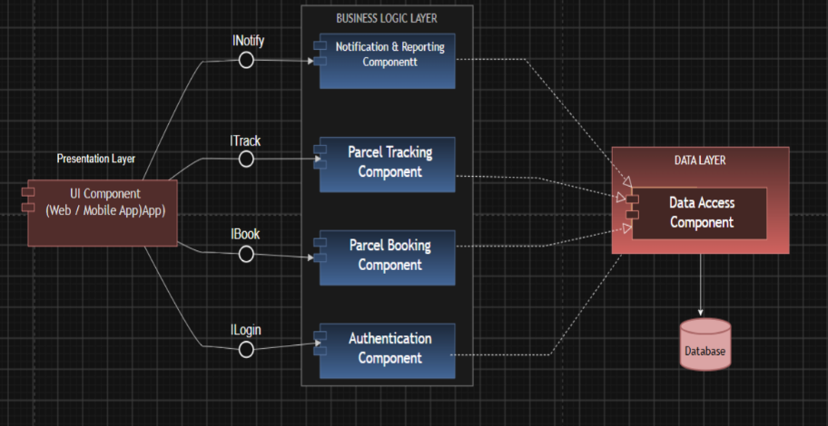
Figure 1: Component Diagram — Parcel Tracking System

7.2 Deployment Diagram
The deployment diagram shows the physical deployment of the system across nodes: (1) Parcel Tracking Device (Barcode Scanner, GPS Module, IoT) communicating via HTTPS/MQTT over Internet/WiFi to the (2) Cloud Server (Data Processing, Alert Management, Monitoring Service), which interacts with the (3) MySQL Database (stores/retrieves parcel data), the (4) SMS/Email Notification Service, the (5) Mobile App (Customer/Staff: Live Parcel Location, Tracking Status, Delivery Updates, Notifications), and the (6) Web Dashboard/Admin Portal (Parcel Tracking, Management, Reports and Analytics).
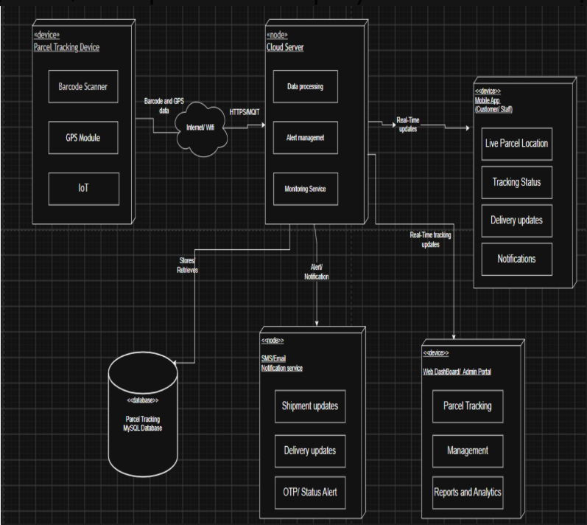
Figure 2: Deployment Diagram — Parcel Tracking System

7.3 Class Diagram
The class diagram models the domain classes and their relationships. The abstract base class Person holds common attributes (+name, +phone, +email) and a method +updateProfile(). Customer and Courier inherit from Person. Customer (+customerId, +address) books Shipment objects via +bookShipment() and +trackShipment(). Courier (+courierId, +vehicleNo) picks up and delivers Shipment via +pickupShipment() and +deliverShipment(). Warehouse (+warehouseId, +location) stores and dispatches Shipment objects. Shipment (+shipmentId, +trackingCode, +weight, +status) exposes +updateStatus() and +getStatus(). Each Shipment has one Payment (+paymentId, +amount, +status) with +makePayment() and +verifyPayment().
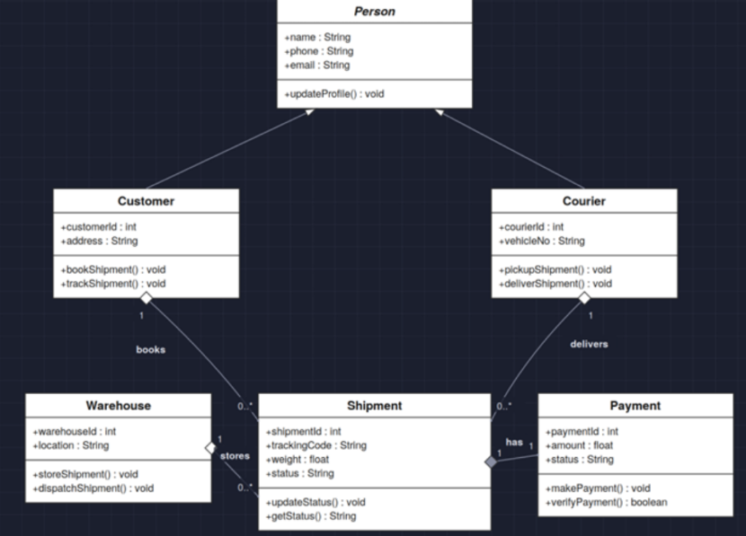
Figure 3: Class Diagram — Parcel Tracking System

7.4 Sequence Diagram
The sequence diagram depicts the primary tracking interaction. The Customer authenticates via login(username, password), receives login success, then submits a Tracking ID. TrackingSystem calls get_status(id) on ParcelDatabase, which returns status and location. TrackingSystem then calls get_live_location on DeliveryAgent, which returns current_location. The system aggregates this information and presents show_tracking_status to the Customer.
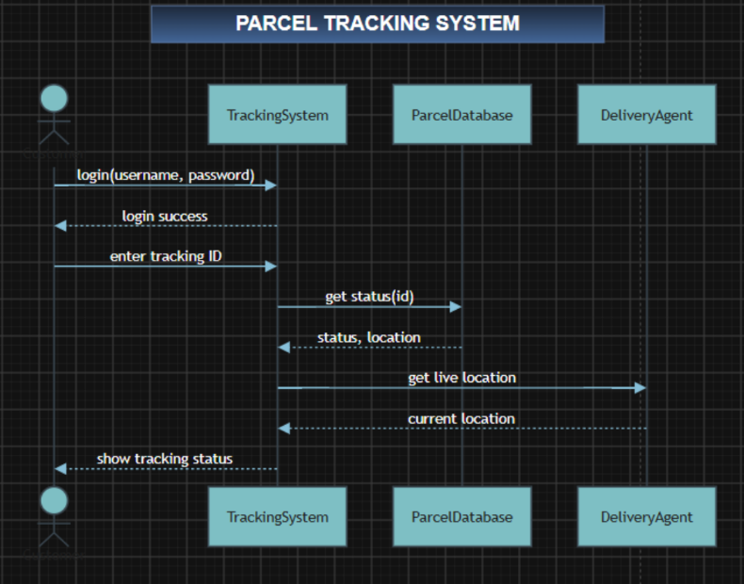
Figure 4: Sequence Diagram — Parcel Tracking System

7.5 State Diagram (Shipment Lifecycle)
The state diagram captures the full lifecycle of a parcel shipment from creation to terminal state. States and transitions are:
- OrderPlaced — Initial state upon booking confirmation.
- PickupScheduled — A delivery agent has been assigned and pickup is scheduled.
- PickedUp — Agent has scanned the barcode and collected the parcel.
- InTransit — Parcel is in transit between locations.
- AtSortingHub — Parcel has arrived at the sorting hub.
- OutForDelivery — Parcel is with the delivery agent en route to the recipient.
- DeliveryFailed — Recipient was unavailable; delivery is rescheduled. Transitions back to OutForDelivery for retry.
- Delivered — Terminal success state: OTP confirmed, status updated.
- ReturnedToSender — Terminal state: maximum delivery attempts reached.
- Cancelled — Terminal state: customer cancelled the order (possible from OrderPlaced, PickupScheduled, OutForDelivery, or DeliveryFailed states).
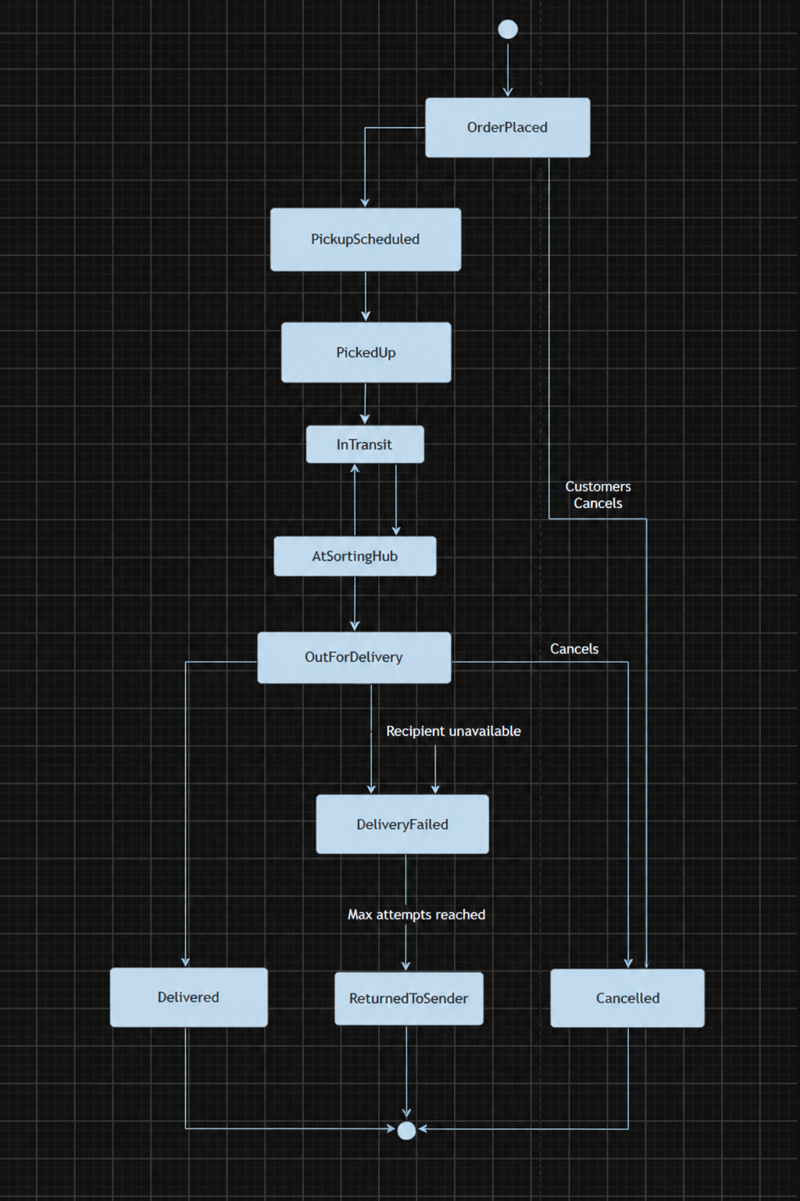
Figure 5: State Diagram — Shipment Lifecycle

7.6 Activity Diagrams

7.6.1 Book Parcel
Flow: Customer enters parcel details → System validates details → [Invalid: show validation error, loop back] → [Valid: Calculate shipping cost] → Customer confirms and makes payment → System creates order status (OrderPlaced).
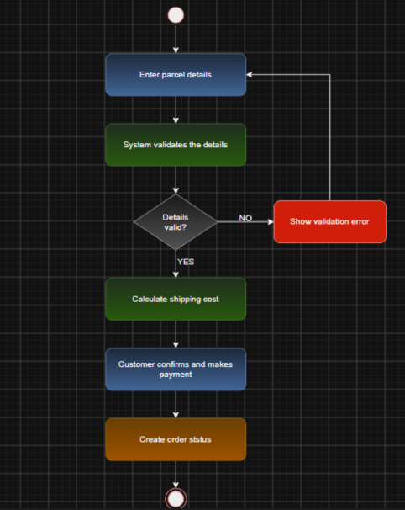
Figure 6: Activity Diagram — Book Parcel

7.6.2 Track Parcel Status
Flow: Customer enters Tracking ID → System checks tracking database → [Not found: display INVALID ID, loop back] → [Found: retrieve current status and location] → Display status to customer.
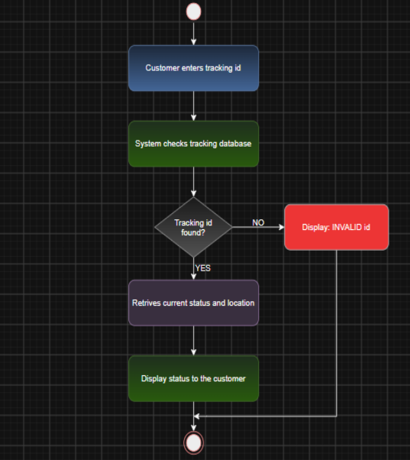
Figure 7: Activity Diagram — Track Parcel Status

7.6.3 Confirm Delivery
Flow: Agent arrives at customer address → Agent scans parcel barcode → [Customer not available: reschedule delivery, end] → [Customer available: collect confirmation code] → Update status as DELIVERED → Notify customer of delivery.
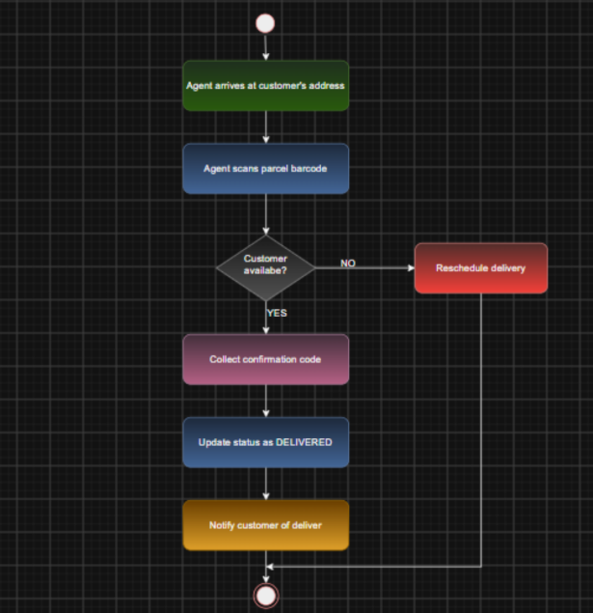
Figure 8: Activity Diagram — Confirm Delivery

8. Entity-Relationship (ER) Description
The following entities and their key attributes form the data model of the system. Relationships are as follows: Customer (1) books (M) Parcel/Shipment; Courier/Agent (1) delivers (M) Shipment; Warehouse (1) stores (M) Shipment; Shipment (1) has (1) Payment.
Entity | Key Attributes | Keys / Constraints
Customer | Customer_ID (PK), Name, Email, Phone, Address, Password (hashed) | PK: Customer_ID
Shipment / Parcel | Shipment_ID (PK), Tracking_Code (Unique), Sender_Details, Receiver_Details, Weight, Status, Booking_Date, Customer_ID (FK), Warehouse_ID (FK), Courier_ID (FK) | PK: Shipment_ID; FK: Customer_ID, Warehouse_ID, Courier_ID
Courier | Courier_ID (PK), Name, Phone, Email, Vehicle_No | PK: Courier_ID
Admin | Admin_ID (PK), Name, Login_Credentials | PK: Admin_ID
Delivery Agent | Agent_ID (PK), Name, Contact, Assigned_Parcel_ID (FK) | PK: Agent_ID; FK: Assigned_Parcel_ID
Warehouse | Warehouse_ID (PK), Location | PK: Warehouse_ID
Payment | Payment_ID (PK), Shipment_ID (FK), Amount, Status (Paid/Pending) | PK: Payment_ID; FK: Shipment_ID
Status Log | Log_ID (PK), Shipment_ID (FK), Status, Timestamp, Location | PK: Log_ID; FK: Shipment_ID

9. Feasibility Study

9.1 Technical Feasibility
The system can be built using freely available, well-documented, and widely used technologies — HTML/CSS/JavaScript for the frontend; PHP, Python (Django/Flask), or Java for the backend; and MySQL as the relational database. All tools are open-source and require no specialised hardware for the core web application. IoT device integration (barcode scanner, GPS) uses standard communication protocols (HTTPS/MQTT) over Internet/WiFi and is technically feasible with available hardware. The project is fully achievable within the skill set of the development team.

9.2 Economic Feasibility
The project relies exclusively on open-source software, resulting in negligible direct cost for development tools and frameworks. Cloud hosting and SMS/Email notification services may incur marginal costs but are well within budget for an academic project. No licensed software purchases are required. The COCOMO Basic Model estimation (Section 10) confirms the project is achievable within a small team at academic scale.

9.3 Operational Feasibility
The customer-facing interface is designed to be simple and intuitive, requiring no formal training beyond basic web navigation. Admin staff and delivery agents require only brief onboarding given the minimal complexity of their respective dashboards. The system replaces a manual/phone-based process with significant improvements in transparency, speed, and accuracy, making it operationally beneficial for all stakeholders.

10. Project Estimation (COCOMO Model)
The Basic COCOMO (Constructive Cost Model) in Organic mode was applied to estimate the effort, development time, and team size for this project. The estimation was executed using the Python script Cocomo_Model.py.

10.1 COCOMO Parameters (Organic Mode)
Parameter | Symbol | Value
Coefficient a | a | 2.4
Exponent b | b | 1.05
Coefficient c | c | 2.5
Exponent d | d | 0.38
Project Size | KLOC | 15.0

10.2 Estimation Results
Metric | Formula | Value
Project Size | — | 15.0 KLOC
Effort | E = 2.4 × (KLOC)^1.05 | 41.22 person-months
Development Time | T = 2.5 × (E)^0.38 | 10.27 months
Average Team Size | N = E / T | 4 developers

The COCOMO output screenshot (Cocomo_output.png) confirms the above figures as generated by the Cocomo_Model.py script for a 15 KLOC project size.
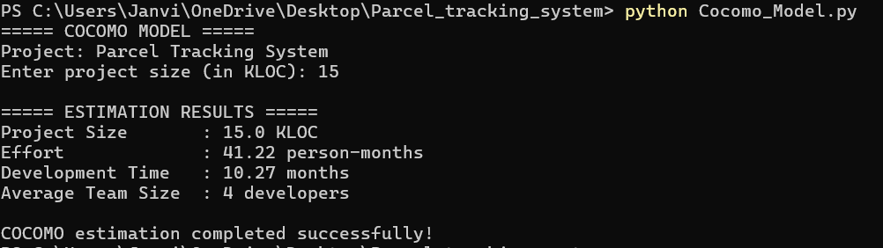
Figure 9: COCOMO Estimation Output

11. Project Schedule (Gantt Chart)
The project schedule spans approximately 6 weeks (late August to mid-October 2026), encompassing the following sequential phases:
ID | Task / Phase | Start Date | End Date
1 | Requirement Analysis | 31-Aug-2026 | 03-Sep-2026
2 | System Design | 04-Sep-2026 | 07-Sep-2026
3 | Database Design | 08-Sep-2026 | 10-Sep-2026
4 | UI Development | 10-Sep-2026 | 14-Sep-2026
5 | Backend Development | 14-Sep-2026 | 19-Sep-2026
6 | GPS Tracking Module | 19-Sep-2026 | 25-Sep-2026
7 | Testing | 25-Sep-2026 | 26-Sep-2026
8 | Integration | 01-Oct-2026 | 06-Oct-2026
9 | Documentation | 04-Oct-2026 | 08-Oct-2026
10 | Final Deployment | 07-Oct-2026 | 10-Oct-2026

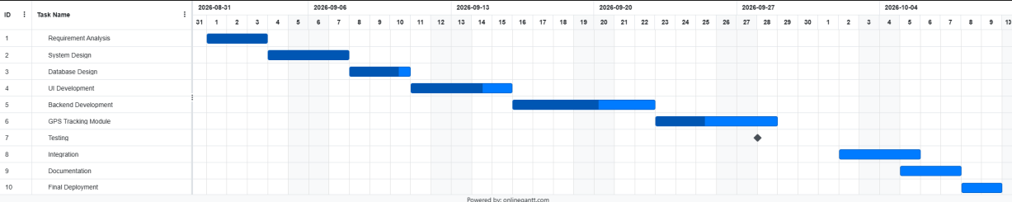
Figure 10: Gantt Chart — Project Schedule

12. Advantages Over Manual System
- Real-time tracking improves transparency and customer trust by providing live parcel status at every stage.
- Reduces lost or misplaced parcels through consistent, timestamped status logging at each transition.
- Centralised digital record of all bookings and deliveries eliminates dependency on physical paperwork.
- Automated billing reduces manual calculation errors and speeds up the invoicing process.
- Reduces operational paperwork and improves overall efficiency for admin staff and delivery agents.
- OTP-based delivery confirmation reduces fraudulent delivery claims.
- SMS/Email notifications keep customers proactively informed without requiring manual follow-up.
- Operational reports enable data-driven decision-making for management.

13. Future Enhancements
- Live GPS tracking of delivery agents integrated into the customer-facing mobile app.
- Native mobile application (iOS and Android) for customers and delivery agents.
- Integration with real payment gateways (e.g., Razorpay, Stripe, PayPal) for online payments.
- Dynamic delivery charge calculation based on real-time distance and route (Google Maps API integration).
- AI/ML-based delivery time prediction and route optimisation for agents.
- Multi-language support for broader customer accessibility.
- Customer rating and feedback system for delivery agents.
- Integration with third-party logistics providers and cross-courier tracking.

