SNOWFLAKE CONTINUOUS DATA LOADING
How we can automatically ingest data from the s3 to Snowflake?
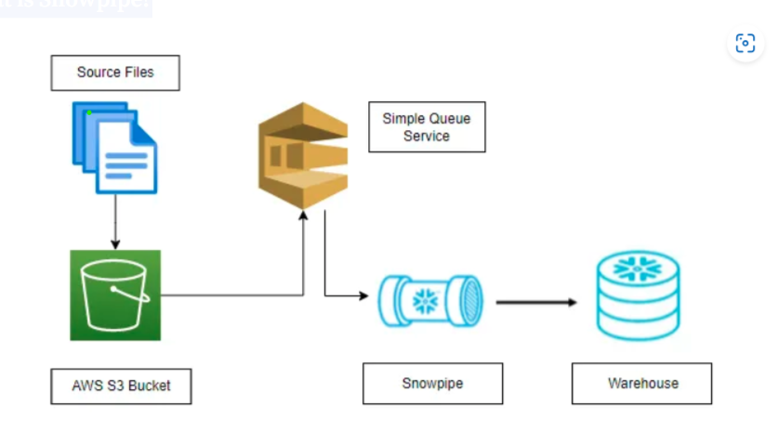
Figure 1: Snowpipe data auto ingest architecture
What is Snowpipe?
Snowpipe enables loading data from files as soon as they’re available in a stage. This means you can load data from files in micro-batches, making it available to users within minutes, rather than manually executing COPY statements on a schedule to load larger batches.
In this document we can see step by step process of data ingest from AWS s3 to snowflake data warehouse by using snowpipe.
- Create an AWS account in aws.amazon.com (by root user)
- After successful account creation and activation, you can use the AWS service.
- Go to the Console home and search for S3 (Simple Storage Service) and click on it.
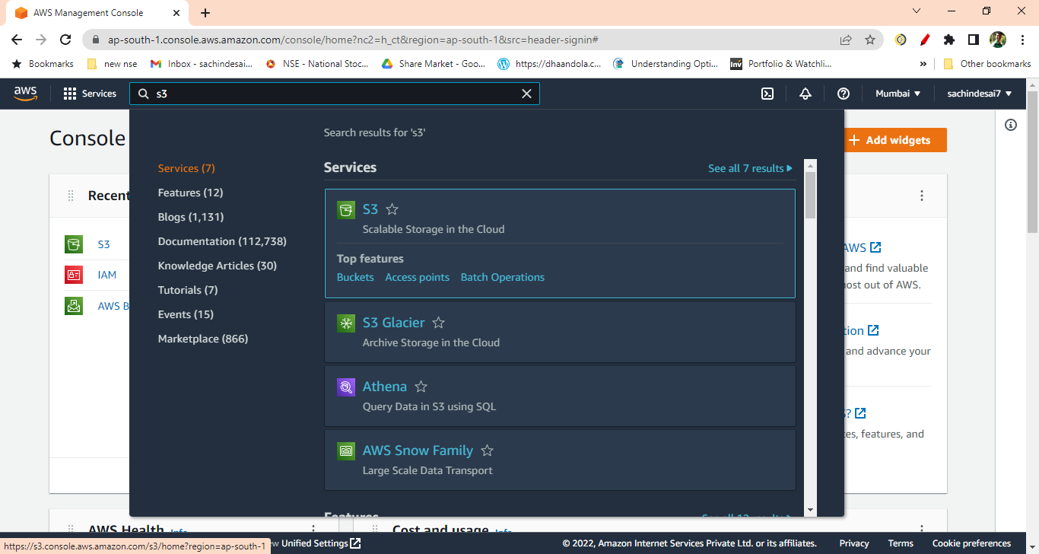
Figure 2: Search for s3 bucket
- Create S3 bucket
Bucket name: cz-bank-bucket
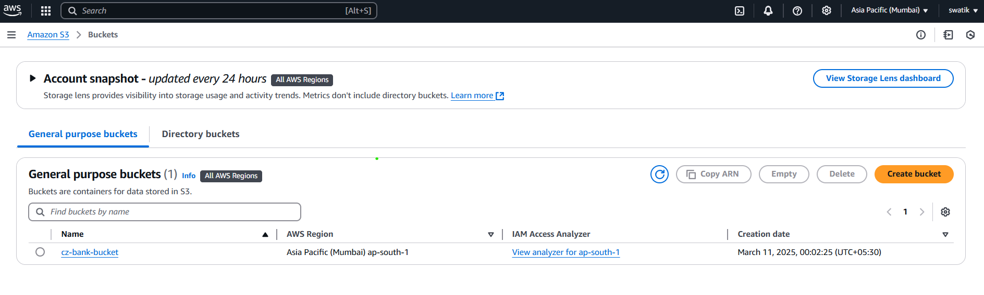
Figure 3: Create bucket
- Create a folder inside the bucket ( e.g. ACCOUNT)
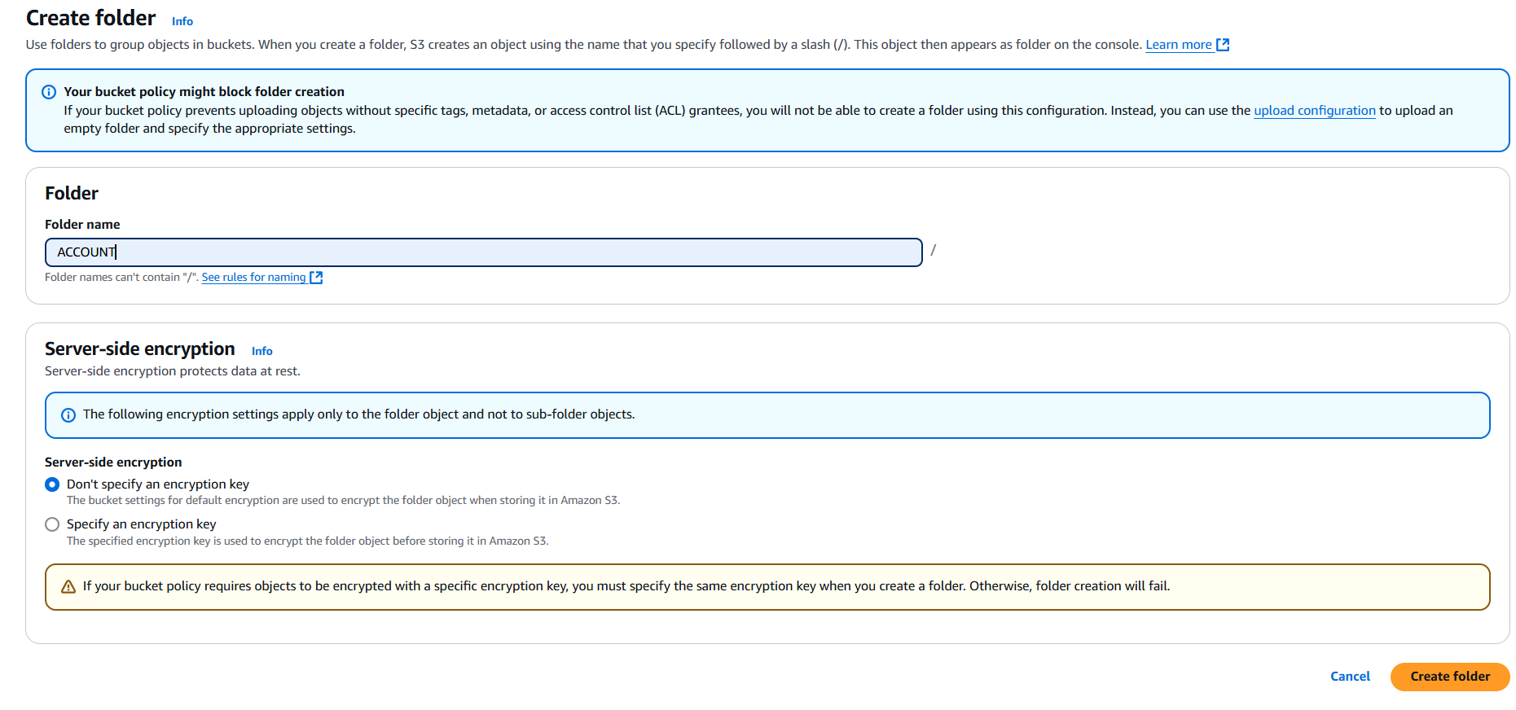
Figure 4: Create folder inside the bucket
For this project we created 8 folders in our bucket:
- ACCOUNT
- CARD
- CLIENT
- DISPOSITION
- DISTRICT
- LOAN
- ORDER1
- TRANSATIONS
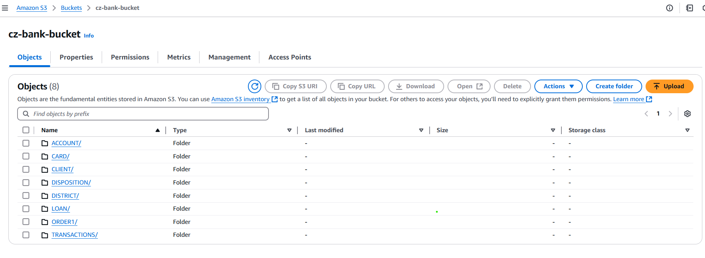
Figure 5: All folders in s3 buckets
- Once the S3 bucket and folders are created, search and select the IAM (Identity and Access Management) service from the AWS console.
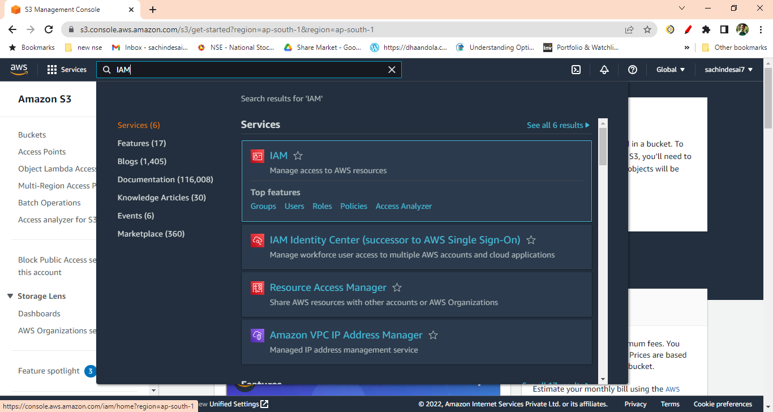
Figure 6: search for IAM service
- Click on the Policies from IAM Dashboard.
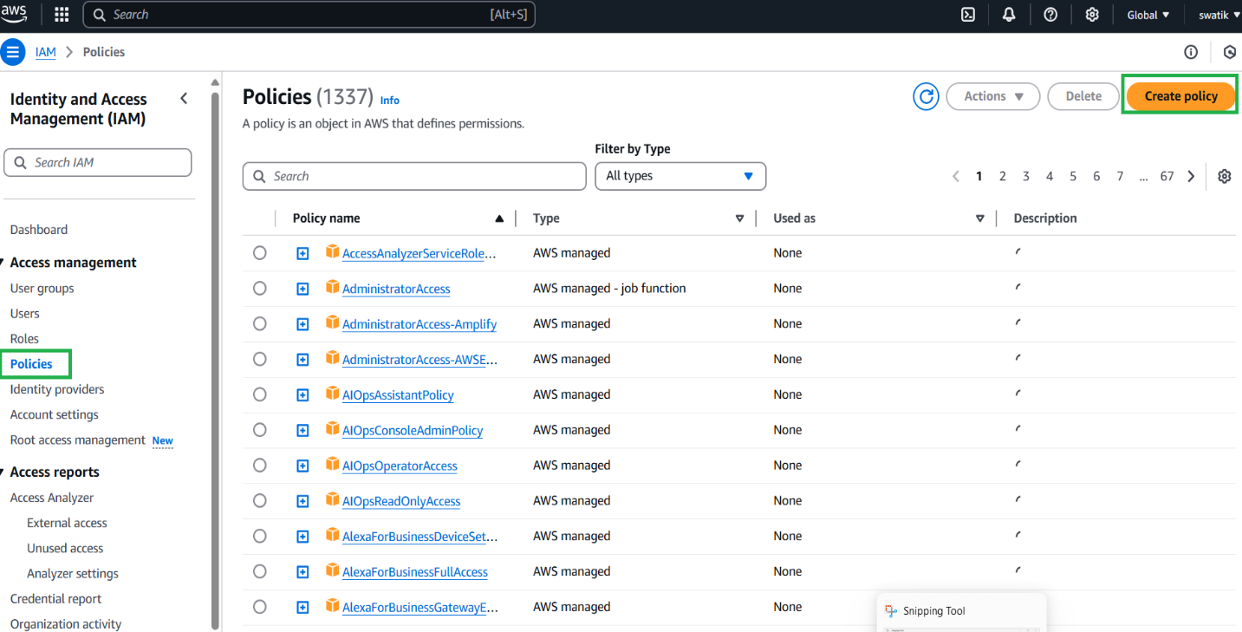
Figure 7: Create policy
- Create IAM policy for the bucket by clicking on the “Create Policy” button. Then click on Json tab and then next.
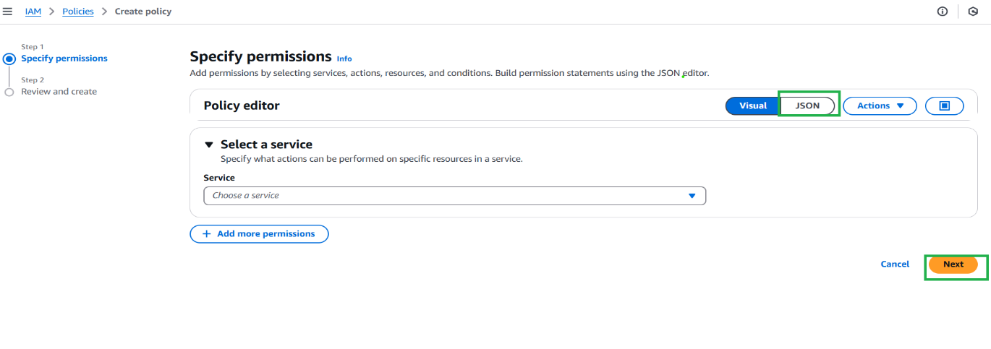
Figure 8: Click on JSON tab and next
- After Clicking the JSON tab and replace the existing text with the text given in the reference
Document click given link for documents.
After clicking on the above link, you will get following doc then just copy the code.
(It is under the step no. 8 from the document)

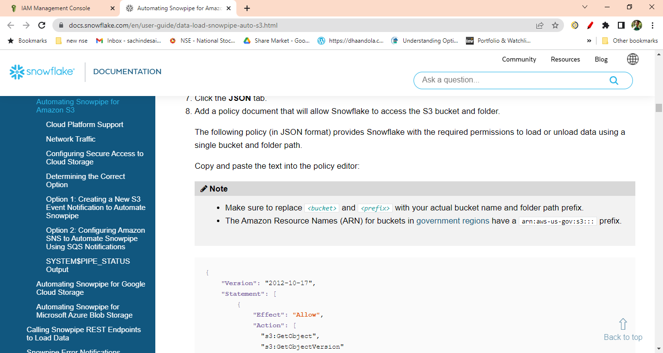
Figure 9: Reference document for policy
- Replace the <bucket> and <prefix > with your actual bucket name and folder path.
Also set the S3: prefix to “ *”
"s3: prefix”: [
“*"
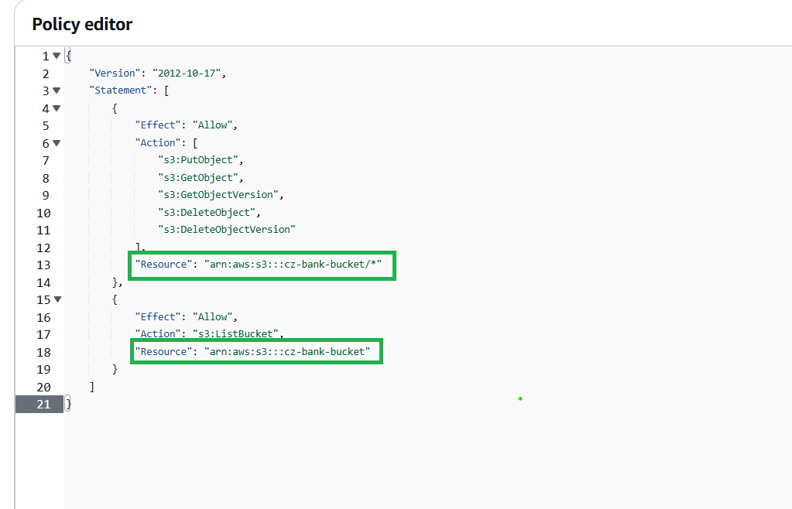
Figure 10: Trust policy permission
- Click Next then skip the Add Tags. Enter the policy name. Click Create Policy. Your policy will get created.
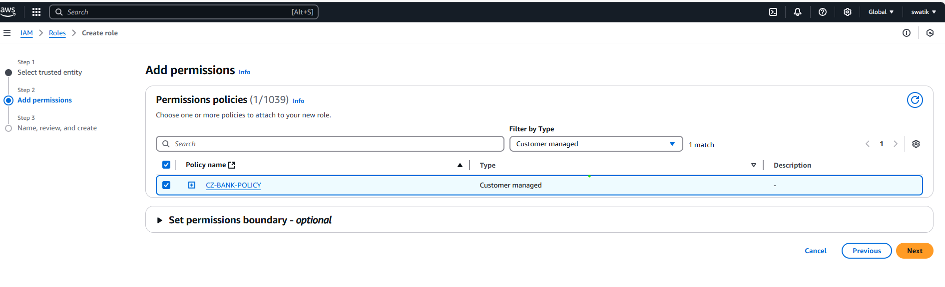
Figure 11: Policy created

- After policy, Create IAM Role. Click on Create Role
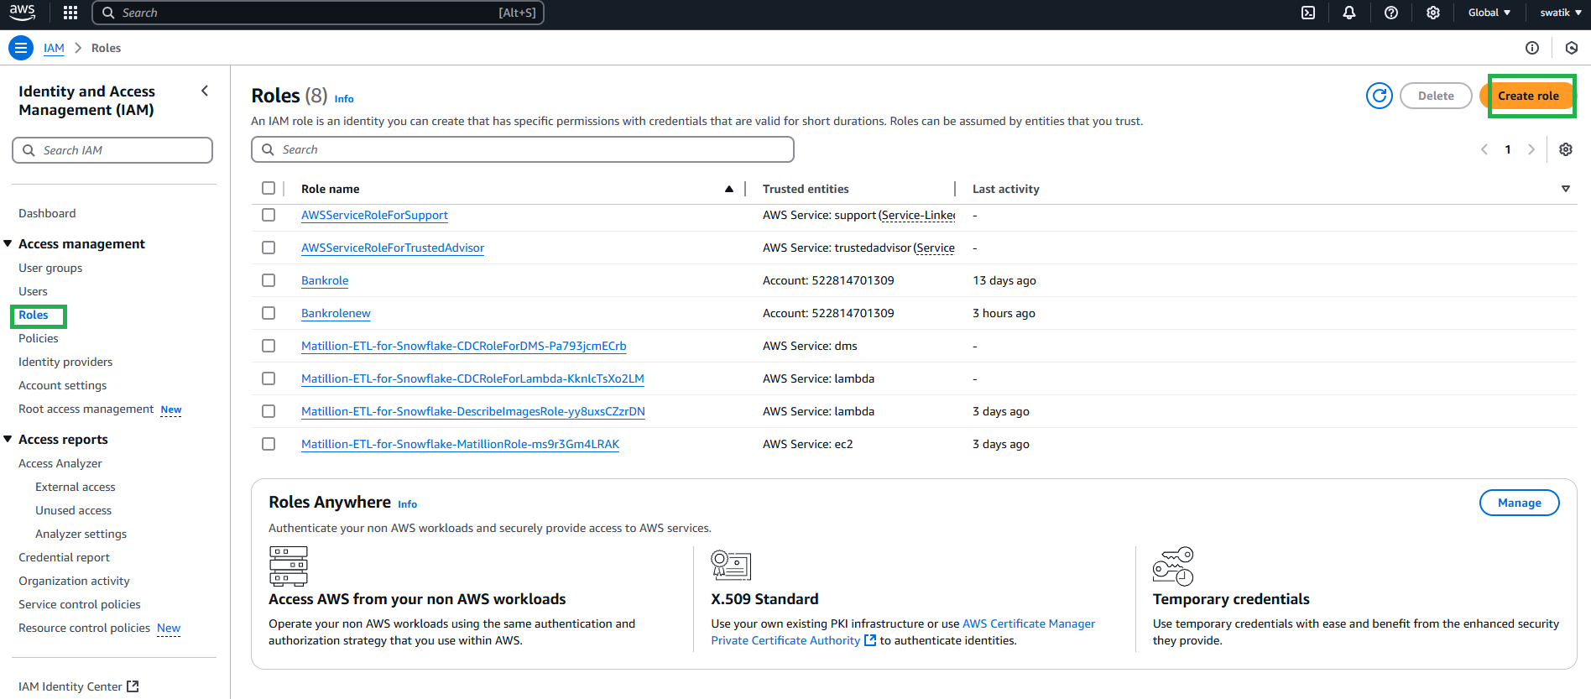
Figure 12: Create role
- Select AWS Account from Trusted Entity Type. You will get your account number selected by default when you select AWS account. Check Require external ID and enter 0000 (as currently we are not having it) and click next
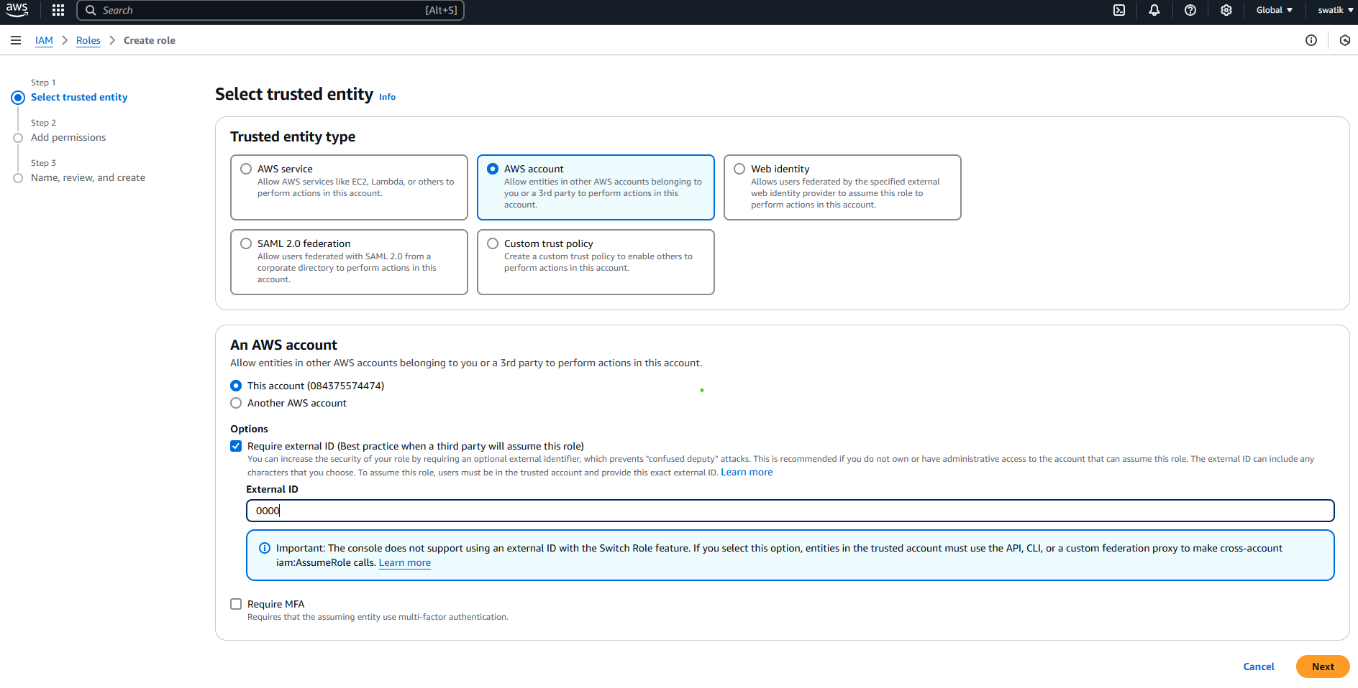
Figure 13: Select AWS account
- On the next page, attached the IAM policy that you have created
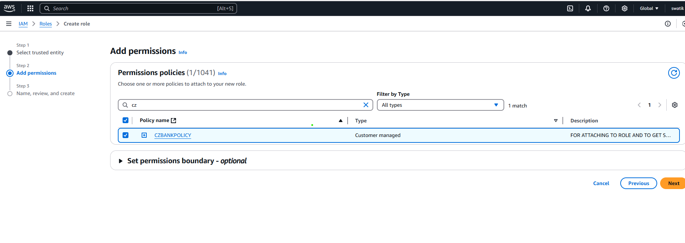
Figure 14: Attached policy to role
- On the next page Enter any unique name to the role you are creating. The description is optional. Click on the Create Role (Skip the Add Tags).
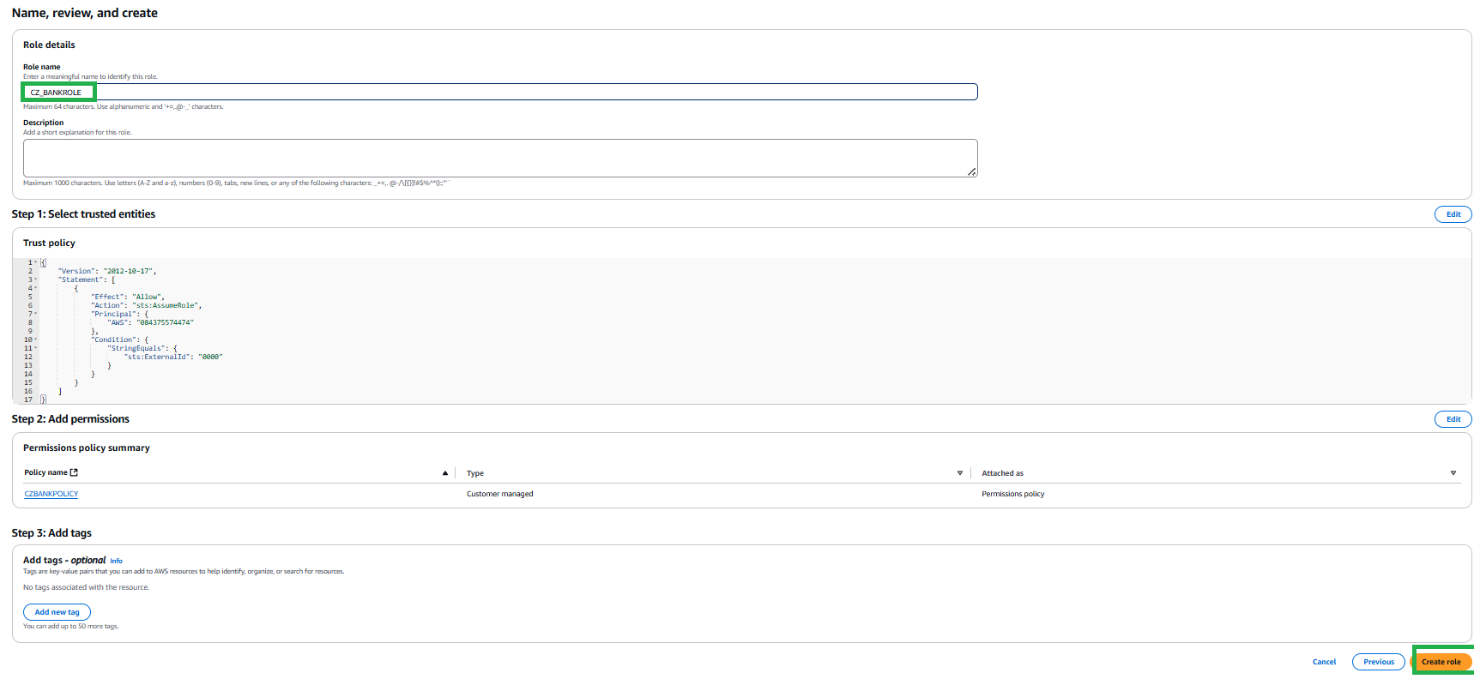
Figure 15: Give name and create role
- Click on the role that you have created. It will show you the summary page. You will get the following window.
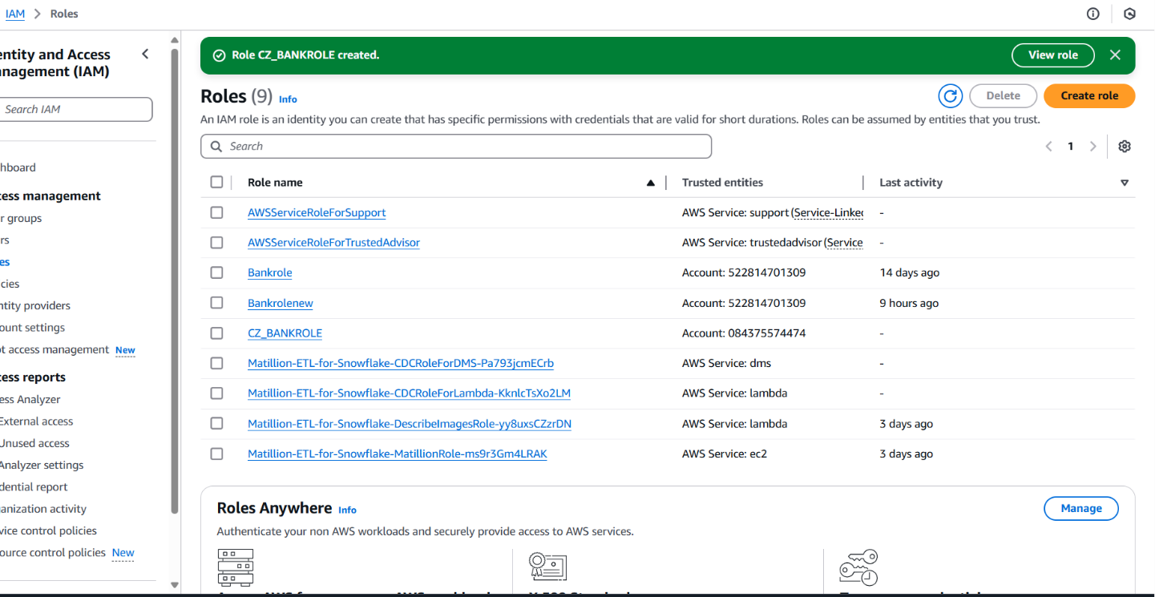
Figure 16: Role created
- Note down the Role ARN, which we will need when we create the ‘Storage Integration’.
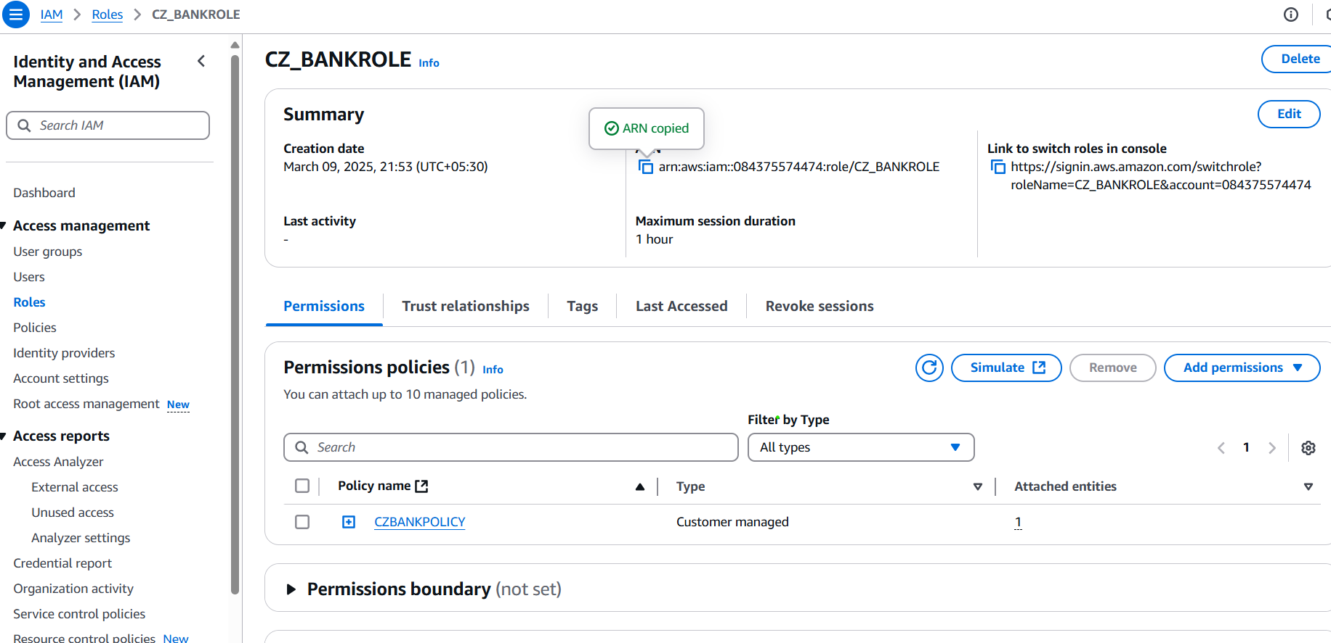
Figure 17: Note down Role ARN
- Login to the Snowflake Account.
Create Cloud Storage Integration in Snowflake and map S3 user/role with it (STORAGE_AWS_ROLE_ARN).
CREATE or REPLACE STORAGE INTEGRATION s3_int
TYPE = EXTERNAL_STAGE
STORAGE_PROVIDER = S3
ENABLED = TRUE
STORAGE_AWS_ROLE_ARN = 'arn:aws:iam::084375574474:role/BANK-ROLE'
STORAGE_ALLOWED_LOCATIONS = ('s3://cz-bank-bucket/');
- In Snowflake worksheet run command
##Desc integration integration_name;
DESC INTEGRATION s3_int;
And note down the STORAGE_AWS_IAM_USER_ARN and STORAGE_AWS_EXTERNAL_ID from the result set.
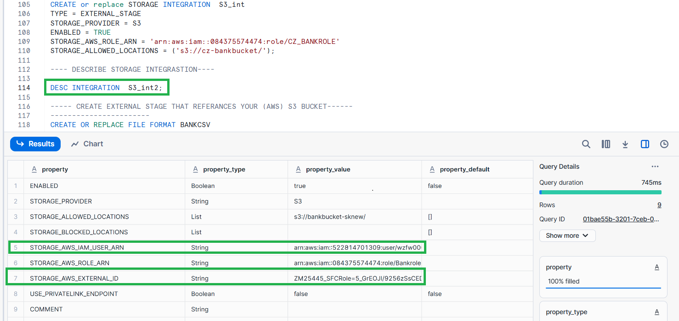
Figure 18: Note down IAM user and AWS externl_id
- Now go to the AWS Console, In IAM Role
- Select the role you created
- Click Trust Relationships -> Edit trust relationship
- Replace the value of "AWS": with the AWS_IAM_USER_ARN String you got using DESC INTEGRATION command and, value of "sts: ExternalId": with AWS_EXTERNAL_ID String
- Click Update Policy
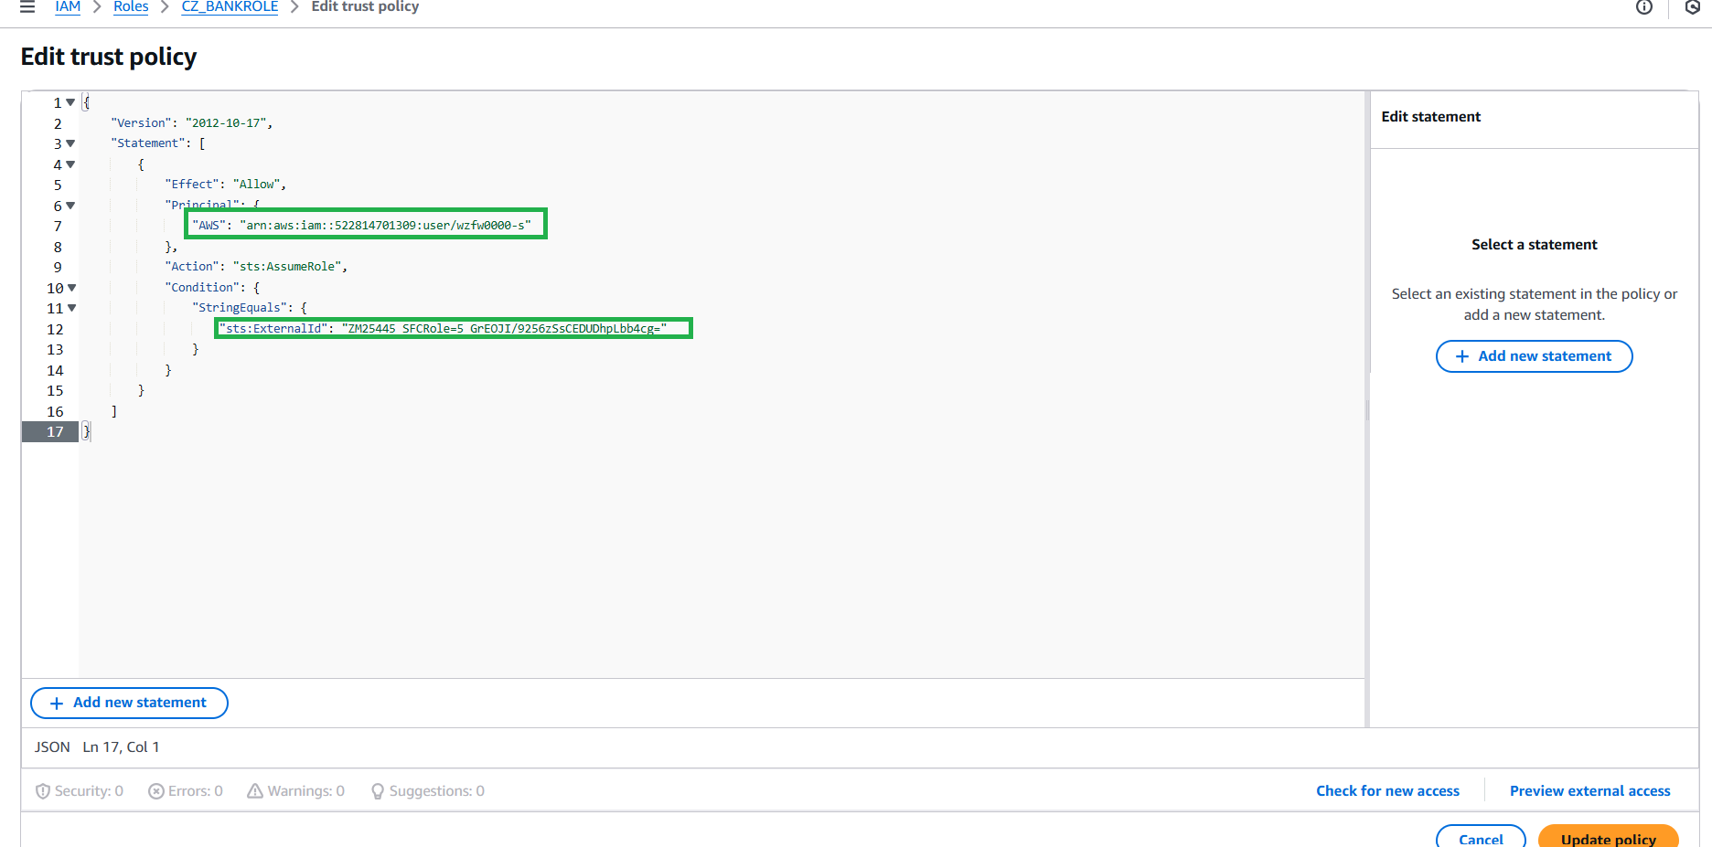
Figure 19: Edit trust policy
- Create Snowflake file format. This file format will be used at the time of Stage creation.
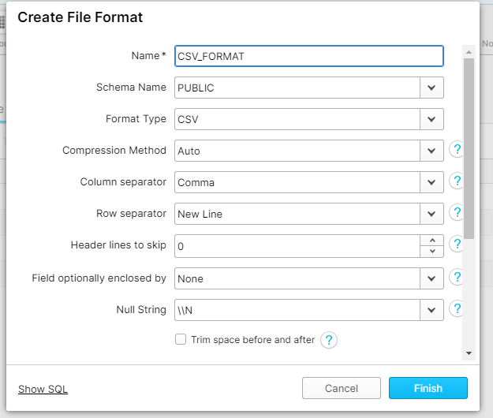
Figure 20: Create file format
OR we also create by using SQL code in snowflake.
CREATE OR REPLACE FILE FORMAT BANKCSV
TYPE = 'CSV'
FIELD_DELIMITER = ','
SKIP_HEADER = 1;

CREATE OR REPLACE FILE FORMAT BANKCSV
TYPE = CSV
FIELD_OPTIONALLY_ENCLOSED_BY = ' " '
SKIP_HEADER = 1;
- Create a stage in snowflake pointing to your S3 bucket:
CREATE OR REPLACE STAGE BANKSTAGE
URL = 's3://cz-bank-bucket' -- (Name of your bucket)
FILE_FORMAT = BANKCSV
STORAGE_INTEGRATION = s3_int;
- Now Create auto-ingest Snowpipe.
CREATE OR REPLACE PIPE SNOWPIPE_ACCOUNT
AUTO_INGEST = TRUE
AS COPY INTO BANK.BANK_SCHEMA.ACCOUNT --table name that you created in snowflake)
FROM @BANKSTAGE/ACCOUNT ---------s3 bucket subfolder name
FILE_FORMAT = BANKCSV;
Create separated Snowpipe for each folders in s3 buckets.
- After creating snowpipe, get ‘Notification Channel’ value
Run command
SHOW PIPES;
Or Go to Database Pipes
Here also you will get the notification channel value.
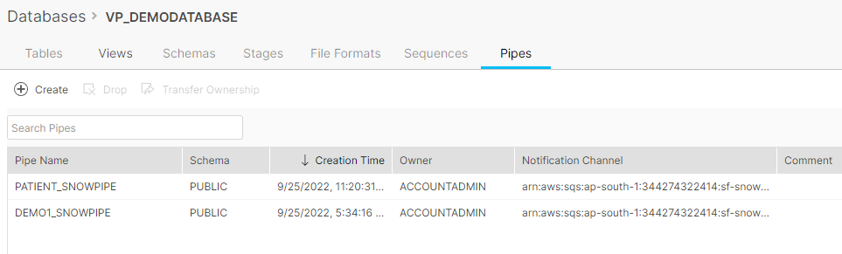
Figure 21: Pipe in snowflake database
- This is the final step. Create an event on S3 bucket. Go to your S3 bucket that you have created. Click on Properties tab and scroll down to
Event Notification Click Create Event Notification
Enter any name for the Notification.
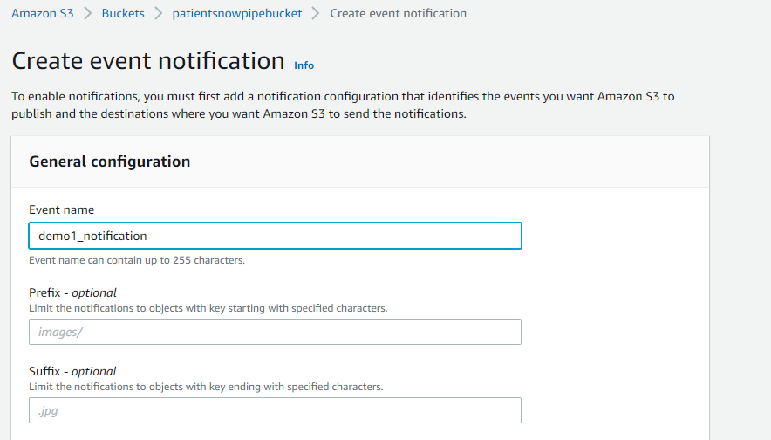
Figure 22: creating event notificatio
Check All Object create Events
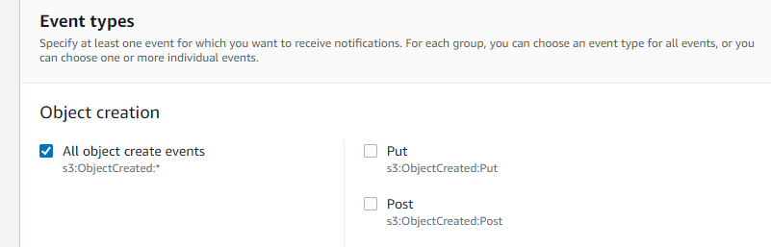
Figure 23: Object for event creation
Scroll down to Destination
To create an SQS notification for the Snowpipe.
What is SQS?
Amazon Simple Queue Service (SQS) lets you send, store, and receive messages between software components at any volume, without losing messages or requiring other services to be available.
As soon as a new file is uploaded to that folder in s3 it will send a notification to pipe. For that first run below command in snowflake
Select SQS Queue, Select Enter SQS Queue ARN. And paste that ‘Notification Channel’ under SQS Queue
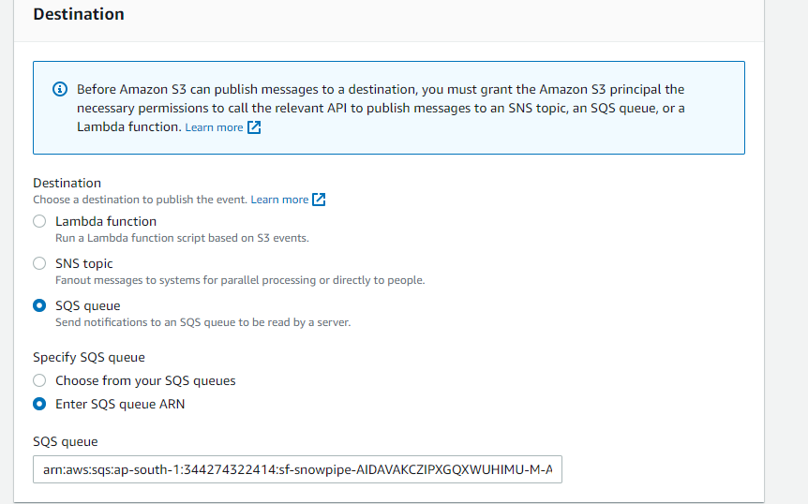
Figure 24: SQS event notification

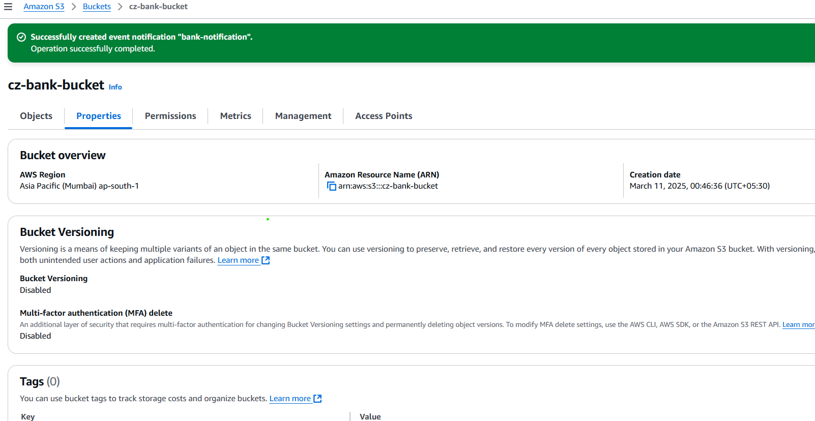
Figure 25: Event notification created
Now you are ready to load the file to s3 bucket.
26]. Following are some snowpipe command which will help you to check snowpipe status

select SYSTEM$PIPE_STATUS('patient_snowpipe');

select * from table(information_schema.copy_history(table_name=>'tab_patient', start_time=>
dateadd(hours, -1, current_timestamp())));

Thus, we can automatically ingest data into a warehouse from your S3 bucket to Snowflake

