源条件的生成与翻译说明书

1.源条件的定义
通过若干条件或条件组来过滤源中的数据，目的是为了增强查询的效率，得到我们查询想要的数据，这样的过滤条件叫源数据查询条件，简称“源条件”。
例如：查询年龄大于10岁的学生
Json: {"rules":[{"field":"AGE","op":"lar","type":"2","value":"10"},{"field":"JOB","op":"eq","type":"1","value":"学生"}],"op":"or","groups":[]}
Sql
AGE>10 and JOB=’学生’

Solr Query Language
AGE:{10 TO *] and JOB:’学生’

2.源条件的规则

2.1条件(filterRule)
条件名 | json | sql | solrQuery
相等 | eq | = | fieldName:’值’
不相等 | not | <> | fieldName:NOT’值’
大于 | lar | > | field:[* TO 值}
小于 | less | < | field:{值TO * ]
大于等于 | larEp | >= | field:[* TO 值]
小于等于 | lessEp | <= | field:[值TO * ]
包括 | inner | in | +field:(值1 值2 )
不包括 | notInner | not in | -field:(值1 值2 )
左模糊匹配 | leftLike | like ‘%test’ | field:*值
右模糊匹配 | rightLike | like ‘test%’ | field:值*
左右模糊匹配 | like | like ‘%test%’ | field:*值*
为空 | is | is null | -(field:*)
不为空 | isNot | Is not null | field:*

例子：
条件名 | 例子 | json | sql | solrQuery
相等 | 年龄等于5 | {"rules":[{"field":"AGE","op":"eq","type":"2","value":"5"}],"op":"","groups":[]} | AGE=5 | AGE:5
不相等 | 年龄不等于5 | {"rules":[{"field":"AGE","op":"not","type":"2","value":"5"}],"op":"","groups":[]} | AGE<>5 | AGE:NOT 5
大于 | 年龄等于5 | {"rules":[{"field":"AGE","op":"lar","type":"2","value":"5"}],"op":"","groups":[]} | AGE>5 | AGE:[* TO 5}
小于 | 年龄小于5 | {"rules":[{"field":"AGE","op":"less","type":"2","value":"5"}],"op":"","groups":[]} | AGE<5 | AGE:{5 TO * ]
大于等于 | 年龄大于或等于5 | {"rules":[{"field":"AGE","op":"larEp","type":"2","value":"5"}],"op":"","groups":[]} | AGE>=5 | AGE:[* TO 5]
小于等于 | 年龄小于或等于5 | l{"rules":[{"field":"AGE","op":"lessEp","type":"2","value":"5"}],"op":"","groups":[]} | AGE<=5 | AGE:[5 TO * ]
包括 | 姓名为张三和李四 | {"rules":[{"field":"NAME","op":"inner","type":"1","value":"张山，李四"}],"op":"","groups":[]} | NAME in (‘张三’,’李四’) | +NAME:(张三 李四 )
不包括 | 姓名不为张三和李四 | {"rules":[{"field":"NAME","op":"notInner","type":"1","value":"张山，李四"}],"op":"","groups":[]} | NAME not in (‘张三’,’李四’) | -NAME:(张三 李四 )
左模糊匹配 | 姓名以亮结尾的 | {"rules":[{"field":"NAME","op":"leftLike","type":"1","value":"亮"}],"op":"","groups":[]} | NAME like ‘%亮’ | NAME:*亮
右模糊匹配 | 姓李的 | {"rules":[{"field":"NAME","op":"leftLike","type":"1","value":"李"}],"op":"","groups":[]} | NAME like ‘李%’ | NAME:李*
左右模糊匹配 | 姓名中含花 | {"rules":[{"field":"NAME","op":"like","type":"1","value":"花"}],"op":"","groups":[]} | like ‘%花%’ | NAME:*花*
为空 | 无名字 | {"rules":[{"field":"NAME","op":"is","type":"1"}],"op":"","groups":[]} | NAME is null | -(NAME:*)
不为空 | 有名字 | {"rules":[{"field":"NAME","op":"isNot","type":"1"}],"op":"","groups":[]} | NAME Is not null | NAME:*

2.2 条件组（filterGroup）
条件组情况 | 例子 | 并且（AND） | 例子 | 或者(OR)
①条件与条件 | 年龄大于6岁而且年龄小15岁的人 | {"rules":[{"field":"AGE","op":"lar","type":"2","value":"6"},{"field":"AGE","op":"less","type":"2","value":"15"}],"op":"and","groups":[]} | 年龄大于30岁或者年龄小15岁的人 | {"rules":[{"field":"AGE","op":"lar","type":"2","value":"30"},{"field":"AGE","op":"less","type":"2","value":"15"}],"op":"or","groups":[]}
②条件与条件组 | 年龄大于6岁而且年龄小15岁的学生 | {"rules":[{"field":"JOB","op":"eq","type":"1","value":"学生"}],"op":"and","groups":[{"rules":[{"field":"AGE","op":"lar","type":"2","value":"6"},{"field":"AGE","op":"less","type":"2","value":"15"}],"op":"and","groups":[]}]} | 年龄大于6岁而且年龄小15岁，或者是成年人 | {"rules":[{"field":"AGE","op":"larEp","type":"2","value":"18"}],"op":"or","groups":[{"rules":[{"field":"AGE","op":"lar","type":"2","value":"6"},{"field":"AGE","op":"less","type":"2","value":"15"}],"op":"and","groups":[]}]}
③条件组与条件组 | 年龄大于6岁而且年龄小15岁的学生而且工资小于1000大于100 | {"rules":[],"op":"and","groups":[{"rules":[{"field":"JOB","op":"eq","type":"1","value":"学生"}],"op":"or","groups":[{"rules":[{"field":"AGE","op":"lar","type":"2","value":"6"},{"field":"AGE","op":"less","type":"2","value":"15"}],"op":"and","groups":[]}]},{"rules":[{"field":"SALARY","op":"less","type":"2","value":"1000"},{"field":"SALARY","op":"lar","type":"2","value":"100"}],"op":"or","groups":[]}]} | 年龄大于6岁而且年龄小15岁的学生和年龄大于40岁而且小50岁 | {"rules":[],"op":"or","groups":[{"rules":[{"field":"JOB","op":"eq","type":"1","value":"学生"}],"op":"or","groups":[{"rules":[{"field":"AGE","op":"lar","type":"2","value":"6"},{"field":"AGE","op":"less","type":"2","value":"15"}],"op":"and","groups":[]}]},{"rules":[{"field":"AGE","op":"lar","type":"2","value":"40"},{"field":"SALARY","op":"less","type":"2","value":"50"}],"op":"or","groups":[]}]}

3.原条件JSON的生成(使用原条件生成工具)

3.1生成Json条件模板
例子：xzqhdm like ‘4401%’
JSON:{"rules":[{"field":"NAME","op":"leftLike","type":"1","value":"4401"}],"op":"","groups":[]}
生成步骤如图：
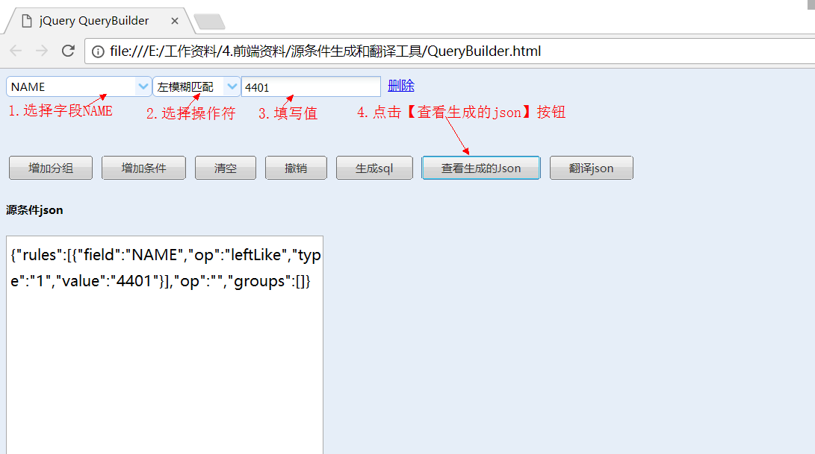

3.2替换你想要的字段
{"rules":[{"field":"xzqhdm ","op":"leftLike","type":"1","value":"4401"}],"op":"","groups":[]}

注意：
模板字段类型的选择
字段类型 | 模板字段 | 可选操作符
字符串类型 | Name | 相等，不相等，包括，不包括，左模糊匹配，右模糊匹配，左右模糊匹配，为空，不为空
整型 | Age | 相等，不相等，大于，小于，大于或等于，小于或等于，包括，不包括，左模糊匹配，右模糊匹配，左右模糊匹配，为空，不为空
小数 | Salary | 相等，不相等，大于，小于，大于或等于，小于或等于，包括，不包括，左模糊匹配，右模糊匹配，左右模糊匹配，为空，不为空
时间 | Birthdy | 相等，不相等，大于，小于，大于或等于，小于或等于，包括，不包括，左模糊匹配，右模糊匹配，左右模糊匹配，为空，不为空

4.原条件JSON翻译成SQL

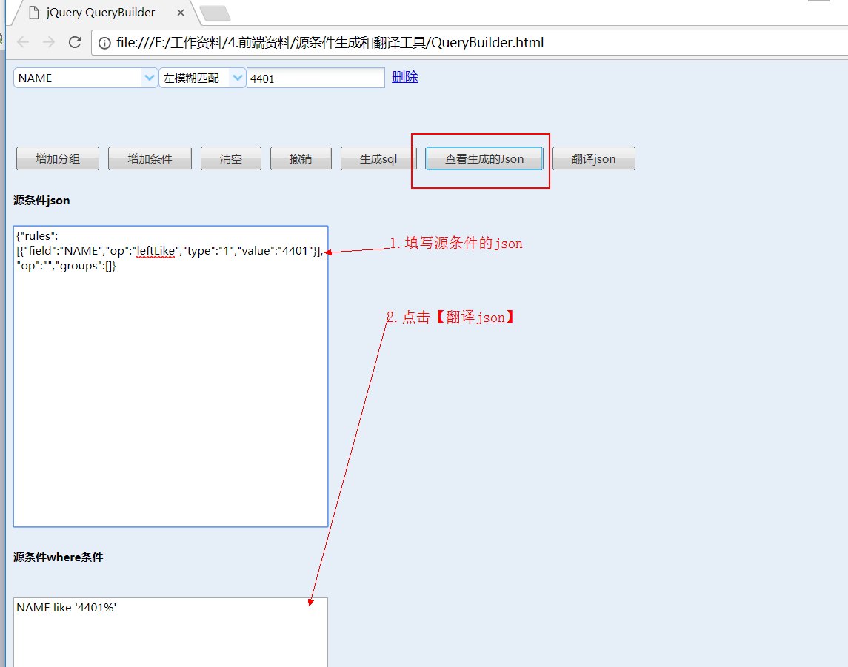

5原条件JSON翻译成solr的查询条件

5.1先翻译成sql
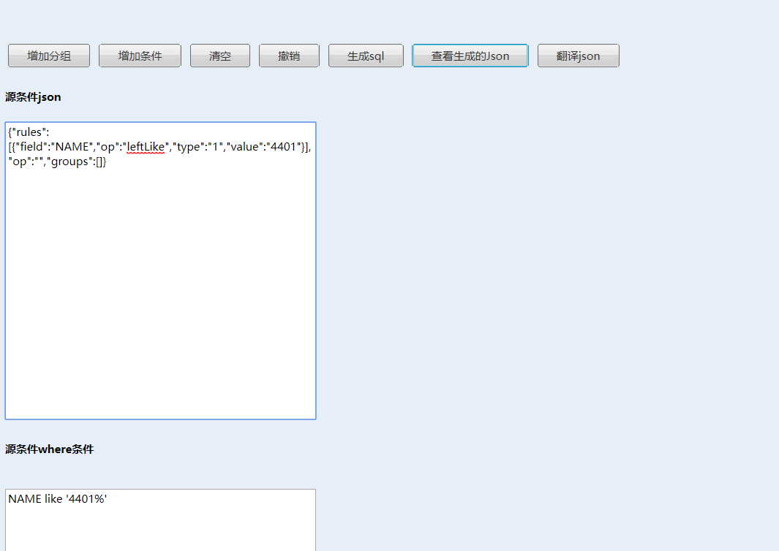

5.2将sql的规则替换成 solr的查询规则
NAME:4401*

solr查询语法参考《solr查询语法》

