ORBIT: A CROSS-PLATFORM CALENDAR PLANNER APPLICATION FOR EFFICIENT PERSONAL SCHEDULING

Batangas State University The National Engineering University JPLPC
Malvar Campus Malvar, Batangas

ALO, EMMANUEL M.
DOTON, JOHN ANSEL C.
TANCHANCO, JAO ALGRIN S.

JULY 2025

SYSTEM FEATURES AND SCOPE

Overview
Orbit is a cross-platform calendar planner application developed using the Flutter framework. The primary objective of Orbit is to help users efficiently organize their personal schedules, manage events, and track important dates. Emphasizing simplicity and usability, the application provides essential planning tools that are accessible across multiple operating systems, including Android, iOS, Windows, macOS, and Linux.

Screens or Modules Included
Orbit comprises the following core screens and modules:
- Main Page: Serves as the central dashboard, providing an overview of the calendar and quick navigation to other features within the application.
- Event Management Module: Enables users to create, view, edit, and delete calendar events, ensuring effective schedule management.
- Database Helper Module: Manages local data storage operations. This module ensures that all user-created events are securely saved on the device and can be retrieved when required, even without an internet connection.

SCOPE AND LIMITATIONS

The scope of Orbit includes the following functionalities:
- Personal Event Scheduling: Users have the capability to create, view, and manage personal events and appointments directly within the app.
- Local Data Storage: All event data is stored locally on the user's device. This ensures privacy and allows the application to function fully offline.
- Multi-Platform Support: Orbit is designed to run seamlessly on various platforms, including mobile and desktop operating systems.
- User-Friendly Interface: The application features an intuitive and straightforward user interface, allowing users to navigate and manage events with minimal effort.

While Orbit provides core scheduling features, it has the following limitations:
- No Cloud Synchronization: Currently, Orbit does not offer the ability to synchronize data across multiple devices or back up data to the cloud.
- No User Authentication: The application does not support user login or account management features.
- Limited Notification Features: If notification functionality is present, it is limited to local device notifications only.
- Basic Reporting: Orbit does not include advanced analytics or detailed reporting tools; its focus remains on essential scheduling tasks.

UI DESIGN / WIREFRAMES
The user interface of the Orbit application is designed to provide an intuitive and efficient navigation experience for users managing their schedules and events. The following paragraphs describe the navigation flow and functionality of each major screen, as depicted in the provided prototype images.

The main screen of the application (Figure 1) serves as the central hub for user interaction. At the top of the interface, a header bar displays the application name alongside two prominent icons: a trash bin and a calendar. The trash bin icon allows users to access the "Trash" screen, where soft-deleted events are temporarily stored, while the calendar icon provides a shortcut to a date selection or search feature. Below the header, a button labeled "UI mode feature setting" enables users to toggle between light and dark modes, enhancing accessibility and user preference. The central portion of the screen is dedicated to the calendar view, which displays the current month and allows users to select specific dates. Beneath the calendar, the "Daily Schedule" section presents a list of scheduled events for the selected day, and the "Events for (dd/mm)" section displays detailed information about events on a hovered or selected date. A floating action button in the lower right corner allows users to quickly add new events, streamlining the event creation process.
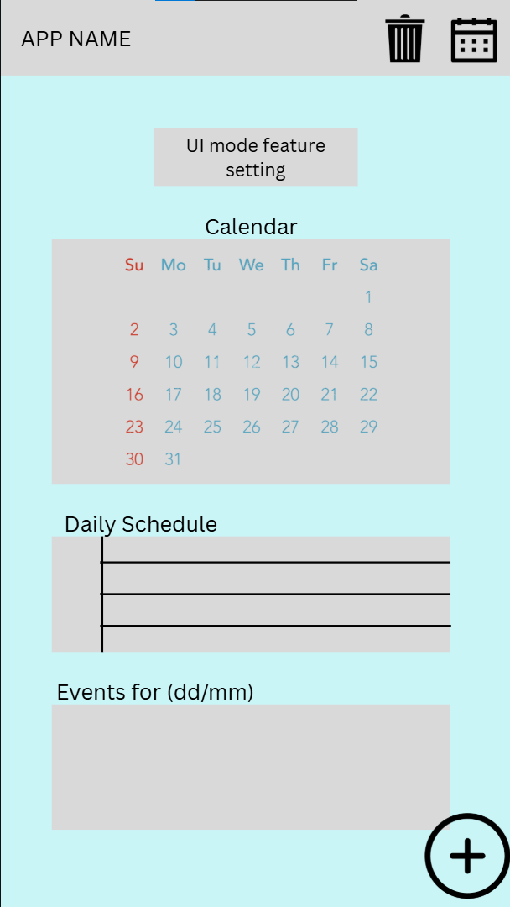
Figure 1. Main Screen

Figure 2 provides annotated details of the main screen's interactive elements. The trash bin icon is clarified as the repository for soft-deleted events, allowing users to recover or permanently delete items as needed. The calendar icon is identified as a tool for locating specific dates within the calendar view. The "UI mode feature setting" button is further explained as a dropdown menu, offering options to switch between light and dark modes. The calendar itself is described as having flexible viewing options, enabling users to display a week, two weeks, or an entire month at a time. The "Daily Schedule" section is highlighted as displaying the schedule for the currently selected date, while the "Events for (dd/mm)" section shows events for the day being hovered over. The floating action button is reaffirmed as the entry point for creating new events.

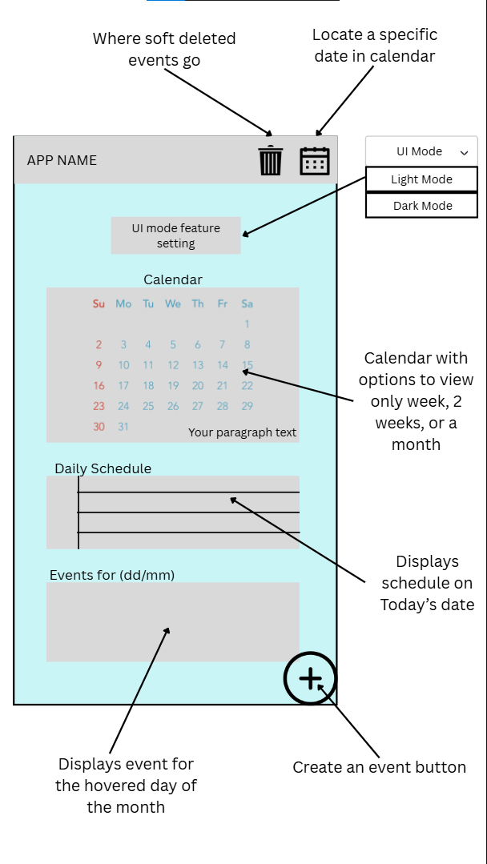
Figure 2. In-depth Main Screen

The third image (Figure 3) illustrates the "Trash" screen, which is accessed by tapping the trash bin icon on the main screen. This screen lists all soft-deleted events, each represented by a colored icon and event details such as date, time, and description. Users are provided with two options for each event: restore, which returns the event to the main schedule, and permanent delete, which removes the event from the application entirely. This design ensures that accidental deletions can be easily reversed, while also allowing users to manage their event history effectively.

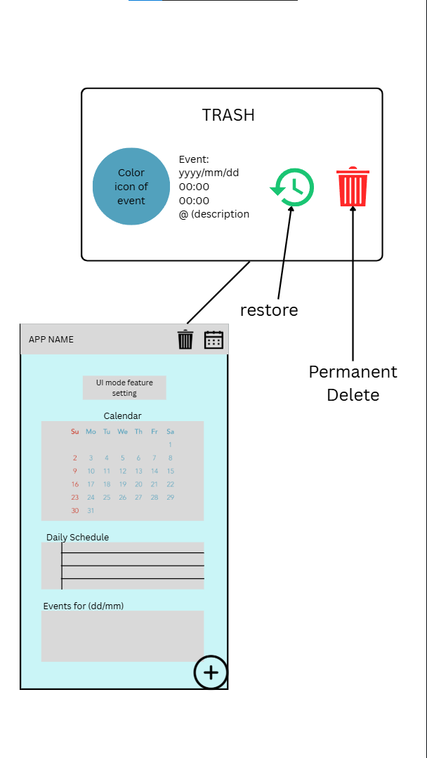
Figure 3. “Trash” Screen

Figure 4 demonstrates the date selection dialog, which is invoked by tapping the calendar icon on the main screen. This dialog presents a detailed calendar view, allowing users to navigate between months and select specific dates. The selected date is prominently displayed at the top, and users can confirm or cancel their selection using the provided buttons. This feature facilitates quick navigation to any date within the calendar, enhancing the user's ability to review or schedule events efficiently.

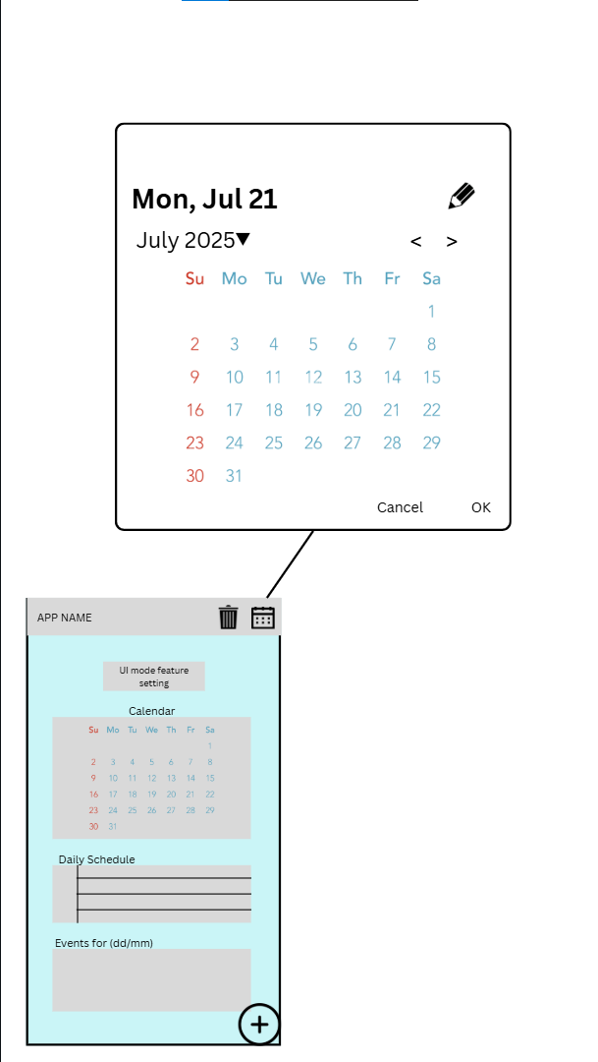
Figure 4. Date Selection Window

The fifth image (Figure 5) depicts the "Add Event" dialog, which appears when the user taps the floating action button on the main screen. This dialog prompts the user to enter essential event details, including the title, location, description, start and end times, and a color code for categorization. The user can confirm the creation of the event by tapping the "Add" button or cancel the operation if desired. This streamlined process encourages users to quickly and accurately input new events into their schedule.

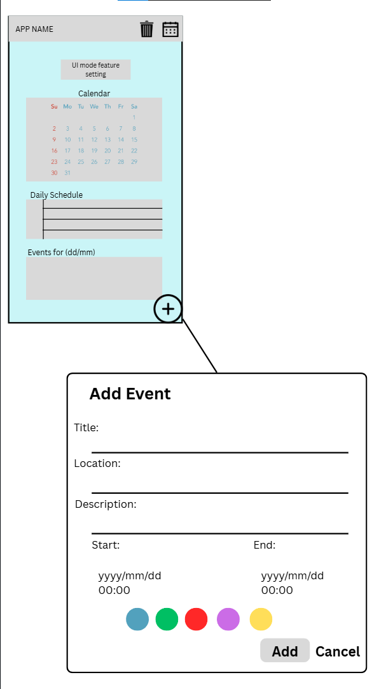
Figure 5. Add Event Window

Finally, Figure 6 shows the "Edit Event" dialog, which is accessed by selecting an existing event from the schedule. This dialog is similar in layout to the "Add Event" dialog but includes options to update or delete the event. Users can modify any event detail, change the color code, or remove the event entirely by selecting the "Delete" button. The inclusion of both "Save" and "Cancel" options ensures that users have full control over their event data, minimizing the risk of accidental changes.

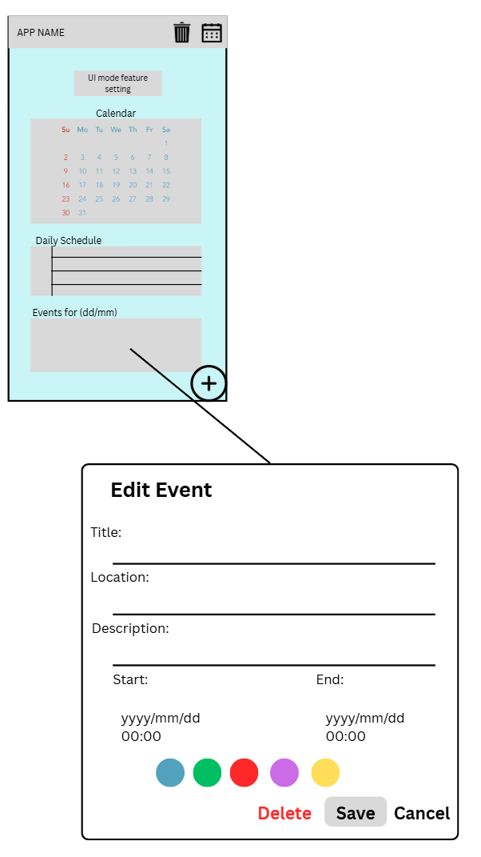
Figure 6. Edit Event Window

