ShopEZ
E-Commerce API — Documentation & Testing Guide
ASP.NET Core 8 • Entity Framework Core • SQL Server • JWT Auth • BCrypt

1. What is ShopEZ?
ShopEZ is a backend REST API for an e-commerce shop. It is built with ASP.NET Core 8 and stores data in SQL Server. It handles three things:

- Products — Anyone can view products. Only Admin can add, edit, or delete them.
- Orders — Logged-in users place orders. The server calculates the total automatically.
- Users — Register and login to get a JWT token. The token controls what you can do.

There are two roles: Admin (full access) and Customer (can view products and place their own orders).

2. How to Run the Project
Step 1 — Extract the ZIP and open Visual Studio 2022.
Step 2 — Go to File → Open → Project/Solution and select ShopEZ.sln
Step 3 — Open ECommerce.API / appsettings.json and update the connection string:

"ConnectionStrings": {
"DefaultConnection": "Server=YOUR_SERVER\\SQLEXPRESS;Database=ShopEZ;
Trusted_Connection=True;TrustServerCertificate=True"
}

Replace YOUR_SERVER with your computer name. For LocalDB use: (localdb)\\mssqllocaldb

Step 4 — Press F5 to run. Database tables are created automatically on first run.
Step 5 — Browser opens at https://localhost:60466 showing the Swagger UI.
Step 6 — Run the SQL scripts below to insert the dummy data.

3. Insert Dummy Data (SQL)
After running the project once so the tables exist, open SSMS, connect to ShopEZ database, and run these scripts in order.

Run Users first, then Products, then Orders. Order matters because Orders reference Users and Products.

Step 1 — Insert Users
Passwords are stored as BCrypt hashes. The plain-text password for each user is shown in the comment.

INSERT INTO Users (Name, Email, Password, Role)
VALUES
(
'Super Admin',
'admin@shopez.com',
'$2a$11$dlZGvJcs1Se5eeUk06PUL.NDFX.r7WEOg4J8WO38ztdi/D00X2O7m', -- Admin@123
'Admin'
),
(
'Aaysha Khan',
'aaysha.khan@example.com',
'$2a$11$uk0ZAA8NItIU3iaJLw6L5O8wt.KrTuzdhqRkbHkBdWnBG6HO1NHZi', -- Aaysha@123
'Customer'
),
(
'Rahul Sharma',
'rahul.sharma@example.com',
'$2a$11$q9uReI3Y7WZZBSJqceanhee2BL3YMynfRxDCQ5IZZTfljzpgyTM7q', -- Rahul@123
'Customer'
);

UserId | Name | Email | Password | Role
1 | Super Admin | admin@shopez.com | Admin@123 | Admin
2 | Aaysha Khan | aaysha.khan@example.com | Aaysha@123 | Customer
3 | Rahul Sharma | rahul.sharma@example.com | Rahul@123 | Customer

Step 2 — Insert Products
INSERT INTO Products (Name, Description, Price, ImageUrl, Stock)
VALUES
('Wireless Headphones', 'Premium noise-cancelling wireless headphones with 30-hour battery life.',
2999.99, 'https://example.com/images/headphones.jpg', 50),
('Mechanical Keyboard', 'Full-size mechanical keyboard with RGB backlight and tactile switches.',
4499.00, 'https://example.com/images/keyboard.jpg', 30),
('USB-C Hub', '7-in-1 USB-C hub with HDMI, USB 3.0, and SD card reader.',
1299.50, 'https://example.com/images/usbhub.jpg', 100),
('Gaming Mouse', 'Ergonomic gaming mouse with 12000 DPI sensor and programmable buttons.',
1899.00, 'https://example.com/images/mouse.jpg', 75),
('Monitor Stand', 'Adjustable aluminium monitor stand with storage shelf.',
899.99, 'https://example.com/images/monitorstand.jpg', 40);

Step 3 — Insert a Sample Order
-- Order for Aaysha Khan (UserId = 2)
INSERT INTO Orders (UserId, OrderDate, TotalAmount)
VALUES (2, GETDATE(), 4299.00);
-- Order line items (OrderId = 1)
INSERT INTO OrderItems (OrderId, ProductId, Quantity, Price)
VALUES
(1, 1, 1, 2999.99), -- 1 x Wireless Headphones
(1, 3, 1, 1299.50); -- 1 x USB-C Hub

Step 4 — Verify the Data
SELECT * FROM Users;
SELECT * FROM Products;
SELECT * FROM Orders;
SELECT * FROM OrderItems;

4. API Reference
Base URL: https://localhost:60466

Every API response follows this format:
{
"success": true or false,
"message": "Human readable result",
"data": { ... } // null on error
}

Authentication APIs
No token needed. These are open to everyone.

POST | /api/auth/register

Create a new user account. Returns a JWT token immediately after registration.
Auth: No token required (Public)

Request Body (JSON):
{
"name": "Jane Smith",
"email": "jane@example.com",
"password": "Jane@1234",
"role": "Customer"
}
// role is optional — defaults to "Customer"
// password must be 8+ chars with uppercase, lowercase, number, special char

201 Created — Registration successful
{
"success": true,
"message": "Registration successful.",
"data": {
"token": "eyJhbGciOiJIUzI1NiIsInR5cCI6IkpXVCJ9...",
"user": { "userId": 4, "name": "Jane Smith",
"email": "jane@example.com", "role": "Customer" }
}
}

400 Bad Request — Validation failed
{ "success": false, "message": "Password must include at least one uppercase letter...", "data": null }

409 Conflict — Email already registered
{ "success": false, "message": "Email 'aaysha.khan@example.com' is already registered.", "data": null }

Screenshot: Register API — Postman Request & Response:
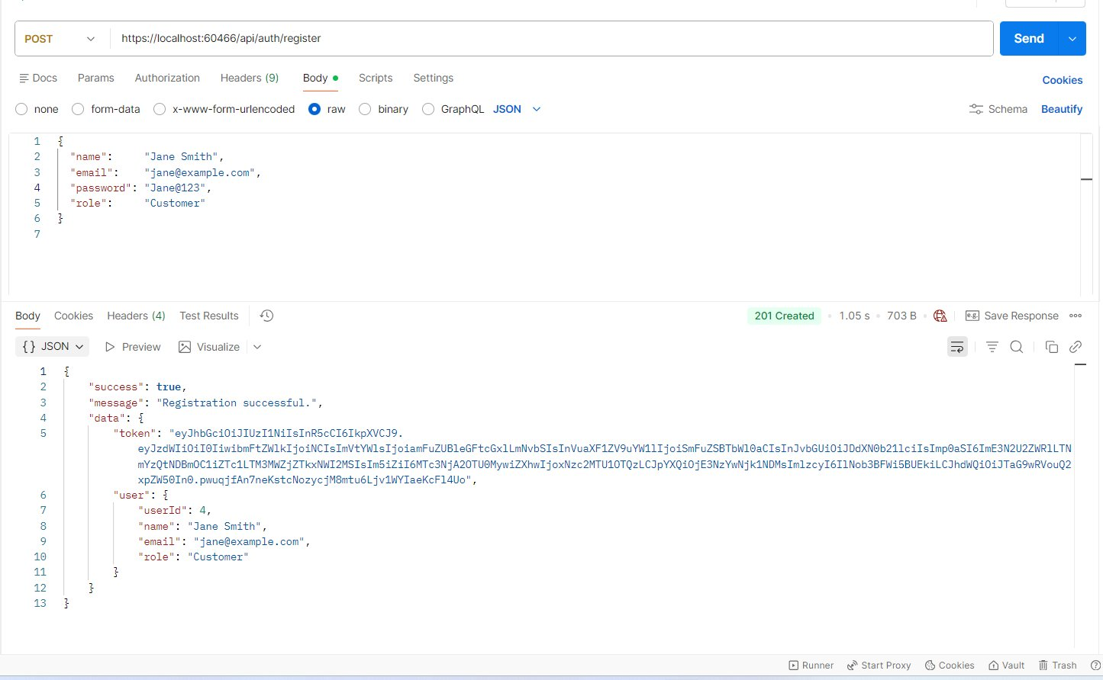
Fig 1 — POST /api/auth/register → 201 Created with JWT token

Screenshot: Register API — Duplicate Email (409 Conflict):
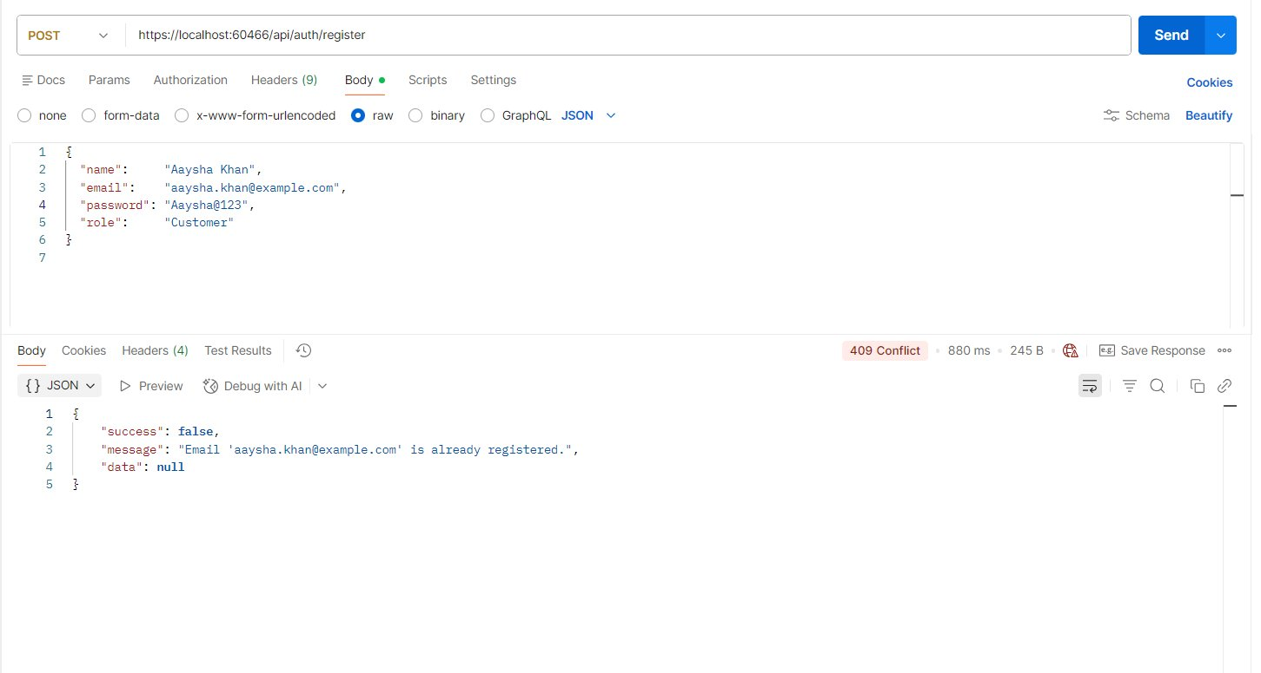
Fig 2 — POST /api/auth/register → 409 Conflict (email already exists)

Password Security (BCrypt)
Passwords are NEVER stored in plain text. ShopEZ uses BCrypt hashing before saving to the database.

BCrypt is a secure, industry-standard password hashing algorithm. It works like this:

- When you register, your plain-text password is passed through BCrypt
- BCrypt automatically adds a random salt and produces a unique hash every time
- The hash (not the password) is stored in the database
- When you login, BCrypt compares the plain-text password against the stored hash
- Even if two users have the same password, their hashes will be different

This protects against:
- Database leaks — attackers see only hashes, not real passwords
- Brute-force attacks — BCrypt is intentionally slow to compute
- Rainbow table attacks — the salt makes precomputed tables useless

Example of a BCrypt hash stored in the database:
Plain text: Admin@123
BCrypt hash stored in DB:
$2a$11$dlZGvJcs1Se5eeUk06PUL.NDFX.r7WEOg4J8WO38ztdi/D00X2O7m
// $2a = BCrypt algorithm version
// $11 = cost factor (2^11 = 2048 iterations — higher = slower = more secure)
// The rest = salt + hash combined

Screenshot: after register user Jane smith the user table SS:

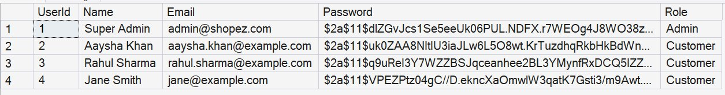
Fig 3 — Users table in SQL Server Management Studio

POST | /api/auth/login

Login with email and password. Copy the token from the response — you need it for all protected endpoints.
Auth: No token required (Public)

Request Body (JSON):
// Login as Admin
{
"email": "admin@shopez.com",
"password": "Admin@123"
}
// Login as Customer
{
"email": "aaysha.khan@example.com",
"password": "Aaysha@123"
}

200 OK — Login successful — JWT token returned
{
"success": true,
"message": "Login successful.",
"data": {
"token": "eyJhbGciOiJIUzI1NiIsInR5cCI6IkpXVCJ9...",
"user": { "userId": 1, "name": "Super Admin",
"email": "admin@shopez.com", "role": "Admin" }
}
}

401 Unauthorized — Wrong email or password
{ "success": false, "message": "Invalid email or password.", "data": null }

Screenshot: Login API — Token Generation:
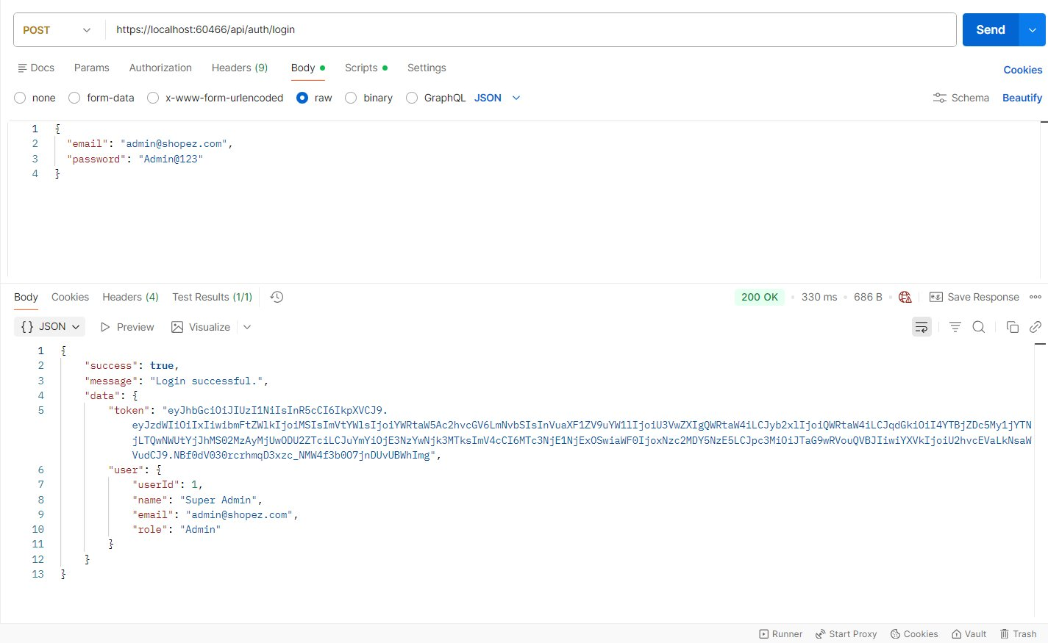
Fig 4 — POST /api/auth/login → 200 OK with JWT token

Product APIs

GET | /api/products

Returns all products sorted by name. No login needed.
Auth: No token required (Public)

200 OK — Products retrieved successfully
{
"success": true,
"message": "Products retrieved successfully.",
"data": [
{ "productId":4, "name":"Gaming Mouse", "price":1899.00, "stock":75 },
{ "productId":2, "name":"Mechanical Keyboard", "price":4499.00, "stock":30 },
{ "productId":5, "name":"Monitor Stand", "price":899.99, "stock":40 },
{ "productId":3, "name":"USB-C Hub", "price":1299.50, "stock":100 },
{ "productId":1, "name":"Wireless Headphones", "price":2999.99, "stock":50 }
]
}

Screenshot: GET All Products:
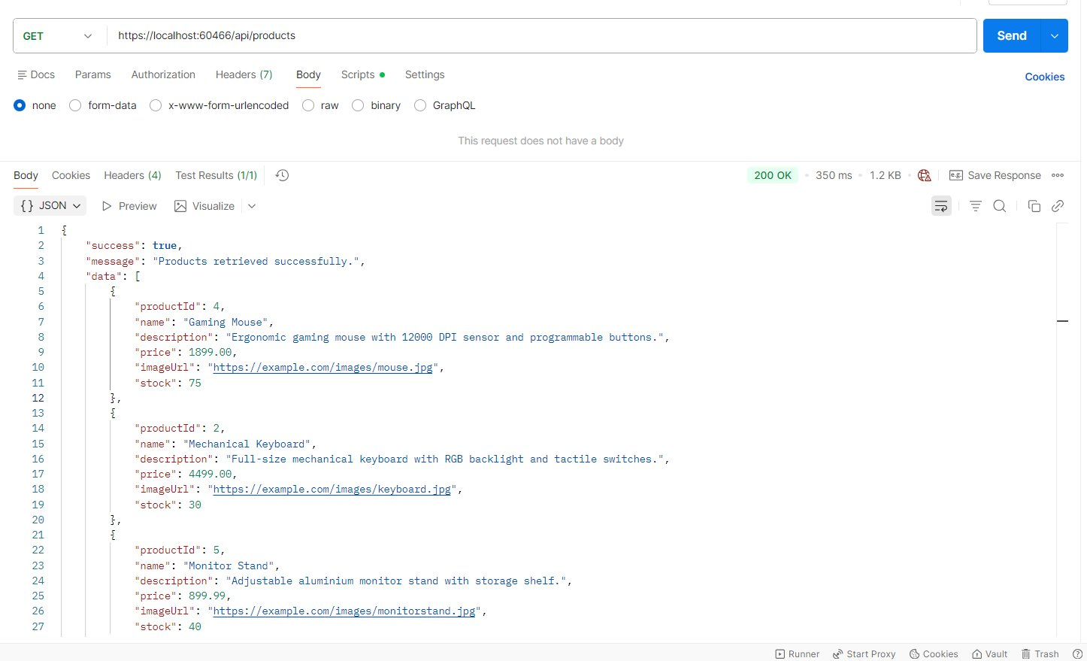
Fig 5 — GET /api/products → 200 OK (all 5 products)

GET | /api/products/{id}

Returns a single product by ID. The message shows which product ID was retrieved. Example: /api/products/1
Auth: No token required (Public)

200 OK — Product found
{
"success": true,
"message": "Product with ID 1 retrieved successfully.",
"data": {
"productId": 1,
"name": "Wireless Headphones",
"description": "Premium noise-cancelling wireless headphones with 30-hour battery life.",
"price": 2999.99,
"imageUrl": "https://example.com/images/headphones.jpg",
"stock": 50
}
}

404 Not Found — Product does not exist
{ "success": false, "message": "Product with ID 99 not found.", "data": null }

Screenshot: GET Product by ID:
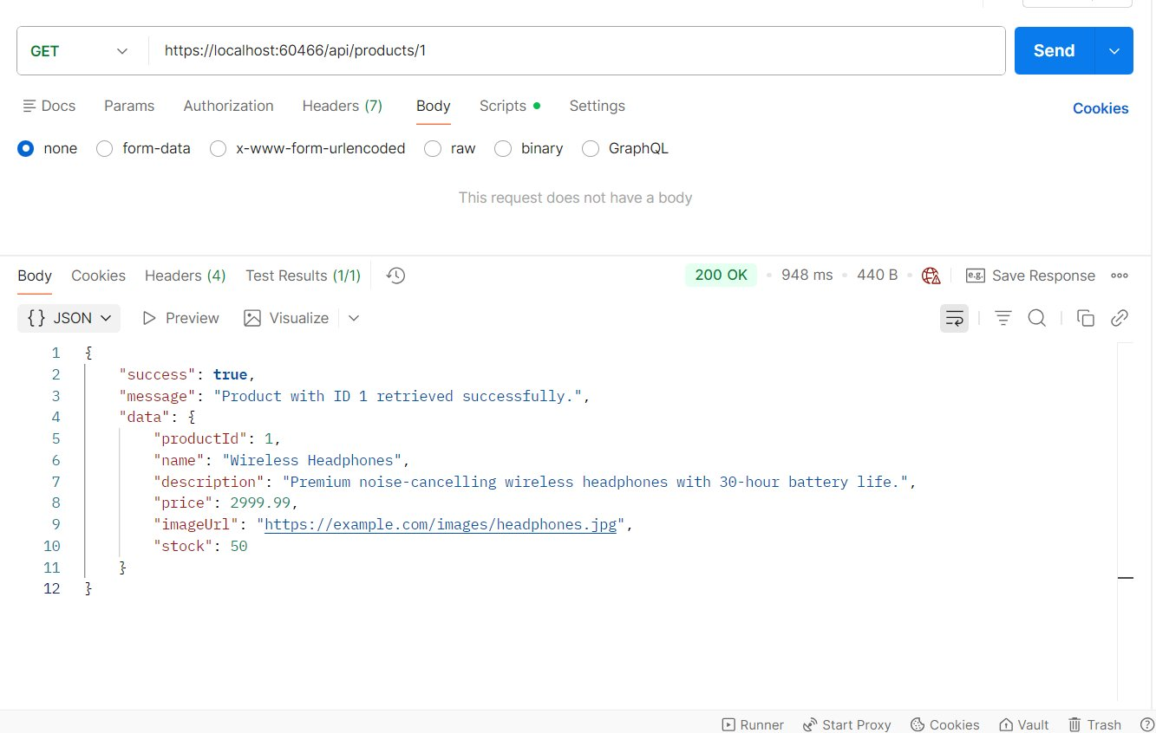
Fig 6 — GET /api/products/1 → 200 OK with product details

POST | /api/products

Create a new product. Only Admin can do this. Set Authorization → Bearer Token in Postman using the Admin token.
Auth: Admin token required | Customers get 403 Forbidden

Request Body (JSON):
{
"name": "Laptop Stand",
"description": "Ergonomic aluminium stand, holds laptops up to 17 inch.",
"price": 1499.99,
"imageUrl": "https://example.com/images/laptopstand.jpg",
"stock": 60
}

201 Created — Product created
{
"success": true,
"message": "Product created successfully.",
"data": { "productId":6, "name":"Laptop Stand", "price":1499.99, "stock":60 }
}

401 Unauthorized — No token sent
{ "success": false, "message": "You are not authenticated. Please login and provide a valid Bearer token.", "data": null }

403 Forbidden — Logged in as Customer
{ "success": false, "message": "You do not have permission to access this resource. Required role: Admin.", "data": null }

Screenshot: Create Product (Admin):
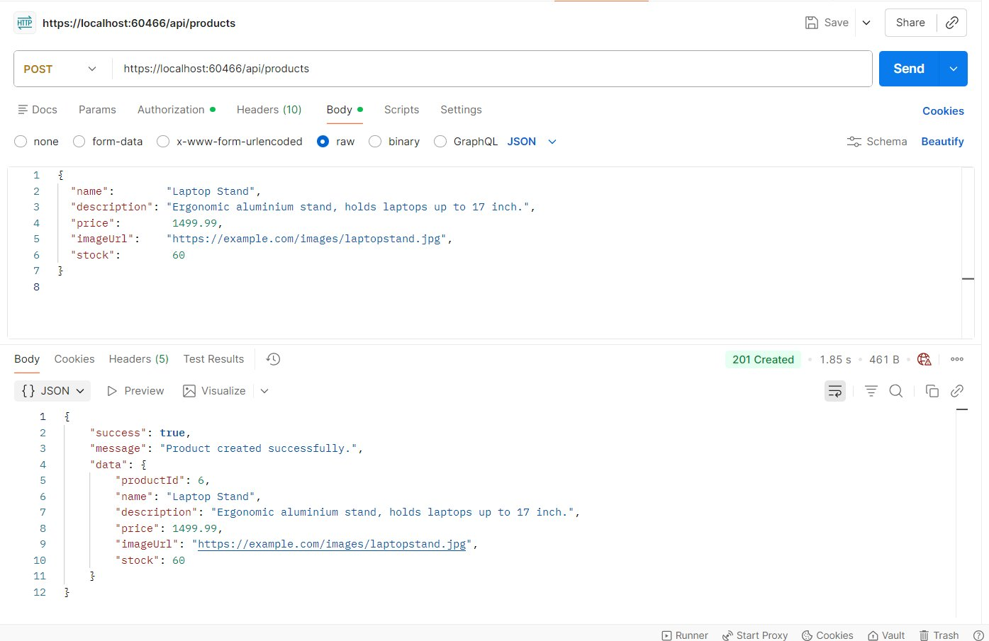
Fig 7 — POST /api/products → 201 Created (Admin token used)

PUT | /api/products/{id}

Update a product. Send all fields. Example: /api/products/1
Auth: Admin token required

Request Body (JSON):
{
"name": "Wireless Headphones Pro",
"description": "Updated — 40-hour battery with active noise cancellation.",
"price": 3499.99,
"imageUrl": "https://example.com/images/headphones-pro.jpg",
"stock": 45
}

200 OK — Product updated
{
"success": true,
"message": "Product updated successfully.",
"data": { "productId":1, "name":"Wireless Headphones Pro", "price":3499.99, "stock":45 }
}

404 Not Found — Product ID does not exist
{ "success": false, "message": "Product with ID 99 not found.", "data": null }

Screenshot: Update Product (Admin):
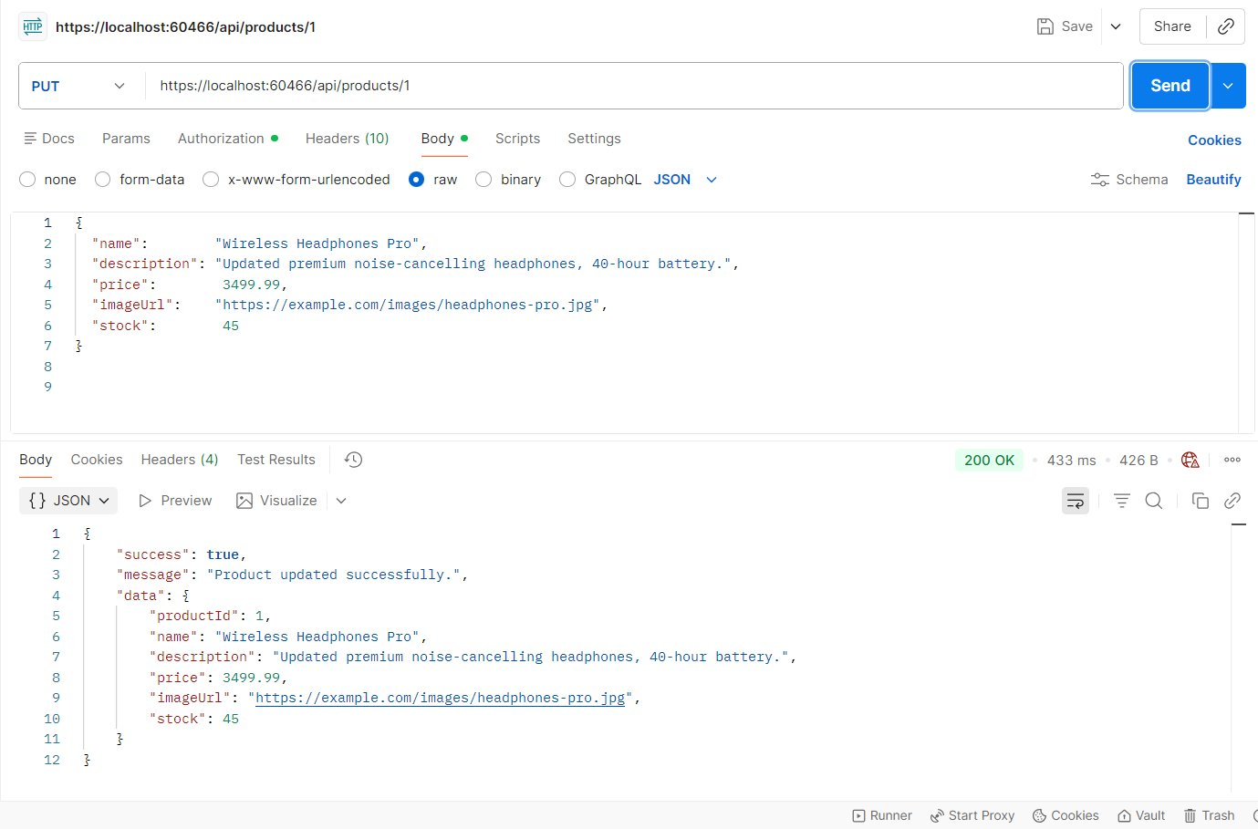
Fig 8 — PUT /api/products/1 → 200 OK (product updated)

DELETE | /api/products/{id}

Delete a product by ID. Example: /api/products/6
Auth: Admin token required

200 OK — Product deleted
{ "success": true, "message": "Product deleted successfully.", "data": {} }

404 Not Found — Product does not exist
{ "success": false, "message": "Product with ID 99 not found.", "data": null }

Screenshot: Delete Product (Admin):
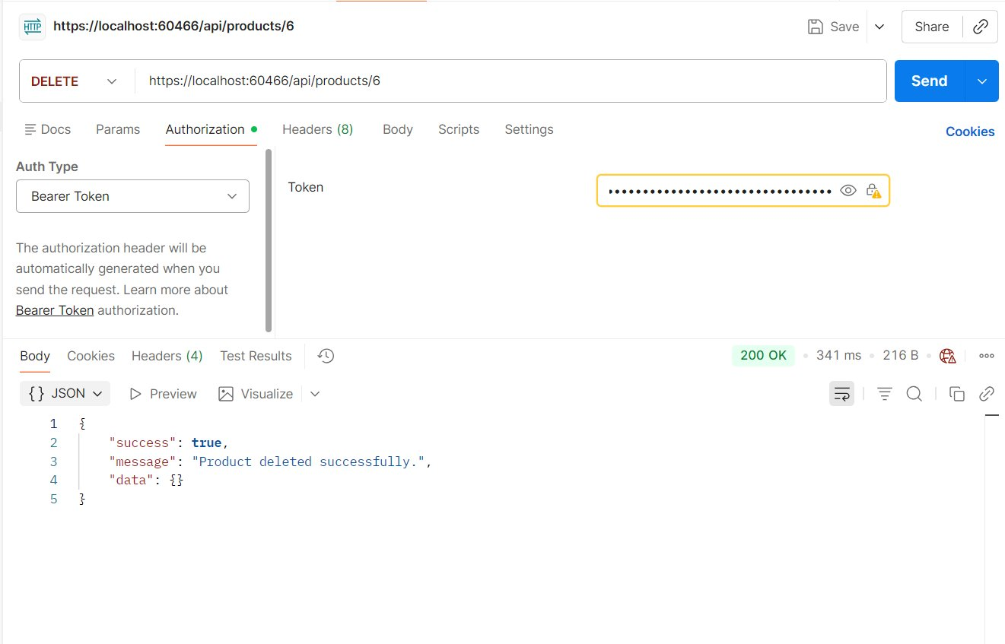
Fig 9 — DELETE /api/products/6 → 200 OK (product removed)

Order APIs
JWT token is required for all order endpoints.

POST | /api/orders

Place a new order. The UserId is NOT sent in the request body — it is automatically extracted from the JWT token. This ensures a Customer can only place orders for themselves.
Auth: Any logged-in user (Admin or Customer)

Request Body (JSON):
{
"cartItems": [
{ "productId": 1, "quantity": 2 },
{ "productId": 3, "quantity": 1 }
]
}
// Important: No userId in the request body.
// The server reads userId from your JWT token automatically.

201 Created — Order placed
{
"success": true,
"message": "Order placed successfully.",
"data": {
"orderId": 2, "userId": 3, "userName": "Rahul Sharma",
"orderDate": "2026-04-13T10:33:38Z",
"totalAmount": 8299.48,
"orderItems": [
{ "orderItemId":3, "productId":1, "productName":"Wireless Headphones Pro",
"quantity":2, "price":3499.99, "subtotal":6999.98 },
{ "orderItemId":4, "productId":3, "productName":"USB-C Hub",
"quantity":1, "price":1299.50, "subtotal":1299.50 }
]
}
}

409 Conflict — Insufficient stock
{ "success": false, "message": "Insufficient stock for 'Wireless Headphones'. Available: 2, Requested: 10.", "data": null }

404 Not Found — Product ID does not exist
{ "success": false, "message": "Product with ID 99 not found.", "data": null }

Screenshot: Create Order (Customer token):
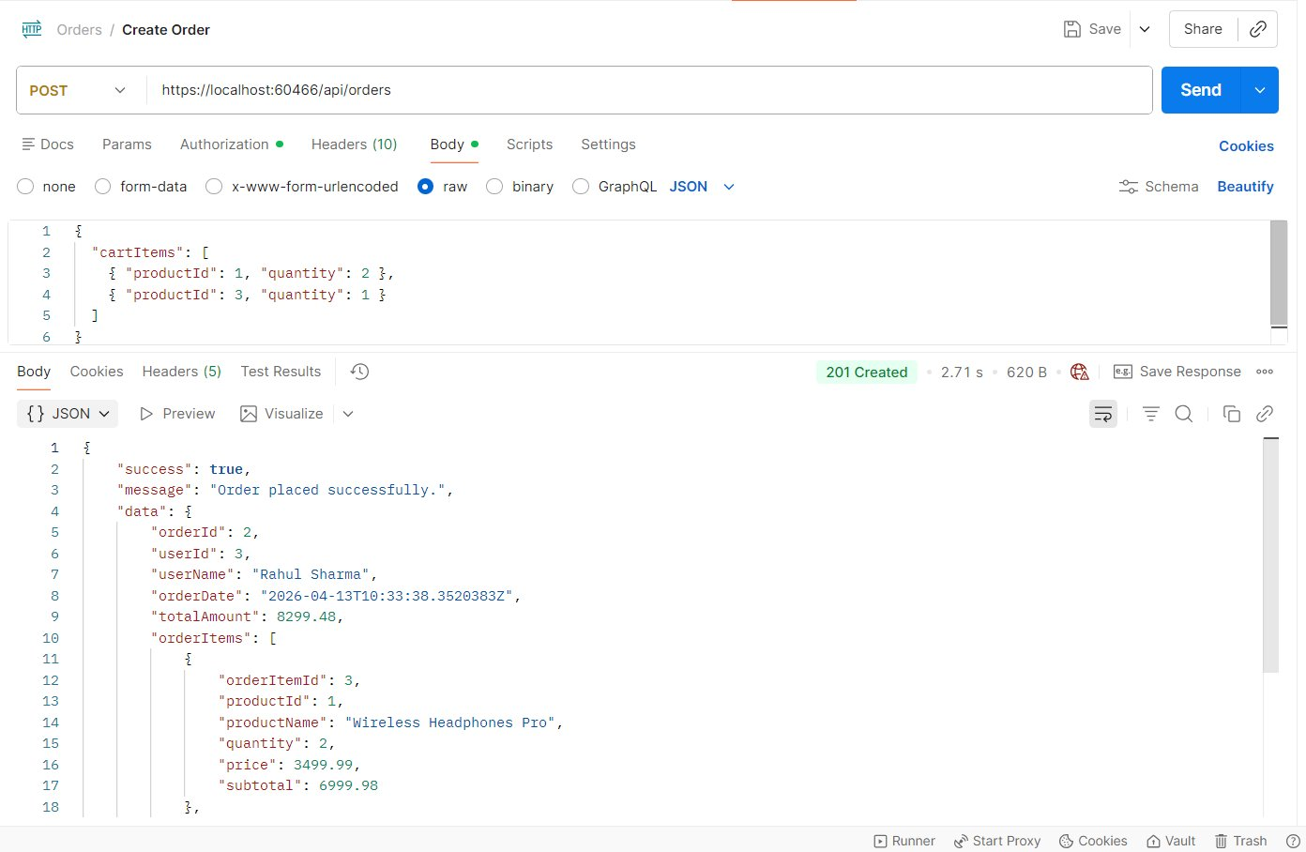
Fig 10 — POST /api/orders → 201 Created (userId from JWT token)

GET | /api/orders

Returns all orders from all users. Only Admin can see this.
Auth: Admin token required | Customers get 403

200 OK — All orders returned
{
"success": true,
"message": "Orders retrieved successfully.",
"data": [
{ "orderId":2, "userId":3, "userName":"Rahul Sharma", "totalAmount":8299.48, "orderItems":[ ... ] },
{ "orderId":1, "userId":2, "userName":"Aaysha Khan", "totalAmount":4299.00, "orderItems":[ ... ] }
]
}

403 Forbidden — Customer trying to see all orders
{ "success": false, "message": "You do not have permission to access this resource. Required role: Admin.", "data": null }

Screenshot: Get All Orders (Admin):
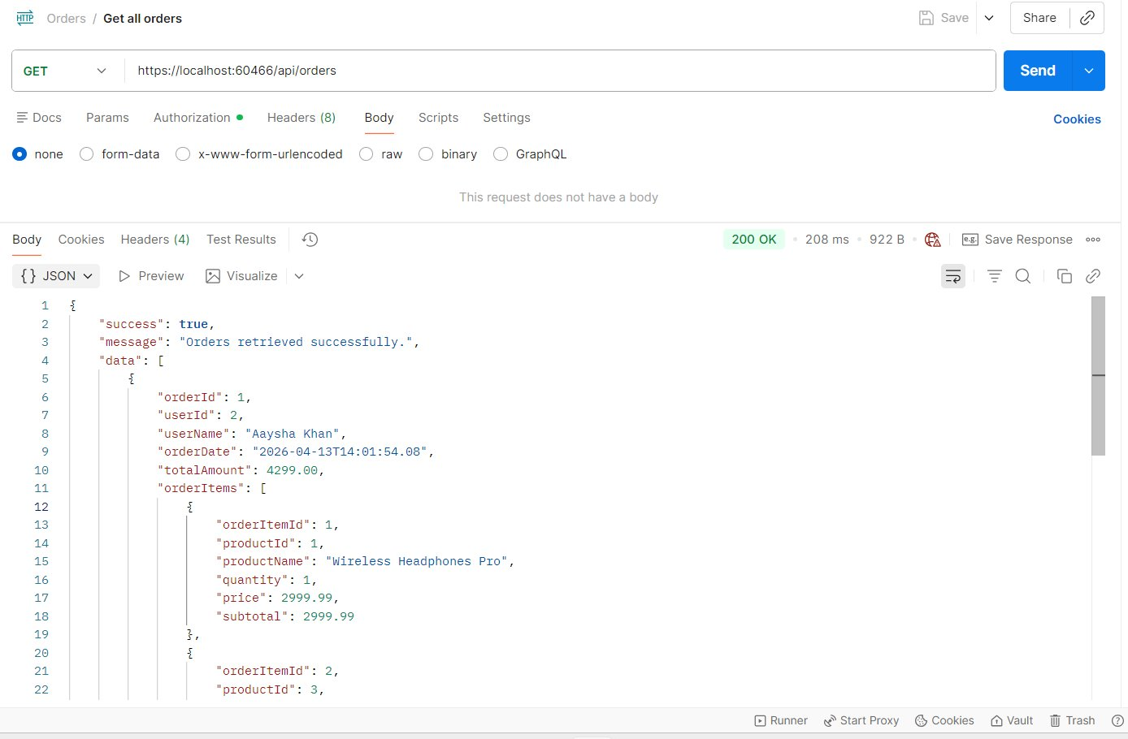
Fig 11 — GET /api/orders → 200 OK (Admin sees all orders)

Screenshot: Get All Orders — Postman Preview View:
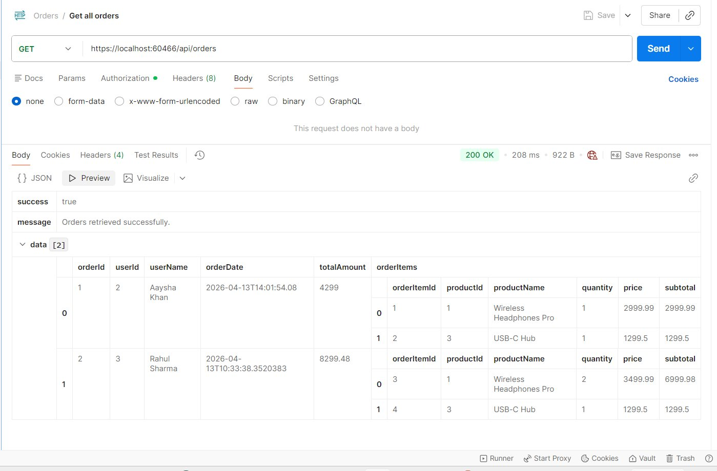
Fig 12 — GET /api/orders → Preview mode showing tabular order data

GET | /api/orders/{id}

Returns a single order by ID. Admin can view any order. A Customer can only view their own orders. Example: /api/orders/2
Auth: Admin = any order | Customer = own orders only

200 OK — Order found
{
"success": true,
"message": "Order with ID 2 retrieved successfully.",
"data": {
"orderId":2, "userId":3, "userName":"Rahul Sharma",
"orderDate":"2026-04-13T10:33:38Z", "totalAmount":8299.48,
"orderItems": [
{ "productName":"Wireless Headphones Pro", "quantity":2, "price":3499.99, "subtotal":6999.98 },
{ "productName":"USB-C Hub", "quantity":1, "price":1299.50, "subtotal":1299.50 }
]
}
}

403 Forbidden — Customer viewing another user's order
{ "success": false, "message": "You are not authorized to view this order.", "data": null }

404 Not Found — Order does not exist
{ "success": false, "message": "Order with ID 99 not found.", "data": null }

Screenshot: Get Order by ID:
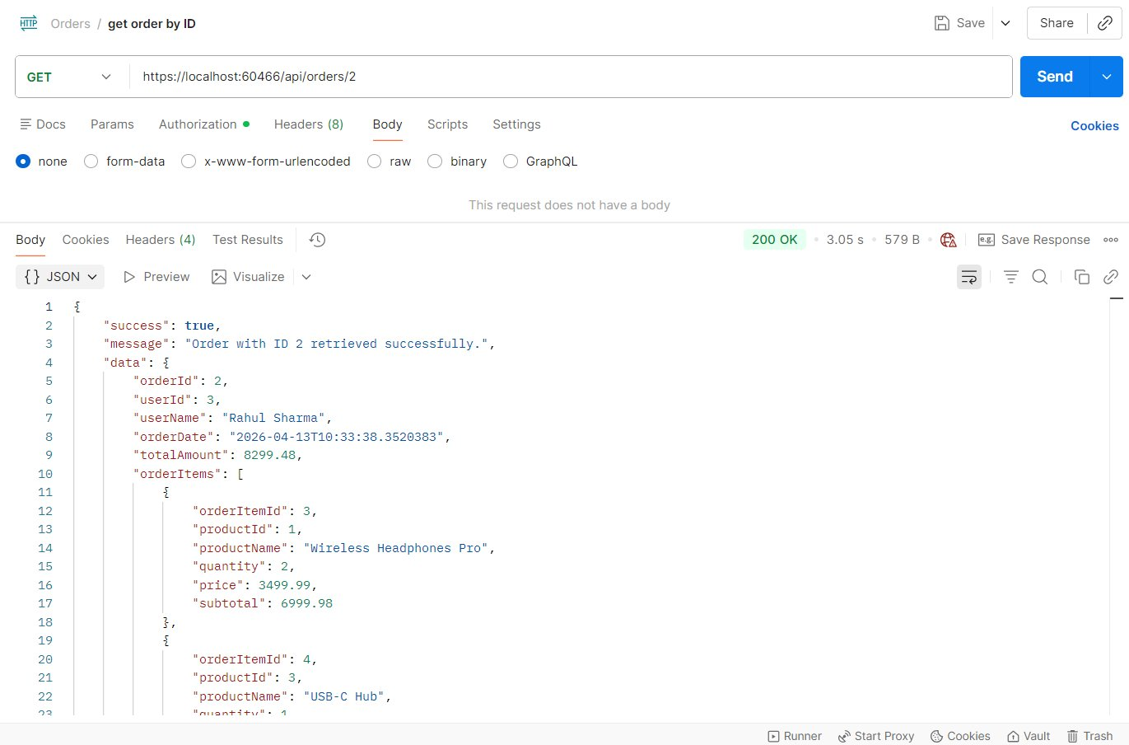
Fig 13 — GET /api/orders/2 → 200 OK with full order details

GET | /api/orders/user/{userId}

Returns all orders placed by a specific user. Returns empty list (not 404) if user has no orders. Example: /api/orders/user/2
Auth: Admin token required

200 OK — Orders returned for the user
{
"success": true,
"message": "Orders retrieved for user 2.",
"data": [
{ "orderId":1, "userId":2, "userName":"Aaysha Khan", "totalAmount":4299.00, "orderItems":[ ... ] }
]
}

200 OK — User has no orders — empty list (not an error)
{ "success": true, "message": "Orders retrieved for user 3.", "data": [] }

Screenshot: Get Orders by User ID:
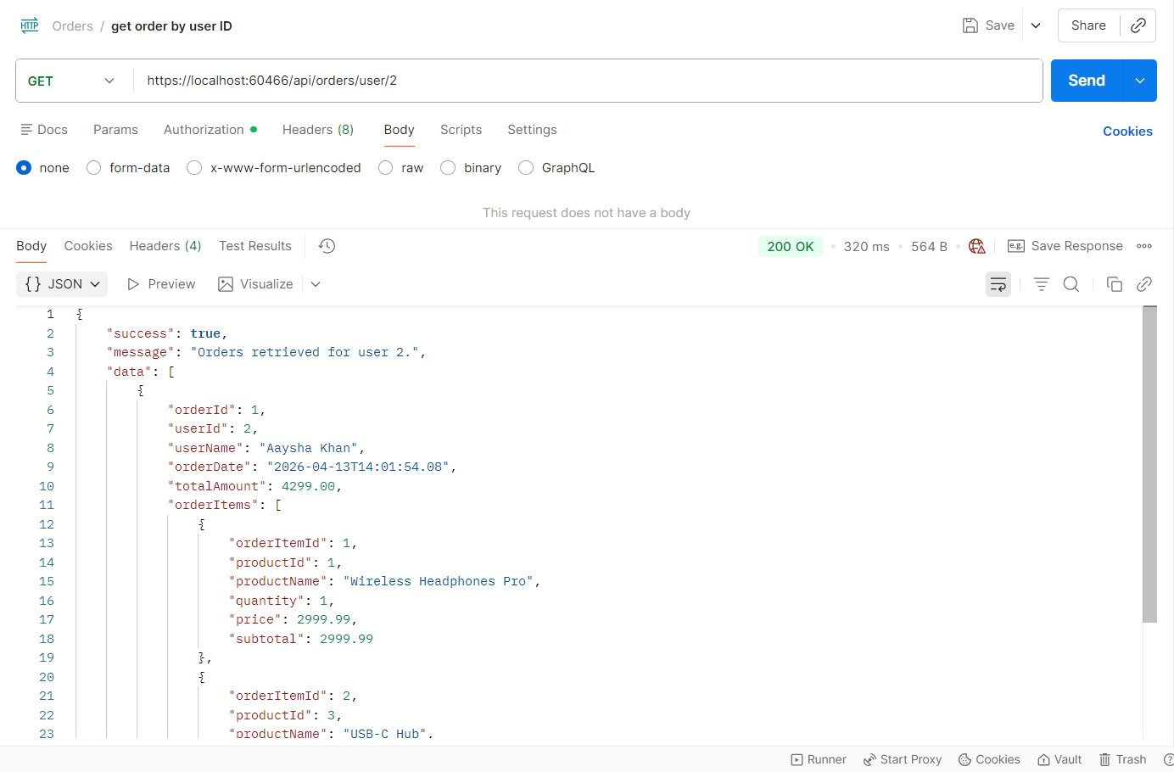
Fig 14 — GET /api/orders/user/2 → 200 OK (Aaysha Khan's orders)

5. Who Can Do What (Role Reference)

Endpoint | No Token | Customer | Admin
GET /api/products | Yes | Yes | Yes
GET /api/products/{id} | Yes | Yes | Yes
POST /api/products | 401 | 403 | Yes
PUT /api/products/{id} | 401 | 403 | Yes
DELETE /api/products/{id} | 401 | 403 | Yes
POST /api/orders | 401 | Yes (own) | Yes
GET /api/orders | 401 | 403 | Yes
GET /api/orders/{id} | 401 | Own only | Yes (any)
GET /api/orders/user/{id} | 401 | 403 | Yes
POST /api/auth/register | Yes | Yes | Yes
POST /api/auth/login | Yes | Yes | Yes

6. Step-by-Step Postman Testing
Make sure the project is running in Visual Studio (F5) before you start.

Step 1 — View Products (No Login Needed)
- Method: GET | URL: https://localhost:60466/api/products
- No Authorization needed
- Expected: 200 OK with all 5 products

Step 2 — Login as Admin
- Method: POST | URL: https://localhost:60466/api/auth/login
- Body (raw JSON):
{ "email": "admin@shopez.com", "password": "Admin@123" }
- Expected: 200 OK — copy the token from data.token
- In Postman: request → Authorization tab → Bearer Token → paste the token
The token stays valid for 24 hours. You only need to login once per session.

Step 3 — Create a Product (Admin)
- Method: POST | URL: https://localhost:60466/api/products
- Authorization: Bearer token (Admin)
- Body:
{
"name": "Smart Watch", "description": "Fitness tracker, 7-day battery.",
"price": 5999.00, "imageUrl": "https://example.com/smartwatch.jpg", "stock": 25
}
- Expected: 201 Created

Step 4 — Login as Customer
- Method: POST | URL: https://localhost:60466/api/auth/login
- Body:
{ "email": "aaysha.khan@example.com", "password": "Aaysha@123" }
- Expected: 200 OK — copy this customer token separately

Step 5 — Customer Places an Order
- Method: POST | URL: https://localhost:60466/api/orders
- Authorization: Bearer token (Customer — Aaysha Khan)
- Body:
{
"cartItems": [
{ "productId": 2, "quantity": 1 },
{ "productId": 4, "quantity": 2 }
]
}
- Expected: 201 Created — userId comes from token, not request body

Step 6 — Test Role Restrictions
Method | URL | Token Used | Expected
POST | /api/products | Customer | 403 Forbidden
GET | /api/orders | Customer | 403 Forbidden
POST | /api/products | No token | 401 Unauthorized
GET | /api/orders | Admin | 200 OK

Step 7 — Admin Views All Orders
- Method: GET | URL: https://localhost:60466/api/orders
- Authorization: Bearer token (Admin)
- Expected: 200 OK — all orders from every user

Step 8 — Get Orders for a Specific User
- Method: GET | URL: https://localhost:60466/api/orders/user/2
- Authorization: Bearer token (Admin)
- Expected: 200 OK — Aaysha Khan's orders

7. Error Reference

Code | Name | When It Happens | How to Fix
400 | Bad Request | Missing field, invalid email, price = 0, quantity = 0 | Read the message — it tells you which field is wrong
401 | Unauthorized | No token sent, token expired, wrong password | Login again at /api/auth/login and use the new token
403 | Forbidden | Token is valid but your role does not allow this | Use an Admin account for product write operations
404 | Not Found | Product or Order ID does not exist in the database | Check the ID is correct and exists in SQL
409 | Conflict | Email already registered, or insufficient stock | Use a different email, or reduce the order quantity
500 | Server Error | Unexpected error — usually a DB connection issue | Check connection string in appsettings.json

ShopEZ — ASP.NET Core 8 • Entity Framework • SQL Server • JWT Auth • BCrypt

