Japanoma — MVP Handover Report
  - Decision-aid platform for Australian buyers in Northern Japan
Craefto · Built for Go&C Partners
2026-05-07
Table of Contents

1 · Executive Summary
Japanoma is a decision-aid platform that helps Australian ski-lovers decide whether — and where — to buy a home base in Northern Japan snow country. It provides transparent total-cost models, practical due diligence, and introductions to licensed local professionals.
Brand promise: Own a Japan ski home base with clarity — not guesswork.
Operator: Go&C Partners (Kaz Yasumura, Director · Shiun, CMO). Builder: Craefto (Obi, Technical Lead · Sara, Project Manager).

What “MVP” means in this handover
The MVP is functionally complete, production-deployed, and gated behind a coming-soon page until Kaz signs off. Specifically:
- All 24 user-facing routes are built and verified returning HTTP 200 in production.
- 24 Postgres migrations applied to the live Supabase project.
- 459 tracked source files in the handover repository, build verified clean.
- Two production deployments running:
  - japanoma.vercel.app — original Craefto-account deploy, full site live.
  - japanoma-japanoma-2058s-projects.vercel.app — new Japanoma-account handover deploy, pre-launch with a coming-soon gate; reviewers bypass via ?preview=<key> cookie.
- Compliance scaffolding present (Privacy + Terms 11-section ToC, append-only acknowledgment audit log), flagged on-page as awaiting legal review before public release.
- Resend transactional email wired up; notifications routed to kaz@goandcpartners.com, craefto@gmail.com, admin@japanoma.com.au.

What’s deferred (not blocking handover)
- Legal counsel review of /privacy and /terms wording. Page banner is visible until lifted.
- Domain DNS — japanoma.com.au apex/www records to be pointed at Vercel.
- Resend domain verification — DKIM, SPF, DMARC records on japanoma.com.au for noreply@japanoma.com.au.
- Sentry / Plausible — env keys unset; add when those services are provisioned.
- Preview-scope env vars — Vercel CLI 50.41.0 has a non-interactive preview-scope add bug; preview env vars can be added via the Vercel dashboard if branch previews are needed.

How to read this document
Sections 2–4 give a technical reviewer enough to inspect the system end-to-end. Sections 5–7 are operations-focused (deploy, env, day-2). Section 8 captures pending work + tech debt. Section 9 lists every visible feature. Appendix A is the diagram set.

2 · Architecture

2.1 Tech stack at a glance
Layer | Choice
Framework | Next.js 15 · App Router · React 19 · React Server Components
Language | TypeScript 5
UI | shadcn/ui + Tailwind CSS v4 + bespoke “Ma Space” components
Database | Supabase Postgres (Sydney ap-southeast-2)
ORM | Drizzle 0.3x
Auth | Supabase Auth (email + password, anonymous-first sessions)
CMS | Sanity (production dataset)
Forms | React Hook Form + Zod
Charts | Recharts
State | TanStack Query + Zustand (quiz answers) + nuqs
3D map | three.js + @react-three/fiber + drei
Email | Resend
Analytics | Plausible (cookieless)
Errors | Sentry
Hosting | Vercel
Architectural decisions are documented in docs/adr/001-012 with rationale.

2.2 System architecture
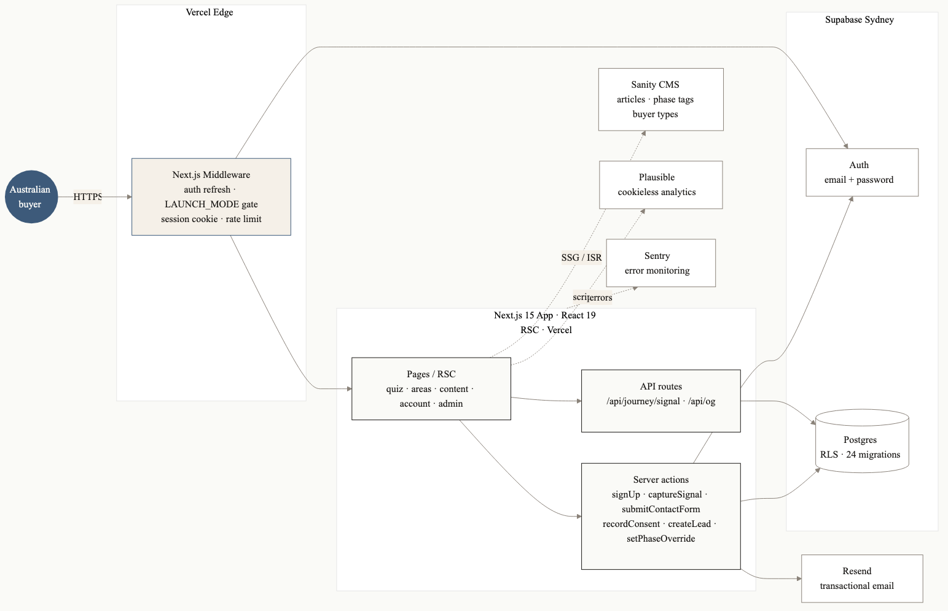
System architecture
The browser hits Vercel’s edge, where Next.js middleware enforces three responsibilities in order:
- Pre-launch gate — when LAUNCH_MODE=coming_soon, every public route 307-redirects to /coming-soon unless the visitor has the jt_preview_unlock cookie. Auth surfaces stay open.
- Auth refresh — Supabase session cookie refreshed in-place via updateSession.
- Analytics session — first-party jt_session UUID cookie set for anonymous event grouping.
Once past the gate, the request reaches a Next.js page (RSC by default). Server actions handle mutations (signup, quiz submit, lead capture, journey signal capture, contact form). API routes handle a small set of cross-component endpoints (/api/journey/signal, /api/og).
Outbound services are minimal:
- Supabase — auth and Postgres for all user data, journey state, leads, consent records, and the policy acknowledgment audit log.
- Sanity — editorial articles for the Content Hub (Kaz and Shiun edit there).
- Resend — transactional email for contact form + lead notifications.
- Plausible — page-view analytics, cookieless.
- Sentry — error monitoring (server + client + edge).

2.3 Deployment topology
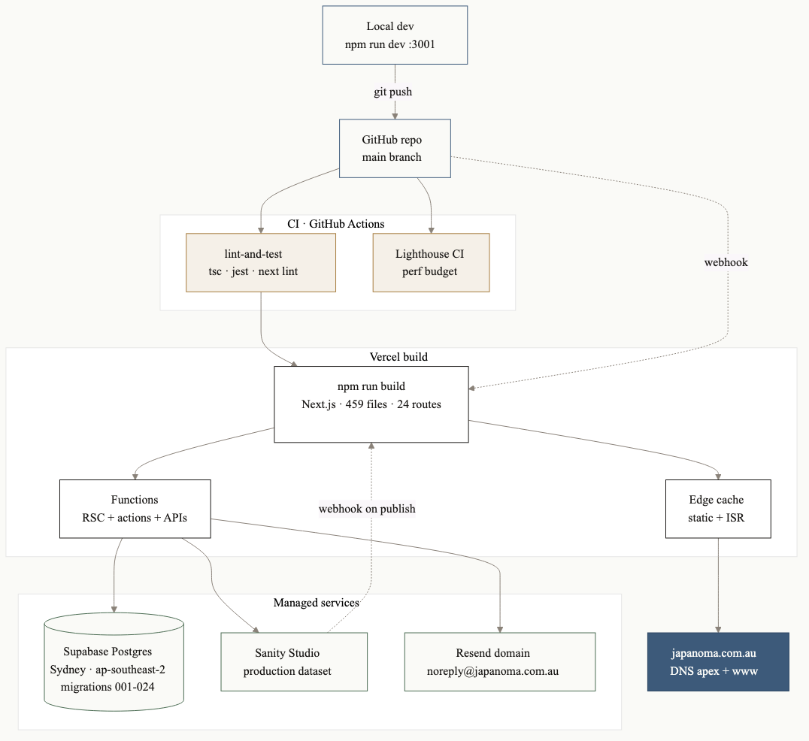
Deployment topology
Each git push to main triggers a Vercel build via webhook. CI (GitHub Actions) runs tsc --noEmit, jest, next lint, and Lighthouse CI in parallel. A successful build creates an immutable production deployment; the *.vercel.app alias is updated atomically. Custom domain japanoma.com.au (when configured) is mapped via Vercel’s DNS records.
Sanity Studio is deployed separately (sanity deploy). When an editor publishes a document, a webhook triggers Vercel ISR revalidation for the affected routes (/content, /content/[slug], etc.), so editorial changes go live within seconds.

3 · Codebase Structure
src/
app/ Next.js App Router routes
(auth)/ login · signup · password reset · verify email
account/ authenticated user dashboard
admin/ Go&C internal admin (gated by app_metadata.is_admin)
areas/ area directory · 3D map · city detail pages
content/ editorial Content Hub (Sanity-backed)
quiz/ 7-step recommendation quiz + results
contact/ contact form
coming-soon/ pre-launch brand page
privacy/ terms/ legal pages with sticky ToC
changelog/ user-facing release history (commit-derived)
api/ journey/signal · og · auth/confirm
components/
japandi/ bespoke Ma Space design system
ui/ shadcn/ui primitives, themed
journey/ D2L journey UI (filters, nav, notes, bookmarks)
legal/ legal-page shell + sticky ToC
photography/ full-bleed image, ken-burns hero
quiz/ quiz step rendering, icons, gauge
layout/ header / footer / shells
brand/ LogoMark + LogoLockup
lib/
db/ Drizzle schema + queries
supabase/ server / service / middleware clients
journey/ state machine, scoring, signal capture
quiz/ scoring algorithm + contact-context extraction
policies/ T&C / Privacy versioning + acknowledgment log
lead-capture/ consent records + leads
sanity/ client + GROQ queries + image builder
seo/ JSON-LD helpers
format/ currency / flight-time / origin formatters
data/ build-time data (e.g. area image blurs)
hooks/ shared React hooks
stores/ Zustand stores (quiz answers)
styles/ design tokens, motion utilities, Ma spacing
test-mocks/ Jest module shims for ESM-only deps
supabase/migrations/ 24 sequential SQL migrations (apply in order)
sanity/schemas/ Sanity content type definitions
public/ static assets (hero photography, fonts, OG art)
docs/ ADRs, architecture, requirements, personas, user stories
e2e/ Playwright tests
scripts/ build / data scripts
The full design-system reference is CLAUDE.md at the repo root — the canonical developer guide. Every new dev should read it first.

4 · Data Model

4.1 ERD overview
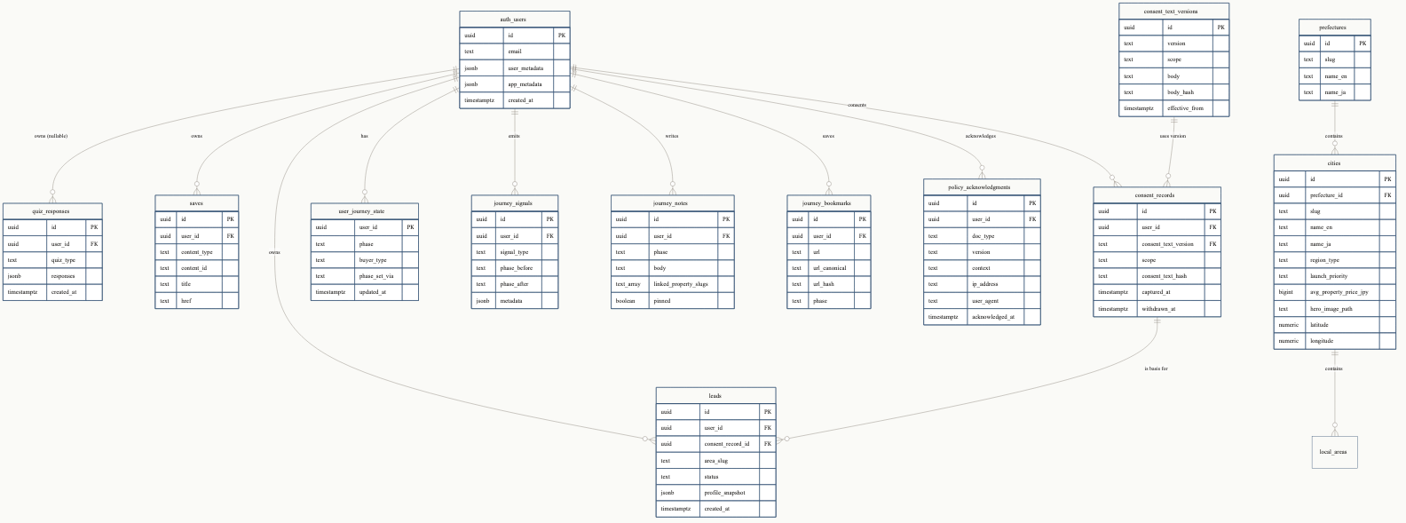
Database ERD
Supabase’s auth.users is the canonical identity. Domain tables fan out from there with user_id foreign keys, almost all governed by Row-Level Security policies that restrict reads to auth.uid() = user_id.

4.2 Migration history
24 sequential SQL files in supabase/migrations/:
# | File | What it adds
001 | init_schema.sql | Initial taxonomy + content scaffolding
002 | add_areas_to_personas.sql | Persona-area join
003 | auth_users.sql | Auth integration scaffolding
004 | seed_taxonomy.sql | Initial prefecture + city + region seeding
005 | cities_lat_lng.sql (early) | Lat/lng on cities
006 | quiz_responses.sql | Quiz response jsonb storage
007 | events.sql | Anonymous event tracking
008 | saves.sql | Saves table for content + areas
009 | consent_text_versions.sql | Versioned consent text
010 | consent_records.sql | Per-user consent capture
011 | leads.sql | Lead pipeline
012 | taxonomy_cra76_refresh.sql | Taxonomy update CRA-76
013 | taxonomy_cra76_refresh_data.sql | Data for above
014 | cities_hero_image_path.sql | Hero image paths on cities
015 | cities_municipality_population.sql | Municipality URL + population
016 | taxonomy_cra76_25apr_data.sql | April taxonomy refresh
017 | form_submissions.sql | Contact form + lead source storage
018 | cities_lat_lng.sql | Lat/lng coordinates for the 3D map
019 | fix_yamanouchi_spelling.sql | Typo fix
020 | taxonomy_latest_sync.sql | Latest taxonomy sync
021 | journey_tables.sql | D2L journey: state, signals, notes, bookmarks, og_cache
022 | rate_limit.sql | Token-bucket rate limit table
023 | policy_acknowledgments.sql | T&C / Privacy audit log (append-only)
024 | remove_shimotakai_taxonomy.sql | Removed irregular district listing
To apply on a fresh Supabase project: run each file in order via the Supabase SQL Editor or supabase db push. Migration order is significant — later migrations reference earlier tables.

4.3 Notable data conventions
- Anonymous-first sessions. Quiz responses + saves can be created without an account. On signup, a server action migrates anonymous rows to the new user_id via a session-cookie match.
- Consent records are append-only. A “withdrawal” sets withdrawn_at, never deletes. Same for policy_acknowledgments.
- Account deactivation is reversible. auth.users.user_metadata.deactivated_at is the soft-delete flag; on next signin the flag clears automatically.
- RLS is the boundary. Service-role writes are reserved for server actions that need to bypass RLS (e.g. signup-time policy log inserts). Public API never has service-role.

5 · Authentication & Compliance

5.1 Signup flow with policy capture
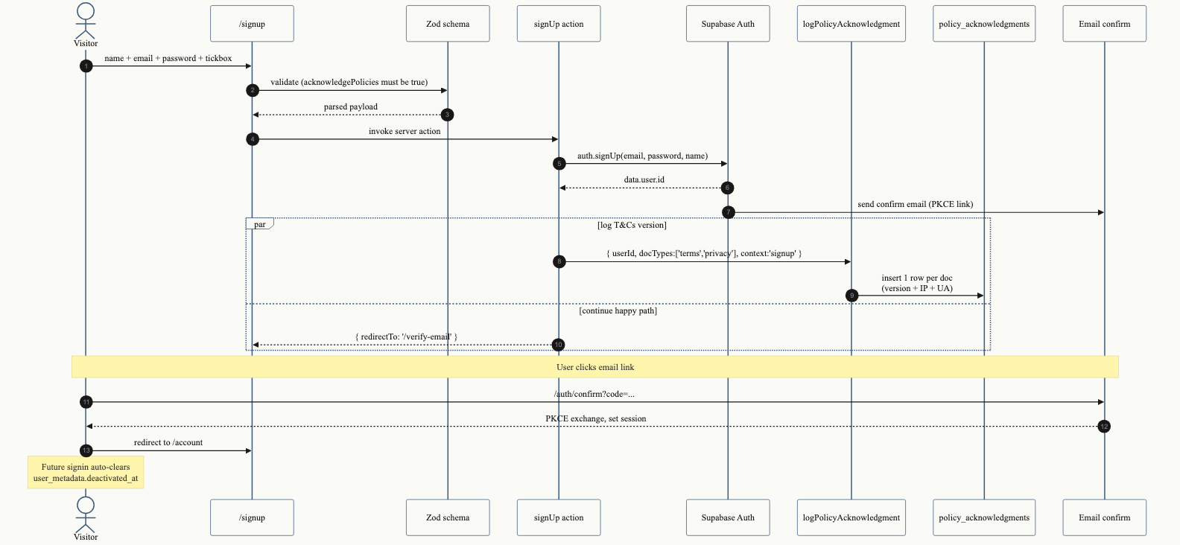
Auth and signup flow
The required tickbox on /signup enforces acknowledgment of both Terms & Conditions and Privacy Policy via Zod (acknowledgePolicies: z.literal(true)). On successful auth.signUp, a server-only helper writes one row per doc type into policy_acknowledgments:
user_id · doc_type ('terms'|'privacy') · version · ip_address ·
user_agent · context ('signup'|'reacknowledgment') · acknowledged_at
Rows are never updated or deleted. Account deletion sets user_id = NULL (anonymises) but the audit row survives indefinitely — that’s the legal record of what version the user accepted, when, and from where.

5.2 Versioning and re-acknowledgment
Single source of truth: src/lib/policies/versions.ts.
export const TERMS_VERSION = '1.0';
export const TERMS_LAST_UPDATED = '2026-05-06';
export const PRIVACY_VERSION = '1.0';
export const PRIVACY_LAST_UPDATED = '2026-05-06';
When counsel finalises wording, the team:
- Updates the version constant + lastUpdated.
- Removes the on-page “Awaiting legal review” banner from LegalShell.
- Deploys.
A version mismatch between a user’s last policy_acknowledgments row and the live TERMS_VERSION / PRIVACY_VERSION surfaces in the /account sidebar in kohaku amber as “Stale”. Re-acknowledgment middleware that prompts on next signin is a planned follow-up phase.

5.3 Privacy Policy structure
The 11 sections per regulatory ToC structure:
- Types of Personal Information We Collect and Why
- How We Collect Your Personal Information
- How We Use Your Personal Information
- How We Disclose Your Personal Information
- International Transfer of Personal Information
- How We Secure Your Personal Information
- How We Retain Your Personal Information
- Your Choices and Rights
- Other Important Information
- Jurisdiction-Specific Notices (AU · JP · EU/UK · CA)
- Contact Us
The page renders with a sticky desktop ToC, anchor links per section, and a version + last-updated header. The starter copy aligns with the Privacy Act 1988 (AU), APPI (JP), and GDPR / UK GDPR principles.

5.4 Lead capture and consent
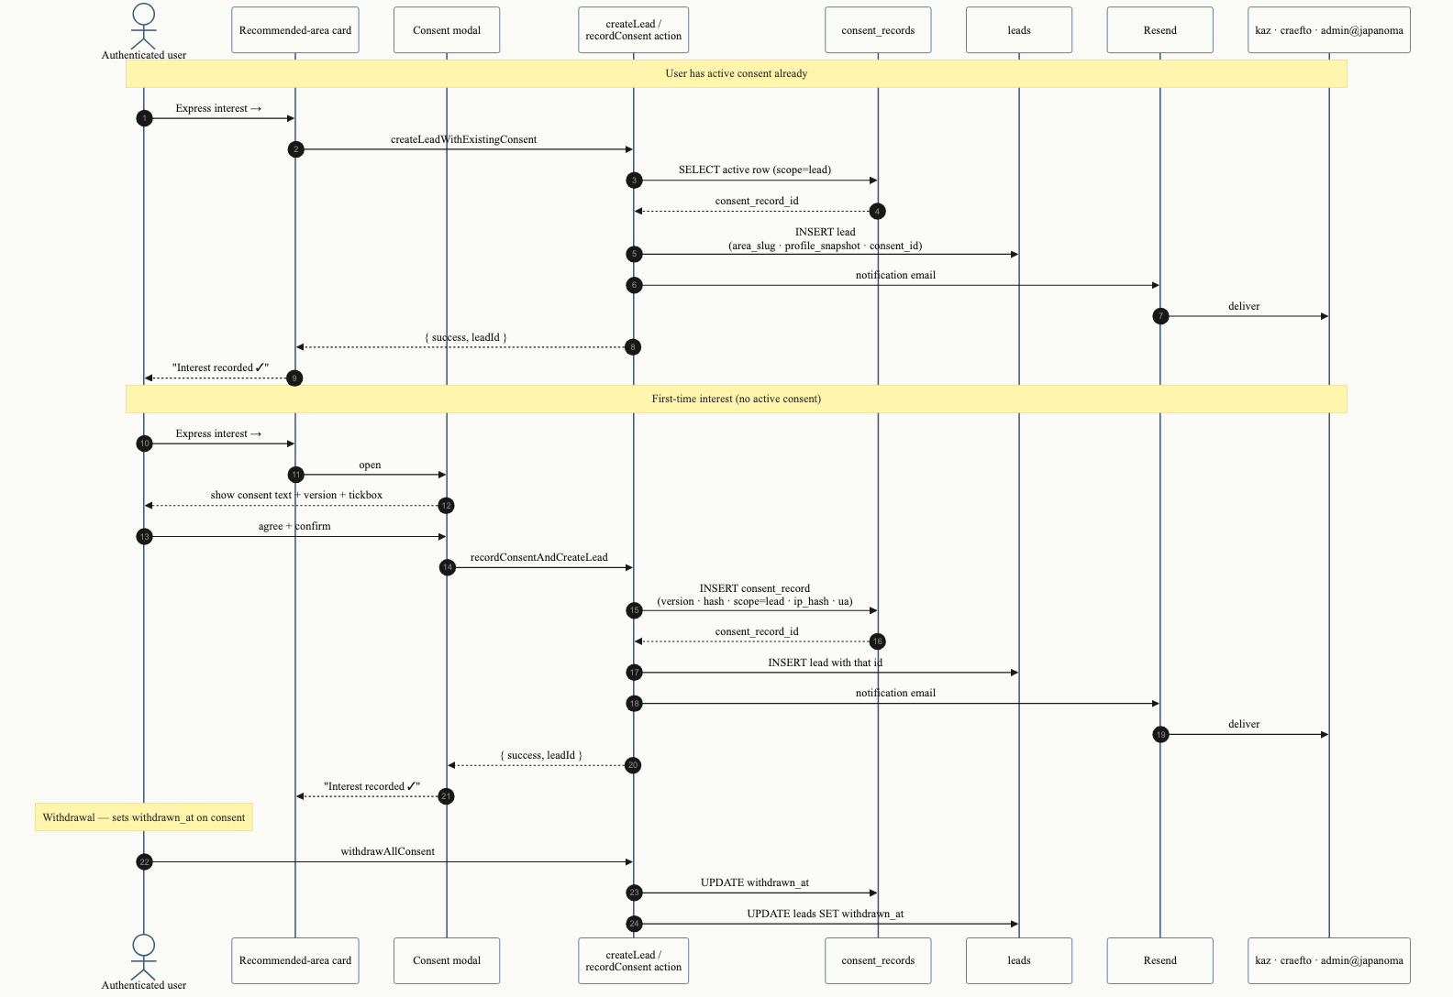
Lead capture flow
The Express-Interest button on each recommended-area card triggers one of two paths:
- Existing active consent → createLeadWithExistingConsent reads the latest active consent_records row, inserts a leads row, fires a Resend notification.
- First-time interest → recordConsentAndCreateLead opens a consent modal showing the current consent_text_versions row. On confirm, a consent_records row is inserted with the version, body hash, scope, IP hash (salted via CONSENT_IP_HASH_SALT), and UA. Then the lead is inserted referencing that consent record.
Withdrawal sets withdrawn_at on the consent row + cascades to all leads under it; the user sees confirmation. The append-only audit chain is preserved.

6 · Key User Journeys

6.1 Decision-to-Living (D2L) journey
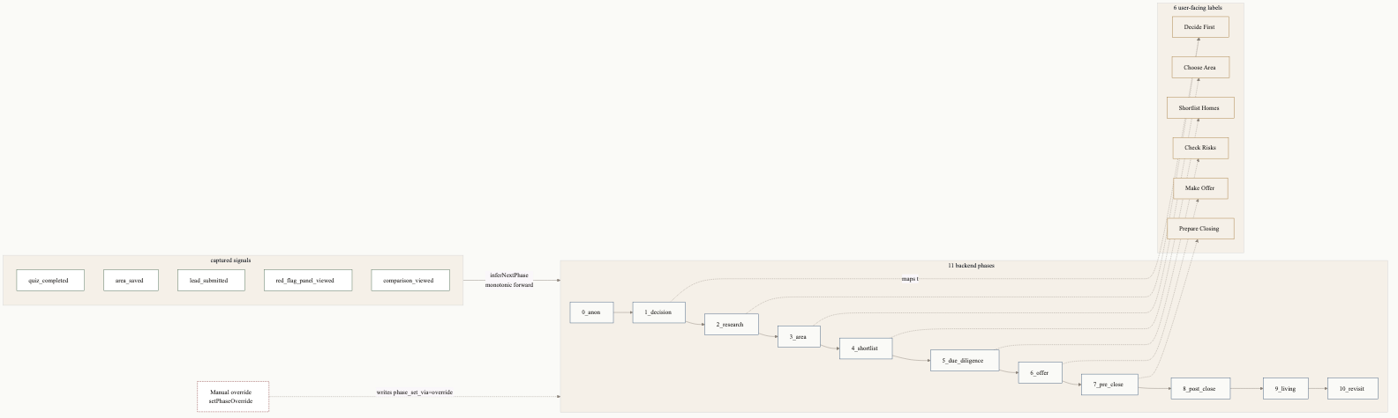
D2L user journey
The D2L model maps the buyer’s full decision lifecycle into 11 backend phases (0_anon → 10_revisit). The visible UI collapses these to 6 user-facing labels (Decide · Area · Shortlist · Risks · Offer · Closing) so the buyer doesn’t see internal granularity.

Phase advancement is monotonic forward by signal.
User actions emit signals through captureSignal:
Signal | Inferred phase advance
quiz_started | → 1_decision
quiz_completed | → 2_research
area_saved | → 3_area
comparison_viewed | → 4_shortlist
red_flag_panel_viewed | → 5_due_diligence
lead_submitted | → 6_offer
inferNextPhase(current, signal) is pure and monotonic — a signal can advance the phase but never regress it. This protects against accidental rollbacks (e.g. a user re-takes the quiz at phase 6 — they don’t get demoted to phase 2).

Manual override.
setPhaseOverride (server action, rate-limited via rate_limit table) lets a user pin their phase explicitly via the journey nav-map sheet. Sets phase_set_via='override' so analytics can distinguish inferred vs. self-reported state.

6.2 Recommendation quiz
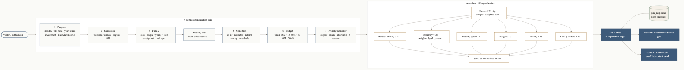
Quiz flow
The 7-step quiz is the platform’s primary conversion surface. Each step uses a measured cascade entrance (title 0ms → subtitle 70ms → answer cards 140ms + 35ms each) for an editorial reveal cadence.

Scoring breakdown (out of 100, normalised from /98).
Dimension | Weight | Source
Purpose × region affinity | 0–22 | PURPOSE_AFFINITY lookup
Proximity × ski_season | 0–22 | carToSlopeMin weighted by SEASON_WEIGHT
Property type × region | 0–13 | TYPE_AFFINITY lookup, best of selection
Budget × content priority | 0–13 | scoreBudget
Priority tiebreaker | 0–18 | scorePriority
Family composition × municipal culture | 0–10 | FAMILY_AFFINITY lookup
Top 3 cities are persisted as a JSONB snapshot to quiz_responses.responses and rendered on /quiz/results, the /account recommended-areas grid, and pre-fill the /contact?source=quiz form.

6.3 Content Hub filtering
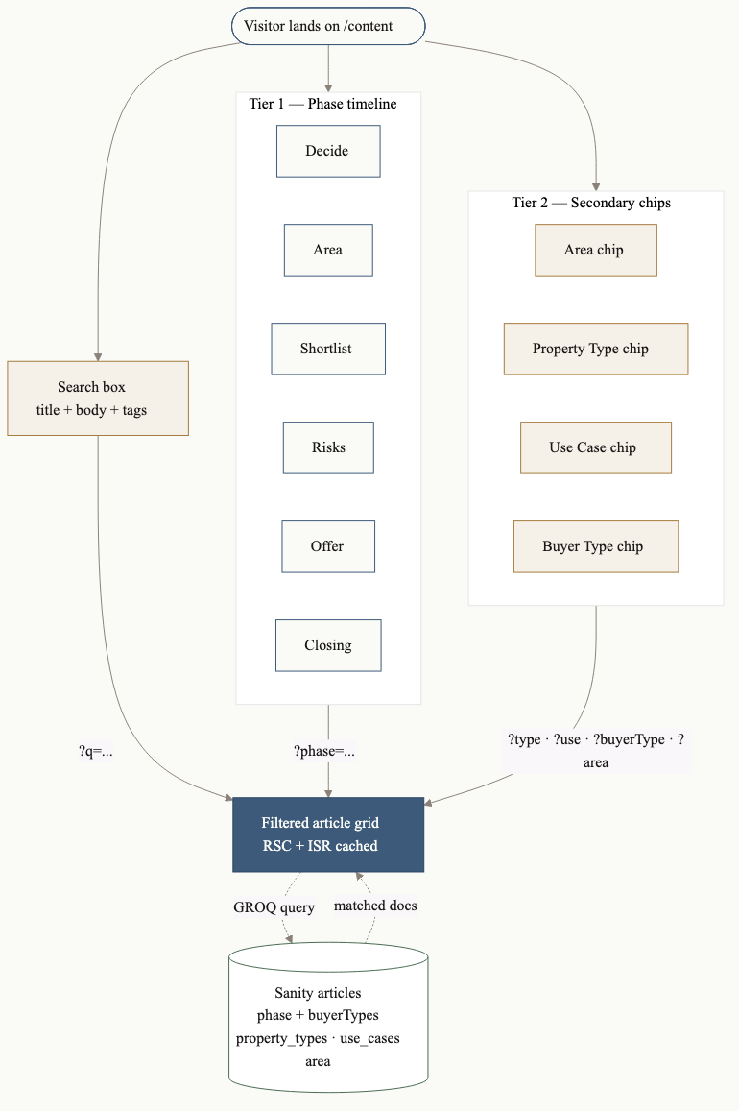
Content Hub filter
Two-tier filter UX:
- Tier 1 — phase timeline with 6 numbered nodes connected by a hairline track. Inferred user phase highlighted with an indigo ring; active filter scaled-up with a soft glow. Click any node → ?phase=... query param.
- Tier 2 — secondary chips for Area, Property Type, Use Case, Buyer Type. Multi-select, additive.
Sanity-side, articles are tagged with phaseTag[] and buyerTypeTag[] document references. The GROQ query in getFilteredArticles filters on the URL params and returns the matched documents. Search is title + body + tag full-text.

7 · Operations Runbook

7.1 Deploy a code change
# Local check
npm run build # Next.js + lint
npm test # Jest
npm run e2e # Playwright (when relevant)
# Ship
git checkout -b <branch>
# ... commit ...
gh pr create --base main --title "..." --body "..."
gh pr merge <num> --merge
# Vercel auto-deploys on merge to main.

7.2 Apply a Supabase migration
Place a new SQL file in supabase/migrations/NNN_description.sql. Apply via:
- Dashboard — Supabase SQL Editor (paste, run).
- CLI — supabase db push after supabase link --project-ref <ref>.
- MCP — mcp__supabase__apply_migration (Claude Code dev sessions).
Always re-generate types after schema changes:
# Supabase CLI:
supabase gen types typescript --project-id <ref> > src/lib/supabase/database.types.ts
Or via MCP: mcp__supabase__generate_typescript_types.

7.3 Bump a policy version
// src/lib/policies/versions.ts
export const TERMS_VERSION = '1.1'; // was '1.0'
export const TERMS_LAST_UPDATED = '2026-06-15';
Then:
- Remove the reviewNotice prop from <LegalShell> in the affected page (privacy or terms) once counsel has finalised wording.
- Push and deploy.
- Existing user acknowledgments are now “stale” — surfaced in /account sidebar. The re-acknowledgment middleware (planned) will gate next signin.

7.4 Rotate the Vercel preview-bypass key
cd ~/Desktop/japanoma-handover # only relevant for the handover deploy
NEW_KEY=$(openssl rand -hex 16)
echo "$NEW_KEY" # copy this — it's the new bypass URL parameter
npx vercel env rm PREVIEW_KEY production --yes
npx vercel env rm PREVIEW_KEY development --yes
printf '%s' "$NEW_KEY" | npx vercel env add PREVIEW_KEY production
printf '%s' "$NEW_KEY" | npx vercel env add PREVIEW_KEY development
npx vercel --prod --yes
Old jt_preview_unlock cookies remain valid until they expire (30 days) — to revoke immediately, the user clears their cookies or you change cookie name in src/middleware.ts.

7.5 Take the site live (lift the coming-soon gate)
Two options on the handover Vercel deploy:
- Remove the env var entirely (recommended): npx vercel env rm LAUNCH_MODE production then redeploy.
- Set to a non-coming_soon value: printf 'live' | npx vercel env add LAUNCH_MODE production.
Either takes effect on the next request — no rebuild needed (the env is read at runtime in middleware).

7.6 Read deploy logs
# Specific deploy by URL slug or ID
npx vercel logs <deploy-url>
# All recent deploys (status + duration)
npx vercel ls

7.7 View Supabase logs
mcp__supabase__get_logs with one of: api · postgres · edge-function · auth · storage · realtime. Or via Supabase Dashboard → Logs.

8 · Environment Reference
Required env vars, copied from .env.example. Never commit .env.local — .gitignore blocks it; git add -A defences also block accidental binary-doc commits.

8.1 Database + Supabase
Var | Required | Where | Description
DATABASE_URL | yes | server | Supabase pooler URL for Drizzle queries
NEXT_PUBLIC_SUPABASE_URL | yes | client + server | https://<ref>.supabase.co
NEXT_PUBLIC_SUPABASE_ANON_KEY | yes | client + server | Public anon key
SUPABASE_SERVICE_ROLE_KEY | yes | server only | Service-role key — bypasses RLS; production scope only

8.2 Auth
Var | Required | Description
AUTH_SECRET | yes | 32-byte hex; rotate per environment
AUTH_URL | yes | Public site URL (used in PKCE redirect targets)
AUTH_UI_ENABLED | yes | 'true' to expose /login, /signup, etc. Otherwise routes 404.

8.3 Sanity
Var | Required | Description
NEXT_PUBLIC_SANITY_PROJECT_ID | yes | Sanity project ID
NEXT_PUBLIC_SANITY_DATASET | yes | Usually production
SANITY_WEBHOOK_SECRET | yes | Secret used to verify Sanity → Vercel ISR webhook

8.4 Observability + analytics
Var | Required | Description
NEXT_PUBLIC_PLAUSIBLE_DOMAIN | optional | Plausible domain; omit to skip analytics
NEXT_PUBLIC_SENTRY_DSN | optional | Sentry DSN; omit to skip error monitoring
NEXT_PUBLIC_SITE_URL | yes | Canonical site URL for OG tags + sitemap

8.5 Lead capture + email
Var | Required | Description
CONSENT_IP_HASH_SALT | yes | 64-char hex. Lifetime-stable — rotating breaks IP correlation across consent records
RESEND_API_KEY | optional | Resend API key. If unset, sends silently no-op (dev-safe)
EMAIL_FROM | yes if Resend | Japanoma <noreply@japanoma.com.au> style. Sending domain must be verified in Resend
EMAIL_NOTIFICATIONS_TO | yes if Resend | Comma-separated internal recipients

8.6 Pre-launch gate (handover deploy only)
Var | Required | Description
LAUNCH_MODE | optional | coming_soon redirects all public routes to /coming-soon. Anything else (or unset) = live
PREVIEW_KEY | required if gate on | Random 32-char hex. ?preview=<KEY> sets a 30-day cookie that bypasses the gate

9 · Feature Inventory

9.1 Public surfaces
Route | What it does
/ | Editorial hero, value prop, three featured calculators
/quiz | 7-step recommendation quiz with cascade entrance + scoring
/quiz/results | Top-3 area cards with AVIF imagery + AUD prices + flight time
/areas | Searchable directory + 3D Japan map view (toggleable)
/areas/[prefecture]/[city] | City detail page with hero, stats, JA copy chip + outbound search links
/content | Editorial Content Hub with phase timeline + secondary filters
/content/[slug] | Article reader with phase tag + buyer-type chips
/contact | Contact form with editorial Field component, Resend integration
/privacy · /terms | Compliance pages with sticky ToC; awaiting legal review banner
/changelog | Commit-derived release history
/about | Operator + brand story
/coming-soon | Pre-launch brand page (only visible behind LAUNCH_MODE gate)

9.2 Authenticated user surfaces
Route | What it does
/account | Concierge sidebar + recommended areas grid + saved items + journey notes + bookmarks + export
/login | Email + password sign in with auto-reactivation
/signup | Account creation with required T&C / Privacy tickbox
/verify-email | Email verification holding screen
/forgot-password · /reset-password | Password recovery flow

9.3 Admin surfaces (gated by app_metadata.is_admin)
Route | What it does
/admin | Hub for internal Go&C tools
/admin/leads | Lead pipeline with CSV export
/admin/quiz-stats | Quiz response analytics

9.4 Calculator tools
The home page features three flagship calculators:
- Total Cost of Ownership — annual upkeep (taxes, management, snow load insurance, utilities) layered onto purchase price.
- AUD ↔ JPY — converter with real-time rate (manually maintained: JPY_AUD_RATE constant in src/lib/quiz/questions.ts).
- Flight Time — Sydney/Melbourne/Brisbane/Perth/Adelaide → nearest Japan airport.

10 · Compliance Summary
Requirement | State
Privacy Policy structure (11 sections) | ✓ Built. Awaiting legal counsel review of wording.
Terms & Conditions | ✓ Built (12 sections). Awaiting legal counsel review of wording.
Required signup acknowledgment with audit log | ✓ Built. policy_acknowledgments append-only, retained indefinitely.
Cookieless analytics | ✓ Plausible (when key is set).
Anonymous-first sessions | ✓ Quiz, browse, save — no account required.
Consent-gated lead capture | ✓ consent_records versioned, IP-hashed via CONSENT_IP_HASH_SALT, withdrawable.
Right to access / correct / delete data | ✓ /account page; deactivation reversible; account deletion in roadmap.
Australian Privacy Act 1988 | Aligned (subject to counsel sign-off).
Japan APPI | Aligned (subject to counsel sign-off).
EU GDPR / UK GDPR | Aligned (subject to counsel sign-off).
California CCPA / CPRA | “Do not sell” — we don’t.
WCAG 2.1 AA | In progress. inert attribute on closed mobile menu, focus trap on modals, aria-live announcements on copy chips.

11 · Pending Work & Tech Debt

11.1 Blocking pre-launch
- Legal counsel review of /privacy and /terms wording. Lift the on-page banner once finalised.
- DNS for japanoma.com.au apex + www to be pointed at Vercel.
- Resend domain verification for noreply@japanoma.com.au (DKIM, SPF, DMARC).
- Sanity content backfill — currently 4/11 articles auto-tagged at high confidence; remaining 7 need editor pass.

11.2 Useful-but-not-blocking
- Re-acknowledgment middleware — when a user’s last policy_acknowledgments.version differs from the current TERMS_VERSION/PRIVACY_VERSION, gate the next signin to a re-accept screen.
- Sentry + Plausible env keys to be set when those services are provisioned.
- Preview-scope env vars — Vercel CLI 50.41.0 has a non-interactive preview-scope add bug. Add via dashboard if branch previews are needed.
- Custom domain for handover deploy — currently a *.vercel.app URL. When japanoma.com.au DNS is configured, point to whichever deploy is the production one and update AUTH_URL + NEXT_PUBLIC_SITE_URL.

11.3 Known issues
- Vercel CLI --force flag doesn’t always work for preview-scope env adds (CLI 50.41.0 bug). Workaround: vercel env rm + add. Documented in deploy runbook.
- THREE.js deprecation warnings in console (THREE.Clock → THREE.Timer, PCFSoftShadowMap → PCFShadowMap). Third-party from @react-three/fiber + drei. Resolved by a coordinated package upgrade — separate session.
- Webpack .next cache occasionally corrupts during long dev sessions. rm -rf .next and restart fixes. Future: switch dev to Turbopack (next dev --turbo) which bypasses the failing PackFileCacheStrategy.
- 2 pre-existing TypeScript test errors in actions.test.ts files — non-blocking, slated for cleanup.

11.4 Roadmap suggestions
- Browser-side PDF download of quiz results + journey export. Currently MD-only.
- Email digest — weekly summary to interested users showing new content matched to their phase.
- Sanity → Slack integration for new article notifications.
- JP-locale version using the existing Shippori Mincho B1 + Noto Sans JP fonts. Sanity dataset already supports language field.

12 · Handover Checklist
For the receiving team:
- Receive GitHub repo invite (push access to Japanoma-com/japanoMa and/or ObiBat/Japa-Tak).
- Receive Vercel project access — japanoma-2058 scope or transfer to a new team.
- Receive Supabase project access — currently project ref dfbyywvogeaxrxsriahp.
- Receive Sanity Studio access — currently project ID ljeqozrv, dataset production.
- Receive Resend account access (or be added to the team).
- Optional: provision Sentry, Plausible, set env vars.
- Read CLAUDE.md (developer guide).
- Read DEPLOYMENT.md (step-by-step setup from scratch).
- Read CHANGELOG.md (release history).
- Walk through /quiz end-to-end on the live site.
- Trigger a contact-form submission and confirm Resend email arrives.
- Review the 8 diagrams in docs/handover/diagrams/ (the source of this report).
- Schedule legal-counsel review of /privacy and /terms.
- Configure japanoma.com.au DNS.
- Verify Resend sending domain (DKIM, SPF, DMARC).
- Lift the LAUNCH_MODE=coming_soon env var when ready to go public.

Appendix A · Diagrams (full set)
The 8 architecture diagrams in this report, listed with source file paths. All are in Mermaid (text source) → rendered to PNG (1600w, embed-ready) and SVG (crisp print + Figma-importable).
# | Title | Source
1 | System architecture | diagrams/01-system-architecture.mmd
2 | Deployment topology | diagrams/02-deployment-topology.mmd
3 | Database ERD | diagrams/03-database-erd.mmd
4 | Auth and signup flow | diagrams/04-auth-and-signup.mmd
5 | D2L user journey | diagrams/05-d2l-journey.mmd
6 | Lead capture and consent flow | diagrams/06-lead-capture.mmd
7 | Content Hub filter | diagrams/07-content-filter.mmd
8 | Quiz flow | diagrams/08-quiz-flow.mmd
To re-render after editing a source:
mmdc -i diagrams/<file>.mmd -o diagrams/<file>.png -b "#FAFAF7" -w 1600
mmdc -i diagrams/<file>.mmd -o diagrams/<file>.svg -b "#FAFAF7"

Appendix B · Document set
This handover package includes:
File | Format | Purpose
Japanoma-Handover-Report.md | Markdown | Master text source — what you’re reading
Japanoma-Handover-Report.docx | Word | Pandoc render of the master, with embedded PNG diagrams
Japanoma-Handover-Report.pdf | PDF | Pandoc render of the master, with embedded PNG diagrams
Japanoma-Handover-Deck.pptx | PowerPoint | Marp executive slide deck — exec-summary cut for stakeholder review
Japanoma-Handover-Deck.pdf | PDF | Same deck as PDF
diagrams/*.mmd | Mermaid | Text source for all 8 diagrams
diagrams/*.png / *.svg | Image | Rendered diagrams

End of report. For questions, contact Craefto · obibatbileg@gmail.com.

