OOP concepts

1. Object

- Object is a component that contains methods and properties. Object tells the behavior of the class.



2. Class

- Class in java works like a blueprint, it describes behavior and what objects will contain.

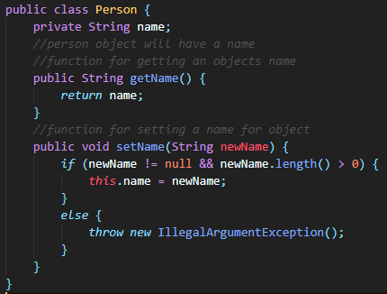

3. Instantiation of object (creating an object)

-

4. Visibility (public/private/protected)

5. Member datas / methods

6. Inheritance

7. Polymorphism

8. Overriding

9. Overriding

10. Abstract classes