TECHNICAL PROPOSAL
USE OF MACHINE-LEARNING TECHNIQUES TO CREATE FUN EXPERIENCES IN VIDEOGAMES

AUTHOR
Javier Villanueva Forner (53794782J)

SUMMARY
This document explains the basics of the project that will be developed by the author during the following months based in finding ways of applying machine learning to video games. Machine learning is a group of algorithms and techniques that allow computers to learn to solve problems efficiently and effectively. The main idea is to explore some machine-learning mechanisms and apply them to a video game, with the main objective being to make the game challenging enough to keep the player’s attention and interest. In other words: the objective is to teach machines to play games in a way that they do not surpass the player excessively, increasing the game’s fun factor. We expect to obtain a mechanism able to learn to play the game and adapt to the player skill.

KEY WORDS
Machine-learning, video games, adaptability.

INTRODUCTION AND MOTIVATIONS - explicar
This project main objective is to implement machine-learning mechanisms like Montecarlo Tree Search and artificial neural networks in a video game. After that, these mechanisms will be adapted to grant player adaptation. The main objective of he project isn’t to create an IA capable of learning fast and being extremely difficult to beat (if not impossible). Instead, as explained before, our main objective is to learn how to teach machines to play in a fun way. We want them to adapt to the player, presenting a challenge just hard enough for the player to want to overcome it without generating frustration and anger due to an excessive difficulty.

The main motivations behind all of this are mainly two. The first one is the experience of the author as a player. Hundreds of hours of gameplay have made the writer notice that the current IA development systems, although complex, are not as good as they could be when presented to players away from the average. Either because their skill level is too high or to low, the AI fails to adapt to them and making the game fun. Segmented difficulties often leave players in the gaps between the steps they provide (easy – medium – hard). Progressive ones (those that can be scaled by the player) provide the player with the control of the world, and that not only affects the immersion, it also delegates the balancing difficulties to the player. Bottom line, a game should push the player to his or her limits, this limits being a difficulty hard enough to be challenging but not frustrating.
The second main motivation is the interest of the author in the subject. During the course of the current academic year, the concept of machine learning has captivated his attention and thus, encouraged him to explore it further trough this project. Thus, one of the objectives is the gain of knowledge in this area.
The project will be developed following 3 main steps: developing the base game in which everything will be tested, implementation of the machine learning techniques and adjustments and adaptations of the techniques to make them fun.
Auralux has been chosen as the base game in which this systems will be developed. The project will use a simplified version with the same main mechanics. We believe that this kind of games is perfect for the purpose of the project. They provide a simple set of rules and direct confrontation between players, in other words, an ideal environment to develop and test machine-controlled agents.
The game is simple: each level contains a determined number of stars. Some of them belong to a player (IA or human). The remaining ones are empty. The players can conquer stars sending enough units to their location. They can also fight each other the same way. When a unit is used, either fighting or conquering a star, it is destroyed. When a star is conquered, it will start producing units for the player that conquered it. To win the game, a player must be the only one with stars in its possession.

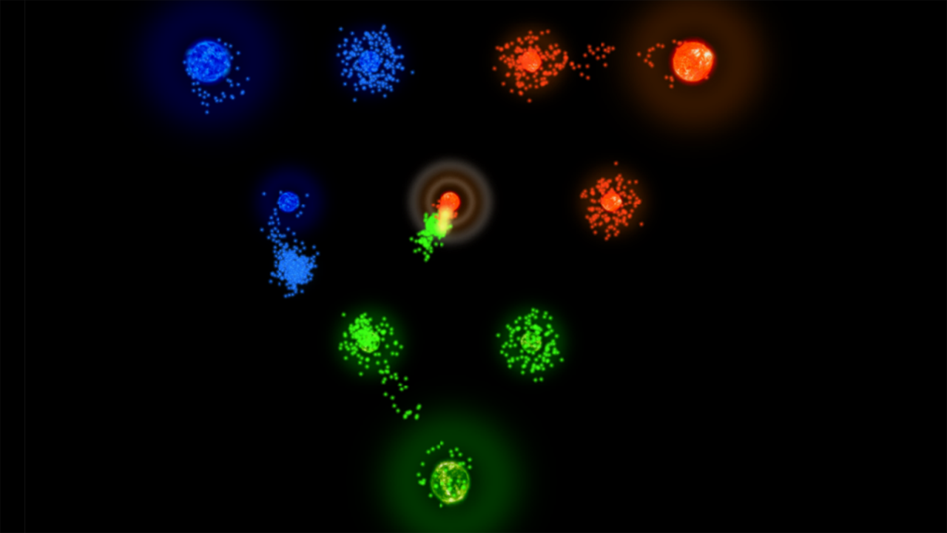
Figure 1: Image of the game Auralux.
Some planets, like the central one that can be seen in Figure 1, have multiple levels. This means that if the player spends units in that planet after conquering it, the planet ascends one level and produces more units.
Again, a simplified version will be developed, much less ambitious in the graphic part and with some of the less important mechanics (the ones that can be seen at higher levels) removed.

RELATED COURSES
Advanced Interaction Techniques (VJ1234)
Algorithms & Data Structures (VJ1215)
Programation I & II (VJ1203 – VJ 1208)
Artificial Intelligence (VJ1231)
Game Engines (VJ1227)

OBJECTIVES
- Understanding the basics of machine learning.
- Learn how Montecarlo tree search and artificial neural networks function.
- Real-time adaptation to the player’s level of skill.
- Create a fun and challenging game.

EXPECTED RESULTS
- Research of methods of adapting machine learning techniques to video games.
- A game that learns to play itself and that adapts its difficulty to the player.
PLANIFICATION
ID | Task | Description | Estimated Hours
01 | Game design | Implementation and testing of a simplified version of the game Auralux. | 40 hours
02 | Montecarlo Tree Search Research | Research to learn the basics of the method and to prepare its implementation | 10 hours
03 | Montecarlo Search Implementation | Implementation and testing of this machine learning technique in the game. | 60 hours
04 | Montecarlo Search Game Adaptation | Investigation of methods to adjust the method to gaming to obtain adapted and fun behaviours. | 30 hours
05 | Neural Network Research | Research to learn the basics of the model and to prepare its implementation. | 15 hours
06 | Neural Network implementation | Implementation and testing of this machine learning technique in the game. | 75 hours
07 | Neural Networks Adaptation | Investigation of methods to adjust the method to gaming to obtain adapted and fun behaviours. | 30 hours

Note: The remaining 40 hours will be used for the following tasks:
1. Redaction of project documentation. This task will be done continuously during the project. That is the reason of its exclusion from the planification table (ID 00).
2. Security margin: If one of the mentioned tasks took longer than expected, this hours will be used to complete it without affecting others.

Note 2: If the project development is faster than the predictions, the spare hours will be dedicated to finding new adaptations that use both methods.

TOOLS
- Unity 3D
- PyTorch
- TensorFlow

https://en.wikipedia.org/wiki/Monte_Carlo_tree_search
https://en.wikipedia.org/wiki/Artificial_neural_network
https://play.google.com/store/apps/details?id=com.wardrumstudios.auralux
https://unity3d.com/
http://pytorch.org/
https://www.tensorflow.org/

