LUX AURA

Having explained the elements that compose the game now we will expose how these have been implemented to construct the final game. We will follow a bottom-top road in which we will start explaining the most basic elements of the game and advance towards those more complicated.

The most basic elements are the classes. These form the basic objects from which the game is built. After that, classes that derive from the basic ones will be treated, as they form the complex objects that are present in the game world. Finally, the relations between these objects, and thus, how the game works, will be treated.
BASIC CLASSES
These conform the most basic entities of the game. Most of them are designed to be expanded through heritage by other classes. Despite that fact, they conform the very core of the game and are responsible of the communication between entities of higher complexity. Because of that, they are very simple and wide-purposed, because they accomplish simple functions and have to be used in contexts that can differ drastically between them.
Some of these have MonoBehaviour as their parent class. This implies that they can’t be instantiated. Instead, they have to be inside if an object in the scene and will execute some functions following the Unity execution order¹. Despite this, they can have their own methods and attributes and those can be accessed and called like a normal class. These methods whose call is controlled by Unity will be marked with the characters “MB”, so the reader can easily identify them.
The classes will be presented in an order that we believe is optimal for its comprehension, since they are introduced as they relate to each other, starting with the central class and switching to the ones more closely related. We hop that this helps the reader to understand easily how the game has been implemented.
The classes related to the machine-learnings techniques that have been implemented will be covered in their respective section.

-GlobalData
We start with this one because it is used almost by every other class. It is simply an information storage. It doesn’t have any methods and it’s not meant to be instantiated. Contains variables that are used by other classes and thus, is recommendable having in one place accessible by all. The disadvantage of this is that the access to this variables needs to be extremely controlled, because they can be accessed and changed by every other class in the game.

- Clock
The name of this class says it all. It is the one in charge of making the game advance and evolve through time. It is basically a clock that ticks every 0.5 and 4 seconds. It extends the MonoBehaviour of Unity, so it needs to be in the scene to be used. There is only one Clock per scene.
We understand a tick as an event that triggers a response in the internal logic of the game and that fires when a determined interval of time has passed since it was activated. This class uses the C# Timer² class.

NAME | ARGUMENTS | RETURN | DESCRIPTION
AddListener | ClockEventReceiver | - | Subscribes the provided element to the events, so when they are fired, the object will be notified.
Awake  (MB) | - | - | Two timers are created: the AI and the main clock. The first one ticks every 4 seconds (4000 milliseconds) and the second every 0.5 seconds (or 500 milliseconds). Both reset automatically once the event is fired and are active until the game ends.
OnApplicationQuit (MB) | - | - | Stops the timers.
OnMainTick /  On AI Tick | Object  ElapsedEventArgs | - | When one of the timers ticks, the corresponding function is called. These start a new thread that spreads the event trough all the entities that have subscribed to them, so they can perform the corresponding actions in response to the tick.  The first one fires a MainTick event, whilst the second one fires an AITick one.
RemoveListener | ClockEventReceiver | - | Deletes a listener. Since the moment this fnction is called, the object will stop being notified of the new clock-related events.
Stop | - | - | Same as OnApplicationQuit, but is not called by the engine.

- ClockEventReceiver
A base class that derives from MonoBehaviour. This class is abstract, which means that it can’t be instantiated or appear in the scene by itself; instead, another class has to implement it. The purpose of this class is to standardize the relation of the clases in the game with the clock. No matter what class implements this one, thanks to polymorphism ³ it can be treated as a ClockEventReceiver object and thus, simplify the interaction.
If an object wants to interact with the clock (subscribe to its events, be alerted when these are fired) it needs to implement this class.
This class defines only an abstract method:
NAME | ARGUMENTS | RETURN | DESCRIPTION
Tick | EventType | - | To be called when a clock event is fired.

- EventType

An enumerator⁴ used to identify the two types of events that can be fired:

- Main Tick: Fired every 0.5 seconds by the Main Timer.
- AI Tick: Fired every 4 seconds by the AI Timer.

The main idea is that the main tick is used to create units and other basic operations. Their cost is cheap and can be executed without overloading with tasks the main flow of the engine. It also controls the peace of the gameplay, as explained before.

The AI timer triggers the execution of the different AIs. This event has been separated for a couple o f reasons: first, these process are very expensive and, like in the case of Montecarlo, can can take several seconds; second, it makes no sense to trigger them so frequently as the other event because the AI will most probably react taking the same actions and thus, no new behaviour will be produced.

In further detail: the changes in the state of the game between the main ticks are so little that the AI will react by performing the same actions over and over until enough events have passed to change the world in a sufficient manner for the AI to react differently. These times the AI is triggered and reacts by doing the same it is already doing (in other words, by doing nothing) are a waste of resources.

- EventEntity

Holds the basic and commom information to all the entities (stars, planets, etc) that can be placed in the map. The basic idea behind this class is to provide methods to interact between entities without specifying how each type will react and thus, allowing for different behaviors. Because of this, EventEntities can’t be spawned in a level, but rather serve as a base class for the rest of the entities.

For example, we can have stars and planets in our level. Both have a certain amount of health and can be attacked and conquered. However, the star can react differently to an attack than the planet. By deriving from this class, both will have a “SufferAttack” method, but each one can perform different actions.

EventEntity derives from ClockEventReceiver, which implies that will react to the clock events. However, it does not implement the Tick function. This will have to be done by the classes that derive from this one, so they can handle the events in different ways.

Here are the attributes that define the objects present in the game,that means, they are common to all the entities that can be interacted within the game:

NAME | TYPE | VALUE RANGE | DESCRIPTION
Conquerable | Boolean | True - False | Indicates if the object can be conquered by a player
CurrentContestantId | Int | -1 – 5 | When a planet is neutral, a player has to send enough units to conquer it by itself. If another player send units, he has to eliminate all the rivals units first before being able to begin the conquest. This variable stores which player is currently claiming the planet so other attacks can be treated accoridingly.
CurrentExp | Int | 0 - ExpForNextLevel | Current experience points
CurrentHealth | Int | 0 - MaxHealth | Current amount of health
CurrentLevel | Int | 0 – MaxLevel | The level the entity has at a given moment
CurrentPlayerOwner | Int | -1 - 5 | Id of the player in control of the entity
CurrentUnits | Int | 0 – 9999 | Units the entity has at a given moment.
ExpForNextLevel | Int | 0 – 1000 | Necessary units to upgrade the entity to its next level.
GenerationRatio | Float | 0 – 10 | Units produced per second.
MaxHealth | Int | 0 - 300 | Maximum amount of health possible in a given moment for this entity.
MaxLevel | Int | 0 - 5 | The maximum level achievable in an entity.
UnitsToConquer | Int | 0 - 1000 | Number of units necessary to conquer the entity.

It also has a method to control the units that has at any given moment:

NAME | ARGUMENTS | RETURN | DESCRIPTION
UseUnits | AttackInfo | - | It spawns an Attack using the amount of units necessary to fulfill the requisites given by AttackInfo. If it hasn’t got enough, it will use all the units that has.
This class is also responsible to handle user interaction. Given that all the elements in a level are susceptible of having to react to player input, that aspect is handled at this level to, again, simplify its implementation. The methods and attributes related with this aspect are the following

Attribute:
NAME | TYPE | VALUE RANGE | DESCRIPTION
SelectedUnits | Int | 0-9999 | Stores the number of units selected by the player. These units (and only these ones) wil be used when an attack is fired.

Methods:
NAME | ARGUMENTS | RETURN | DESCRIPTION
DeselectUnits | - | - | Returns all the units that were selected to the entity
SelectUnits | - | - | Adds:  - 1 unit to SelectedUnits if the entity has 5 or less in total.  - 1/3 of the total units  - 0 units if the Entity has none.  - All if the entity is interacted while holding the left control button.
Useunits | Gameobject | - | Spawns an Attack that contains the SelectedUnits headed for the provided Gamobject.

It is important to note that selected units will be discounted from the total units that entity has when they are selected. If an entity is attacked, this units will behave like if they were not on it. That means they won’t be destroyed, but if the entity is lost, these units will disappear.

- Planet
An extension of EventEntity. This one symbolizes a planet and is the standard entity that can be found in the game.
Attributes:
NAME | TYPE | VALUE RANGE | DESCRIPTION
UnitsNumberText | Text | - | Hold a reference to the UI text element where CurrentUnits will be displayed.
Material | Material | - | Reference of the material of the object in the scene. It is used to change colors when the entity is conquered.
HealthSlider | Slider | - | Reference of the UI slider used for displaying health values.
ExpSlider | Slider | - | Reference of the UI slider used for displaying experience values.

- Methods:

NAME | ARGUMENTS | RETURN | DESCRIPTION
AttackFromSelf | AttackInfo | - | Handles attacks of the player that owns the player.  - If the planet’s health is not at maximum, it will be healed.  - If the maximum level of the planet has not been reached and it has full health, the planet is upgraded (its experience points are increased). If it has enough experience points, the planet levels up.  - If the planet has full health and can’t level up more, the units are added to the units of the planet.  More information on this subject in the SECCION CORRESPONDIENTE
AttackFromOther | AttackInfo | - | Handles attacks of player that do not own the planet.  - If the planet has some experience points but has not leveled up yet, these are reduced.  - If the planet contains units and has no experience points, they will be destroyed.  - if the planet doesn’t have units, its health points are reduced. If these reach zero, the planet is conquered and the owner is the player that produced the attack.
SufferAttack | AttackInfo | - | Handles the provided attack. If the planet is neutral, the function will conquer it (if AttackInfo has enough units) or damage it.  However, if the planet is not neutral:  - If the attacker is the owner of the planet, AttackFromSelf is called.  - If the attacker is not the owner, AttackFromOther is called.
Tick | EventType | - | Handles the clock events:  - Main Tick: Adds 1 + current level to the total number of units.  - AI Tick: Does nothing.

- AttackInfo:
A struct⁵ that stores the basic information needed to define an Attack. It is used to transfer this information between objects. It stores:
NAME | TYPE | VALUE RANGE | DESCRIPTION
Origin | GameObject | - | The entity from which the attack was fired.
Objective | GameObject | - | The entity towards which the attack is headed.
Player | Int | 0 – 5 | ID of the player that ordered the attack.
Units | Int | 0-999 | Number of units contained in the Attack.

- Attack
This class controls the Attack itself in the game. It is responsible of its movement and behaviour since its spawning until its arrival. It “transports” the units from their home entity to its objective.
It is important to notice that attacks move at a constant speed and o not rely on events. Once they are created, they will start to move until they reach their objective, moment in which the attack will be effective.
Attacks start at the same position as the entity which units are being used. It slowly moves until the objective is reached, when the attack is made effective and the object disappears. Its size varies: it starts at size 0 and slowly increases until its completely outside the origin entity. This process is reverted when it is close enough to the objective. This is done to make the game easier to understand.
It has the following attributes:
NAME | TYPE | VALUE RANGE | DESCRIPTION
CurrentAttackInfo | AttackInfo | - | The information of the attack that is being transported by the object.
text | Text | - | Reference to a text object used to display the units that are being transported.

And the following methods:

NAME | ARGUMENTS | RETURN | DESCRIPTION
Prepare | AttackInfo | - | Prepares the Attack to be spawned using the information that AttackInfo contains.
Update (MB) | - | - | Moves the object towards its destination and changes the size accordingly.

- AttackPool:
Generating and destroying GameObjects⁶ in Unity is an expensive task in time and resources. Attacks are so common in our game that generating and destroying them would affect negatively the game’s performance. That is why an object pool⁷ is used.
At the very start of a level, 5 Attacks are created and deactivated, so they are invisible and have no effect in the game. When an entity needs to use one, instead of creating a new one, it simply uses one of these (one that is not already being used), changing its position and the information it contains. There is only one instance of this class per scene.
The AttackPool class administrates this collection of objects. When an attack is needed, the entity that demands it provides this class with the corresponding AttackInfo and this class generates the corresponding Attack. Doing thing this way, entities don’t need to know how the pool is implemented nor used, simplifying the task, thus benefiting of the principle of cohesion⁸.
The pool size (that is, the number of attacks it contains) it’s not constant. If all of its elements are being used and a new one is required, the pool size will be increased (new attacks will be created). After that the pool will keep its new size until the game ends or it is increased again.

These are the attributes used by the class:
NAME | TYPE | VALUE RANGE | DESCRIPTION
AttackPrefab | GameObject | - | Model used to create the attacks that will be used by the pool.
AvailableAttacks | List<Attack> | - | List that stores all the attacks in the pool (those that are and that aren’t being used at any given moment)
pendingAttacksInfo | List<AttackInfo> | - | When an object is instantiated in Unity, a complete cycle must have been passed before it is usable. This list stores the information of those attacks that have to wait a frame to be prepared because all the atacks in the pool were being used and a new one had to be instantiated.
TotalAvailable | Int | 5 – 100 | The number of attacks available (not being used at the moment) .

And these are the methods:
NAME | ARGUMENTS | RETURN | DESCRIPTION
Attack | AttackInfo | - | Selects an available Attack from the pool and prepares it. If not available Attack is found, instantiates a new one, stores the AttackInfo in pendingAttacksInfo and starts PrepareNextFrame.
PrepareNextFrame | - | - | Waits one frame and then iterates over pendingAttacksInfo and invokes the Attack function for each one of the elements in the list.

- Selection Manager
This class handles the interaction of the player with the game. It is in charge to select the desired untis by the player, to use them or to deselect them again. Togheter with CameraMovement cover the input needs of the game.
Details about the controls of the game have already been given out in their corresponding section, so we will simply comment the basics of the implementation here.

The class has the following attributes:
NAME | TYPE | VALUE RANGE | DESCRIPTION
entitiesSelected | List<EventEntity> | - | Stores all the entities that have at least one unit selected by the player.
unitsCarried | Int | 0 - 999 | Stores the total amount of units selected by the player (counting selected units of all entities selected)
UnitsMouseText | Text | - | Reference to a text that will follow the mouse and will display unitsCarried.

Methods:

NAME | ARGUMENTS | RETURN | DESCRIPTION
checkForSelection | - | - | Implements the logic described in the SECCION DE CONTROLES E INTERACCIÓN for selecting units.
deselect | - | - | Deselects all selected units.
prepareAttack | GameObject | - | Prepares the necessary attacks to send all selected units to GameObject.
Update (MB) | - | - | Updates the unitsMouseText position and checks for new selections calling checkForSelection.

- CameraMovement
Moves the player’s camera following the logic described in SECCION DE CONTROLES.

- Game
Stores information about the game that is currently being played. Contains level (entities that can be found in the scene), players and attacks information. It is used mainly by players and entities to obtain information about the state of the game and other players and entities.
It is important to notice that this class can be accessed from anywhere in the scene, but not modified.

Attributes:

NAME | TYPE | VALUE RANGE | DESCRIPTION
attackPool | AttackPool | - | Reference to the scene’s AttackPool.
level | GameObject | - | Parent object that contains all the entities of the level.
Planets | EventEntity[] | - | Array of all the EventEntities that exist in the level.
Players | Player[] | - | References to the players that compete in the level.

Methods
NAME | ARGUMENTS | RETURN | DESCRIPTION
SomeoneWon | - | Int | Returns the ID of the Player that won or -1 if no one did.

- Player
Represents the entities that can play the game, whether they are controlled by a human or by an AI. They are used basically to keep record of the state of each player and what entities belong to him and thus which units can control.
It derives from ClockEventReceiver, because each Player controls its AI in terms of starting their process. This class is also responsible for executing the Actions that the AI orders.

Attributes & methods:
NAME | TYPE | VALUE RANGE | DESCRIPTION
AI | AI | - | Stores the AI of the player, independently of its type.
CurrentGame | Game | - | Reference to the game that is being played.
Deactivated | Boolean | True – False | When a player is eliminated, it still receives clock events and, thus, its AI is triggered. This boolan is set to true when the last EventEntity of the player is conquered, so it won’t use its AI any more.
myEffector | Effector | - | Stores a reference to the player’s Effector. More information in its current section.
pendingAICycle | Boolean | True – False | The AI executes in a separate thread to avoid affecting the game’s performance. To do so, coroutines ⁹ are used. However, because the AI is triggered through a separate thread (the thread that spreads the clock events), a coroutine can’t be started (because of the way Unity is implemented).  This value is used to start those coroutines the next frame after clock event are recevied.
typeAI | AIType | None - Dumb – Random – Classic – Montecarlo - NeuralNetwork | Stores the type of AI used by the player (if any).

NAME | ARGUMENTS | RETURN | DESCRIPTION
AICycle (CR) | - | - | Coroutine that executes the AI of the player, waits one frame and then uses myEffector to execute its orders.
GetCurrentUnitsNumber | - | Int | Returns the total number of units the player has at any given moment but does not select them.
HasLost | - | Boolean | Returns true if the player does not has any entities under its domain.
PrepareList | List<EventEntity> | - | Used at the start of the game to set the initial entities of each player.
Start (MB) | - | - | Adds the player to the clock’s listners, instantiates the corresponding AI and an instance of Effector.
SelectAllUnits | - | Int | Selects and returns the total number of units of the player (that is, every unit from every planet the player controls).
Tick | EventType | - | When an AITick is prouced, starts the process for executing its AI.
Update (MB) | - | - | If pendingAICycle is true, the coroutine AICycle is started.

- AI
Interface used to simplify the interaction with the different types of AIs. It has only one method:
NAME | ARGUMENTS | RETURN | DESCRIPTION
Decide | - | Actions | Returns an action that has to be executed.

Again, this is used to avoid dealing with the particularities of each type of AI. The player only needs to invoke Decide and execute the Action it returns.

- Actions
Enumerator that defines the actions that can perform non-human player. Its values are:
None: Represents the absence of an action.
Wait: The player does nothing.
AttackEnemy: The player will attack entities that have been conquered by another player.
AttackNeutral: The player will attack entities that have not been conquered yet.
Upgrade: The player will spend units to level up its own entities.
Heal: The player will spend units to restore the healh points of its own entities.

There are some classes (Effector, AI related…) that have not been mentiones. Those will be explained in greater detail in their corresponding section, because we feel that treating them like a normal class wouldn’t be enough to cover them correctly.

EFFECTOR

This class is the executor of the non-human players Actions. It was created to simplify not only the process of action execution, as said before, but also to do it with the decision making as well. The first part is simple and we have already seen it before: it simplifies the execution of the actions by the principle of cohesion.
By having this class, the players do not need to know anything about how to make actions happen or what criteria to follow depending on its state, etc. It only needs to trigger the AI, store the action it chooses as the best and let Effector do the job.
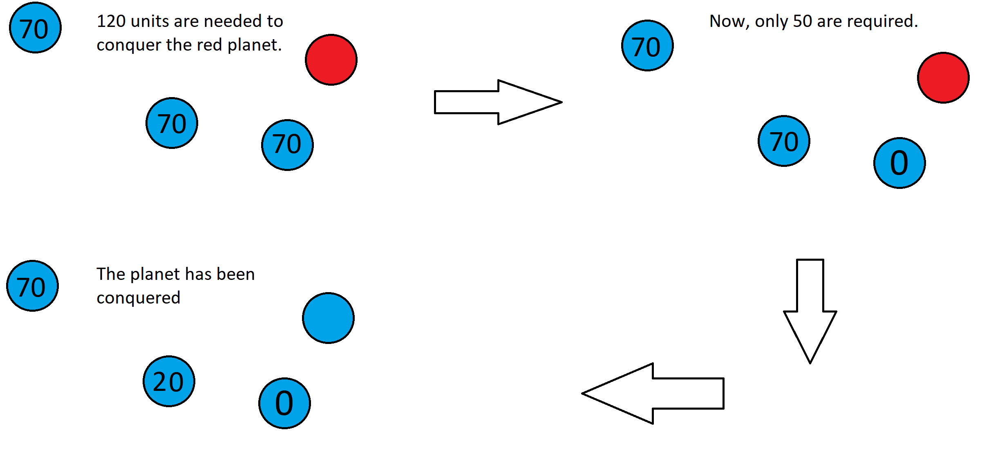Figure 1: Process of unit sending. Units that are in closest planets are sent first.
But the most important simplification is the one related to decision making. By defining a constant set of rules about how every action has to be done, we can simplify the possible number of actions. In its original state, a player could do nothing or could attack every entity there was with any number of units between 0 and the amount of units the entity that was “using” had. And that is if only one of its own entities were used, because several can be used at the same time.
As the reader can see, that represents a huge number of possible actions. And trying to choose only on using any type of AI would be higly difficult. By having the effector, players now can only perform 5 actions: wait, attack entities conquered by other players, attack neutral entities, upgrade its own entities and heal them.
The effector is in charge of deciding the best way of performing those actions and executing them using the player’s resources. Of course, this is done introducing random factors that adapt to the difficulty to perform these actions not as optimal as they could be done.
Here we explain how the effector executes the actions. Again, keep in mind this is the best performance scenario. By introducing variations in the number of units that will be used, the difficulty can be adjusted so the player is presented with a challenge and not overwhelmed with a merciless rival.

- Wait: It simply does nothing. But in a very effective way.
- Attack enemies / Attack neutral entities: Both actions are executed similarly.
  - The number of units necessary to conquer the objective is counted. That includes (in the case of non-neutral entities) counting the health points, the experience points and the units that the entity possesses. The effector will try to send 1.5 times this numbers, to ensure success.
  - A list of the player’s entities sorted by distance to the objective is obtained.
  - Units of the players entities will be used starting by the closest one to the objective, as it can be seen in Figure 1.
- Upgrade / heal: The process is similar to the followed in the attack actions, however, only the necessary amount of units is sent. Again, the closest units are used first.

This approach has also some limitations. Only one entity can be attacked per execution. This slows the gameplay and makes the game easier, because the player has time to react to the attacks and the AI has to be executed again implying that several seconds have to pass for another attack to be produced.
To be able to function, the class needs two attributes:

NAME | TYPE | VALUE RANGE | DESCRIPTION
map | GameObject | - | Reference to the parent object in the scene that contains all the entities of the level.
myPlayer | Player | - | Reference of the player that owns the instance of the class.

The effector also has security checks. It handles the special cases like, for example, when it receives an Upgrade action and all the player’s entities are already at their maximum level. In those cases, the effector behaves the same way that does when it receives a Wait action type.
AI

In this section the basic AI mechanisms will be explained in detail. Both Montecarlo Tree Search and Deep Learning will be treated in their own section. This techniques are more simple approaches (trivial in some cases) that allow a game to take place, with or without human player. These AI techniques have been implemented mainly to be compared with the more complex ones, main subject of this project.
Again, we want to remember that all of these techniques implement the interface AI. They all implement a different version of the Decide method, where the work is done. After finishing, an action (passed as a variable of type Actions) is returned, and the AI work is done.
There will be explained three AI types in this section: dumb, random and classic.
We start with the Dumb AI. The most simple and easy to defeat. It simply waits, forever. When the Decide function is called, it immediately returns the action wait, and does nothing else. It is useful for checking the main strategies of other types of AI.
The Random AI is a little more complex. Instead of returning always the same action, it chooses one arbitrarily. Very useful for cheking the reaction of other types of AI to its behaviour.
The classic AI is the most complex of these three, although it is rather simple. It uses a behavior tree to decide which action is the most appropriate given the context of the game that is being played. To avoid making an AI too predictable, random elements have been introduced in the tree, so it might perform strange and even ilogical actions at any moment.
Here can be seen the decision tree:
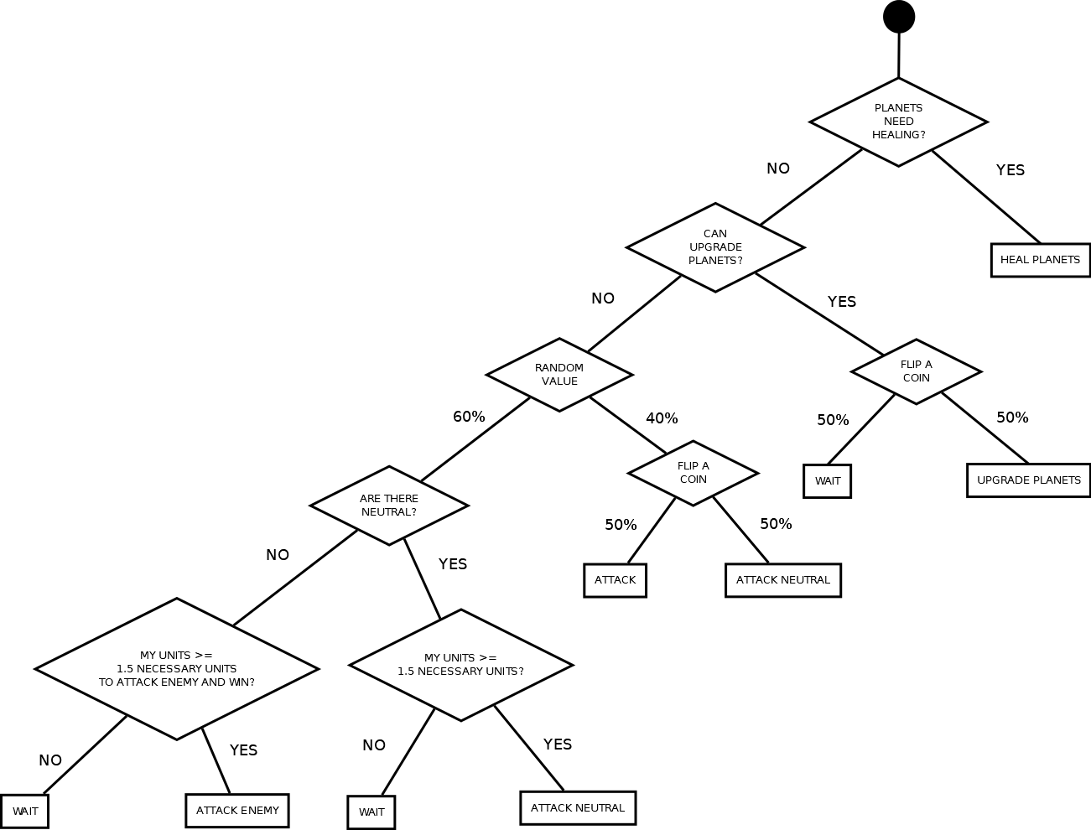Figure 2: Classic AI decision tree.
The random values that can be appreciated are included to create a behavior more human-like. This will enhance the gameplay quality, by having an AI more enjoyable to fight and it will also will provide a rival less predictable for the machine learning techniques to practice. This is because the classic AI will be used to train and test the machine learning techniques that will be implemented.
TRAINING VERSION

Until now, we decribed the “normal” version of the game and how it has been implemented. This version is the one users can play and interact with. It has also a graphical component that represents the state of the game at any given moment in a screen, in an easy and understandable way.
However, this has some limitations. First of all, the execution of the actual “game” has to wait and take care of the graphical part. Attacks and entities have to be updated and that has to be done at a slow enough speed for the human player to be able to interact and react to the events. The second limitation is that the game must follow the Unity execution flow, being very careful to not block it. If it does, the game freezes, temporarily or forcing he user to close the application.
There are some tasks that can’t be performed under those circumstances. Either because they need to be done as fast as possible and have to be repeated huge amounts of times or because need to use all the resources possible. Using the “normal” version of the game is impossible to perform those tasks.
Is at this point where developing a “training” version of the game becomes a necessity. By “training version” we refer to a variation in which no graphical nor interactive aspects of the original game remain. It is simply the core logic of the game executed as fast as possible and communicating with the exterior through console output. In this section we will discuss how this variant has been implemented and the most fundamentals aspects of it. We will not, however, talk about the different uses it will have.
The first thing the reader needs to know is that this version will be an exact copy of the games logic. The rules and outcomes will be the very same that those of the normal version. This version modifies how the game is executed, not how is it played. And by how is it played we refer to how the performance of determined actions changes the game’s state, we are not talking about input.
But in regards to that, the input is eliminated from this version. No human will be able to interact (and of course, to play) this variation. We want the game to execute as fast as a computer is able to do it and adding a human factor will make this impossible. Humans are infinitely slower than any machine and thus, need to be ignored to achieve fast execution.

-New flow:
In the normal version, the gameplay depends on the clock. The AI and the units are produced as a response of the events triggered by timers. The human player, of course, can perform actions between events, but still needs units to do so, and units are created when these events are triggered. So it is pretty fair to say, the flow of the game is completely bound to the clock.
Because we want to execute the game as quick as we can, this bound has to disappear. Attacks behavior needs to be revised too. In the normal version of the game, they moved from the entity which created them to their objective, but now there are no objects in the scene and thus, nothing to be moved.
The solution we adopted was to use turns instead of time or movement. A turn is equivalent to a MainTick event. There is nothing between turns and they happen constantly, one after the other, as seen in Figure 3.
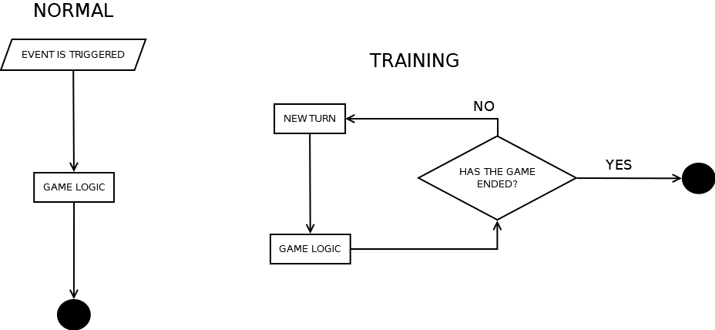Figure 3: Normal flow VS. training flow.
Now only the attack aspect remains. Our solution was to count how many turns would it take for an attack to reach its objective by dividing the distance by the speed, and then by the time between MainTicks. The first operation returns how many seconds the travel would take and the second translates that into turns. It is not perfect, but because all attacks will follow the same rules, the precision loss is compensated.

Formula 1: Conversion from real-time movement to turns.

Every attack will now store this information and update it accordingly as the turns pass. When all the necessary turns have passed, the attack becomes effective.
With this new system, a minor change can be performed to optimize the execution. Instead of advancing turns at a time, which would produce the execution of operations that don’t have any important effect on the game whatsoever, we can advance several at a time.
The idea behind this is that a normal turn only increases th number of units in the entities of the level. But as long as an attack reaches its destination or the AI is triggered, nothing happens. In the normal version we had a human player, that could perform actions whenever he wished, but now that element does not exist.
So, to avoid performing operations each time a turn is executed, we execute several turns at once. This implies that instead of having to check and add one to every entities units counter, we can add the corresponding number at once.
This has to respect a simple condition: the number of turns that will be advanced will correspond to the minimum between the remaining turns for the next attack to arrive at its destination and the remaining turns for the next AI tick.

Formula 2: Formula to calculate turns to advance at once.

- Simplified classes:
Until now, the main classes and mechanisms of the game have been explained to the reader. However, all of this classes were designed to create a playable game. This can be seen clearly taking into account how the flow is dependent on a clock. By doing things this way, the game can be tied to real time and allow humans to interact.
But in this version, as it has already been said, we need to free the game flow from human needs. That is why, a lot of classes need to be redesigned. Redesigned, but not rebuilt, because the logic is still the same. So the first pass we are going to take is to modify the main aspects of the game and create new modified classes, designed to execute as fast as possible. We will also suppress any graphical elemnts from them, because graphics would slow down the game.
Because these classes do the same as their user-friendly sisters, they will be presented by alphabetical order. Their functions are the same that their original counterparts, so if the corresponding section NOMBRE SECCION was read, the reader should understand how they relate with each other and form the game. They have the same name, but whit a capital “T” at the beginning.

- TAttackInfo – modifies Attack and AttackInfo
This enumerator⁴ replaces both Attack and AttackInfo. It stores the information needed to track an attack since the moment it is created until it reaches its destiny. Because it will not be an object in the scene any more, only this info is required to keep track of each attack’s state. Here are the attributes it contains:

NAME | TYPE | VALUE RANGE | DESCRIPTION
Destiny | Int | 0 – number of entities in the scene | Stores the index of the entity where the attack is headed. With it, the Entities array in the class TGame can be accessed and thus, perform it.
Player | Int | 0 – 5 | Index of the player in the Players array of the class TGame. Used to identify who launched the attack.
remainingTurns | Int | 0 – 99 | The amount of turns, obtained the way explained before, that remain until the attack becomes effective. Each turn is reduced by 1.
Units | Int | 0 - 999 | Amount of units contained within.

- TClassicAI – Moifies ClassicAI
The only difference with its counterpart is that it now stores a reference to the array of entities of the TGame being played at the moment. The Player reference has also been updated to one of type Tplayer.

-TEffector: - Modifies Effector
Again, same as the original, but the attributtes suffered minor changes:
NAME | TYPE | VALUE RANGE | DESCRIPTION
myPlayer | Tplayer | - | Reference to the player that owns the instance.
map | TEventEntity[] | - | Reference to all the entities in the level.

-TEventEntity – Modifies EventEntity
Again, little has changed when adapting this class. These are the attributes that have been added or updated:

NAME | TYPE | VALUE RANGE | DESCRIPTION
currentGame | TGame | - | A reference to the game being played. Its function is the same, but the type has been updated.
Position | Vector3 | (-1000, -1000, -1000)  –  (10000, 10000, 10000) | Because there isn’t an object in the scene to which position attribute can be accessed, it needs to be stored when the TEventEntities are stored

- TGame – Modifies Game

This class has suffered some major changes to adapt it to the new flow of execution. It now handles the events and passes them to the corresponding entities, because there is no clock that does that in this version.

These are the attributes and methods that define the new behaviors this class now has:

NAME | TYPE | VALUE RANGE | DESCRIPTION
PendingAttacks | List<TAttackInfo> | - | Stores the attacks that have been launched but have not reached their destiny.
Planets | TEventEntity[] | - | Stores the entities of the game.
Players | Tplayer[] | - | Stores the players of the game.
WeHaveAWinner | Boolean | True - False | Set to true when a player wins the game, false otherwise.
Winner | Int | 0 – 5 | ID of the player that won.

NAME | ARGUMENTS | RETURN | DESCRIPTION
AITick | - | - | Triggers an AITick, making all players decide their next action.
GetUnitGenerationRatio | - | Float | Returns the amount of units generated per turn.
Initialize | Tplayer[], TeventEntity[], List<TAttackInfo> | - | Initializes the game at a given state.
CheckPendingAttacks | Int | Int | When a turn is advanced, all the attacks that have been launched but have no reached its destiny have to be updated (their remaining turns have to be decreased). This function receives the number of turns the game has advanced and updates the attacks accordingly.  If an attack, after being updated, has zero or less remaining turns, it is executed and removed from the list.  It also returns the maximum number of turns that can be advanced; that is, the turns until the next attack arrives at its destiny.
CreateUnits | Int | - | Advances the provided number of turns for all the entities. The corresponding amount of unities per turn are created in every entity multiplied by the number of turns that have passed.

- TPlanet – Modifies Planet

The modifications made in this class only suppress the graphical elements. The logic is still the same and no new elements have been added.

- TPlayer – Modifies Player

Again, this class only modifie the types of some of the variables. The logic is untouched. The changes are:

NAME | TYPE | VALUE RANGE | DESCRIPTION
Planets | List<TEventEntity> | - | List of the entities under control of the player.
effector | Teffector | - | Instance of the TEffector that will execute the actions commanded by the AI.

NAME | TYPE | VALUE RANGE | DESCRIPTION

NAME | ARGUMENTS | RETURN | DESCRIPTION

TRAINING GAME EXECUTION CYCLE

In the previous section we described the components of the training version and some basic insight about its functioning. In this section we will describe in greater detail how the game is executed without the clock or elements of human interaction.
The training has been designed with the idea of playing more than one game consecutively. A diagram of the full cycle can be found in Figure 4. Here its explained in detail:
- The information from the scene is loaded. The distribution of entities, and players is read. A new instance of the class TGame is created with this information.
- The instance of objects that represent the entities are created and initialized following the information that was found on the in the scene. That includes:
  - Creating instances for every entity, specifying its position, current level, maximum level, etc.
  - Initializing the entities giving them a player that owns them (or none if that’s the case).
- Generate the players that will compete:
  - Instances of TPlayer are created and its AI its initialized.
  - The planets that belong to each player since the beginning of the game are added to each player’s Planets list.
- A snapshot of the current state of the game is taken. This will be used to restart the game when needed.

At this point we have all that we need to start playing, the entities are prepared and the players have an AI and some initial planets. The game can start.

- Results for the last game and accumulated results (that is, how many times a player has won in all the games that have been played) are shown through console. If it was the first game, nothing is showed.
- If the required amount of games have been played, results are shown and the execution ends.
- If not, the game is restarted using snapshots. That means that the snapshot taken at step 4 is loaded, to ensure a fresh start.
- We enter the main loop of the game:
  - The decided amount of turns (or 1 by default is advanced).
  - The attacks are checked. They remaining turns are updated and if one or more has reached its destination, the attack is executed. This step also provides with the amount of turns that can be advanced until another attack reaches its destination.
  - If someone has won, the game ends and we return to step 5.
  - If nobody won, units are created. The number of units that will b created in each units corresponds to the units that will be created in one turn [FORMULA CREACION UNIDADES] times the number of turns that have been advanced.
  - It is checked if the AI should be triggered.
    - If it has to be, we continue to step 8.6.
    - If not, the remaining turns for it to be triggered is compared to the number of turns obtained in step 8.2.
      - If the number of turns remaining until the AI is triggered is less than the turns obtained in step 8.2, the game will advance the number of turns remaining for the AI to be executed.
      - If not, the number of turns obtained in 8.2 will be advanced.
After that, the flow returns to step 8.1.
  - Number of turns until next AI execution is reset.
  - For every player, a thread is started. Each thread will execute their type of AI and the decision it determines. When all the actions have been executed (that is, every AI has ended and then its command was obeyed).
  - After all of them ended, the execution returns to step 8.1.

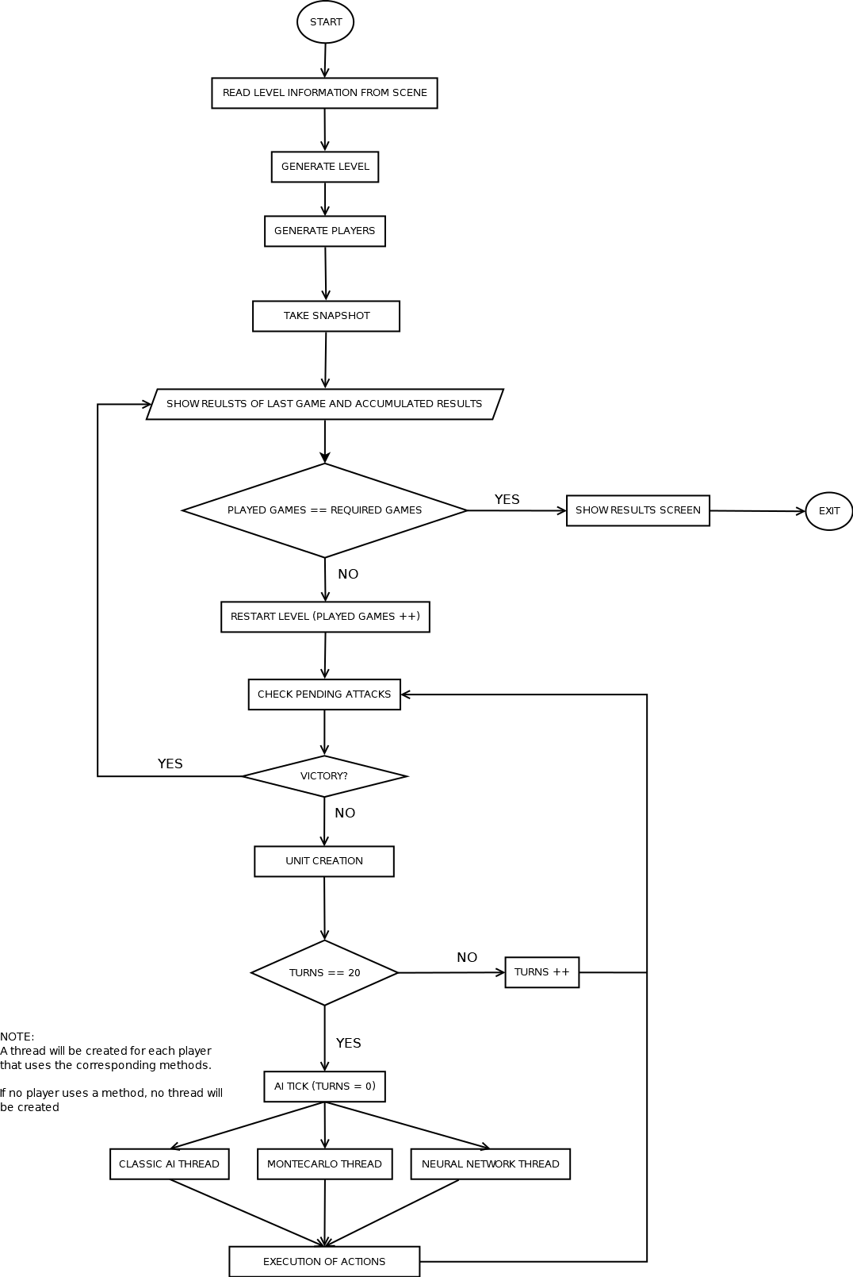Figure 4: Diagram of the execution cycle in the training version of the game.

REFERENCIAS

- https://docs.unity3d.com/Manual/ExecutionOrder.html
- https://msdn.microsoft.com/en-us/library/system.timers.timer(v=vs.110).aspx
- https://docs.microsoft.com/en-us/dotnet/csharp/programming-guide/classes-and-structs/polymorphism
- https://docs.microsoft.com/en-us/dotnet/csharp/language-reference/keywords/enum
- https://docs.microsoft.com/en-us/dotnet/csharp/language-reference/language-specification/structs
- https://docs.unity3d.com/ScriptReference/GameObject.html
- https://en.wikipedia.org/wiki/Object_pool_pattern
- https://en.wikipedia.org/wiki/Cohesion_(computer_science)
- https://docs.unity3d.com/Manual/Coroutines.html
- https://docs.microsoft.com/en-us/dotnet/csharp/language-reference/keywords/interface

